Continuous Space

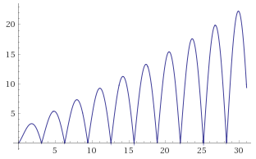

Binary Space

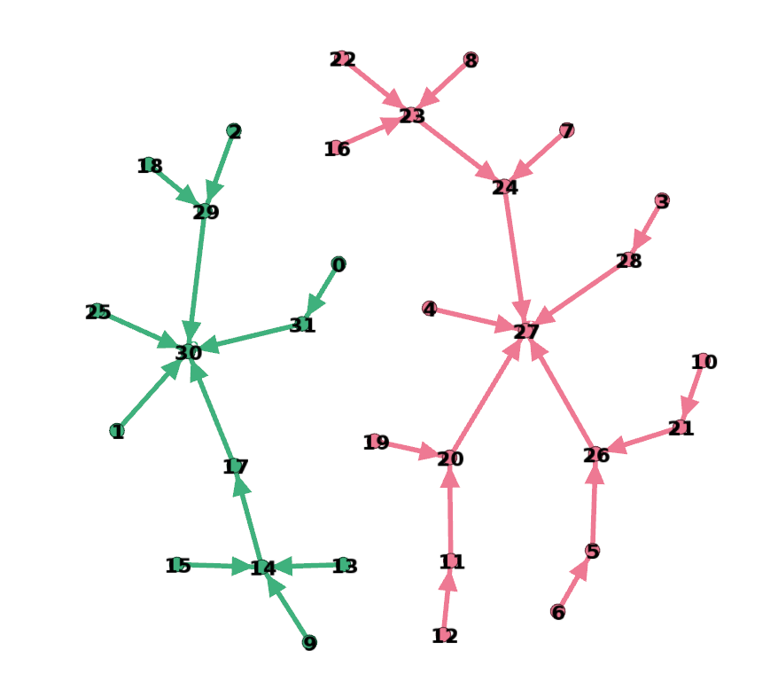
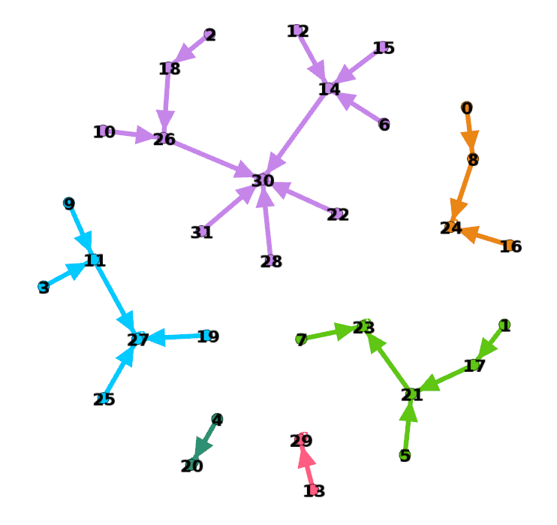

CX Operator (SAN) SBC Operator (SAN)
Integer Space

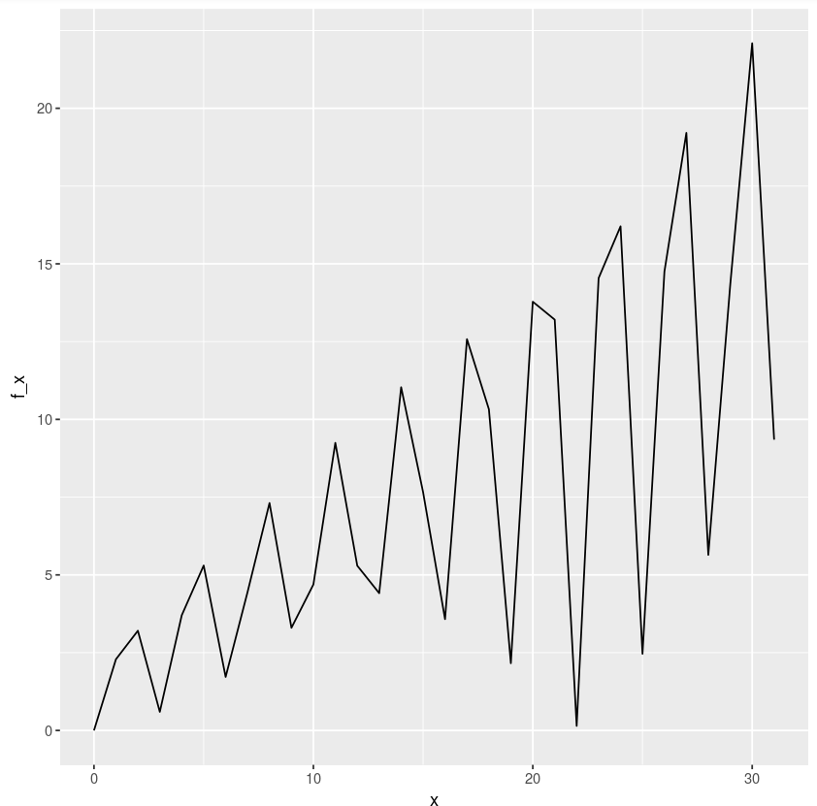
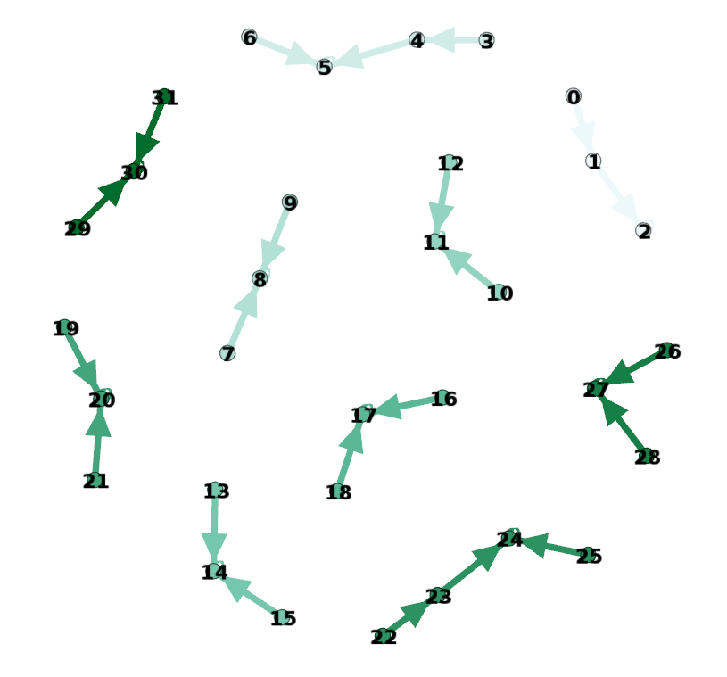

Numerical Landscape – Cartesian coordinates

Numerical Landscape – Single value increment/decrement operator (SAN)

