Visualizing Fitness Landscapes: A Need for a New Metaphor

Thomas Green
Computer Science
Boise State University
Boise, ID
thomasgreen@u.boisestate.edu
Dr. Tim Andersen
Computer Science
Boise State University
Boise, ID
email

Keywords—component, formatting, style, styling, insert (key words)

Introduction
Optimized search encompasses a wide range of techniques which can vary “a lot.” Common to all optimized search techniques, however, are the two spaces necessary to perform an optimized search: the set of all possible solutions, the search space, and the set of all possible objective function values, the fitness space. Evaluation of candidate solutions via an objective function produces a mapping from the search space to the fitness space. This mapping has no inherent structure. How individual elements of the search space relate … However, if an order is imposed on the search space, e.g. gray code over a binary space, then a neighborhood structure arises in the ordered search space as each element can be seen as connected to the other elements which are within a single step based on the ordering. This ordered mapping of elements in the search space to values in the fitness space is what has come to be referred to as a fitness landscape, and can provide a means for visualizing how relations in the search space correspond to values of an objective function. It is important to note that different orderings of the search space produce different layouts, and necessarily, different fitness landscapes.
Discuss and show Sewall Wright landscape metaphor.

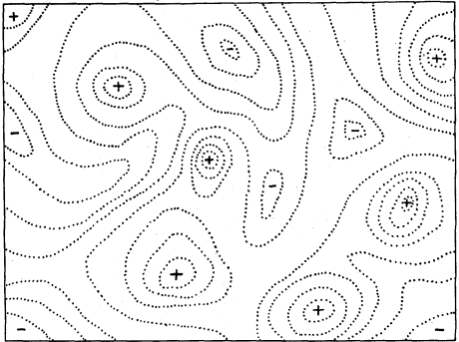

New Visualization Technique
Identify applicable funding agency here. If none, delete this text box.
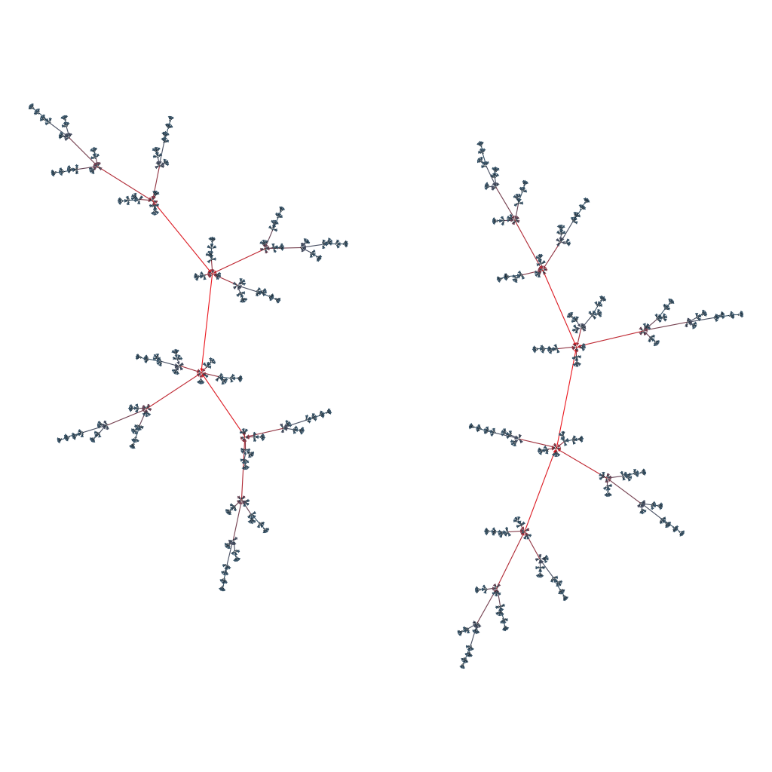
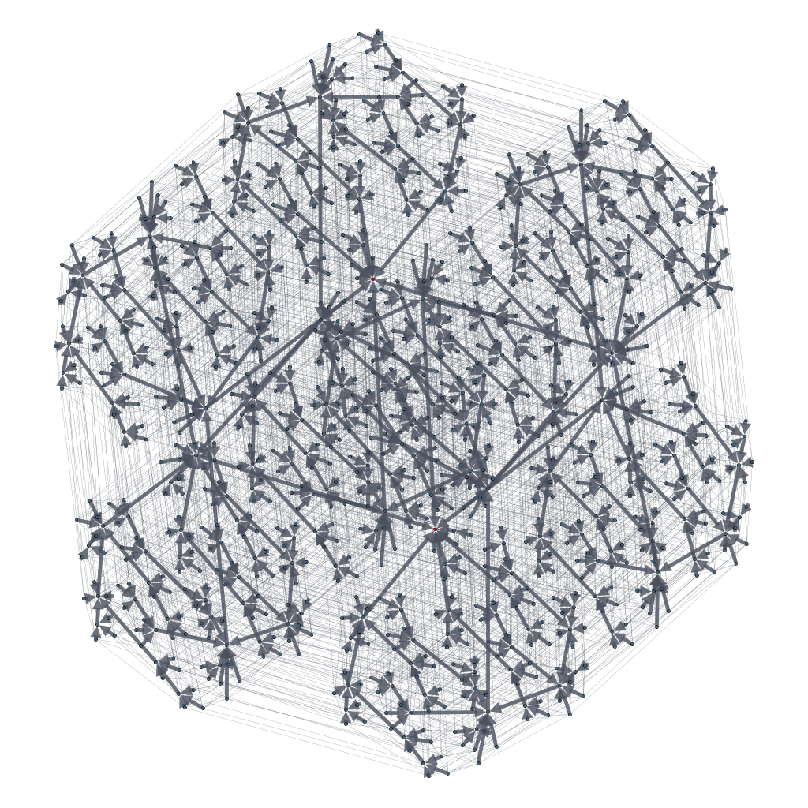

References

- G. Eason, B. Noble, and I. N. Sneddon, “On certain integrals of Lipschitz-Hankel type involving products of Bessel functions,” Phil. Trans. Roy. Soc. London, vol. A247, pp. 529–551, April 1955. (references)
- J. Clerk Maxwell, A Treatise on Electricity and Magnetism, 3rd ed., vol. 2. Oxford: Clarendon, 1892, pp.68–73.
- I. S. Jacobs and C. P. Bean, “Fine particles, thin films and exchange anisotropy,” in Magnetism, vol. III, G. T. Rado and H. Suhl, Eds. New York: Academic, 1963, pp. 271–350.
- K. Elissa, “Title of paper if known,” unpublished.
- R. Nicole, “Title of paper with only first word capitalized,” J. Name Stand. Abbrev., in press.
- Y. Yorozu, M. Hirano, K. Oka, and Y. Tagawa, “Electron spectroscopy studies on magneto-optical media and plastic substrate interface,” IEEE Transl. J. Magn. Japan, vol. 2, pp. 740–741, August 1987 [Digests 9th Annual Conf. Magnetics Japan, p. 301, 1982].
- M. Young, The Technical Writer’s Handbook. Mill Valley, CA: University Science, 1989.

