I. Introduction
A. Description of Fitness Landscape

B. Wright Landscape Metaphor
C. Structure in Continuous Landscapes

II. New Technique
A. Discussion of Binary Landscape Representation
B. Visualization of Binary Landscapes
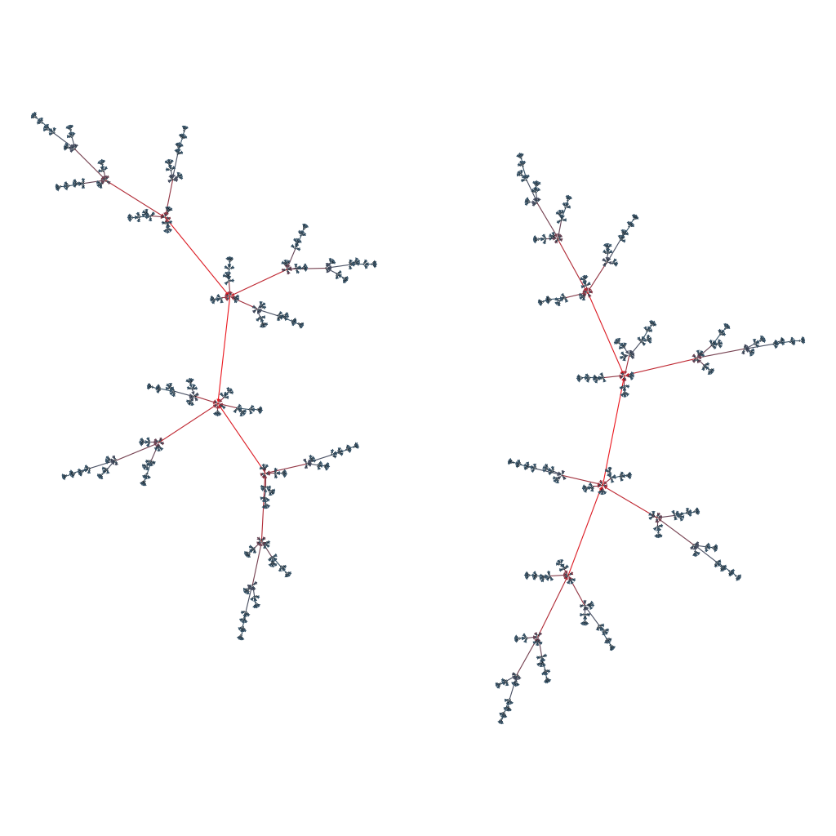
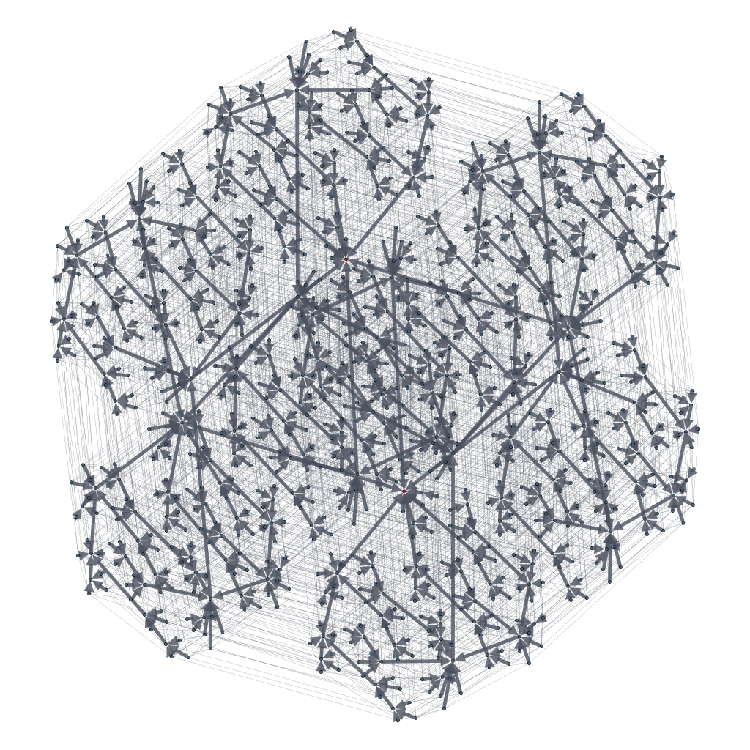
C. Structure and Analysis in Binary Landscapes

