Update and ensure nginx is installed for the web server.
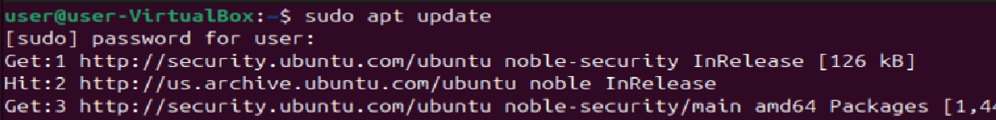
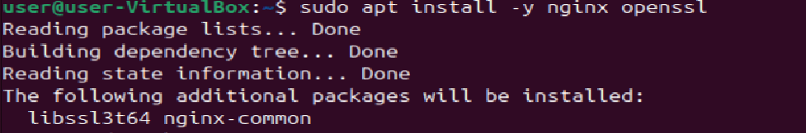
Enable nginx at start
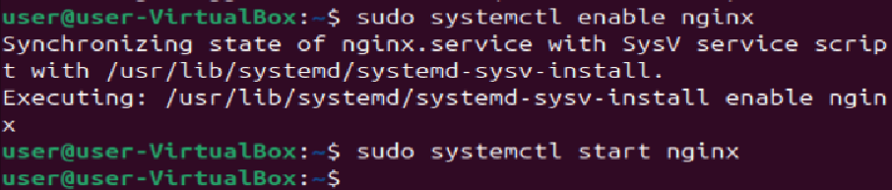

Making directory location and files for the website
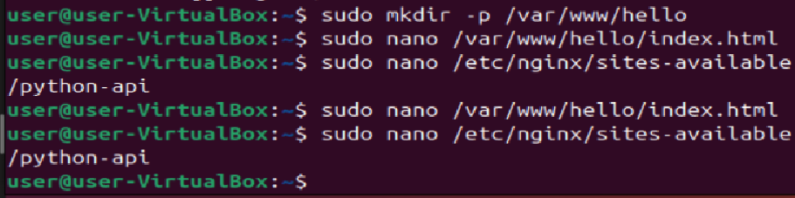
Verifying that the Python API still works
Making a key and certificate:
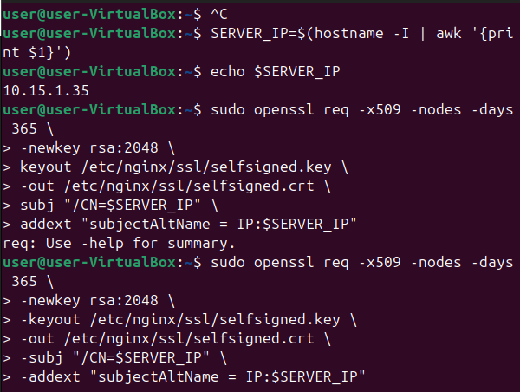

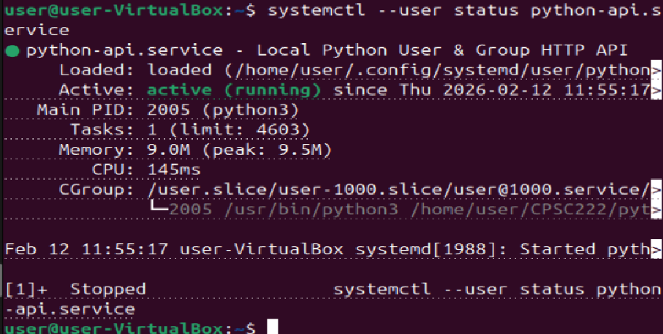
Git config
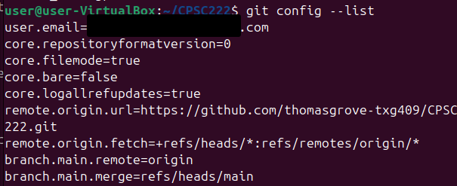

API is accessible:
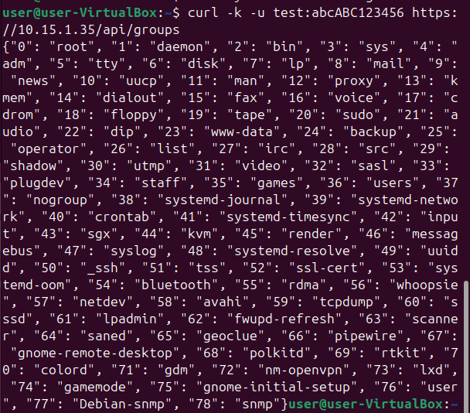
Hello world website works:
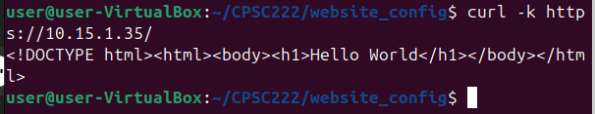
Redirect Works
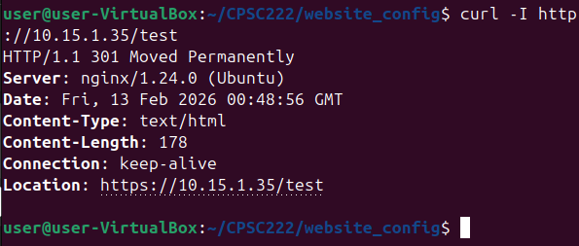
pwd and ls -la
