Mini Programming Assignment 1 Report
Thomas Hillyer
260680811

Testing Procedure
Procedure run a test command 10 times and record the nanoseconds it takes to run commands. Start time is recorded before creating a child process. End time is recorded after child returns. No user operated processes were changed between testing the separate implementations.

System Results
Command: ls
Time (ns)
3296245
3290729
3283060
3360935
3266484
3303882
2714523
2543286
3293746 | Avg time taken (ns)
3193288 | 3154617.8

The default system() implementation takes a long time on average because more code is actually being timed.

FORK Results
Command: ls
Time (ns)
2135440
1920899
1376326
2097799
1435624
1989234
2186507
742410
2097805 | Avg time taken (ns)
1987316 | 1796936

Shorter than system(), likely due to timing just the fork() function and the child process, not the parsing and other overhead.

VFORK Results
Command: ls
Time (ns)
924745
1908873
1634881
1139766
1728411
1748665
1670876
1724540
1733955 | Avg time taken (ns)
1704711 | 1591942.3

The VFORK() implementation is faster on average than the FORK() implementation since it does not make a copy of memory for the child to use, instead its uses the same address space as its parent, which saves time.

CLONE Results
Command: ls
Time (ns)
48532
54944
57062
56881
59780
47972
46038
45365
48626 | Avg time taken (ns)
55800 | 52100

The CLONE() implementation is by far the shortest. I believe this is primarily due to my implementation, and that the timer is ending before the child process has completed.
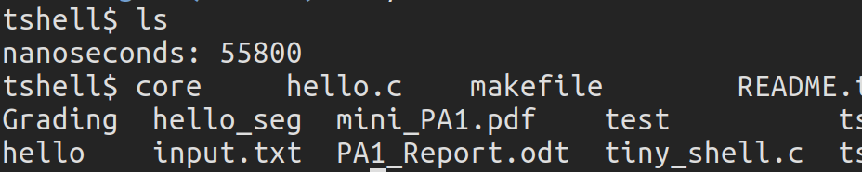
Looking out the output we can see that the timer prints out before the result of the command does. The command also prints out after the prompt is printed again, which leads me to believe the parent is not properly halted. The clone implementation also exits after every command, again leading me to believe there is an error somewhere.

PIPE and FIFO
I was unable to implement the FIFO component of this assignment thus there are no results.

