Laparoscopic Hartmann procedure: is it a good option for acute colonic diverticulitis with generalized peritonitis? A comparative matched cohort study using a national database

Authors
Thomas Husson¹, …, Antoine Mariani¹
1. Service de Chirurgie Digestive, Hôpital Européen Georges Pompidou APHP, 75015 Paris, France
2.

Corresponding author
Antoine Mariani, M.D, Ph.D.
Department of digestive surgery and surgical oncology
Hôpital Européen Georges Pompidou
Assistance Publique des Hôpitaux de Paris

Phone : +33 1 56 09 35 62
E-mail : antoine.mariani@aphp.fr

Conference presentation
The results reported in this paper were presented as a poster presentation at the 20th congress of ESCP (September 6th 2025) and oral communication at the 1st mutual French annual congress of surgery (3CVD). The manuscript, including related data, figures and tables has not been previously published and the manuscript is not under consideration elsewhere.

Abstract
Aim
Laparoscopic surgery is increasingly used in emergency settings, but its role in generalized diverticular peritonitis remains debated. We aimed to compare laparoscopic Hartmann’s procedure with open sigmoidectomy with primary anastomosis and diverting ileostomy.
Methods
This retrospective study used a national multicenter cohort from the Association Française de Chirurgie, including 7,053 patients who underwent surgery for colonic diverticulitis. We included emergency cases with generalized peritonitis (Hinchey III or IV) treated by laparoscopic Hartmann or open anastomosis with ileostomy. Elective cases, Hinchey I–II, or other procedures were excluded. Pre-, intra-, and postoperative outcomes and stoma-free survival were compared after propensity score matching on preoperative variables.
Results
A total of 285 patients met inclusion criteria (138 laparoscopic Hartmann, 147 open anastomosis). After matching, 101 patients were included in each group. Baseline characteristics were comparable. 30% of the overall population had Hinchey IV diverticulitis. Conversion was required in 49% of the laparoscopic Hartmann cases. Laparoscopic Hartmann’s procedure did not confer significant benefits concerning postoperative outcomes including 90-day morbidity (53% vs 50%, p = 0.8), major complications (27% vs 26%, p > 0.9), 90-day mortality (5% vs 3%, p = 0.7), or length of hospital stay (12 vs 10 days, p = 0.095), and was associated with fewer stoma reversal (70% vs 88%, p = 0.002), with longer delay (144 vs 113 days, p = 0.068). Stoma-free survival at 2 years was significantly better in the anastomosis group (88% vs 70%, respectively; log-rank p < 0.0001; Cox model HR = 2.28 [1.39–2.44], p < 0.0001).
Conclusion
Although early outcomes were comparable, the minimally invasive Hartmann’s procedure was associated with fewer stoma reversals and poorer stoma-free survival. When feasible, open primary anastomosis should remain the preferred approach.

MeSH Keywords : Diverticulitis; Laparoscopy; Perforated diverticulitis; Sigmoid resection, Hartmann Procedure, Propensity score.

Introduction
Acute perforated sigmoid diverticulitis with generalized peritonitis (Hinchey III–IV) is a surgical emergency requiring rapid source control while balancing postoperative morbidity and the risk of a permanent stoma ^{1,2}. Historically, Hartmann’s procedure was the standard of care but is associated with substantial morbidity, non-negligible mortality, and low reversal rates^{3,4}. Following recent randomized trials and meta-analyses, national and international guidelines have shifted the paradigm, now favoring sigmoid resection with primary anastomosis when possible, as it offers similar short-term safety but significantly higher reversal rates and better long term stoma-free survival than Hartmann’s Procedure, reserving the latter for unstable of very high-risk patients ^{5–12}. Regarding the omission of a diverting stoma, guidelines remain cautious, suggesting unprotected anastomosis only for highly selected cases. As results from ongoing randomized trials assessing the specific role of diversion are still awaited primary anastomosis protected by a diverting ileostomy remains the safest standard of care for generalized peritonitis ¹³.
Over the same period, minimally invasive colorectal surgery has expanded into the emergency setting ^{14,15}. While laparoscopic peritoneal lavage has fallen out of favor due to high rates of persistent sepsis, laparscopic sigmoid resection has emerged as a feasible option^{16–18}. Current data suggest that in experienced hands, emergency laparoscopic resection reduces parietal morbidity and hospital stay compared to open surgery ^{19–22}. However, the specific role of the Laparoscopic Hartmann’s Procedure (LHP) remains debated. Limited retrospective or registry-based datas suggest that this procedure can be performed safely and may reduce overall complications and length of stay compared with open Hartmann’s procedure.
Crucially, the potential benefits of LHP may extend beyond the acute phase. The low reversal rate of the Hartmann’s strategy is often attributed to dense intra-abdominal adhesions formed after open surgery. Emerging evidence suggests that performing the initial Hartmann’s procedure laparoscopically may reduces adhesion formation, thereby facilitating a subsequent laparoscopic reversal ^{22,23}. This "minimally invasive two-stage strategy" could potentially combine the immediate safety of a non-restorative procedure with a higher likelihood of successful future restoration of bowel continuity.
It remains unclear, however, whether this minimally invasive approach can compete with the current standard of care. The aim of the present study was to evaluate, in a large national cohort, whether Laparoscopic Hartmann’s Procedure offers comparable short-term outcomes and stoma-free survival to Open Sigmoid Resection with Primary Anastomosis and diverting ileostomy.
Tu peux reprendre ton rationnel du topo de la SFCD :
Introduction générale
Recommandations françaises et internationales
Développement de la coelioscopie en urgence colorectale
Historiquement les séries de Hartmann sont toujours en laparo
Y a-t-il un bénéfice à la coelio qui pourrait apporter les bénéfices de la chirurgie mini-invasive ???

Patients and Methods
Patients
Data were obtained from a retrospective multicenter database including all adult patients operated on for sigmoid diverticulitis (SD) between January 2010 and September 2021 across 43 French centers. This analysis is part of a study registered at ClinicalTrials.gov (NCT06200857). The need for informed consent was waived owing to the retrospective study design.
Patients were included if they underwent emergency surgery for SD peritonitis classified as Hinchey III or IV, treated either by open resection with primary anastomosis and diverting stoma or by laparoscopic Hartmann’s procedure.
Exclusion criteria included: scheduled or non-urgent surgery, Hinchey stages < III, surgical approaches other than the two evaluated strategies, American Society of Anesthesiologists (ASA) score = 4 and/or preoperative admission to an intensive care unit. These latter criteria were used as a surrogate for hemodynamic instability, a parameter not recorded in the database.
Endpoints
Primary Endpoint
The primary outcome was the 24-month stoma-free survival, defined as the time from the index emergency surgery to the successful restoration of intestinal continuity, with patients censored at death, loss to follow-up, or at 24 months if no stoma reversal had occurred.
Secondary Endpoints
Secondary outcomes included intraoperative morbidity (any adverse event occurring during the index procedure), the conversion rate in the LHP group, postoperative morbidity according to Clavien–Dindo classification²⁴, length of hospital stay, recurrent diverticulitis during follow-up, and the occurrence of incisional hernias.
Surgical procedure
Two types of procedure were assessed: the Laparoscopic Hartmann’s Procedure (LHP group)²⁵, consisting of laparoscopic sigmoidectomy with rectal closure and an end colostomy, with or without conversion to open surgery; and the Open sigmoidectomy with a primary anastomosis with a defunctioning stoma (OPA group), Decisions concerning the lowering of the splenic flexure and abdominal drainage were left at the surgeon’s discretion.

Statistical analysis
In this observational study, propensity score matching was used to reduce selection bias related to the surgical approach and other confounding factors, ensuring comparability between groups by adjusting for baseline differences between patients undergoing either LHP or OPA. Propensity scores were estimated using multivariable logistic regression including all pre-specified covariates. These covariates comprised age, sex, smoking history, BMI, ASA score, immunodepression, anticoagulant therapy, previous laparotomy, and the Hinchey classification. These factors were selected as known confounders of both the choice of surgical approach and perioperative outcomes. An "optimal" case-control match without replacement was used, minimizing abdolute differences in propensity scores ²⁶. Covariate balance after matching was assessed using standardized mean differences (SMD), with values < 0.1 indicating adequate balance (Supplementary Figure S1) ²⁶. Missing data were addressed using pairwise deletion. Continuous variables were reported as median ± interquartile range (IQR) and compared using paired t-tests for approximately normally distributed variables (normality assessed visually and with the Shapiro–Wilk test), or Wilcoxon signed-rank tests otherwise. Categorical variables were expressed as frequency (%) and compared within matched pairs using McNemar’s test.
A Cox proportional hazards model was used to compare 24-month stoma-free survival between the two groups in the matched cohort. To account for the matched design, models were fitted using a robust sandwich variance estimator clustered on matched pairs²⁷ . Additionally, a supplementary analysis separated patients who underwent a laparoscopic Hartmann procedure with or without conversion, to explore whether conversion affected stoma-free survival.
Results are presented as hazard ratios (HR) with 95% confidence intervals (CI). Statistical analyses were performed using RStudio software version 4.5.1 (R Foundation for Statistical Computing, Vienna, Austria). A p-value < 0.05 was considered statistically significant.

Results
Preoperative characteristics
A total of 1,521 patients underwent surgery for diverticular peritonitis (Hinchey III or IV) between January 2010 and September 2021 across 43 centers, including 34 university hospitals. The final study population comprised 284 patients: 138 in the LHP group and 146 in the OPA group (Fig. 1). After propensity score matching, two comparable groups of 101 patients each were obtained, with adequate balance across all baseline covariates (SMD < 0.1 for covariates included; Supplementary Fig. S1).
Before matching, patients in the LHP group were older (median age 63 vs 50 years, p = 0.03), more frequently classified as ASA 3 (26% vs 17%, p = 0.04), and had a higher proportion of Hinchey IV peritonitis (37% vs 23%, p = 0.01). Other baseline characteristics were similar between groups.
After matching, severe diverticulitis remained frequent, with Hinchey IV peritonitis observed in 31% of patients in the LHP group and 29% in the OPA group, and no other differences in preoperative characteristics were observed (Table 1).Flowchart + quels patientsTableau 1
Intraoperative findings and adverse events
In the propensity score–matched (PSM cohort, intraoperative outcomes are summarized in Table 2. Median operative time tended to be shorter in the LHP group compared with the OPA group (138 [100–169] vs 180 [120–240] minutes), although this difference did not reach statistical significance (p = 0.065). Conversion to open surgery occurred in 49% of patients undergoing LHP.
Splenic flexure mobilization was performed far less frequently in the LHP group than in the OPA group (15% vs 72%, p < 0.001), as was high ligation of the inferior mesenteric artery (4.9% vs 14%, p = 0.003), with high ligation defined as division of the inferior mesenteric artery proximal to the origin of the left colic artery ²⁸. As expected, anastomosis was performed exclusively in the OPA group, most commonly as a latero-lateral configuration (59%), Intraoperative transfusion rates were low and comparable between groups (3.3% vs 4.3%, p > 0.9).
Tableau 2
Postoperative outcomes
Postoperative outcomes are detailed in Table 3. Overall 90-day morbidity was high but comparable between groups (53% in the LHP group vs 50% in the OPA group, p = 0.6). Ninety-day mortality did not significantly differ (5.0% vs 3.0%, p = 0.5), nor did the rate of intensive care unit admission (16% vs 11%, p = 0.3).
The severity of postoperative complications was similar between groups, with no difference in the distribution of Clavien–Dindo grades (p = 0.5). Severe complications (Clavien–Dindo >2) occurred, in 27% of patients in the LHP group and 26% in the OPA group (p > 0.9). Rates of intraperitoneal abscess were comparable (7.1% vs 9.0%, p = 0.6). Anastomotic leakage was observed in 8 patients (8%) in the OPA group

Longer-term postoperative events, including incisional hernia anastomotic stenosis, and recurrence of diverticulitis, were not significantly different between groups,.
Tableau 3
Stoma Free Survival
(Figure 1). At 24 months, the probability of being stoma-free was higher in the OPA group than in the LHP group (88% vs 70%, respectively; stratified log-rank p < 0.0001). The median follow-up duration, estimated using the reverse Kaplan–Meier method, was 671 days in the LHP group and 390 days in the OPA group. In the Cox proportional hazards model accounting for the matched design with robust standard errors, OPA was associated with a significantly higher rate of stoma closure compared with LHP (HR = 1.84, 95% CI 1.39–2.44; p < 0.001), corresponding to a shorter time to stoma-free status (Table 4).
Additionally, a supplementary analysis according to conversion status within the LHP group was performed (Supplementary Fig. S2). OPA was associated with a higher rate of stoma closure compared with both converted (HR = 1.59, 95% CI 1.12–2.27; p = 0.01) and non-converted LHP (HR = 2.09, 95% CI 1.44–3.01; p < 0.001). No significant difference in stoma-free survival was observed between converted and non-converted LHP (HR = 1.34, 95% CI 0.85–2.13; p = 0.21).Courbe survie

Discussion

Reprendre résultats principaux et les discuter :

Taux de rétablissement plus bas du Hartmann : quel positionnement par rapport a Diverti et LADIES – éventuellement tableau avec les principaux résultats des essais randomisés pour bien se positionner.

Problème du rétablissement lié au Hartmann et non pas à la coelio car la conversion en change rien.

Taux de fistule peu élevé pour anastomose dans la péritonite – Y a-t-il une place pour ne pas protéger les anastomoses ??

Plus grosse série de la littérature ++

Le hartmann reste une opération recommandée mais uniquement en cas d’instabilité.
Quand on a le choix rester sur l’anastomose protégée

Funding/Support
This research was conducted without external or internal sources of funding.

Conflict of interest/Disclosure
AM:
Acknowledgements

This study was supported by AFC association
References
1. Hinchey EJ, Schaal PG, Richards GK. Treatment of perforated diverticular disease of the colon. Adv Surg. 1978;12:85-109.
2. Hanna MH, Kaiser AM. Update on the management of sigmoid diverticulitis. World J Gastroenterol. 2021;27(9):760-781. doi:10.3748/wjg.v27.i9.760
3. Regenbogen SE, Hardiman KM, Hendren S, Morris AM. Surgery for Diverticulitis in the 21st Century: A Systematic Review. JAMA Surg. 2014;149(3):292-303. doi:10.1001/jamasurg.2013.5477
4. Hallam S, Mothe BS, Tirumulaju R. Hartmann’s procedure, reversal and rate of stoma-free survival. Ann R Coll Surg Engl. 2018;100(4):301-307. doi:10.1308/rcsann.2018.0006
5. Sartelli M, Weber DG, Kluger Y, et al. 2020 update of the WSES guidelines for the management of acute colonic diverticulitis in the emergency setting. World J Emerg Surg. 2020;15(1):32. doi:10.1186/s13017-020-00313-4
6. Hall J, Hardiman K, Lee S, et al. The American Society of Colon and Rectal Surgeons Clinical Practice Guidelines for the Treatment of Left-Sided Colonic Diverticulitis. Dis Colon Rectum. 2020;63(6):728. doi:10.1097/DCR.0000000000001679
7. Haute Autorité de Santé HAS. Prise en charge médicale et chirurgicale de la diverticulite colique.; 2017. https://www.has-sante.fr/jcms/c_2806798/fr/prise-en-charge-medicale-et-chirurgicale-de-la-diverticulite-colique
8. Bridoux V, Regimbeau JM, Ouaissi M, et al. Hartmann’s Procedure or Primary Anastomosis for Generalized Peritonitis due to Perforated Diverticulitis: A Prospective Multicenter Randomized Trial (DIVERTI). J Am Coll Surg. 2017;225(6):798-805. doi:10.1016/j.jamcollsurg.2017.09.004
9. Oberkofler CE, Rickenbacher A, Raptis DA, et al. A Multicenter Randomized Clinical Trial of Primary Anastomosis or Hartmann’s Procedure for Perforated Left Colonic Diverticulitis With Purulent or Fecal Peritonitis. Ann Surg. 2012;256(5):819. doi:10.1097/SLA.0b013e31827324ba
10. Lambrichts DPV, Vennix S, Musters GD, et al. Hartmann’s procedure versus sigmoidectomy with primary anastomosis for perforated diverticulitis with purulent or faecal peritonitis (LADIES): a multicentre, parallel-group, randomised, open-label, superiority trial. Lancet Gastroenterol Hepatol. 2019;4(8):599-610. doi:10.1016/S2468-1253(19)30174-8
11. Cirocchi R, Afshar S, Shaban F, et al. Perforated sigmoid diverticulitis: Hartmann’s procedure or resection with primary anastomosis-a systematic review and meta-analysis of randomised control trials. Tech Coloproctology. 2018;22(10):743-753. doi:10.1007/s10151-018-1819-9
12. Acuna SA, Wood T, Chesney TR, et al. Operative Strategies for Perforated Diverticulitis: A Systematic Review and Meta-analysis. Dis Colon Rectum. 2018;61(12):1442-1453. doi:10.1097/DCR.0000000000001149
13. Pinson J, Tuech JJ, Ouaissi M, et al. Role of protective stoma after primary anastomosis for generalized peritonitis due to perforated diverticulitis-DIVERTI 2 (a prospective multicenter randomized trial): rationale and design (nct04604730). BMC Surg. 2022;22(1):191. doi:10.1186/s12893-022-01589-w
14. Esparza Monzavi CA, Naffouje SA, Chaudhry V, Nordenstam J, Mellgren A, Gantt G. Open vs Minimally Invasive Approach for Emergent Colectomy in Perforated Diverticulitis. Dis Colon Rectum. 2021;64(3):319-327. doi:10.1097/DCR.0000000000001805
15. Lee YF, Brown RF, Battaglia M, Cleary RK. Laparoscopic Versus Open Emergent Sigmoid Resection for Perforated Diverticulitis. J Gastrointest Surg Off J Soc Surg Aliment Tract. 2020;24(5):1173-1182. doi:10.1007/s11605-019-04490-9
16. Schultz JK, Yaqub S, Wallon C, et al. Laparoscopic Lavage vs Primary Resection for Acute Perforated Diverticulitis: The SCANDIV Randomized Clinical Trial. JAMA. 2015;314(13):1364-1375. doi:10.1001/jama.2015.12076
17. Hoek VT, Edomskis PP, Stark PW, et al. Laparoscopic peritoneal lavage versus sigmoidectomy for perforated diverticulitis with purulent peritonitis: three-year follow-up of the randomised LOLA trial. Surg Endosc. 2022;36(10):7764-7774. doi:10.1007/s00464-022-09326-3
18. Marshall JR, Buchwald PL, Gandhi J, et al. Laparoscopic Lavage in the Management of Hinchey Grade III Diverticulitis: A Systematic Review. Ann Surg. 2017;265(4):670. doi:10.1097/SLA.0000000000002005
19. Turley RS, Barbas AS, Lidsky ME, Mantyh CR, Migaly J, Scarborough JE. Laparoscopic versus open Hartmann procedure for the emergency treatment of diverticulitis: a propensity-matched analysis. Dis Colon Rectum. 2013;56(1):72-82. doi:10.1097/DCR.0b013e3182749cf5
20. Vennix S, Lips DJ, Di Saverio S, et al. Acute laparoscopic and open sigmoidectomy for perforated diverticulitis: a propensity score-matched cohort. Surg Endosc. 2016;30:3889-3896. doi:10.1007/s00464-015-4694-8
21. Vennix S, Boersema GS, Buskens CJ, et al. Emergency Laparoscopic Sigmoidectomy for Perforated Diverticulitis with Generalised Peritonitis: A Systematic Review. Dig Surg. 2015;33(1):1-7. doi:10.1159/000441150
22. Cassini D, Miccini M, Manoochehri F, Gregori M, Baldazzi G. Emergency Hartmann’s Procedure and Its Reversal: A Totally Laparoscopic 2-Step Surgery for the Treatment of Hinchey III and IV Diverticulitis. Surg Innov. 2017;24(6):557-565. doi:10.1177/1553350617722226
23. Tan L, Liu XY, Zhang B, Wang LL, Wei ZQ, Peng D. Laparoscopic versus open Hartmann reversal: a propensity score matching analysis. Int J Colorectal Dis. 2023;38(1):22. doi:10.1007/s00384-023-04320-0
24. Clavien PA, Barkun J, de Oliveira ML, et al. The Clavien-Dindo classification of surgical complications: five-year experience. Ann Surg. 2009;250(2):187-196. doi:10.1097/SLA.0b013e3181b13ca2
25. Hartmann H. Nouveau procédé d’ablation des cancers de la partie terminale du colon pelvien. In: 1921. http://www.grandroundsjournal.com/articles/gr089001/hartmann-original.pdf
26. Austin PC. An Introduction to Propensity Score Methods for Reducing the Effects of Confounding in Observational Studies. Multivar Behav Res. 2011;46(3):399-424. doi:10.1080/00273171.2011.568786
27. Austin PC, Cafri G. Variance estimation when using propensity‐score matching with replacement with survival or time‐to‐event outcomes. Stat Med. 2020;39(11):1623-1640. doi:10.1002/sim.8502
28. Pezim ME, Nicholls RJ. Survival after high or low ligation of the inferior mesenteric artery during curative surgery for rectal cancer. Ann Surg. 1984;200(6):729-733. doi:10.1097/00000658-198412000-00010

Tables

Table 1 : Preoperative characteristics

 | All patients (n=285) |  |  | Matched patients (n=202)
Characteristic | LHP  (n=138) | OPA  (n=147) | p | LHP  (n=101) | OPA  (n=101) | p
Age (year) | 63 [51, 76] | 50 [50, 69] | 0.03* | 58 [49, 72] | 60 [51, 73] | 0.2
Gender, male | 73 (52,9%) | 88 (59,9%) | 0.2 | 58 (57%) | 55 (55%) | 0.6
ASA score = 3 | 36 (26%) | 25 (17%) | 0.04* | 21 (21%) | 18 (18%) | 0.6
BMI kg/m2 | 25.5 [22.3, 28.3] | 25.4 [22.9, 29.4] | 0.7 | 25.5 [22.3, 28.3] | 25.1 [21.7, 28.6] | 0.9
Active smoker | 30 (21,7%) | 45 (30,6%) | 0.09 | 30 (30%) | 27 (27%) | 0.6
Immunodepression | 24 (17,4%) | 14 (9,5%) | 0.051 | 15 (15%) | 14 (14%) | 0.8
Anticoagulation | 13 (9,4%) | 9 (6,1%) | 0,3 | 8 (8.5%) | 5 (5.1%) | 0.2
Medical antecedents
Cardiologic | 50 (36,2%) | 59 (40,1%) | 0.5 | 29 (30%) | 41 (42%) | 0.13
Neurologic | 23 (16,7%) | 19 (12,9%) | 0.4 | 14 (14%) | 12 (12%) | 0.7
Pulmonary | 24 (17,4%) | 18 (12,2%) | 0.2 | 15 (16%) | 11 (11%) | 0.6
Diabetes | 10 (7,2%) | 10 (6,8%) | 0.9 | 6 (6.2%) | 7 (7.1%) | 0.6
Previous laparotomy | 15 (10,9%) | 13 (8,8%) | 0.6 | 10 (9.9%) | 12 (12%) | 0.6
Previous diverticulitis | 29 (21%) | 41 (27,9%) | 0.2 | 23 (24%) | 28 (29%) | 0.5
Actual diverticulitis
Hinchey Score
III | 87 (63%) | 113 (76,9%) | 0.01* | 70 (69%) | 72 (71%) | 0.7
IV | 51 (37%) | 34 (23,1%) | 0.01* | 31 (31%) | 29 (29%) | 0.7
Associated hemorrhage | 1 (0,7%) | 0 (0%) | 0.5 | 1 (1.0%) | 0 (0%)
Associated occlusion | 7 (5,1%) | 10 (6,8%) | 0.5 | 6 (5.9%) | 6 (5.9%) | >0.9
Associated fistula | 2 (1,4%) | 5 (3,4%) | 0.4 | 2 (2.0%) | 4 (4.0%) | 0.4
Surgery within 24 hours of diagnosis | 134 (97,1%) | 139 (94,6%) | 0.3 | 98 (97%) | 98 (97%) | >0.9
Surgery after 24 hours | 1 (0,7%) | 5 (3,4%) | 0.6 | 1 (1.0%) | 1 (1.0%) | >0.9
Conversion to open surgery | 69 (50%) | Not concerned
Quantitative variables are expressed as median (interquartile range [IQR]), and qualitative variables are expressed as frequencies and percentages.
ASA, American Society of Anesthesiologists; BMI, body mass index; CRP, C-reactive protein;SD, standard deviation.
*Statistically significant differences.
†
‡
§
||

Table 2 : Intraoperative outcomes of propensity-score matched patients
Intraoperative outcome | LHP (N = 101) | OPA (N = 101) | p-value
Operative time, min* | 138 [100, 169] | 180 [120, 240] | 0.065
Conversion to open surgery† | 49 (49%) | Not concerned
Splenic flexure mobilization* | 15 (15%) | 73 (72%) | <0.001*
High IMA ligation* | 5 (4.9%) | 14 (14%) | 0.003*
Anastomose type
Laterolateral | Not concerned | 60 (59%)
Terminoterminal | Not concerned | 32 (32%)
Transfusion | 3 (3.3%) | 4 (4.3%) | >0.9
Quantitative variables are expressed as median (interquartile range [IQR]), and qualitative variables are expressed as frequencies and percentages.
IMA, Inferior Mesentery Artery
* Statistically significant differences.
† Reasons for conversion are unknown as they were not collected in the database.

Table 3: Postoperative outcomes of propensity-score matched patients
Postoperative outcome | LHP (N = 101) | OPA (N = 101) | p-value
Overall 90 days morbidity | 54 (53%) | 50 (50%) | 0.6
Overall 90 days mortality | 5 (5.0%) | 3 (3.0%) | 0.5
ICU hospitalization, % | 16 (16%) | 11 (11%) | 0.3
Dindo-Clavien |  |  | 0.5
1 | 29 (29%) | 34 (34%)
2 | 24 (24%) | 19 (19%)
3 | 8 (7.9%) | 13 (13%)
4 | 14 (14%) | 10 (9.9%)
5 | 5 (5.0%) | 3 (3.0%)
Dindo-Clavien >2 | 27 (27%) | 26 (26%) | >0.9
Intraperitoneal abscess | 7 (7.1%) | 9 (9.0%) | 0.6
Anastomotic leakage |  | 8 (8.0%)
Percutaneous drainage for complication | 1 (1.0%) | 3 (3.0%) | 0.3
Reintervention for complication | 10 (10%) | 16 (16%) | 0.2
Reintervention delay | 14 [7, 141] | 10 [4, 66] | 0.3
Length of hospital stay, d | 12 [8, 19] | 10 [8, 16] | 0.095
30-day readmission | 15 (16%) | 19 (21%) | 0.5
Incisional hernia | 19 (21%) | 21 (23%) | 0.9
Anastomotic stenosis | 1 (1.1%) | 2 (2.2%) | NS
Recurrence of diverticulitis | 2 (2.2%) | 0 (0%) | NS
ICU, intensive care unit; NS, not significant
Table 4. Cox proportional hazards model for time to stoma closure.
Results from a Cox proportional hazards model with robust standard errors clustered by matched pairs, assessing the association between surgical procedure and time to stoma closure..
Variable | Hazard Ratio¹ | 95% CI¹ | p-value¹
Laparoscopic Hartmann | — | —
Open Primary Anastomosis with Ileostomy | 1.84 | 1.39, 2.44 | <0.001
¹Hazard ratios were obtained using a Cox proportional hazards model with robust standard errors clustered on matched pairs. HR greater than 1 indicates a higher risk of stoma closure, corresponding to a shorter time to stoma-free status.
Abbreviations: CI = Confidence Interval, HR = Hazard Ratio

Figure 1 : Flow chart for patients inclusion

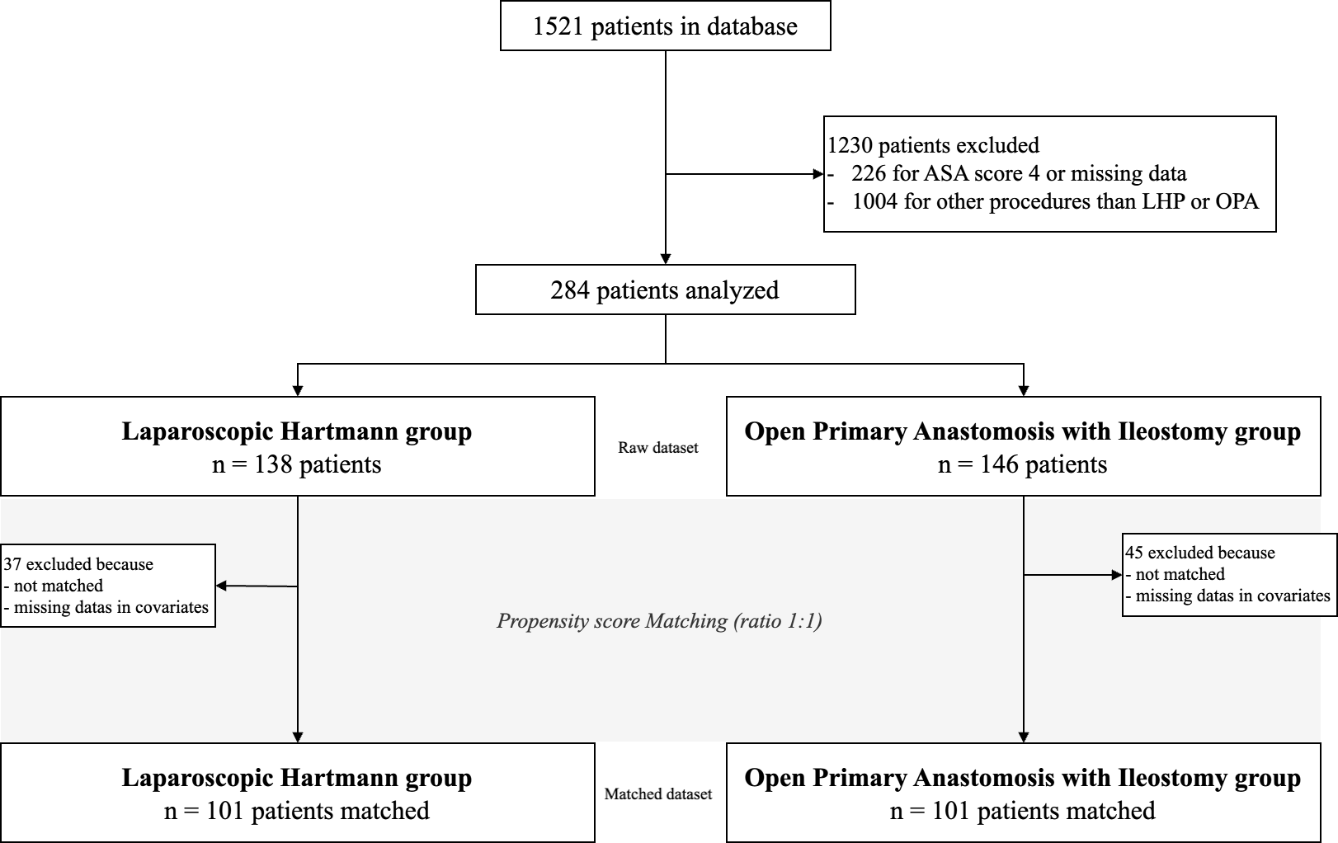

Figure 2 : Probability of being stoma-free up to 24 months after index surgery in propensity score-matched patients, comparing LHP (red) versus OPA (blue). Kaplan-Meier estimates of the probability of remaining stoma-free (stoma-free survival) are shown for patients undergoing LHP compared with those undergoing OPA, with follow-up censored at 24 months. The difference between groups was assessed using a stratified log-rank test accounting for the matched pairs. Corresponding p-value from the stratified log-rank test is reported. Numbers of patients at risk at selected time points are shown below the plot.
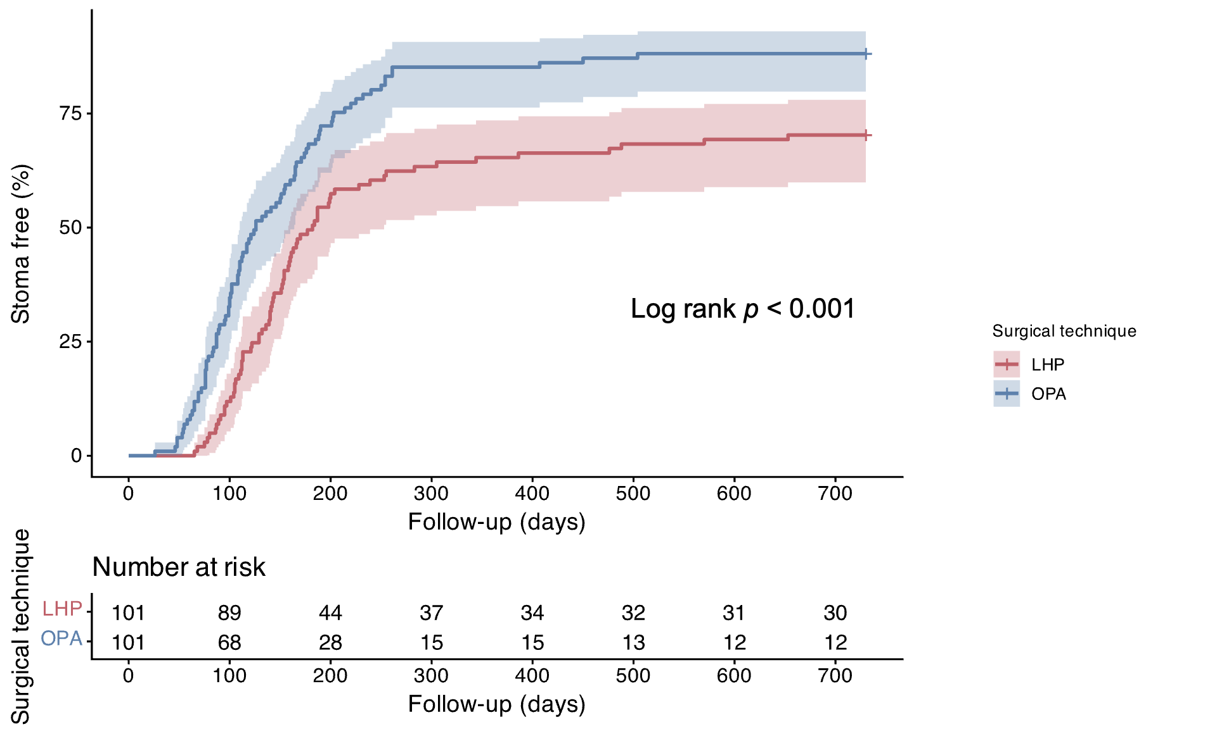

Supplementary Figure S1 : Covariate Covariate balance before and after propensity score matching.
Standardized mean differences (SMD) are shown for all covariates in the unmatched (red) and matched (blue) samples. The vertical dotted line represents the predefined threshold for acceptable balance (SMD < 0.1). After matching, all covariates exhibited SMD values < 0.1, indicating excellent covariate balance between groups.
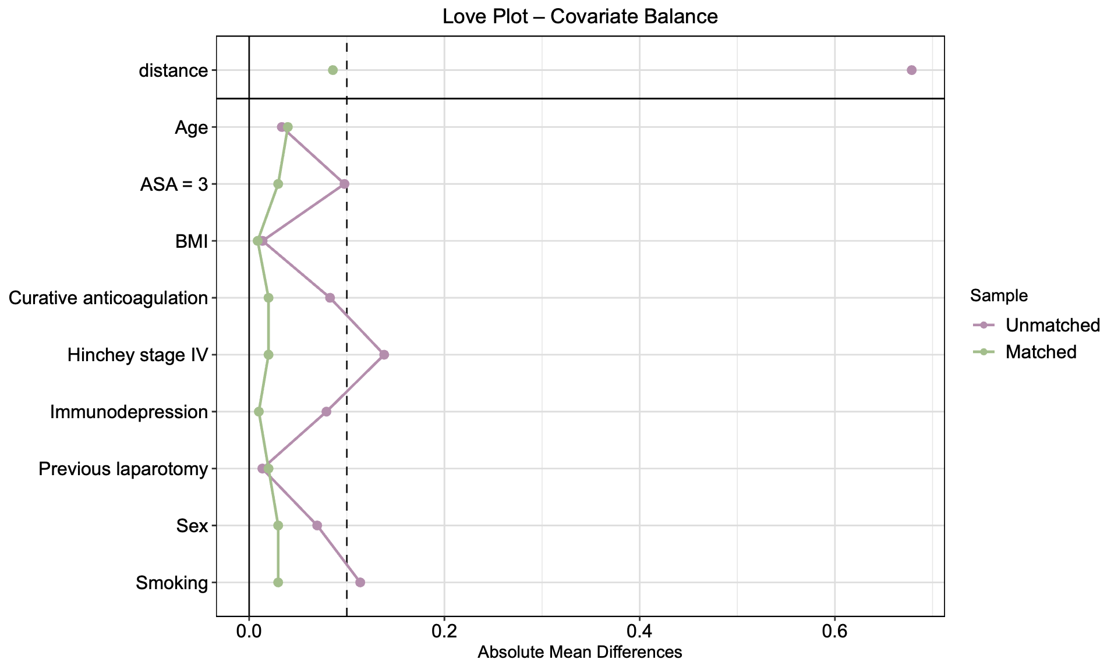
Supplementary Figure S2 : Probability of being stoma-free up to 24 months after index surgery in propensity score-matched patients, comparing LHP not converted to open surgery (orange), LHP converted to open surgery (pink) and OPA (blue). Kaplan-Meier estimates of the probability of remaining stoma-free (stoma-free survival) are shown for patients undergoing LHP compared with those undergoing OPA, with follow-up censored at 24 months. The difference between groups was assessed using Cox proportional hazards accounting for the matched design with robust standard errors. Numbers of patients at risk at selected time points are shown below the plot.

