**Tom’s Engineering Consultant Corp.**

**Thomas Jung**

**(580)917-2174**

**“We solve all your engineering problems with the science and the brute force :^)”**

**Abstract:**

Dear court swaggers and court’s software master swagger, I am Thomas Jung, a fellow engineering swagger from Tom’s Engineering Consultant Corp. I was hired from manufacture of the Dangerous Toy to investigate the sued case and its toy’s safety. I have used my lab’s equipment and LabVIEW to scientifically prove the innocence of my client’s company’s product. Thorough experimentation has been performed in order to prove that the cat is safe from playing around with the toy with the result of approximately .59Hz production from oscillation, which is well over the maximum tolerance level of the danger zone for the cats.

**Intro:**

First Law of Motion is widely accepted in physics. Few simple algebra can be derived in order to achieve the following equations.

$a=\frac{∆v}{∆t}$ => $a=\frac{v-v0}{∆t}$ => $v=v0+at$… (1)

$v=\frac{∆s}{∆t}$ => $v=\frac{s-s0}{t}$ => s = s0 + vt[a] … (2)

Due to applying the mean speed theorem or the Merton rule, the Equations (1) and (2) have later been improved into the following

$v=v0+1/2at$… (3)

Using the Equation (3), new displacement equation has been driven in the following

s = s0 + (v0 + ½at)t => s = s0 + v0t + ½at2  => s = v0t + ½at2 … (4)

Second Law of Motion have further improved from introduction of calculus. For example,

$a=\frac{dv}{dt}$ => dv = a dt => => v – v0 = at => v = v0 + at … (5)

=> ds = v dt => ds = (v0 + at) dt = => s – s0 = v0t + 1/2at2

s = s0 + v0t + 1/2at2 … (6)

It would be extremely hard to scientifically prove our case using the equations above due to one reason. This case the acceleration, which we have no idea the values of in units of a = $\frac{g}{mV}$.

However, with the way we performed the experiment, there is another way of which is more accurate.

Using exponential decay functions (7) and Eigen functions (8),

-αt => -αt … (7)

x(t) = cos(ωt) => $\frac{dx(t)}{dt} =-ωsin⁡(ωt)$

Through utilizing the equation (7) and (8), we can negate the effect of not knowing exact value of the acceleration. The following equations of motion are the centralized focus of this experiment to prove our innocence.

x(t) = -αtcos(ωt) … (9)

v(t) = = --αt v), where v = tan-1 ( … (10)

a(t) = = --αta), where a = v + tan-1 ( = 2 tan-1 ( … (11)

The equations of motion above can be simplified into

*x(t)* = x-αtcos(ωt) … (12)

*v(t)* =v-αtv) … (13)

*a(t)* = x-αtcos(a) … (14)

**Methods:**

The toy was at rest at 40 inches. The toy was positioned 40 inches from the ceilings and dropped to 60 inches from the ceilings to measure the damping oscillation. The data acquisition of the oscillation was performed using DAQ Assistant feature of the LabVIEW along with Collector VI, which was written to and saved in a file. The data was collected using voltage range of 0V to 5V in RSE terminal configuration at a continuous rate of 1000Hz and 10 samples to read, which resulted in sampling rate of 100Hz as shown in the Fig. 1.

The subtraction of the mean from the data was performed. The period, T was calculated using the average of the first tenth difference in successive peak, of which were found using peak location detector, which then were divided by sampling rate of 100Hz. The Equation 15 was applied for the frequency; the Equation 16 was applied for the half period; the Equation 17 was applied to find the appropriate number of samples; the Equation 18 was used to find width; and the Equation 19 was used to find the value of omega constant. The amplitude was found, which was calculated using the average of the first tenth difference in successive amplitude. This was used as an alpha constant. With the calculated constant values, the Equations 12, 13, and 14 were calculated using Wolfram Alpha and plotted. Actual Equations are provided under Other Useful Equations, located right under this paragraphs.

**Other Useful Equations:**

f = $\frac{1}{T}$…(15)

(Half period) 1/2f = $\frac{1}{2T}$…(16)

80% of half period = appropriate number of samples … (17)

Width = 10 * appropriate number of samples … (18)

ω = 2πf …(19)

**Result:**

The total displacement the toy was pulled was 20 inches, which is 0.508 in meters. The subtraction of the mean from the data resulted in centralization of data, which ranged from negative to positive at the mean being zero as shown in the plot of Graph 1. Fig. 2 and Fig. 3 show LabVIEW coding to calculate the crucial information mentioned in the following. With the sampling rate of 100Hz, Period, T was calculated to be 1.69914 sec. The frequency was calculated to be 0.588533Hz. The omega was 3.69786. The half period was 0.84957. The number of samples was 0.679656. The width was 6.79656. The alpha was calculated to be -0.03381.

Using the constants that were calculated in this experiment, wolfram alpha website was used to plot the function for the position (the Equation 12) as depicted in Graph 2. The plot for the velocity (the Equation 13) is depicted in Graph 3, and Graph 4 for the acceleration function plot (the Equation 14).

**Conclusion:**

Using this complicatedly found width will result in finding true peaks instead of inaccurate peaks from noise that may result in discrepancy of data, which is what we want. As recent publications by the American Feline Medical Association show that cats that are subjected to movement of around a half of a hertz (+/-10%) tend to flip out and head for the wheels of a CART bus. Our client’s production is not guilty of the sued since client’s product has produces frequency of .588533Hz, which is well past the maximum tolerance level of the dangerous zone (.550 Hz). The new cat should also be mortally safe from playing the dangerous toy.

**Graphs, Figures, Tables:**

Figure 1: data acquisition

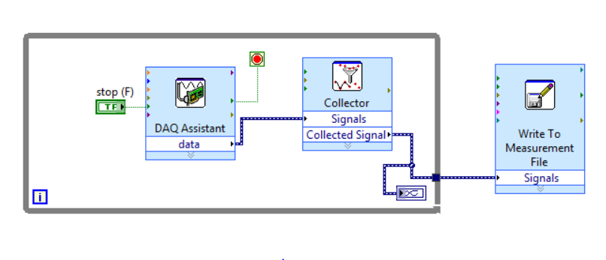

Figure 2: Peak location detection and Amplitude from the acquired data

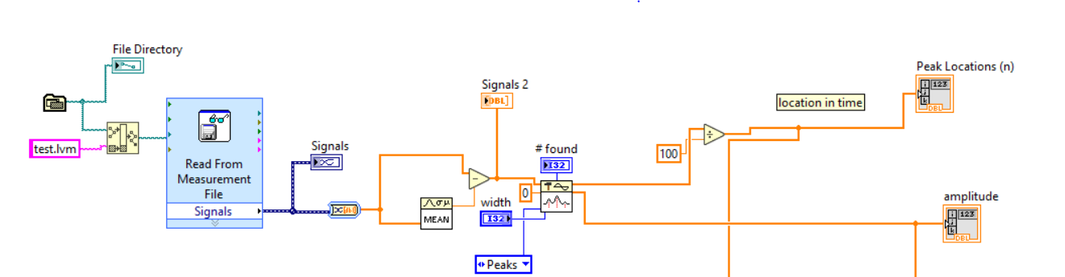

Figure 3: 10th successive iteration of the peaks and omega calculation in VI

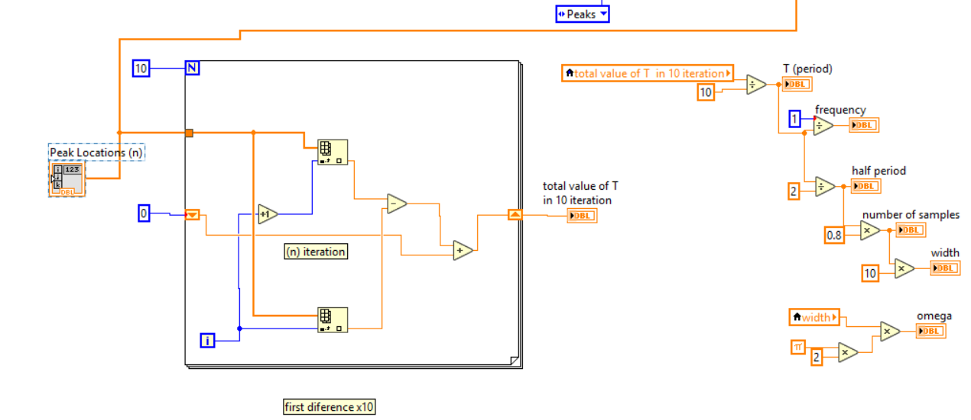

Figure 4: Calculation of the Amplitude in VI

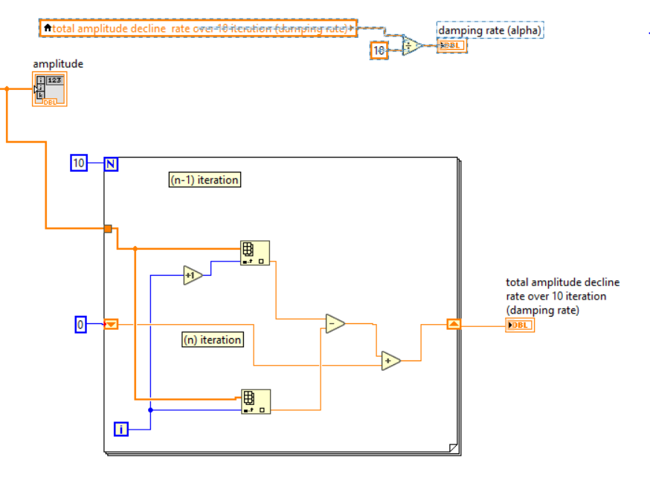

Graph 1: plot of peaks from data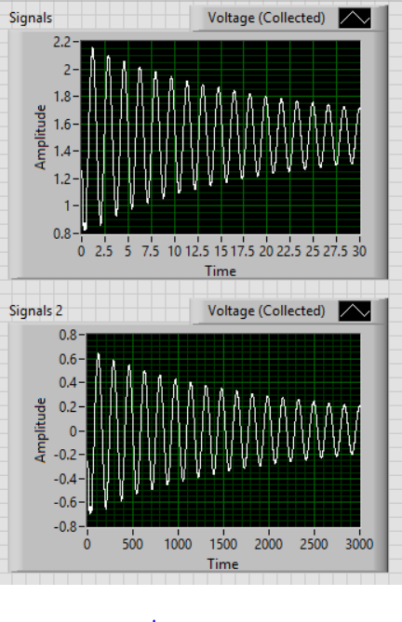

Graph 2: position plot

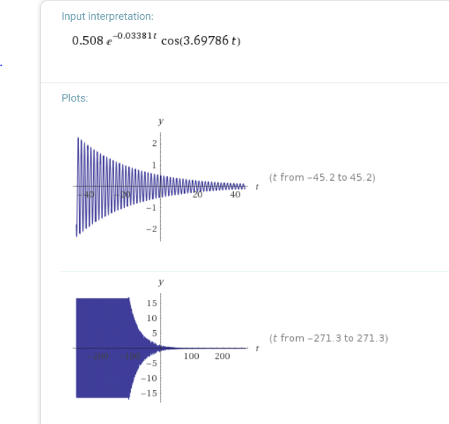

Graph 3: velocity plot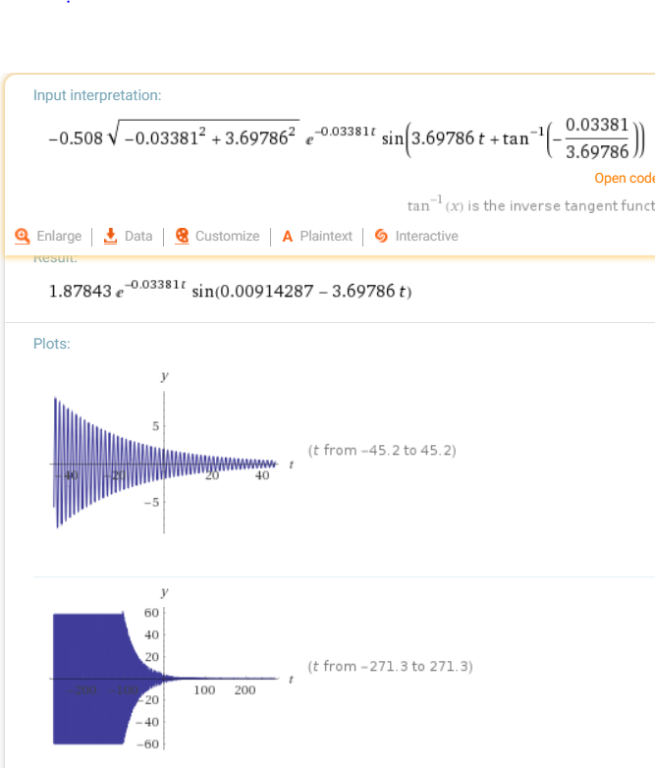

Graph 4: Acceleration Plot

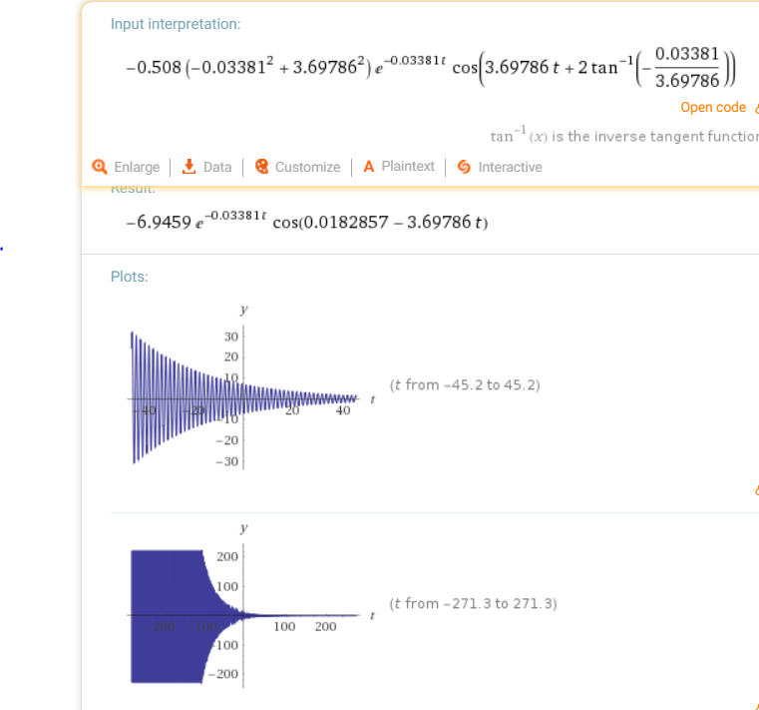

**Work Cited:**

1. **“Alpha: Making the world’s knowledge computable,” *Wolfram*. [Online]. Available:**

[**https://www.wolframalpha.com/.[Accessed**](https://www.wolframalpha.com/.%5bAccessed)**: 17-Nov-2018].**

1. **G. Elert, “Equations of Motion,” Free Fall—The Physics Hypertextbook. [Online]. Available: https://physics .info/motion-equations/. [Accessed: 17-Nov-2018].**