Noise in Signal Data Acquisition*
Subtitle as needed (paper subtitle)

Thomas Jung
College of Engineering
University of Oklahoma
Norman, OK

Abstract—This electronic document is a “live” template and already defines the components of your paper [title, text, heads, etc.] in its style sheet. *CRITICAL: Do Not Use Symbols, Special Characters, or Math in Paper Title or Abstract. (Abstract)
Keywords—component; formatting; style; styling; insert (key words)

Introduction (Heading 1)
Noise can easily be found in the daily environment. It is present in both measurements performed in analog or digital. Therefore, most measurements are bound to have some type of error in it, which is called noise. Since it could be applied in just about any discipline of study, it is defined in many ways. In terms of signal data acquisition, the noise is defined as any component of recorded signal that is not the desired signal. Equation (1) has been driven in order to address the noise, which is considered to be additive. In equation (1), the s[n] is the acquired signal, x[n] is the desired signal, and η[n] is the additive noise.
There are two processes that can be taken for data acquisition through digital signal: (A) the single-ended measurement and (B) the differential ended measurement. Figure 1 represents (A) while Fig 2 represents (B). The single ended measurement is taken as the voltage difference between a wire and ground. The noise is only on the positive wire, which is measured along with the output voltage from the sensor. The differential ended measurement is “floating”, meaning that it has no reference to ground. The measurement is taken as the difference between the two wires. The main benefit of a differential measurement is noise rejection, because the noise is added to both wires and can then be filter out by the common mode rejection of the data acquisition system. The single-ended measurement uses equation (2) where η(t) is the residual noise coupled into the signal line and ξ(t) is the residual noise that is incurred on the ground (v1) line. The differential measurement utilizes the equation (3), which shows realistic version of differential measurement.
An example of the single-ended measurement is in Image (1). An example of the differential measurement is in Image (2)

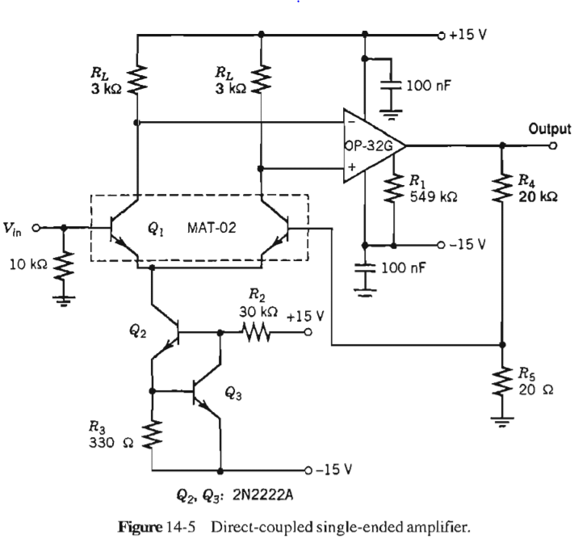

Image 1: RCE application [1]

Image 2: differential measurement application [2]
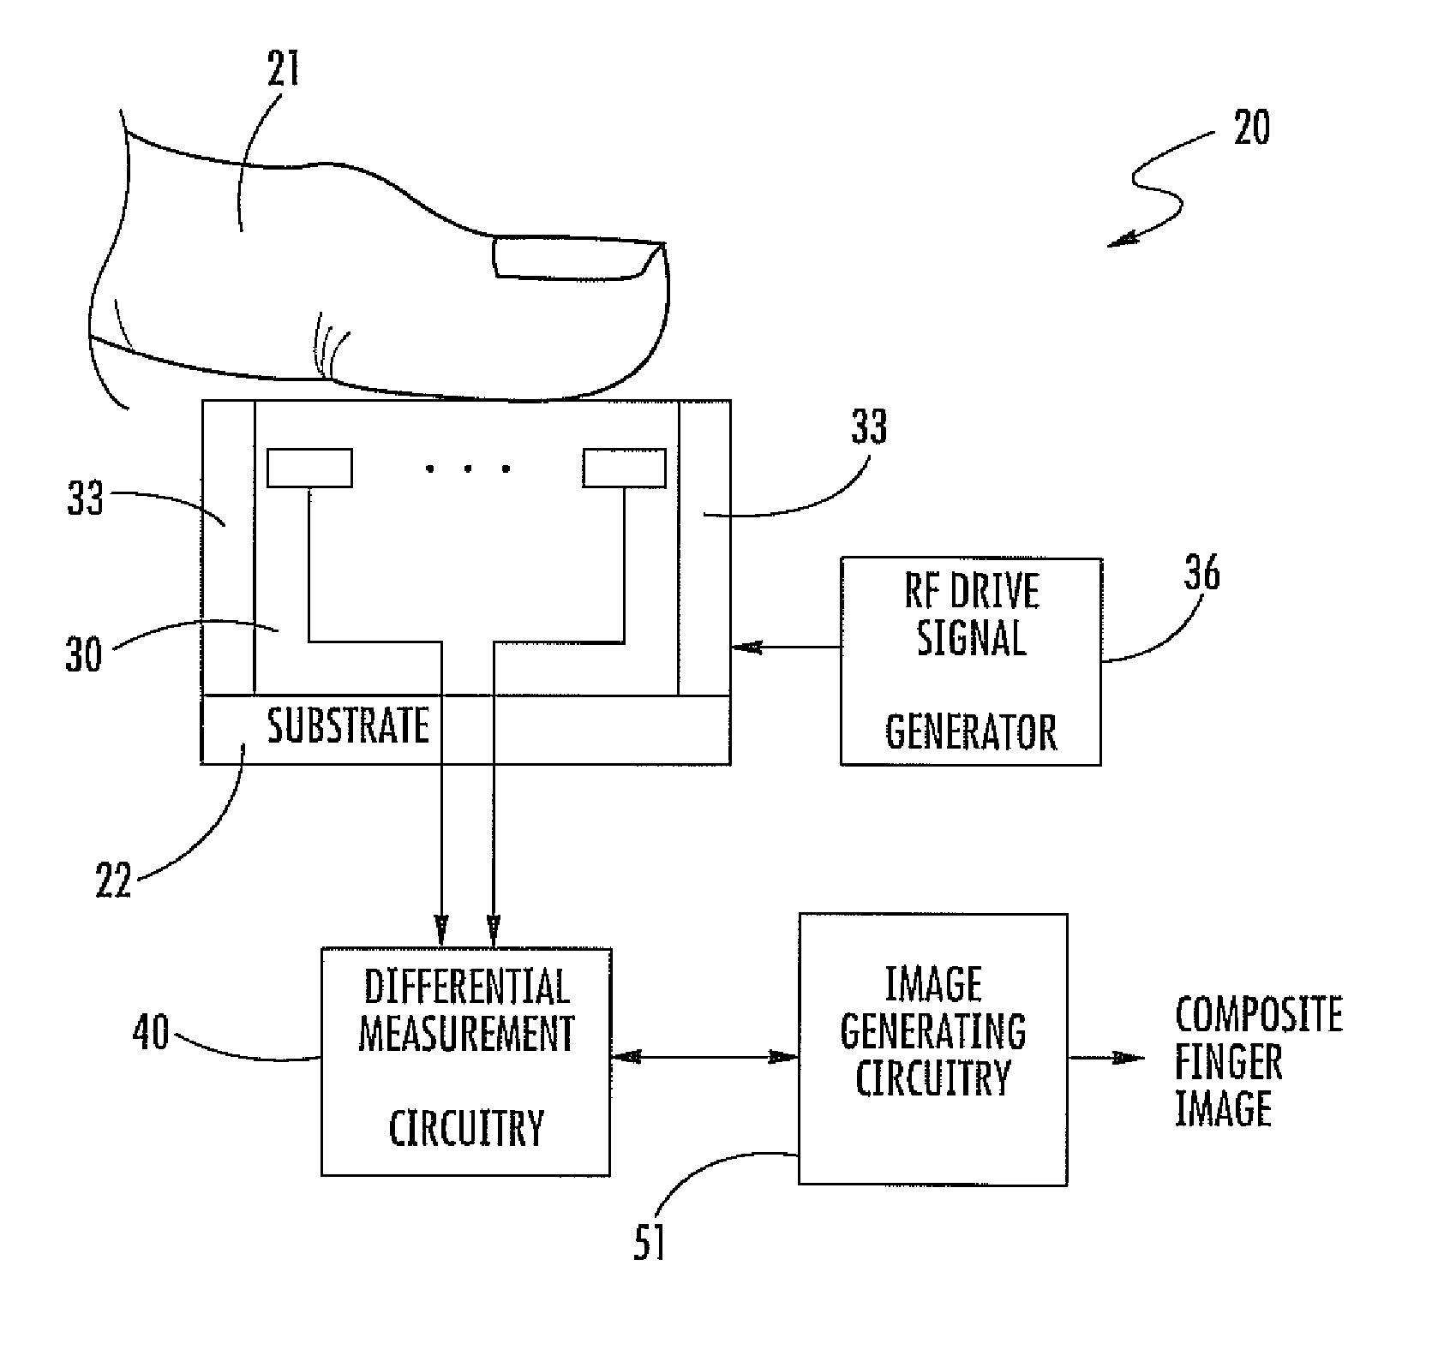

Methods & Measurement

LabVIEW set up
Two types of data were acquired using Automation and Measurement lab equipment and LabVIEW. Fig. 1 and Fig. 2 shows the codes used to acquire data using LabVIEW in this study.

Acquisition of the single-ended data
First, 5 minutes of single-ended recording data from channel 5 was collected with parameters of sample rate of 1000 Hz, range of +/-1 volt, bin size of 500, and RSE configuration (reference single-ended).

Acquisition of the differential data
Second, 5 minutes of a differential configuration data was collecting by shorting the two terminals of 5 and 13. The data parameters were the sample rate of 1000Hz, range of +/- volt, bin size of 500, and Differential configuration.

Datamization of the measurements
Matlab was used to graphically represent the histogram of the data collected using hist function using parameter values of the data and delimiter value of 100.

Result

Fig 1…

Graph 1…

Fig 2..

Graph 2…

Before you begin to format your paper, first write and save the content as a separate text file. Keep your text and graphic files separate until after the text has been formatted and styled. Do not use hard tabs, and limit use of hard returns to only one return at the end of a paragraph. Do not add any kind of pagination anywhere in the paper. Do not number text heads-the template will do that for you.
Finally, complete content and organizational editing before formatting. Please take note of the following items when proofreading spelling and grammar:

Abbreviations and Acronyms
Define abbreviations and acronyms the first time they are used in the text, even after they have been defined in the abstract. Abbreviations such as IEEE, SI, MKS, CGS, sc, dc, and rms do not have to be defined. Do not use abbreviations in the title or heads unless they are unavoidable.

Equations

s[n]  x[n]  [n]  
v_{out}[n]  x[n]   [n]  
v_{out}[n]  x[n] – y[n] (3)
v_{out}[n]  x[n] – y[n])   [n], where [n]  

conclusion
After the text edit has been completed, the paper is ready for the template. Duplicate the template file by using the Save As command, and use the naming convention prescribed by your conference for the name of your paper. In this newly created file, highlight all of the contents and import your prepared text file. You are now ready to style your paper; use the scroll down window on the left of the MS Word Formatting toolbar.

Authors and Affiliations

Thomas Jung of University of Oklahoma

For author/s of only one affiliation (Heading 3): To change the default, adjust the template as follows.

Selection (Heading 4): Highlight all author and affiliation lines.

Acklowedgement
Thanks to these individuals for making this white-paper possible.
- John Dyer, research professor of ECE in University of Oklahoma
- Chad Davis teaching professor of ECE in University
- Garret Robinson, Teaching Assistant of ECE in University of Oklahoma.

Figures and Graphs

FIGURE 1: DATA ACQUISITION USING LABVIEW
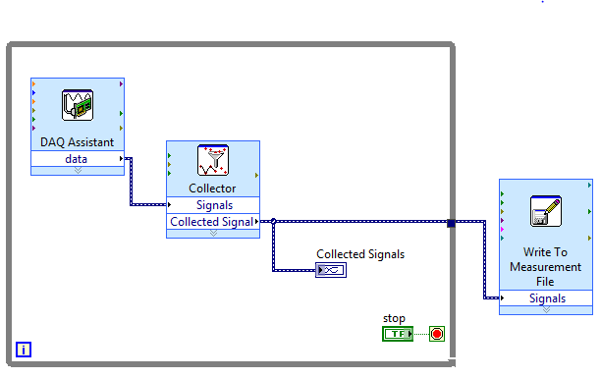

FIGURE 2: READ FROM FILE
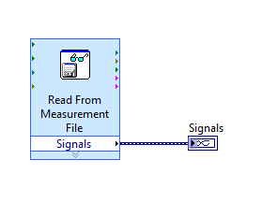
figure 3 : Single ended measurement
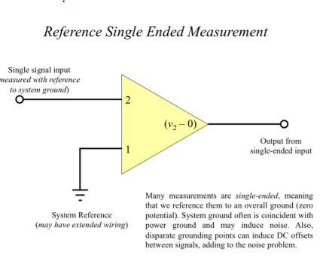

FIGURE 4 DIFFERENTIAL ENDED MEASUREMENT
Graph 1: graph of rce data
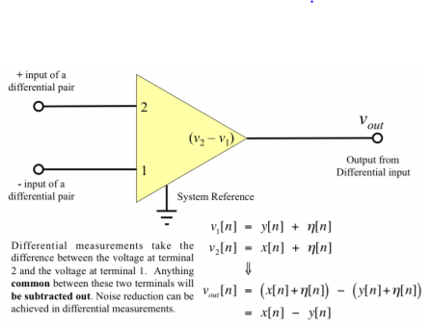
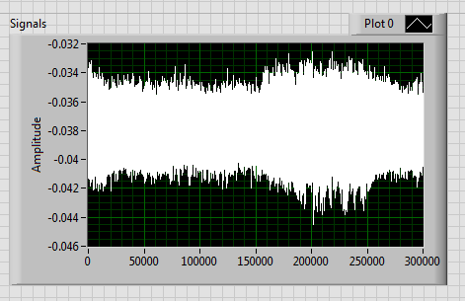
Graph 2: graph of Differential data
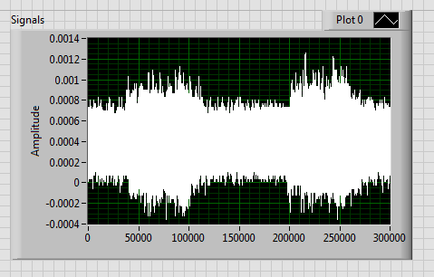

graph 3: Histogram of rsc measurement
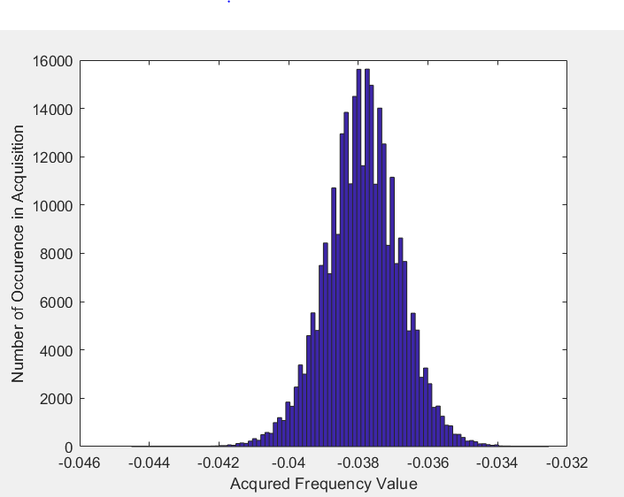
Graph 4: histogram of differential measurement
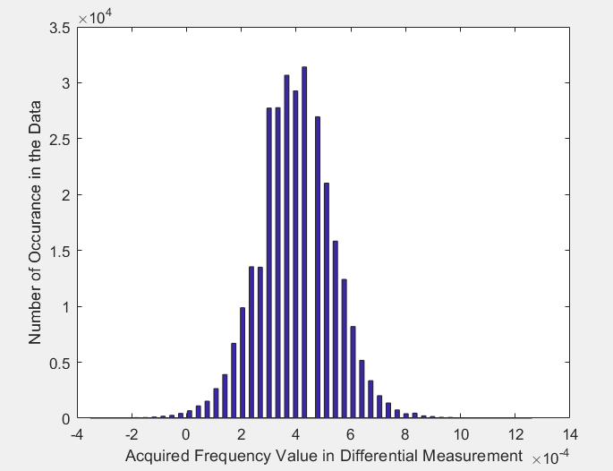

[1] D. Setlak, P. Landy, A. Straub, and R. L. Schenk, “Finger sensing device including differential measurement circuitry and related methods,” AuthenTec Inc, 2010-10-07.

- 334-335

- I. S. Jacobs and C. P. Bean, “Fine particles, thin films and exchange anisotropy,” in Magnetism, vol. III, G. T. Rado and H. Suhl, Eds. New York: Academic, 1963, pp. 271–350.
- K. Elissa, “Title of paper if known,” unpublished.
- R. Nicole, “Title of paper with only first word capitalized,” J. Name Stand. Abbrev., in press.
- Y. Yorozu, M. Hirano, K. Oka, and Y. Tagawa, “Electron spectroscopy studies on magneto-optical media and plastic substrate interface,” IEEE Transl. J. Magn. Japan, vol. 2, pp. 740–741, August 1987 [Digests 9th Annual Conf. Magnetics Japan, p. 301, 1982].
- M. Young, The Technical Writer’s Handbook. Mill Valley, CA: University Science, 1989.

