Noise in Signal Data Acquisition
of RCE and Differential Measurement

Thomas Jung
College of Engineering
University of Oklahoma
Norman, OK

Abstract—this experiment have been performed in order to study the noise in signal data acquisition. Automation and Measurement lab equipment and LabVIEW were used to acquire data using single-ended and differential measurements. The stored data in frequency were then examined using Matlab histogram graphing function and bar graph function using LabVIEW. The data between RSE and differential measurement were then compared to see how useful the differential measurement is when reducing the effect of noise in data acquisition.
Keywords—noise; single-ended; differential; Gaussian.

Introduction
Noise can easily be found in the daily environment. It is present in both measurements performed in analog or digital. Therefore, most measurements are bound to have some type of error in it, which is called noise. Since it could be applied in just about any discipline of study, it is defined in many ways. In terms of signal data acquisition, the noise is defined as any component of recorded signal that is not the desired signal. Equation (1) has been driven in order to address the noise, which is considered to be additive. In equation (1), the s[n] is the acquired signal, x[n] is the desired signal, and η[n] is the additive noise.
There are two processes that can be taken for data acquisition through digital signal: (A) the single-ended measurement and (B) the differential ended measurement. Fig. 1 represents (A) while Fig. 2 represents (B). The single-ended measurement is taken as the voltage difference between a wire and ground. The noise is only on the positive wire, which is measured along with the output voltage from the sensor. The differential ended measurement is “floating”, meaning that it has no reference to ground. The measurement is taken as the difference between the two wires. The main benefit of a differential measurement is noise rejection, because the noise is added to both wires and can then be filter out by the common mode rejection of the data acquisition system. The single-ended measurement uses equation (2) where η(t) is the residual noise coupled into the signal line and ξ(t) is the residual noise that is incurred on the ground (v1) line. The differential measurement utilizes the equation (3), which shows realistic version of differential measurement.
An example of the single-ended measurement is in Image (1). An example of the differential measurement is in Image (2)

Image 1: RCE application [1]
Image 2: differential measurement application [2]
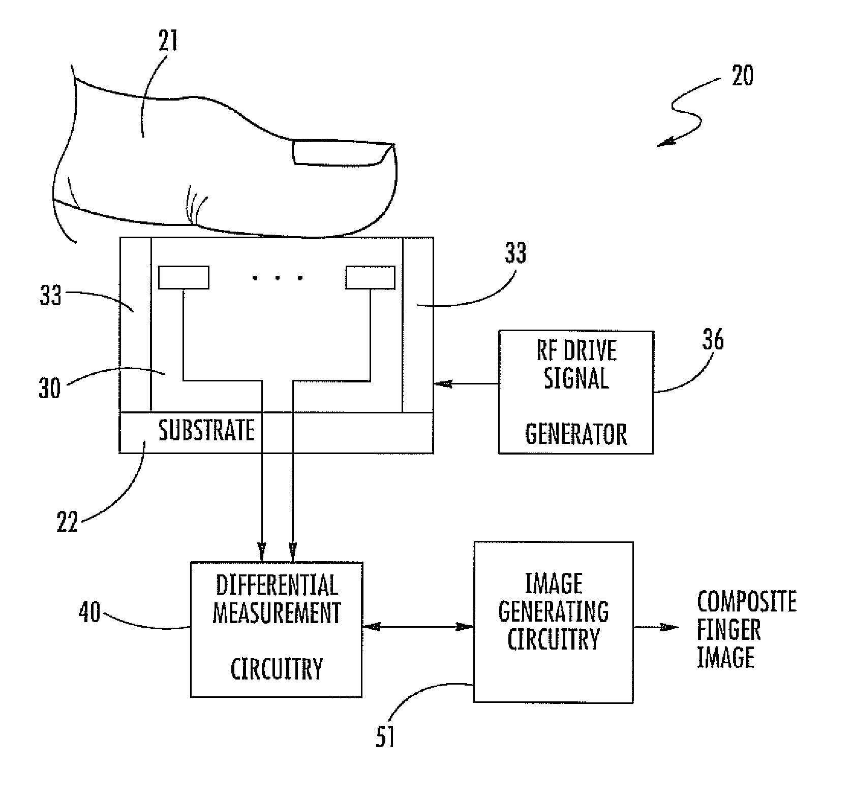
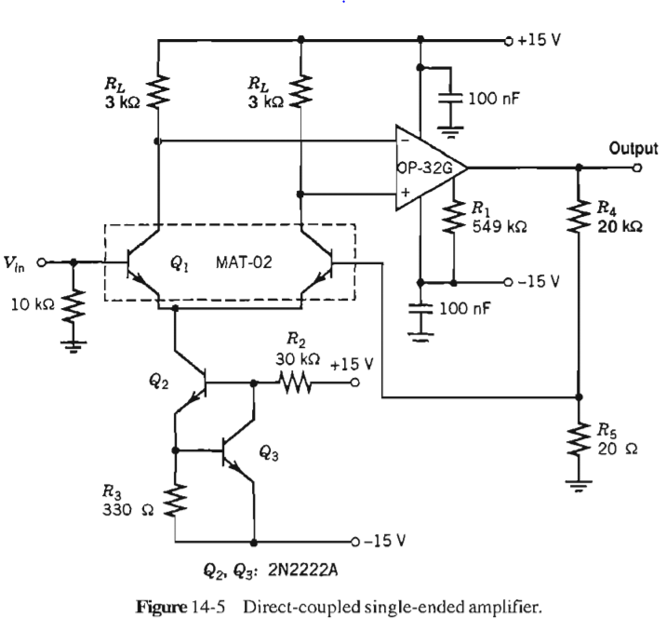

Methods & Measurement

LabVIEW Set-up
Two types of data acquisition methods performed in this study was single-ended and differential measurement, which used Automation and Measure lab equipment and LabVIEW. Fig. 1 and Fig. 2 shows the codes used to acquire data in LabVIEW.

Acquisition of the single-ended data
First, the measurement from channel 5 collects data for 5 minutes. The measurement parameters were sampling rate of 1000 Hz, range of +/- volt, bin size of 500, and RSE configuration (reference single-ended) as depicted in Fig. 3.

Acquisition of the differential data
Second, 5 minutes of a differential configuration data was collecting by shorting the two terminals of 5 and 13. The data parameters were the sample rate of 1000Hz, range of +/- volt, bin size of 500, and Differential configuration as depicted in Fig. 4.

Datamization of the measurements
Matlab utilized to represent the histogram of the data collected using hist function using parameter values of the data and delimiter value of 100.

Result

Fig. 1 and Fig 2 present the data being collected using DAQ assistant function of the LabVIEW for the RCE and differential measurement. Fig. 3 and Fig. 4 represents simplified logic diagram of the physical machinery of the equipment in the lab for signal measuring purposes. The data stored in a file are 1-dimentional array of integer values. Graph 1 and 2 represent histogram of the data graphed from MatLab. Table 1 also represents differences between using RCE and Differential measurement. The values in the Table 1 were derived using MatLab with parameters using the data collected. Graph 3 and Graph 4 shows Gaussian distribution. Approximately 90% or more of the samples in the SRE reside between -0.041 to -0.035 and also reside approximately between 0.0001 to 0.0007 for Differential measurement. There were significantly higher occurrences of data in differential measurement than the RSE measurement.

Equations
s[n]  x[n]  [n]  
v_{out}[n]  x[n]   [n]  
v_{out}[n]  x[n] – y[n] (3)
v_{out}[n]  x[n] – y[n])   [n], where [n]  

conclusion
Frame Graph 1 and Graph 2, I noticed significant different in amplitude of the data sample, where RSE would have significantly larger range of amplitude, meaning it is recording louder sound or energy. The differential measurement with significantly less amplitude must be gathering smoother sound or less energy than that of RSE since amplitude is much less, which mean less data.
From Graph 3 and Graph 4, I noticed that there are significantly higher occurrences of data values in the history for differential measurement. This must mean that in a given amount of sample size and time, there were a lot more necessary information gathered for the differential measurement than the RSE measurement. The data from RSE measurement must have had many noise in the data that are all over the place so that it would not be significant enough to be noticed in the histogram plot while differential measurement must have had a ton of necessary information unhindered by noise.

Authors and Affiliations

Thomas Jung, ECE student at the University of Oklahoma

Acklowedgement

Thanks to these individuals for making this white paper possible.
- John Dyer, research professor of ECE in University of Oklahoma
- Chad Davis teaching professor of ECE in University
- Garret Robinson, Teaching Assistant of ECE in University of Oklahoma.

Figures, Graphs, and Tables

FIGURE 1: DATA ACQUISITION USING LABVIEW
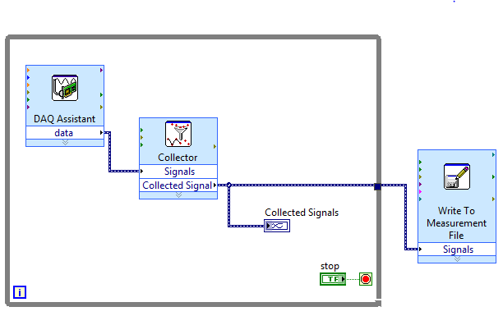

FIGURE 2: READ FROM FILE
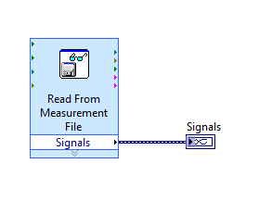
figure 3 : Single ended measurement
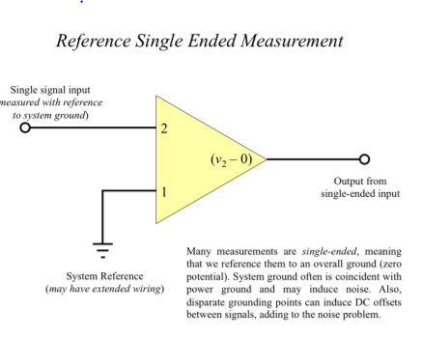

FIGURE 4 DIFFERENTIAL ENDED MEASUREMENT
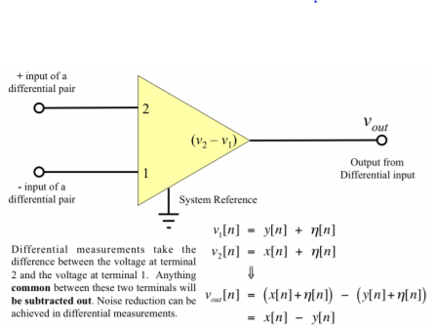

Graph 1: graph of rce data
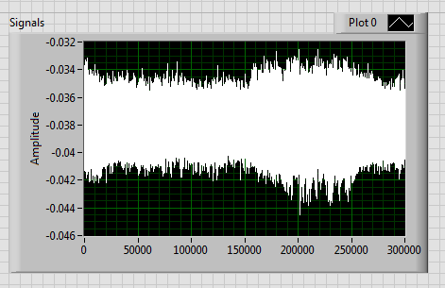
Graph: 2 graph of Differential data
graph 3: Histogram of rsc measurement
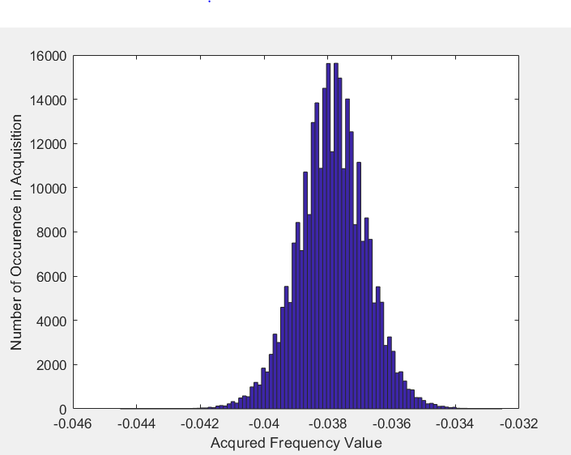
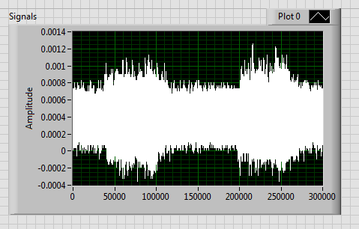

Graph 4: histogram of Differential measurement

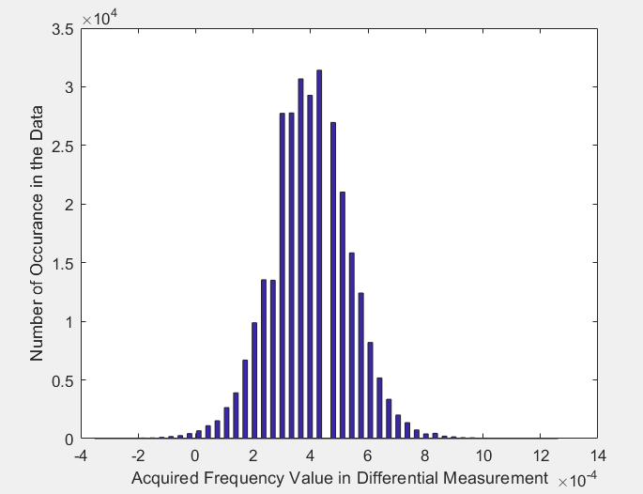

Table 1: Gaussian distribution of Data
Table | Measurement method
Table | RCE | Differential
Mean | -.0379 | 3.9868e-04
Max | -.0325 | .0013
Min | -0.0445 | -3.5200e-04
Mode | -0.0376 | 4.3800e-04
Median | -0.0379 | 4.0500e-04

Reference:
[1] D. Setlak, P. Landy, A. Straub, and R. L. Schenk, “Finger sensing
device including differential measurement circuitry and related
methods,” AuthenTec Inc, 2010-10-07.
[2] C. D. Motchenbacher and J. A. Connelly, “Low-Noise Electronic
System Design,” A Wiley-Interscience Publication, John Wiley
& Sons, INC., 1993, pp. 334-335.

