Tableau Systems Documentation

**2016 EDITION**



Materials compiled by:

**IS Careers Advisory Staff**

advisorassistant@byu.edu

Table of Contents

Getting Started 4

Downloading Tableau 4

Connecting to BYU’s Tableau Server 4

Setting up the VPN 4

Vocabulary 5

How To: Workbooks 6

Template Workbook 6

Template Workbook Contents 6

Configuring 6

Template Data sources 7

Navigating Within a Workbook 8

Upper Tool Bar 8

Lower Tool Bar 8

How To: Data Sources 9

Adding a New Data Source 9

Modifying a Published Data Source 10

Editing a Published Excel Data Source 10

Editing the Published Database Data Source 11

Configuring Extracts After Updating MAster Data Source 2.0 12

How To: Worksheets and Visualizations 13

Data Tab 13

Dimensions and Measures 13

“Show Me” Button 14

Marks 14

Calculated Fields 15

Name or NetID 15

Protected Salary 16

Linking Worksheets 16

Linking by Student Name 16

Linking by Company Name 17

User Filters 18

Average Salary with Less than 3 Data Points 18

How To: Dashboards 19

Creating a Dashboard 19

Background and Buttons 19

Font and Color 19

How To: Data Extracts 21

Why Use a Data Extract? 21

Creating an Extract 21

Creating a Schedule 21

Problems with Extracts 21

How To: Publishing Dashboards 22

Publishing a Dashboard 22

Editing Published Dashboards 23

Groups & Permissions 24

Groups 24

Permissions 24

Support Tickets 25

Handling Tickets 25

Helpful Links 26

Non-Technical Resources 26

Technical Resources 26

# Getting Started

## Downloading Tableau

The easiest way for students to get Tableau is the free student license. That license will last a year, and after that you just need to renew it and then you have it for another year.

Go to tableau.com/academic/students and click “Get Tableau for Free.” You’ll need to provide some basic information (name, email, university, etc.) and then it will ask you to provide a supporting document showing your current status as a student. Follow the guidelines listed to submit a valid document. After submitting, download Tableau Desktop. You may have to wait an hour but you should receive an email confirming your documentation was processed and in that email it will have a product key you can enter in to Tableau Desktop. Enter that product key and you will now have access to create and publish Tableau workbooks.

## Connecting to BYU’s Tableau Server

Ask your project lead to add you as a user to BYU’s tableau server. *(If your project lead doesn’t know how to do it, tell them to talk to Shane Allred, MSM Director of Technology, in 390 TNRB)*

## Setting up the VPN

Accessing the Marriott School Database from a computer that is not hardwired to the BYU Network requires a VPN connection. The following links will guide you through the process of gaining the VPN access, downloading, installing and setting up the VPN client.

1. [Requesting VPN Access](https://it.byu.edu/byu/sc_help.do?sysparm_document_key=kb_knowledge,b0c288300a0a3c0e11ddf116b98ff60f) - If you have ever filled out an OIT ticket, then this will look very familiar. Fill out the information and submit for approval. It might be helpful to send an email to Mike Roberts to alert him that you have requested access, so that he can approve the request.
2. [Downloading VPN Client](https://drive.google.com/file/d/0B2X97cYI-JRUU1lSX2xueEZuTTQ/view?usp=sharing) - For some reason, the client download file is virtually impossible to find through the OIT support page, so this is a direct link to a zip of the .dmg/.exe files.
3. [Installation Instructions](https://it.byu.edu/byu/sc_help.do?sysparm_document_key=kb_knowledge,22c914250a0a3c5401c852af7e9f591c) - Once you have downloaded and unzipped the file from the link above, follow these instructions to perform the initial setup of the Cisco VPN client.

# Vocabulary

Here are some of our definitions of commonly misunderstood vocabulary. Click [here](http://onlinehelp.tableau.com/current/pro/online/en-us/glossary.html) to see more technical vocabulary definitions.

**Data Extract:** See the definition of a data extract in the Why Use a Data Extract section.

**Dashboard:** A dashboard is where you assemble multiple worksheets into one place so you can see everything on one page. You can have multiple dashboards in a workbook, but usually you’ll only have one that has all the worksheets of that workbook included on it. We have created a template dashboard so when you start publishing, all BCC dashboards have the same UI.

**Report:** Many Relationship Managers will call Tableau dashboards reports. Dashboards ARE NOT reports. They are data visualizations not reports. A report is something you run every day, week, month, etc. and then print out (usually in pdf or excel format). Making a conscious decision to emphasize this distinction helps everyone better understand what to expect from Tableau.

**Tableau Desktop:** This is the program you use to create workbooks, dashboards, and visualizations. This is also the program that can then publish those to Tableau Server or Online.

**Tableau Online:** Along with Tableau Server, this provides a way to publish, share, and distribute Tableau workbooks and data sources. They both require Tableau Desktop to publish. Where the two differ is that Tableau Online is outside of your company firewall (the hardware is maintained by Tableau). You can purchased multiple sites. There is no guest access; users must be authenticated through TableauID or a single sign-on using SAML.

**Tableau Server:** Along with Tableau Online, this provides a way to publish, share, and distribute Tableau workbooks and data sources. They both require Tableau Desktop to publish. Where the two differ is that Tableau Server is installed on maintained on your own hardware (inside or outside of your company firewall). You can create and maintain multiple sites at no additions cost, and configure users and permissions. Can be configured for local authentication, Active Directory integration, trusted authentication, or single sign-on using SAML or Kerberos.

**Visualization:** These are the graphs, maps, trend lines, etc. that you create in a worksheet. They can also be viewed in a dashboard if that worksheet has been added to a dashboard.

**Workbook:** A workbook contains worksheets and dashboards. A workbook has the file type ‘.twb’ or ‘.twbx’ which stands for Tableau Work Book. You don’t publish a workbook; you publish the contents of a workbook.

**Worksheet:** A worksheet is where you create a single visualization. You can have as many worksheets in a workbook, and they show up as tabs at the bottom of Tableau Desktop. Most of the time you do not publish a worksheet directly, rather you include a worksheet(s) on a dashboard and then you publish that.

# How To: Workbooks

We highly recommend downloading the Template Workbook and using that as your starting point for creating visualizations. It will already have data sources connected and template dashboards. Otherwise you can create a new workbook and start from scratch, connecting any data sources you want to use and configuring your dashboards in whatever way you’d like.

## Template Workbook

To simplify getting started with Tableau, a template workbook has been created that you can download. When you download this template it will already be connected to the Marriott School database extract that all Tableau workbooks connect to. It will also have correct group permissions associated with it. For those two reasons we highly recommend downloading and using the template as the starting point for all new workbooks.

To download the template go to the Tableau folder “Test & Template Files.” The template workbook is currently called “DASHBOARD TEMPLATE 2.1” but is subject to change. Click on it and you will see that there are two worksheets in the workbook. In the top middle of the screen next to the template title, click on download.

### Template Workbook Contents

When you open the downloaded template workbook you’ll see that there are 4 tabs at the bottom already in place. “1200 x 800” is the smaller template dashboard, and “1200 x 1600” is the larger template dashboard with a bottom half to include more details.

“Dashboard Instructions” is where you can edit the tooltip for the question mark (more information) symbol. This is where you should explain what your dashboard does and how to use it.

The last worksheet is labeled “Sheet 4” and is just an empty sheet where you can start creating your own visualizations.

### Configuring

When you first open the template workbook that you just downloaded you will need to configure a few things so that all the data sources are properly connected and interfacing with each other. Once you have completed all these steps and see no warnings/errors, you are ready to start.

To start, you may see a popup for “data source connection errors.” Click “Edit Connection” then “Connect” and enter your CAS login credentials (only administrators have edit and publishing permissions, so make sure you are in the system as an admin - see the User and Group Permissions section for more on that). It may also ask for the server password, see the Database Credentials section on the previous page for the information.

Next you need to make sure the data sources are connected to the right server (different than the popup mentioned above). Double click on one of the red exclamation points (see screenshot below), change the server from localhost to tableau.byu.edu, and enter your CAS credentials.

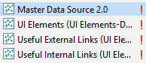

Next right-click on “UI Elements”, hover over “Tableau data server” and click “Edit server and site path.” In the window that pops up you’ll notice that “Step 3” is greyed out. Double click on the dropdown under “Step 2.” That will re-select “UI Elements” and bring “Step 3” into focus. Click ok, and repeat these steps for all data sources not including “Master Data Source 2.0” (you should do this 3 times). Click yes if a popup appears asking if you want to modify all of the data server sources to point to the same server. Repeat these steps if you ever get an error that says “This workbook contains a Data Source that is dependent on a different Tableau Server.”

While working on your Tableau workbook you can either save it locally or you can publish it to Tableau in the same “Test & Template Files” folder where you found the template (just make sure to save it as a different name, otherwise you will overwrite the template workbook).

### Template Data sources

When you are using the template workbook you will notice that there are four data sources already connected; Master Data Source 2.0, UI Elements, Useful Internal Links, and Useful External Links. For more information, check out the data sources section.

**Master Data Source 2.0**: This is the data source that contains the data from the Marriott School database, and is the only data source you will be using to create visualizations (the rest of the data sources are used in the background to make the template dashboard work). This data source was created to simplify using data from the database. Some data field names have been changed to be more intuitive, and all data members have been grouped into categories to make it easier to find the data field you’re looking for.

**UI Elements**: This data source is responsible for the “Main Menu” and “Submit a Ticket” buttons that are present in the top right hand corner of every dashboard.

**Useful Internal Links**: This data source is responsible for the buttons and links within the BCC Dashboards Menu.

**Useful External Links**: This data source is responsible for the “Main Menu” and “Submit a Ticket” links that will take you either to the Tableau Main Menu Dashboard, or the Marriott School IT Page (depending on which button you click).

## Navigating Within a Workbook

### Upper Tool Bar

The file tab will look similar to other toolbars you’ve used before (you can save, close, open, print, etc.), but the rest of the tabs are Tableau specific. It will take some time before you are able to use these features efficiently and naturally, so we recommend clicking through and spending some time discovering what you can do with this tool bar. Here we’ll outline a few of the useful features, but it would be impossible to create a comprehensive list.

It’s important to realize that there are usually multiple ways to do something. For instance, there are two buttons in this toolbar that create a new data source. You can also create a new data source via the Data Source window. The point is, look for shortcuts that will help you develop faster and it will make your Tableau experience much less frustrating.



Under the worksheet tab is “Actions”. We use actions to create links (see Linking Worksheets).

When creating a map visualization, under the map tab check out the map layers. This will allow you to customize your map and include some useful features Tableau has built in, but aren’t the default.

The server tab will be frequently used because that is where you publish a workbook, publish a data source, and create user filters.

### Lower Tool Bar

On the far left side of lower tool bar there is the “Data Source” button that will take you to the screen where you can manage all of your data sources. On the right side of the tool bar there are buttons to create a new worksheet (mini bar chart icon), dashboard (grid icon), and story (book icon - we don’t use stories so you can ignore that).

In between the Data Source button and the buttons to create new worksheets/dashboards/stories are the worksheet and dashboard tabs. A worksheet doesn’t have a symbol next to the name, but a dashboard has the grid icon next to its name. This is how you switch between the worksheets you are creating and the dashboard you are using to assemble them. If you double click on a tab you can rename it. If you right click on one of these tabs you’ll see a menu popup. With that menu you can delete, copy, or duplicate a sheet. You can also copy and paste formatting so if you get one worksheet to look perfect you can easily pass those formatting parameters to your other worksheets.

# How To: Data Sources

To simplify getting started with Tableau, we recommend downloading the template workbook that will already be connected to the necessary data sources. Visit the Template Workbook section for more, otherwise continue reading for how to add new data sources or edit existing sources.

## Adding a New Data Source

Tableau has made adding a new data source easy whether you’re just creating a workbook, or if you’re adding another data source to a workbook you’ve already been working on. And in both of those cases, the process is the same.

When you are in Tableau desktop you will see in the top left corner the Tableau Logo: This is present on all pages of desktop. When you click it you will be taken to the desktop home page. On the left side of the screen is the “Connect” menu bar. Here you can see various types of connections Tableau can use. You should already be connected to the Marriot School Student Database (if not, we recommend downloading the template outlined in the Template Workbook section), so we are going to assume that 99% of the time the additional data source you want to connect to is an Excel file.

To connect to an Excel file, click “Excel” (the first option in the “Connect” menu bar). Navigate to and then select the Excel file with your data. This will take you to the “Data Source” tab in your workbook. This is where Tableau displays a preview of what your data will look like.

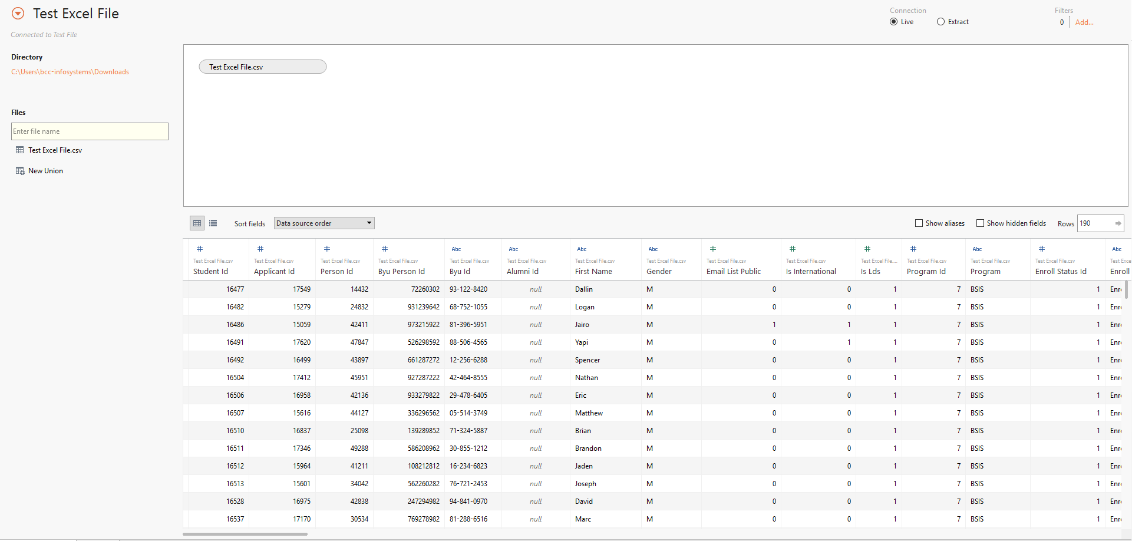

When Tableau first imports your data it does its best to determine the data type of each field. Usually it’s pretty accurate, but if you notice something is wrong you can click on the icon above the column name and change the data type. You can also double-click on the data field names to edit them.

Over on the left side is where you can find a list of the worksheets in your excel file. Tableau allows you to join different worksheets before importing it into Tableau. Do this by dragging the name of the worksheet into the blank worksheet above the preview table. When you have multiple worksheet in that blank workspace Tableau will start joining the worksheets, which you can then edit.

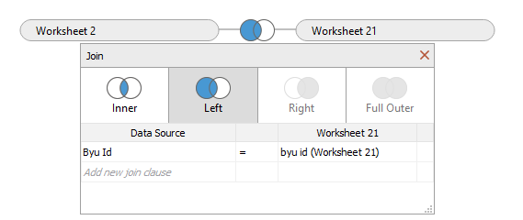

Once you have finalized you data fields and worksheet joins, you are ready to start using that data source. Navigate to a new Tableau worksheet, or one that you have already been working on, and you’ll find your new data source in the data window.

## Modifying a Published Data Source

Editing a published data source can cause a lot of problems, so DO NOT edit a published data source unless you absolutely have to. And even then you probably shouldn’t do it. There are currently two different types of published data sources, published excel files (ex: Useful Internal Links) and the published data source pulling data from the Marriott School student database (ex: Master Data Source 2.0). You edit each kind of data source differently so I’ll outline steps for both below.

### Editing a Published Excel Data Source

The Excel data source you will edit is the one that services the Menu dashboard. The other two shouldn’t be touched. The steps below outline how to add to or edit the spreadsheet that hosts the data for the Menu (adding a new dashboard to the menu, or updating a description).

**First:** Download the Excel data source you want to edit. Find them in the Content section of the site, under the “Data Sources” tab. When you open the downloaded data source file it will open a blank workbook.

**Second:** Right click on the data source in the Data section at the top left of the worksheet. Select properties. In the pop-up window, copy the entire “File Name” field (just click that row and copy). Then open the file explorer and paste into the file path bar. Hit enter.

**Third:** The excel file containing the menu links should have opened. Here you can add new dashboards, edit links, and change dashboard descriptions. Once you’ve made all the changes you need to, save the Excel file and close it.

**Fourth:** Go back to your Tableau workbook. In the top toolbar menu, go to “Server” and then “Publish data source.” Select the data source you just edited (it should be “Useful Internal Links...”). In the pop-up window make sure everything looks right (you shouldn’t have to change anything, but check just to be sure). Make sure that you don’t change the name. When you click publish it should warn you that there is already a data source with the same name. That is good because you don’t want to create a new data source. Click ok to overwrite the old data source with your new data source.

Once you’ve followed these steps you should be able to go to the Menu Dashboard and see the changes you’ve made.

### Editing the Published Database Data Source

Editing Master Data Source 2.0 should only be done in a life or death situation. If you change this data source and publish it, all of the extracts will break and you have to manually reconfigure each dashboard extract. We’ve outlined how to do that in the next section, but try to avoid editing this data source at all cost.

**First:** Download the data source (find it in the Content section of the site, under the “Data Sources” tab). When you open the downloaded data source file it will open a blank workbook. Right-click the data source in the Data section at the top left of the worksheet, and select “Edit data source.”

**Second:** You can change data field names, edit the data type for each field, and add new tables from the database. Don’t mess with any of the table joins.

**Third:** Once you’ve made your changes go back to the blank worksheet. In the top toolbar menu, go to “Server” then “Publish data source” and select “Master Data Source 2.0.” In the pop-up window make sure everything looks right (you shouldn’t have to change anything, but check just to be sure). Make sure that you don’t change the name, and be sure that the authentication settings is “Embedded Password.” When you click publish it should warn you that there is already a data source with the same name. That is good because you don’t want to create a new data source. Click ok to overwrite the old data source with your new data source.

Now when you work on a worksheet, you should see your changes reflected in the data fields for Master Data Source 2.0. However, you need to follow the steps in the next section to make sure all of your extracts connect to your newly-updated Master Data Source 2.0.

### Configuring Extracts After Updating MAster Data Source 2.0

When you make changes to a data source and publish it, all of your data extracts will break (they won’t automatically refresh and after a while your dashboards will be outdated). If you don’t know what a data extract is, go read the section that talks about how to make extracts. The good news is that you won’t have to fix this right away because no one will be able to notice if your dashboards are 2 days out of date. The bad news is you have to manually configure each data extract to pull from the new data source.

For each dashboard/worksheet that uses a data extract, follow these steps:

1. Add a new “Tableau Server” data source
2. Back in a worksheet view, right click on the new data source you just created (it should be called “tableau.byu.edu”
3. Hover over “Tableau Data Server” and click “Edit Server and Site Path”
4. The dropdown under “Step 2” should be “Master Data Source 2.0” (or whatever the old data source is called)
5. Make sure that the input box under “Step 3” is the exact same as the name of the data source in “Step 2” and then click ok
6. At this point there should be two data sources that look the same. There will be the old one (Master Data Source 2.0) and a duplicate that is actually the updated data source (Master Data Source 2.0 (2)). Now we need to replace the old data source with the new data source so that the worksheets won’t be broken when we delete the old data source.
7. Right click on the old data source (Master Data Source 2.0) and click “Replace Data Source”
8. Make sure you’re replacing the correct data source with the updated one (current data source should be Master Data Source 2.0 and the replacement data source should be Master Data Source 2.0 (2)
9. Now you can right click on the old data source and close it.
10. Right click somewhere in the “Dimensions” box and choose “Group By Folder” if applicable

# How To: Worksheets and Visualizations

At its core, Tableau is really just a tool that creates pivot tables. A sheet is where you actually create you pivot table, map, trend line chart, or whatever visualization you’re making. A dashboard is where you can pull together multiple visualizations into one place. The template workbook we created has two template dashboards of different sizes. You can create whatever kind of visualization you want, we just ask that you put your visualizations into a template dashboard so that when you publish it (you should only publish dashboards, not workbooks) it looks uniform with the other workbooks already published. Here is what a blank worksheet looks like:

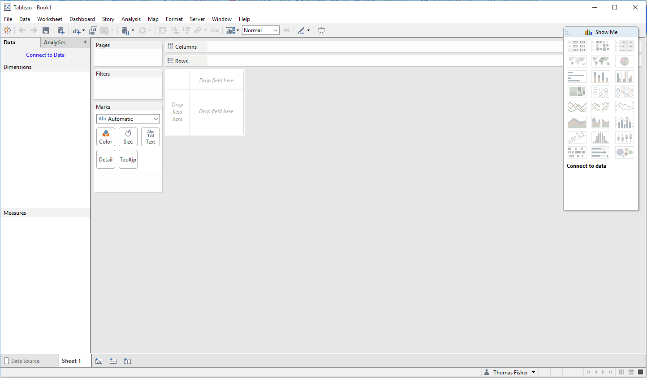

## Data Tab

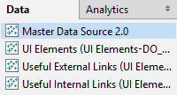This will show you the list of data sources you are connected to. When you select a different data source, the dimensions and measures windows below will update to show the data fields within that data source. If you are using the template workbook these are the four data sources you will see (you only need to use Master Data Source 2.0):

## Dimensions and Measures

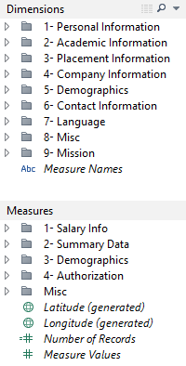Dimensions are the information in the MSM database that are qualitative. Examples of these are names, dates, ID’s, some Boolean values, etc.

A measure is the data that is quantitative. Examples are salary info, percentages, counts, etc.

Right click (or click the dropdown button) on a dimension/measure to manipulate it. Click and drag a few “pills” (data fields) over to the columns or rows bars that are at the top of the sheet. This is the pivot table part of Tableau.

## “Show Me” Button

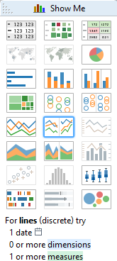Once you have some dimensions and measures in the column and rows, click on the show me button at the top right of the sheet. This will show you what visualizations you can create with the dimensions/measures you’re using.

Alternatively, if you just want to explore what visualizations can be created using your data hold ctrl and select a few dimensions and measures you’re interested in. As you do this, different visualization types in the Show Me box will light up denoting what visualizations can be used with the data you have selected. This a good tool to use when you know what data you want to show, but you don’t know how you want to show it.

## Marks

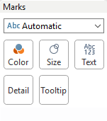The Marks options are next to the dimensions/measures list. This is where you can customize your visualizations (or if you already know what you want to display you can start here and skip the “Show Me” button). Drag dimensions or measures onto the Color, Size, Text, Detail, or Tooltip boxes.

Color: When you drag a dimension/measure onto this box you are telling Tableau that you want colors on you visualization to be dependent on that dimension or measure.

Size: This is the same as color but instead of the color being dependent, the size of your visualizations will be dependent on the dimension or measure.

Text: You’ll notice when you create a simple table with Tableau there is always a column on the end that has ‘abc.’ When you drag a dimension/measure onto the text box you will be replacing the ‘abc’ with that dimension or measure. If you aren’t using a table and you drag something onto the Text box, it will list out all values of that dimension/measure.

Detail: Dragging a dimension/measure onto the Detail won’t put it in the visualization but will allow you to use it in Tooltips.

Tooltip: Tooltips are popups that can display more information when space is tight in a visualization or if you don’t want it to look cluttered.

## Calculated Fields

If you want to create a custom dimension or measure right click anywhere in the dimension/measure toolbar and click “Create calculated field...” This is where you can use built in methods or write your own code. Tableau has its’ own syntax but it is similar to Excel so it doesn’t take long to get a good feel for it.

Here is what the calculate field box looks like. Notice the collapsible help bar on the right side. This displays all the functions within Tableau. It’s very useful because it gives the description of each function along with examples of how to use it.

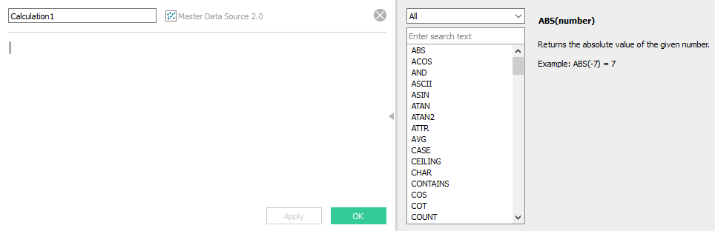

### Name or NetID

A calculated field we recommend creating is “Name or NetID.” It’s a combination of those two data fields so you can search using either field. We also recommend creating it because that is what the Student Profile workbook uses, and if you want your dashboard to link to the Student Profile dashboard it’s easiest if you use the same field. Here is what the calculated field box looks like:

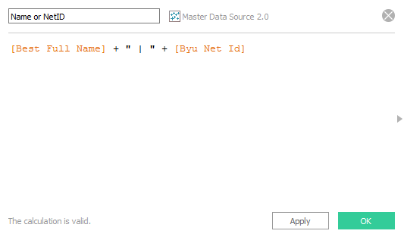

It’s this simple line of code: **[Best Full Name] + " | " + [Byu Net Id]**

### Protected Salary

Whenever individual salary information is shown, it should be protected to only be seen by Relationship Managers and Administrators. The formula for the calculated field is as follows-

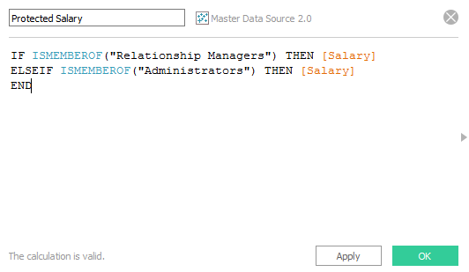

Here it is to copy and paste:

**IF ISMEMBEROF("Relationship Managers") THEN [Salary] ELSEIF ISMEMBEROF("Administrators") THEN [Salary] END**

Copy this into the dimensions as a calculated field and use this instead of Salary on that workbook. We attempted to make this a standard part of the data-source, but it isn’t working as of now. We will research why. This is a good example of why not to change group names. If either the “Relationship Managers” or “Administrators” group names were changed it would break this protected salary calculation and could possibly show salaries to people not authorized to see them.

## Linking Worksheets

This is the documentation for how to link worksheets (aka how to enable drill downs from one dashboard to the next): <http://kb.tableau.com/articles/knowledgebase/view-filters-url>

### Linking by Student Name

If you want to link student names to their Student Profile Tableau dashboard you need to create the Name/NetID calculated field. Also be sure to drag that calculated field to the “Detail” box within the Marks section otherwise it won’t recognize it.

Here are the steps:

1. Select the element on the worksheet that you want to become a link
2. Select the “Worksheet” tab > “Actions” > “Add Action” > “URL”
3. Choose “Run action on”
   1. Hover: As soon as you hover over the element you will be redirected. DO NOT use this option. It often gets stuck in an infinite loop.
   2. Select: When you click the element you will be redirected to the link
   3. Menu: This requires the user to hover over the element to access the tooltip and then click the link within the tooltip.
4. Name the action
5. Uncheck all of the worksheets except the one you want to link
6. Paste the default URL of the dashboard you want to redirect to in the URL box. The default URL is the URL that appears when you first open a dashboard before any filters or settings are changed.
7. Delete everything in the URL that is after “?”
8. Put the title of the filter you want to use after the “?” using “%20” in place of spaces.
9. Follow the filter name with “=” (ex: ?Company%20Name=)
10. Click the > arrow to the right of the URL and select the element you want to send with the URL. This inserts a dynamic tag.
11. This is an example of what a complete URL should look like:

https://tableau.byu.edu/#/site/MSMBCC/views/StudentProfile/StudentView?Name%20or%20NetID=<Name/NetID>

1. After finalizing the URL click ok and the element you selected should now link to that URL

### Linking by Company Name

The method above doesn’t work for company names because there frequently special characters in the names of companies (such as commas and ampersands). Those special characters break the URL and won’t show the correct information. Here is the method to account for special characters:

1. You need to create a calculated field using the REPLACE function that will replace all special characters to their URL encoded values (for more on encoded values go to <http://www.w3schools.com/tags/ref_urlencode.asp>).
2. Here is the calculated field.

**REPLACE(REPLACE(REPLACE([Company Name],",","%5C%2C"),"&","%26"),".","%5C%2E")**

1. Using this calculated field instead of the company name field, follow steps 1-11 in the above section to create the link.
2. There is one additional thing you need to watch for when using this calculated field. Before you click ok, you need to make sure that “URL Encode Data Values” is NOT checked. Otherwise it will replace all ‘%’ (inserted by your calculated field) with ‘%25’ because it’s trying to encode values automatically which we are already doing with the calculated field.

## User Filters

In order to protect our students, a dashboard with sensitive student information only displays that information to those associated with that students program (i.e. only the Accounting RM or Accounting career specialist will be able to see individual information of Accounting Students). We followed [this tutorial](http://kb.tableau.com/articles/knowledgebase/row-level-security-and-user-filters) to make the filters work but here is our explanation of how to do it.

**Note: If user group names are ever changed, it will break user filters. DO NOT change the name of any of the current groups.**

1. When viewing a worksheet, select the “Server” tab > "Create User Filter" > “Program”
2. Rename the Filter: Protected Program
3. Allow administrator’s access to all programs (select all programs).
4. For each program group (p_MBA or p_BSFin) select the corresponding program.

Do not give the Relationship Manager group any access because they should be in their program group already. Do not give All Users any access.

Also be aware that these filters are only as accurate as your groups, so make sure to stay updated on who is in what group.

## Average Salary with Less than 3 Data Points

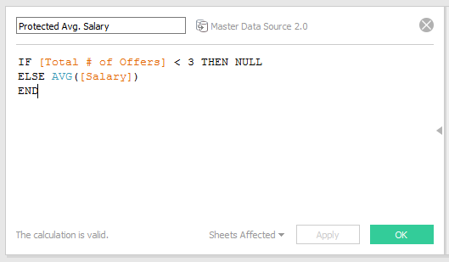It was decided early on in the creation of Tableau that average salary numbers would only be shown if there were three or more salaries to average. That means when there are only two data points you can’t average those and display that average, or when there is only a single data point you cannot label and display that single salary as an average. Simply create a calculated field like the one below.

Here it is to copy: **IF [Total # of Offers] < 3 THEN NULL ELSE AVG ([Salary]) END**

# How To: Dashboards

We created the 2 template dashboards (included in the template workbook) so that all BCC Tableau dashboards look unified, professional, and are easy to use and navigate.

## Creating a Dashboard

When you first open the template workbook, you will see 4 tabs on the bottom toolbar. The two template dashboards that we recommend using are “1200 x 800” and “1200 x 1600.” They already have the background and buttons setup. All a dashboard does is display multiple worksheets and their filters in one place. This is done by dragging the title of a worksheet from the “Dashboard” menu on the left side of the dashboard onto the dashboard.

It would be impossible to explain every little tool and setting you can use to make a dashboard, so just start putting worksheets on your dashboard and then click around to see what you can change.

On the smaller template (1200 x 800) we have made two sections for you, the section in the middle is where you should put worksheets and the smaller section on the right side is where you should put filters. The larger template is the same except for the addition of another large area below for you to put more worksheets.

## Background and Buttons

Here are the links to the two different sized background images. If you are using the template you shouldn’t have to worry about these.

**Standard Size (1200 x 800):** <https://drive.google.com/open?id=0B2X97cYI-JRUMDk3QTZpV2NNMmM>

**Detailed View (1200 x 1600):** <https://drive.google.com/open?id=0B2X97cYI-JRUeENublhSN05TczA>

The “Main Menu” and “Submit a Ticket” buttons are both built into the template dashboard and will work as long as the UI Elements and the two Useful Links data sources are connected properly (which they should be if you are using the template workbook).

## Font and Color

The font you should always be using is Century Gothic. Bold titles and keep all other text normal. The standard text should be 10 pt., the dashboard title is 24 pt., the UI Elements (Main Menu and Ticket buttons) are 12 pt., and the questions mark more information symbol is Arial 48 pt. Bold.

Here are the color codes for the two main blues we use. Use your best judgment but we want to stick with similar colors so that our dashboards look unified.

BYU Dark Blue: #09314F or RGB 6, 49, 79

BYU Light Blue: #46A2DE or RGB 70, 162, 222

We use the Tableau 10 Medium color palette as the standard color scheme for colored elements. If there are more than 10 colored elements, use Tableau 20 and use transparency (set at around 50%) to mimic the lighter colors.

# How To: Data Extracts

## Why Use a Data Extract?

Every time someone changes a filter on one of your dashboards, Tableau is querying the Marriott School database to pull that information. This can lead to high database traffic, and slow load times for Tableau. The solution to this is to create a data extract.

A data extract is a copy of the data source that is stored by Tableau, but it only copies the data that is being used in your dashboard. It drops all unused data fields which allows for faster querying and more efficient traffic to the actual database. You can set a refresh schedule for an extract so that once a month, once a week, once a day, etc. Tableau queries the data source (the MSM database) and updates the extract.

## Creating an Extract

Creating an extract is easy. Right click on the data source you want to extract (top left of the screen in the data tab), and then click extract data. The extract data popup window should now appear. First remove all filters in the top section. Then click the button at the bottom that says “Hide All Unused Fields” (this will make your extract even faster). Simply click “Extract” and after a few seconds you will have switched to a data extract

**Note: If you are using hierarchies in you dashboard, you need to expand them all the way before creating an extract. If you don’t expand them, those data fields are considered unused fields and will be removed from the extract.**

## Creating a Schedule

When you create an extract you are no longer accessing a live connection to your data source. That means you need to schedule automatic refreshes to keep your data up-to-date. You set that automatic refresh schedule when you publish a dashboard, so go to that section to learn how.

## Problems with Extracts

If your refreshes aren’t executing successfully, try removing and re-extracting the extract and then re-publishing as outlined below:

1. Right click on the data source
2. Hover over “Extract” and click “Remove”
3. Select “Remove the extract and delete the extract file” and click ok
4. Wait for it to remove the extract, right click on the data source, and click “Refresh”
5. Recreate the extract as detailed above
6. Re-publish the workbook and manually refresh the extract to ensure it works

# How To: Publishing Dashboards

## Publishing a Dashboard

This process is the same whether you have created an extract for your data source or not (but we highly recommend that you do). If you are using an extract, make sure to create that extract before you publish the dashboard. And if you do have an extract and are using hierarchies in your dashboard, be sure to follow the steps outlined in the Hierarchies section.

To publish a dashboard:

1. Click on the “Server” tab in the top toolbar and click “Publish workbook.” If you get an error saying “This workbook contains a Data Source that is dependent on a different Tableau Server” it is because you didn’t follow the steps outlined in Connecting Data sources to Correct Server.
2. Change the project folder to where you want your dashboard to be.
3. Rename it (make sure to do this especially if you started with the template, we don’t want to overwrite it).
4. Enter a description, usually the same description as what is used in the question mark tool-tip.
5. If you are publishing in the public “BCC Dashboards” folder, do not change any of the permissions. We have set it up so that when you publish to that folder, it automatically gets the correct permissions. Otherwise change the permissions to suit your needs.
6. Select which sheets you are going to publish. Normally you want to publish just the one dashboard you’ve created, rather than publishing all of the workbooks you’ve used to create that dashboard.
7. Don’t change any of the options.
8. If you aren’t using an extract, click the “Authentication” button and make sure that each data source is set to “Embed Password.” If you are using an extract, click the “Scheduling & Authentication” button and also make sure that all data sources are set to “Embed Password.” In addition, click the extract schedule above and choose your schedule. The more frequent the scheduling the more up-to-date your data will be, but also the more traffic to the data source. Choose what fits your dashboard the best

Once you have published a dashboard, always make sure that your extract (if used) will refresh properly. To do this you need to go to the website (tableau.byu.edu), navigate to your newly published workbook, click the menu button on the workbook (not worksheet) thumbnail, click “Refresh Extracts”, and then click “Full Refresh.” That will manually start a refresh for that workbook. To check its progress click on the “Status” tab in the top toolbar of the website, and then click “Background Tasks for Extracts.” There you will be able to see the status of all refreshes, scheduled and manual.

Once a dashboard is published you don’t need to save that workbook to your computer (though you can if you want). If you ever need to edit it, you can download it from the website and edit that copy.

## Editing Published Dashboards

We’ve found that it’s easiest to not keep dashboards saved to the computer, and when we need to change something we download it from the website, edit it, and republish it so that the online version is always the most current version. Here are the steps to do this:

1. First download the worksheet you want to make changes to. This is done by going tableau.byu.edu, finding the worksheet you want to edit, clicking on the menu button (three horizontal circles on top right of thumbnail) of the worksheet, and clicking Download.
2. When you first open the worksheet you’ll probably need to enter in your credentials a few times to set everything up. This is outlined in Connect Data Sources to Correct Server.
3. Once the data sources are connected you can make changes and add to your workbook. If there are data fields that seem to be missing (in the data panel on the left) it is because you are editing an extract and all the unused data fields were hidden when that extract was created. To unhide those fields you need to remove the extract. Do this by following steps 1-3 outlined in the Problems with Extracts section. Once the extract is removed, click on the carrot button on the top right of the dimensions section and choose “Show Hidden Fields.” You will then be able to see all of the data fields, but they will be greyed out. If you want to use a greyed out data field, right click on it and select “Unhide”
4. After your changes have been made, create an extract.
5. You are then ready to publish your workbook.

# Groups & Permissions

## Groups

It’s important to keep groups up-to-date because many of the filters and dashboards permissions rely on them. At the time of writing here are the groups we have in place and why:

* We have a group for each program. We use this is conjunction with User Filters to allow only Finance individuals (RM’s and student employees) to see sensitive Finance data, only Information Systems individuals to see sensitive IS data, etc.
* The next group we have is Administrators. Those in the administrator group can bypass user filters and can view all data for all programs.
* All Users is group that is automatically setup by default. We don’t use it yet.
* The Relationship Managers is the most important group because users in that group can see individual salaries (by way of the Protected Salary calculated field). It’s just another layer of security. An example of this would be a dashboard with individual students and their job/internship offers. Only an Accounting Individual (either RM or student employee) that is in the Accounting program group would be able to see that list of Accounting students and where they were hired. However, only the RM and not the student employee would be able to see the amount of each individuals offer.

## Permissions

We have yet to decide how we are going to handle external access requests (people not in the BCC who want access to our Tableau dashboards).

At the time of writing, if there is someone who is in the list of Tableau users but is not in a group (either a program group, administrators, or RM) they wouldn’t be able to access a majority of the dashboards because of the user filters we have in place on most dashboards.

# Support Tickets

Relationship managers have been instructed to submit tickets rather than requests in person. Otherwise we would get sticky notes all the time, lose those sticky notes, and then have to deal with disgruntled RM’s. We have included a button in all Tableau dashboards that will quickly take them to the ticketing system.

In order to access the Business Career Center ticket queue as a developer, go to [marriottschool.byu.edu/it/support/staff](http://marriottschool.byu.edu/it/support/staff).

If you do not already have an account setup (this does not happen automatically), you will need to email or go talk to Shane Allred. He can create an account for you using your netID as your username.

## Handling Tickets

As a part of the BCC Tech team, you will receive an email when a user creates a new ticket. Do your best to respond to these tickets promptly, even if it is just a simple reply to let them know that it has been added to our queue. *Trust me, it will make your life easier to give them some sort of feedback saying that you are working on it.*

Once a ticket has been added to the queue, assign it to a developer and change the ticket status. Each developer will have a responsibility to handle the tickets in their queue in a timely manner. The development manager will be responsible for following up with the developers if a ticket remains outstanding for too long.

# Helpful Links

## Non-Technical Resources

|  |  |
| --- | --- |
| Link | Description |
| [Tableau Drive](http://www.tableau.com/drive) | This is a business intelligence deployment methodology that Sam McKnight recommended we look into. |
| [What Tableau IS and IS NOT](https://www.interworks.com/blog/dmurray/2014/12/29/what-tableau-and-not) | This is a good article that explains what Tableau is meant to be used for. |

## Technical Resources

|  |  |
| --- | --- |
| Link | Description |
| [Tableau Training](http://www.tableau.com/learn/training) | These are the official training/tutorial videos for Tableau development. Definitely watch as many of these as you can. |
| [Advanced Dashboards](http://mindmajix.com/tableau/how-to-build-your-first-advanced-dashboard-in-tableau/) | How to build “Advanced Dashboards” |
| [Images](http://stackoverflow.com/questions/5340299/dynamicly-show-images-in-tableau) | Dynamically show images in Tableau |
| [Using Images](http://www.theinformationlab.co.uk/2014/08/21/using-images-tableau/) | Dynamically show images in Tableau (2) |
| [Creating User Filters](http://kb.tableau.com/articles/knowledgebase/row-level-security-and-user-filters) | We used this tutorial to create filters for each relationship manager and career specialist so that they only see their own data. |
| [Linking Dashboards with Filtered Views](http://kb.tableau.com/articles/knowledgebase/view-filters-url) | This is how you can link any dashboard to an individual Student Profile or Company Overview. |