Tableau User Documentation

**2016 EDITION**



Materials compiled by:

**IS Careers Advisory Staff**

advisorassistant@byu.edu

Table of Contents

Introduction 3

Vocabulary 4

Using Tableau 5

Setting Your Start Page to the Main Menu 6

Navigating Within Tableau 6

Using Maps in Tableau 7

Expanding Data Fields 7

Using Filters 8

Linked Filters 8

Workbook Tabs 9

Tool Tips 9

Creating Custom Dashboard Views 10

Tableau Out-of-the-Office 11

Career Specialist Access 11

CAS Timeout error 12

Published Dashboards 13

BCC Dashboards 13

BCC Dashboards Menu 13

BCC Tableau Tutorial 13

Company Overview 13

Job Search Statistics 14

Student Profile 14

Top 25 Companies 14

Company Location 14

International Student Sponsors 15

Recently Reported Offers 15

Students Seeking 15

Average Salaries 15

Regional Overview 16

Student Demographics 16

# Introduction

The purpose of the Tableau dashboards is to give those in the BCC a deeper insight into placement data to allow them to better achieve their goals of helping students achieve their dreams.

The Information Systems Career Specialist team at the Business Career Center has adopted Tableau as its primary data visualization tool. There has been enough interest and support that we have worked to develop Tableau visualizations that everyone in the BCC can use. This documentation will outline the basics of how to use Tableau and explain existing Tableau dashboards and their use cases.

We are excited to give you access to these dashboards. We hope that you will find them helpful as you explore the various questions they can answer. We recognize that Tableau will not solve all your placement problems, but we hope that you will try it and catch the vision of what is possible.

If you have any problems, questions, or suggestions, please [submit a ticket](http://marriottschool.byu.edu/it/support/index.php?/Tickets/Submit) through the Marriott School IT support system (<http://marriottschool.byu.edu/it/support/index.php?/Tickets/Submit>). You can also submit a ticket through the “Submit a Ticket” button in the top right corner of most dashboards. This system will allow us to track progress on your issue and keep you updated on your request. Be sure to select “Business Career Center Support (Tableau).” In order to be more efficient, we ask that in the subject line of the ticket you include the name of the dashboard you are having a problem with or question about.

**If you send us an email or stop by our office regarding an issue, we will create a ticket for your request.** We recommend you skip this middle step and submit a ticket directly. This will allow you to make a full description of your issue, rather than having us make a ticket based on what we remember from our conversation. We will review each ticket to determine priority and complete the task as soon as we can.

If you would like individual training we have developed a step-by-step tutorial that we can take time to walk you through. It will go through what is in this documentation but in tutorial form. Email us to setup a tutorial meeting.

Thanks,

IS Careers Staff

# Vocabulary

*Here are some useful definitions of commonly misunderstood Tableau vocabulary.*

**Dashboard:** A dashboard is where you see multiple data visualizations, and use filters to customize that data. Anytime you are looking at a visualization, you are also looking at a dashboard.

**Report:** A lot of people incorrectly call Tableau dashboards, reports. Dashboards ARE NOT reports. They are data visualizations not reports. A report is something you run every day, week, month, etc. and then print out (usually in pdf or excel format). Making a conscious decision to emphasize this distinction helps everyone better understand what to expect from Tableau.

**Visualization:** These are the graphs, maps, trend lines, etc. Visualizations are combined with other visualizations onto a dashboard.

# Using Tableau

Navigate to [tableau.byu.edu](http://tableau.byu.edu/) on any browser and log in through the BYU CAS authentication system. If it asks you to “Select a Site” choose “MSMBCC.”

**Note: Users have to be manually added to the system. We believe we have added everyone, but if you are not able to login please contact us and we can add you quickly.**

When logging in for the first time, you should see a list of "***Projects***”



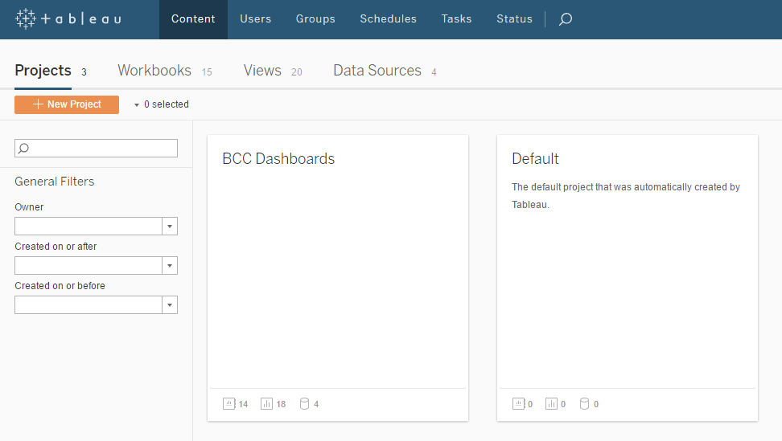These are different folders where we will be storing dashboards. As of now you should see at least one folder if not more depending on your permissions.

Clicking on a folder will reveal a list of "***Workbooks***". Each Workbook has one or more "***Views***". A workbook is like an Excel workbook and a view is like an individual sheet in Excel (or like a tab in a web browser). Most workbooks will only have one view, but if there are multiple views you can switch between the views with tabs at the top of the dashboard (explained in the “Workbook Tabs” section).

All of our currently available dashboards will be housed in the ***BCC Dashboards*** folder. If you can’t see that folder or don’t have access to a dashboard and you think you should, please contact us and we can edit your permissions.

## Setting Your Start Page to the Main Menu

In order to make Tableau more user-friendly, we have created a main menu where you can access all dashboards. Currently there are 12 on the menu, but we’ll be adding more as time goes on. We recommend that you make this main menu your start page so that every time you log in to Tableau you see the menu first and from there can easily access any dashboard. To do this first navigate to the main menu (it’s in the folder labeled “BCC Dashboards” and the menu is called “BCC Dashboards Menu”). Once you are viewing the menu, click on your name at the top right corner of the page and choose “Make This My Start Page.” To learn more about the main menu, go to Tableau Main Menu Dashboard description in the published dashboards section.

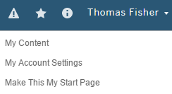

## Navigating Within Tableau

Once you are at the Menu you will be able to see what all BCC dashboards look like. At the top right of the screen all dashboards have a question mark icon. When you hover over it, a description of the dashboard and instructions on how to use it will popup.



Next to the question mark there are two buttons, “Main Menu” and “Submit a Ticket.”

The “Main Menu” button will take you back to the menu where you can access any dashboard. A quirk of Tableau is that when you click on a link it will sometimes open in a new tab. **If you click on a link (whether it be the name of a dashboard, the “Main Menu” button, or any other button) and nothing happens, check your already open tabs.** Sometimes instead of opening a new tab, Tableau will instead refresh one of the tabs you already have open. **If you click on a link, nothing happens, and you didn’t have any tabs open, make sure you’re allowing popups from Tableau.** Some browsers automatically block new tabs and Tableau might be getting blocked.

The “Submit a Ticket” button takes you to the Marriott School IT page. See the Introduction section to learn more about tickets.

## Using Maps in Tableau

Screen Shot 2016-03-22 at 3.17.37 PM.png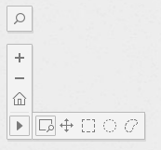When a map is used in as a visualization, you can often select a state or region filter on the dashboard outside of the map, but if you want to use the map itself to select a specific area there are multiple options available to you. In the upper left corner of a map, you can zoom in and out, as well as select a specific area. The horizontal pop out menu provides you several options (to view these options you must first click on the right arrow button that will then expand as shown to the left):

Screen Shot 2016-03-22 at 3.18.33 PM.png Zoom in to a specific area, while maintaining all the data.

Screen Shot 2016-03-22 at 3.18.46 PM.png Select only the data within a specific square.

Screen Shot 2016-03-22 at 3.19.01 PM.png Select only the data within a specific circle.

Select only the data within a lassoed area.

 Drag to move view around map

## Expanding Data Fields

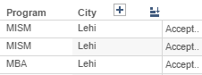Some data, such as locations and dates, can be expanded to see more detailed information. If this is available, a plus sign will appear when your mouse hovers anywhere over the column. Click it and a new column will appear to the right.

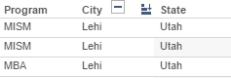To close the expanded data column, click the subtract button that replaced the plus sign.

## Using Filters

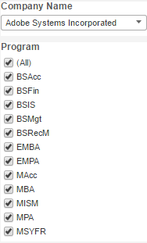On most dashboards, relevant filters like company, student, and program (as well as any others) will be displayed on the right side of the dashboard. In some cases, you will also be able to click on a specific portion of a visualization to use it as a filter. It is usually best to use these filters before analyzing the data on the visualization so that only the relevant information will be displayed in the visualizations. For some dashboards, the filters you are allowed to access are determined by your account and have been preset to the programs you represent or work for. A complete list of available dashboards can be found at the end of this document. If you believe that you are unable to view data that you should have access to, please contact us and we can edit your permissions.

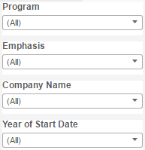

## Linked Filters

In some dashboards there are multiple filters that work together. This happens automatically, but some don’t recognize it and don’t utilize this feature to filter more efficiently. For example, below is a screenshot of a dashboard that displays two visualizations; the average salary of each state (in map form), and below it a separate visualization that shows individual companies sorted by the number of their recruiting numbers. When you click on one or more states, the visualization below the map filters to show only companies in the state(s) you selected.

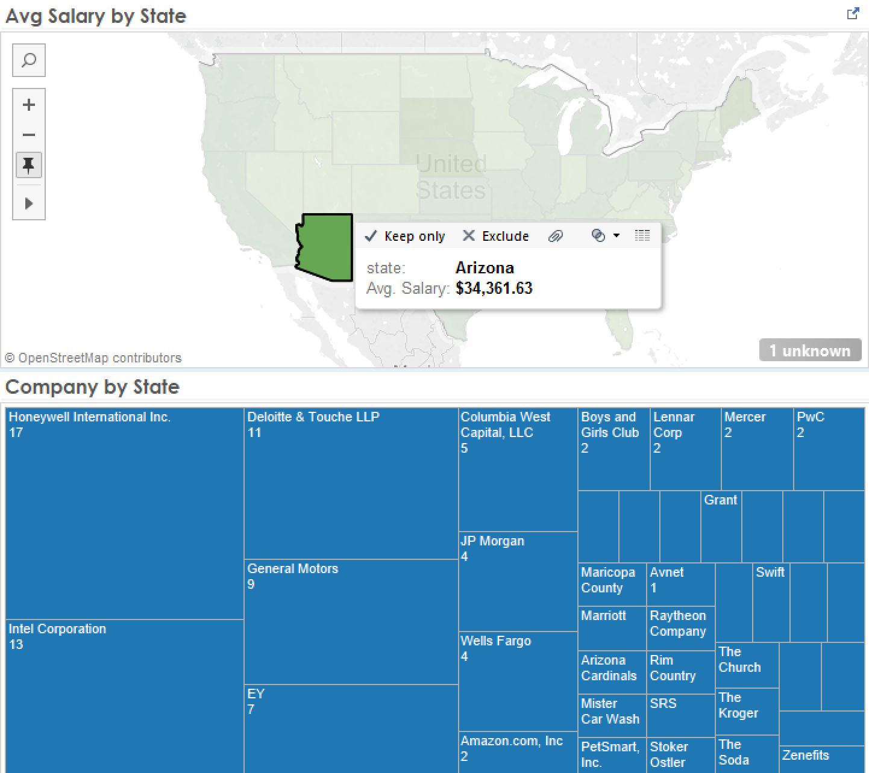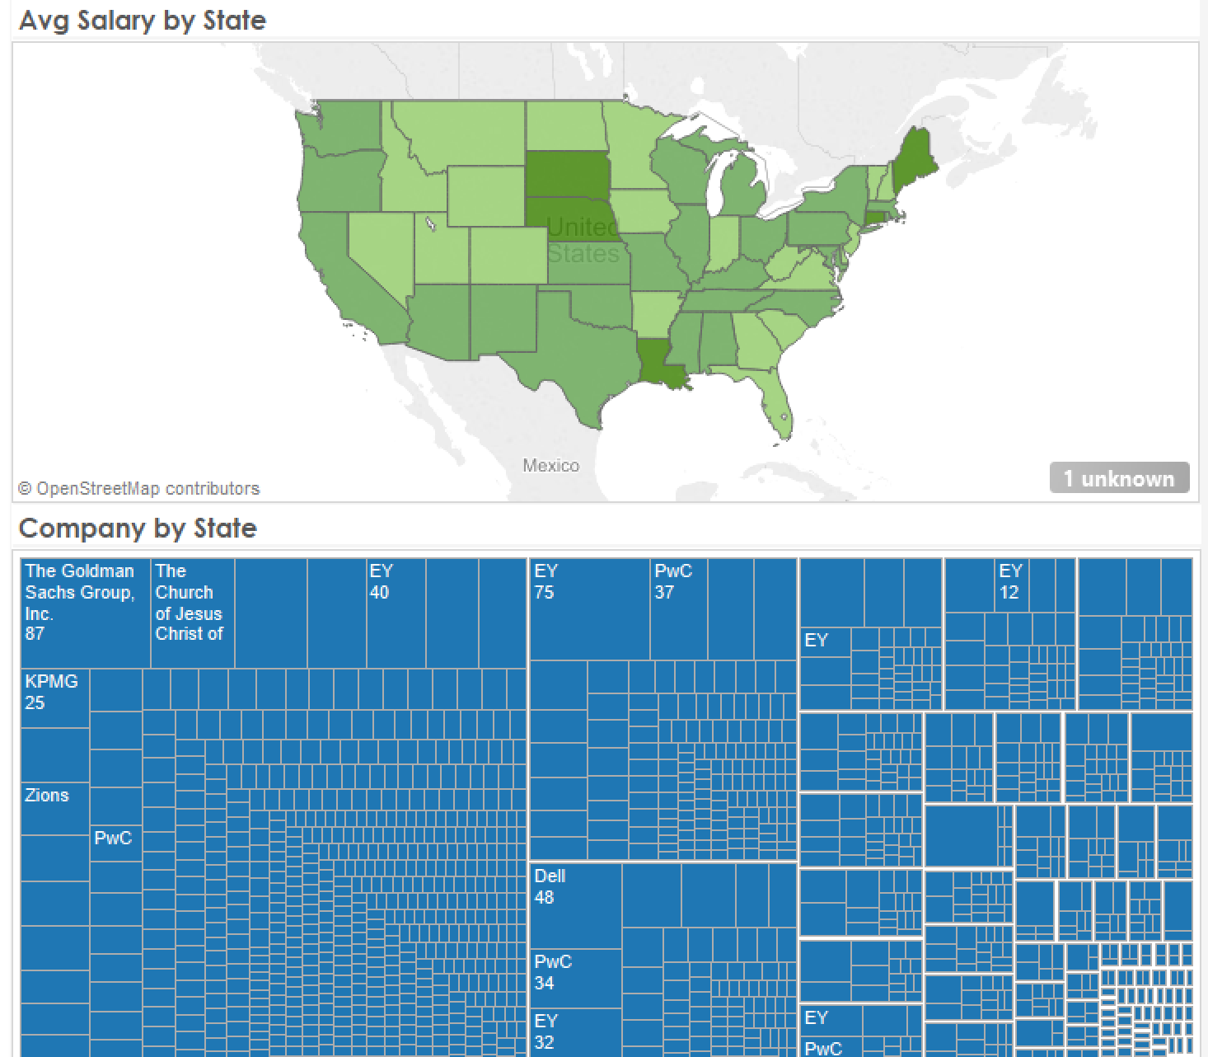

## Workbook Tabs

Some workbooks have multiple views that can be accessed by the tabs at the top left of the screen, above the title of the workbook. We are slowly phasing out the use of these tabs because many people miss them because they’re small and not very noticeable. There aren’t many dashboards that use these anymore but be sure to watch for them.

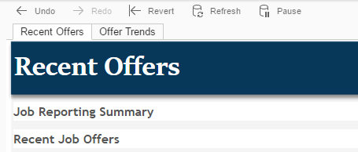

## Tool Tips

Many dashboards have “Tool Tips” which are pop-ups used to display more information when you hover over parts of a visualization. They aren’t used in every dashboard, but we try to include them to provide additional insight or keep a visualizations’ appearance clean and simple.

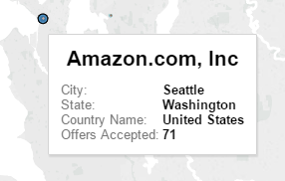

In this example we are viewing a company location map, and by hovering over Amazon’s main location we are able to see the exact city as well as the total offers accepted.

Some of the visualizations use squares or circles to show various data (like the screenshots in the Linked Filters section). When the square or circle is too small, it will appear blank because it can’t fit the data within that small shape. Too see that data simply hover over the square/circle and a tool tip will pop up with the relevant data.

## Creating Custom Dashboard Views

If there are dashboards that you find yourself using frequently, you may want to save the common views/configurations that you always look at (aka you always change the filters to show you the same data every time you use that specific dashboard).

Let’s say you’re the director for Information Systems and you have multiple students coming in every day asking about getting an internship at Adobe. Rather than adjusting the necessary filters every time a student comes in, create a ‘view’ that saves those. First filter to show BSIS and MISM data and select Adobe. Once you are looking at the data you frequently use, click on the button labeled “Original View” near the top center of the dashboard. Then name that view, in our example we chose to name it “Adobe Information Systems.”

Now the next time a student comes in asking about Adobe we can simply change the view to “Adobe Information Systems” instead of filtering and changing the company every time. To do that, just click “Original View” and choose the view you want.

If you always want to see a specific view when you open a dashboard, you can customize a view like we did above, and then check the box titled “Make it my default.” Then every time you open that dashboard it will default to that custom view.

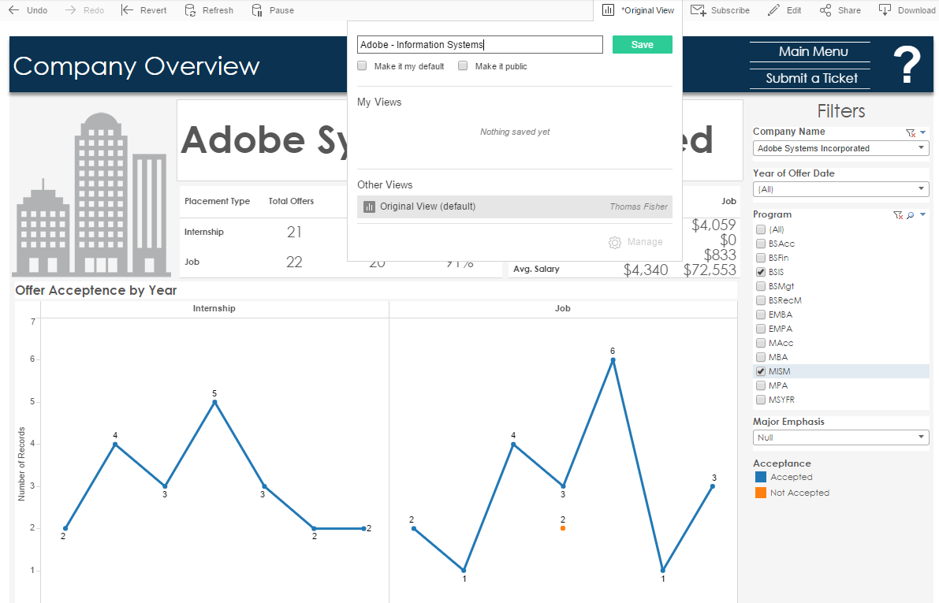

## Tableau Out-of-the-Office

You do not need to be on BYU’s network to access these Tableau Dashboards. As long as you have an internet connection, you can access Tableau from anywhere.

You can take your dashboards on-the-go by downloading the *Tableau Mobile* app for iPad or Android Tablet. All you need to do is open the app, use ‘tableau.byu.edu’ as the server name, and then log in using your BYU CAS credentials the same way you would on your desktop browser.

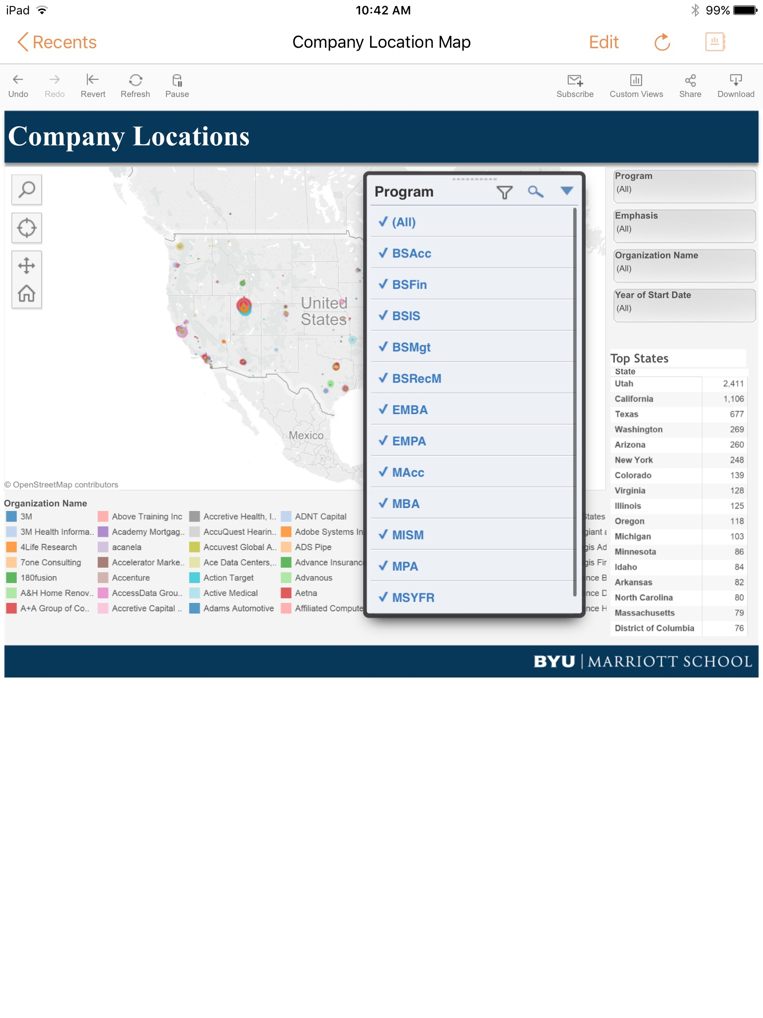

You can also log in to Tableau with any mobile phone or tablet using a browser, however, many dashboards may not render correctly on smaller screens so we don’t recommend doing so at this time.

## Career Specialist Access

We know that many of you rely upon your Career Specialists to handle your data. If you would like us to add your student assistants as users to the Tableau system, have them contact us with their BYU netID and we can add them as an authorized user (make sure the specify who they work for or what program they cover so we can give them correct permissions).

In the near future we will begin training career specialists on how to develop Tableau dashboards. This will allow them to create custom dashboards for you using your program-specific data.

## CAS Timeout error

Logging in to Tableau is done through BYU’s authentication system (CAS). If you leave Tableau open for an extended period of time, CAS will time out but Tableau will not. When this happens Tableau won’t notify you, but will give you an error when trying to navigate the site.

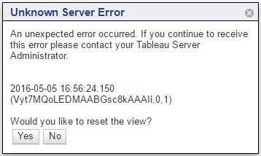

There is currently no way to log out of Tableau, so there is no way to re-enter you CAS credentials. We are working to find a better solution, but the best way to solve this problem currently is to open a new incognito window and sign in again, or to sign into Tableau again using a different browser.

# Published Dashboards

Below is a list of available dashboards with descriptions and use cases. We will continually update this section as new dashboards are added or changes are made.

## BCC Dashboards

*These dashboards are built for all Business Career Center Relationship Managers and their employees.*

### BCC Dashboards Menu

Description: Displays a menu of dashboards grouped by category. Each one has a short description. They are grouped by category (company, placement, or student). Click on the title or description of a dashboard to take you to it.

Use Case: For simplicity, we would like this to be the first screen you see when you log into Tableau, but each individual user has to do this. See the “Setting Your Start Page” section to enable this.

### BCC Tableau Tutorial

Description: This provides step-by-step instruction on how to use basic Tableau features. This is what we use to demonstrate Tableau when we do individual trainings. The tutorial and this User Training Manual are our two training guides for beginning Tableau users. Please note that the tutorial uses dummy data so do not be alarmed when you see number that appear to be inaccurate.

Use Case: Use the tutorial when first starting to learn Tableau. This should get you on your feet, but once you’re comfortable you probably won’t need to reference it again.

### Company Overview

Description: This displays various information about individual companies. You’re able to view internship and job offer numbers, salary information, offer trend lines, and a list of students who have received offers from that company.

Use Case: This dashboard gives a good overview of individual companies and their statistics. Use it to give students a better idea of what they can expect in terms of job offers, location, and salary.

### Job Search Statistics

Description: This displays current placement numbers for each individual program in the Marriott School (and emphasis if you expand the program column). It is filtered by the “Class Of” date. The right half of the dashboard displays the same information but for the entire Marriott School instead of being broken into individual programs.

Use Case: This dashboard allows you to see placement data in one place which is useful for quick checks to see how a program is doing in their placement. It’s also useful to see how the Marriott School as a whole is doing with placement, and to see how this year compares to previous years.

### Student Profile

Description: This shows contact information, expected and actual graduation dates, as well as internship and job information for individual students. The far right column (to the right of the “Accepted” column) shows the salary for that individual offer and is only visible if you are a Relationship Manager.

Use Case: Use this as a contact page for current students and alumni. Easily see where a student has offers from and whether or not they accepted.

### Top 25 Companies

Description: Displays the top 25 companies based on the number of full-time and/or internship offers. You can also show the top companies based on how many of their offers were not accepted. The rank of each company (1 through 25) is listed in the top left corner of each square. The size of the square represents how many offers a company has extended to BYU students. If a square is too small to fit all the information it will appear blank, but if you hover over it you will see the same information.

Use Case: This dashboard is useful to give to both students and recruiters alike. Use it to show students which companies are interested in students with their degree, or to show recruiters where they fall in overall program recruiting.

### Company Location

Description: View the location for each company. You can search by company name to see where the company has hired BYU students, by state to view what companies hire in that state, or by city to view what companies hire students in that city. You can filter by program/emphasis to view companies pertaining to a specific major as well as the type of placement (internship or full-time). The bottom half of the dashboard shows individual offers, top states ranked by number of offers, and gender and international student information.

Use Case: This is a good way to visualize where Marriott School students go after graduating. It can show trends by year or show patterns in company recruiting locations. You can also see gender statistics and the number of international students.

### International Student Sponsors

Description: Displays companies that have hired international students in the past. The size of the circle indicates how many international students that company has hired. Hover over a circle to view exactly how many students that is. It also displays, in a list, the top companies that hire international students. This data is based on the fact that an employer has an international students and does not necessarily mean they sponsor international students.

Use Case: Use this dashboard to give international students an idea of what companies can sponsor them for full-time positions after graduation.

### Recently Reported Offers

Description: Shows full-time and internship offer information that have been reported within a specific amount of time (note that the salary of an individual offer is only visible to Relationship Managers). The default view shows those offers than have been reported within the current week, but you can change that filter to show you offers that have been reported in the past week, month, 6 months, etc.

Use Case: This gives you the ability to quickly see if someone has reported overnight, over the weekend, or to check to see if someone reported when they said they would.

### Students Seeking

Description: This dashboard displays a list of students who have not yet accepted a full-time offer. It also shows if they’ve ever accepted an internship, and what their current job search status is. If you click on “More Information” it will take you to that students Student Profile Tableau dashboard. When a student is added to the Marriott School database (when they are accepted to a program) their job search status is defaulted to null. Unless they change their status themselves, or they accept a full time offer a students’ status will be null. Therefore we show all students whose status is either null or actively seeking.

Use Case: This gives you the ability to quickly who is still looking for full-time opportunities.

### Average Salaries

Description: This dashboard displays average salary by program, by company, and you can filter between average full-time or average intern salaries.

Use Case: Use this dashboard to understand the salary trends of your program or of a specific company. This can allow students a good idea of what salary they can expect from a specific company and if they need to negotiate their offer.

### Regional Overview

Description: This dashboard shows you trends/popular companies by pre-defined regional boundaries in addition to showing regional average salaries for both internships and full-times jobs.

Use Case: Use this to help students who have a certain area they would like to move to, or for analysis of how regional area affects the salary of your students.

### Student Demographics

Description: This dashboard shows various student demographic statistics by year (class of) and program.

Use Case: Use this to get a better understanding of who is in your program.