1.0 System Planning and Design

1.1 Chosen Scenario: Inventory Tracking System
For this project, our group selected the Inventory Tracking System. This system is designed for a small office that needs a simple way to record, store, and monitor items in its inventory. The system allows staff members to add new items through an online form, and the information is stored in a MySQL database. A listing page displays all existing items along with their quantity, price, and category. This helps users keep track of stock levels and the overall value of the items.

1.2 System Features

Core Features
The system includes the following essential functions:
- Add Inventory Item
Users can submit new items through an HTML form.
- Store Item in Database
Submitted data is saved into a MySQL database using PHP.
- Display Inventory List
All items are retrieved and shown in a table format for easy viewing.

Additional Features (Enhanced Functionality)
To improve usability, the system also includes:
- Edit Existing Items
Users can modify the item name, quantity, price, or category.
- Delete Items
Items can be removed permanently from the database.
- Search Function
Users can search for items by name.

1.3 Database Design
The system uses a single table named items, structured as follows:
Field Name | Data Type | Description
id | INT, Primary Key, Auto Increment | Unique identifier for each item.
item_name | VARCHAR(100) | Name of the inventory item.
quantity | INT | Quantity in stock.
price | DECIMAL(10,2) | Price per unit.
category | VARCHAR(50) | Item category (optional).
created_at | TIMESTAMP | Automatically records creation time.
This design is simple, efficient, and suitable for a beginner-level PHP web application.

1.4 System Pages
The system is implemented using the following PHP pages:
Page | Description
index.php | Homepage describing the system and linking to functions.
add_item.php | Contains the form for submitting new items and handles POST processing.
list_items.php | Retrieves and displays all items stored in the database.
edit_item.php | Allows users to update an existing item.
delete_item.php | Removes selected items with confirmation.
db.php | Shared database connection script used by all pages.

1.5 Input Validation Rules
To maintain data quality and prevent invalid entries, the following validation rules are applied:
Field | Validation Requirements
item_name | Required; text; maximum 100 characters.
quantity | Required; must be an integer; must be zero or greater.
price | Required; must be a decimal number; must be zero or greater.
category | Optional; maximum 50 characters.
These rules ensure the system stores clean, meaningful, and safe data.

1.6 Project Folder Structure
The project follows a clean and organized layout:
inventory_system/
│ index.php
│ add_item.php
│ list_items.php
│ edit_item.php
│ delete_item.php
│ db.php
│
├── screenshots/ (All images for documentation)
└── docs/ (Drafts and project notes)
This structure keeps the project easy to maintain and prepare for final submission.

2.0 Environment Setup and Configuration

2.1 Installation of XAMPP
To develop the Inventory Tracking System, the XAMPP package was installed because it provides Apache, MySQL, and PHP in a single environment. After installation, both Apache and MySQL services were started through the XAMPP Control Panel. These services are necessary for running PHP scripts and communicating with the MySQL database.
Screenshot: XAMPP Control Panel with Apache and MySQL running.
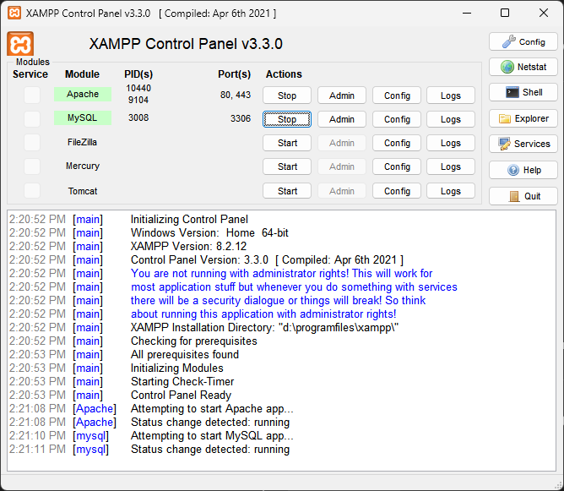

2.2 Verifying PHP Installation Using phpinfo()
To confirm that PHP was correctly installed, a file named info.php was created in the htdocs directory with the following content:
<?php phpinfo();
When accessed through http://localhost/info.php, the page displayed detailed PHP configuration information, confirming that the environment was functioning correctly.
Screenshot: phpinfo() output page.
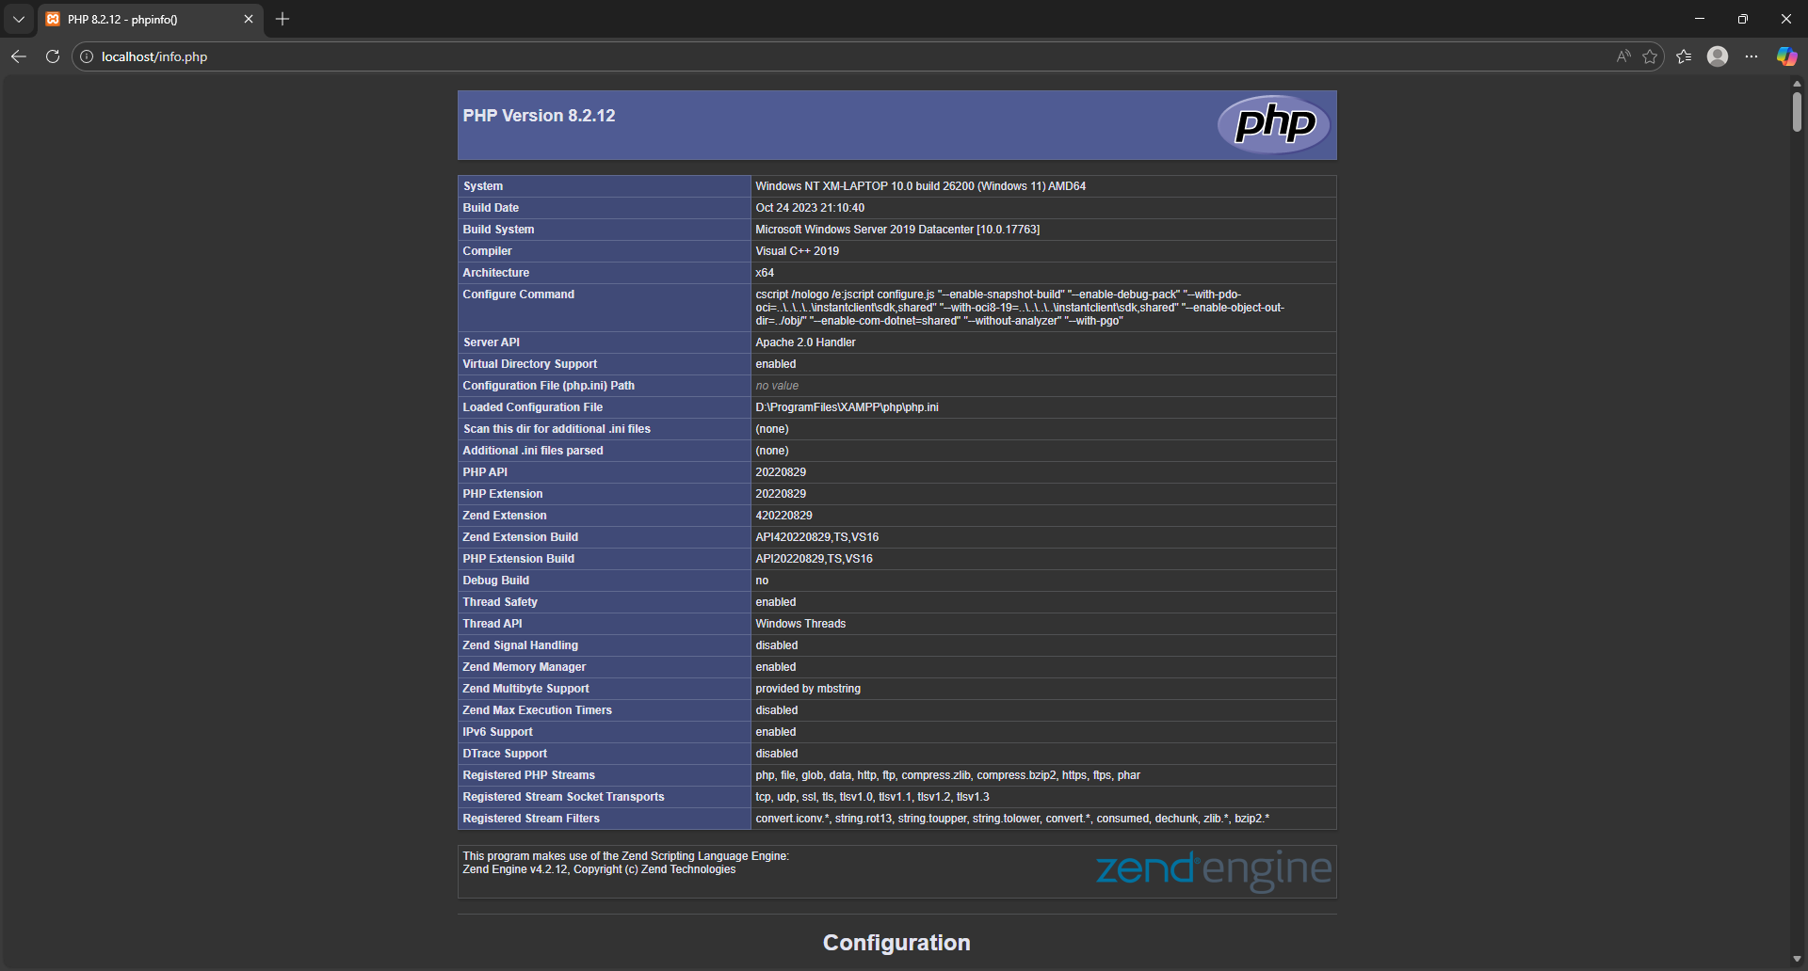

2.3 Understanding php.ini Configuration File
The file php.ini is the main configuration file for PHP. It controls how PHP behaves, including error reporting, memory usage, file uploads, and extensions. This configuration file is located in:
C:\xampp\php\php.ini
The following settings within php.ini are particularly important:

1. display_errors
This setting controls whether errors are shown directly in the browser.
It is useful during development because it helps developers quickly identify mistakes.

2. upload_max_filesize
This setting determines the maximum size of a file that can be uploaded via an HTML form.
It is relevant for any system that accepts file uploads.

3. memory_limit
This value restricts the amount of memory that a PHP script is allowed to use.
It prevents poorly written scripts from consuming excessive system resources.
These configurations are essential for managing development behavior, debugging, and script performance.

3.0 Database Creation and Configuration

3.1 Creating the Project Database
A MySQL database named inventory_db was created using phpMyAdmin.
This database stores all inventory records submitted through the PHP web application.
Screenshot: phpMyAdmin showing the creation of the inventory_db database.
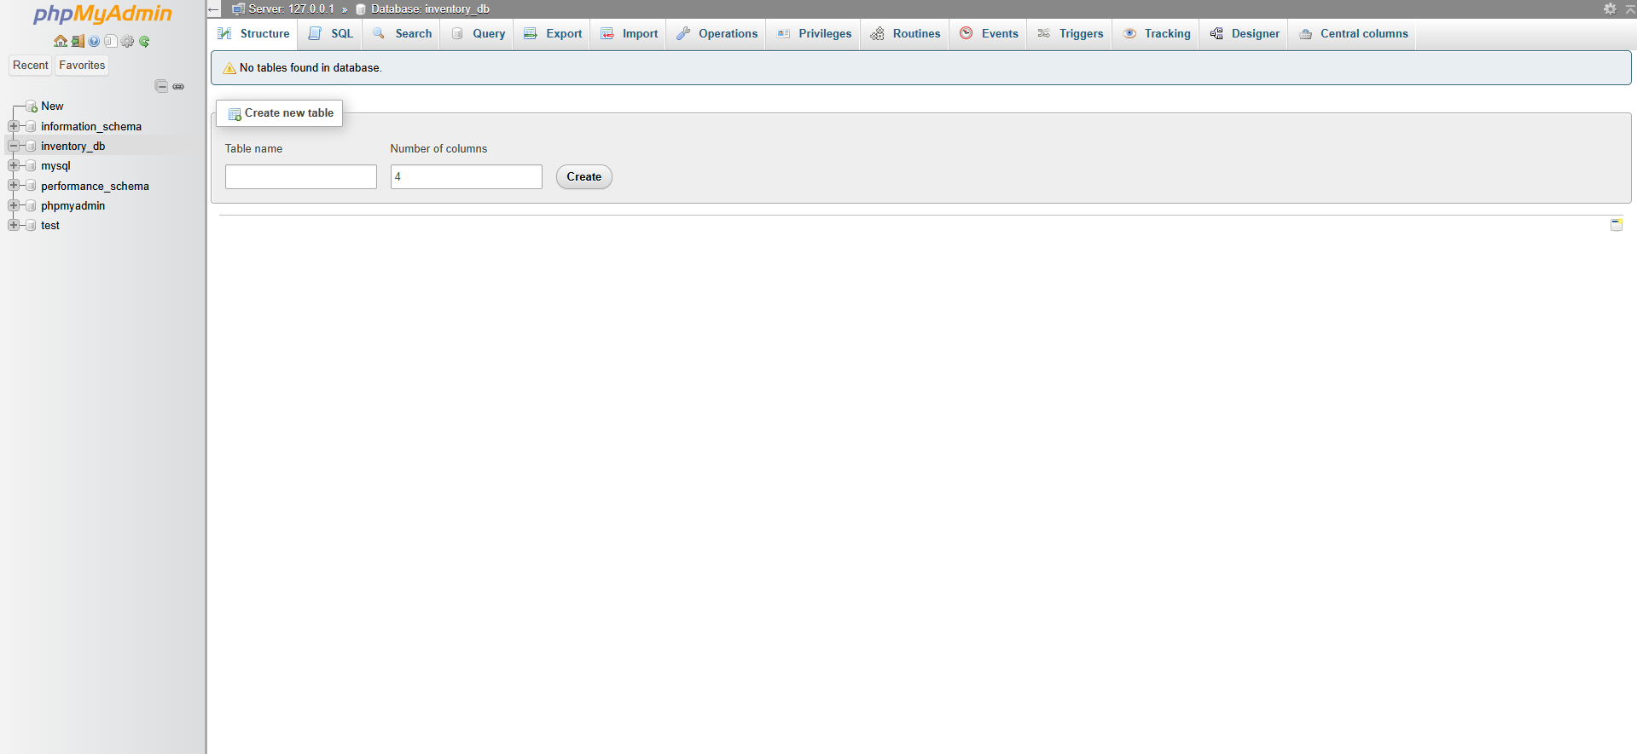

3.2 Designing the Items Table
The system requires a table to store the item name, quantity, price, category, and creation timestamp.
A table named items was created using the following SQL command:
CREATE TABLE items (
id INT AUTO_INCREMENT PRIMARY KEY,
item_name VARCHAR(100) NOT NULL,
quantity INT NOT NULL,
price DECIMAL(10,2) NOT NULL,
category VARCHAR(50),
created_at TIMESTAMP DEFAULT CURRENT_TIMESTAMP
);
This table forms the foundation of the Inventory Tracking System and supports all insert, update, delete, and retrieval operations.
Screenshot: Table structure in phpMyAdmin.
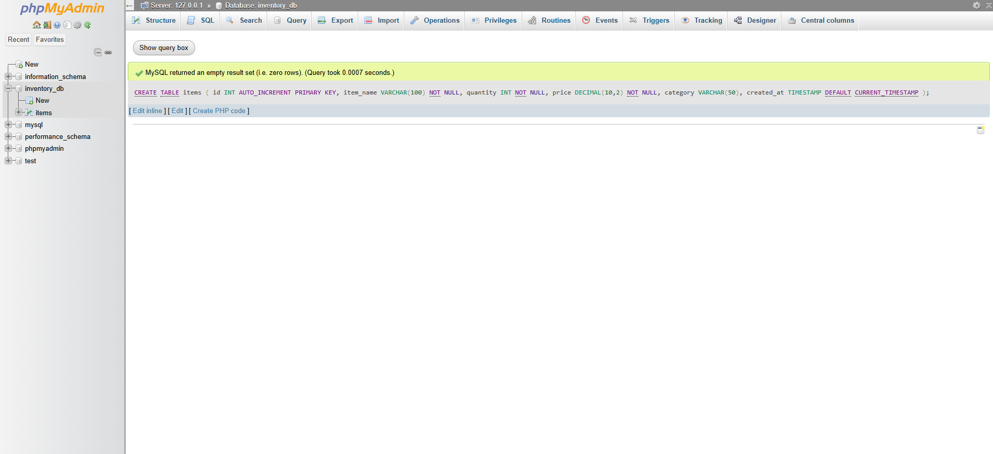

3.3 Sample Data Insertion (for Testing)
To test the database connection and listing page, a sample record was inserted:
INSERT INTO items (item_name, quantity, price, category)
VALUES ('USB Cable', 50, 9.90, 'Electronics');
This helps verify database connectivity before building the PHP application.
Screenshot: Table Browse view showing sample row.
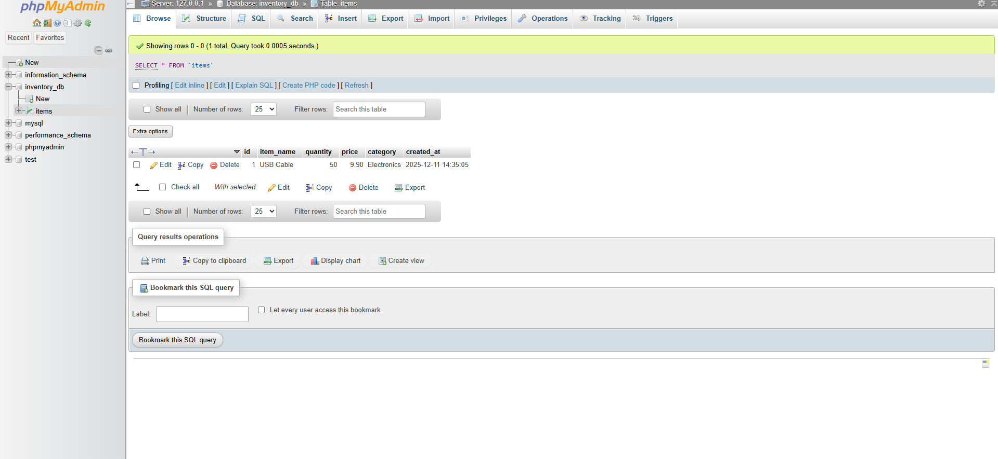

4.0 Web Application Development

4.1 Overview of the Mini Web Application
The Inventory Tracking System was implemented as a PHP based mini web application. It consists of a homepage, a form input page for adding new items, and a listing page that retrieves data from a MySQL database. Basic input validation and error handling are included to ensure that only valid data is stored.

4.2 Database Connection (db.php)
A reusable database connection script named db.php was created. This file uses the mysqli extension to connect to the inventory_db database on localhost with the default XAMPP credentials (user root, no password). If the connection fails, the script stops and displays an error message. This centralised file is included in all other PHP pages so that the database connection is consistent and easy to manage.

4.3 Homepage (index.php)
The homepage introduces the Inventory Tracking System and provides navigation links to the “Add New Item” page and the “View Items” page. Its purpose is to give users a starting point and explain the basic function of the system.
Screenshot: Homepage with navigation links.
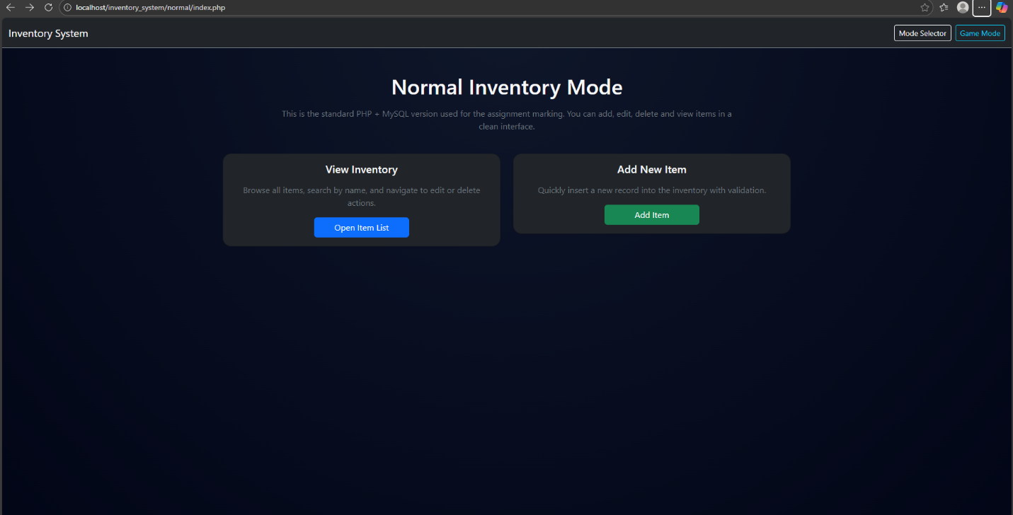

4.4 Add Item Page (add_item.php)
The add_item.php page serves two roles:
- Displaying the HTML form where users can enter item name, quantity, price, and category.
- Processing the submitted form using the POST method.
Server side validation is applied to each field:
- item_name must not be empty and must not exceed 100 characters.
- quantity must be present, must be an integer, and must be zero or greater.
- price must be present, must be numeric, and must be zero or greater.
- category is optional but limited to 50 characters.
If any rule is broken, user friendly error messages are displayed at the top of the page and the form values are preserved. When all validation passes, a prepared statement is used to insert the data into the items table. A success message is shown and the form fields are cleared.
Screenshot: Add Item form with error messages.
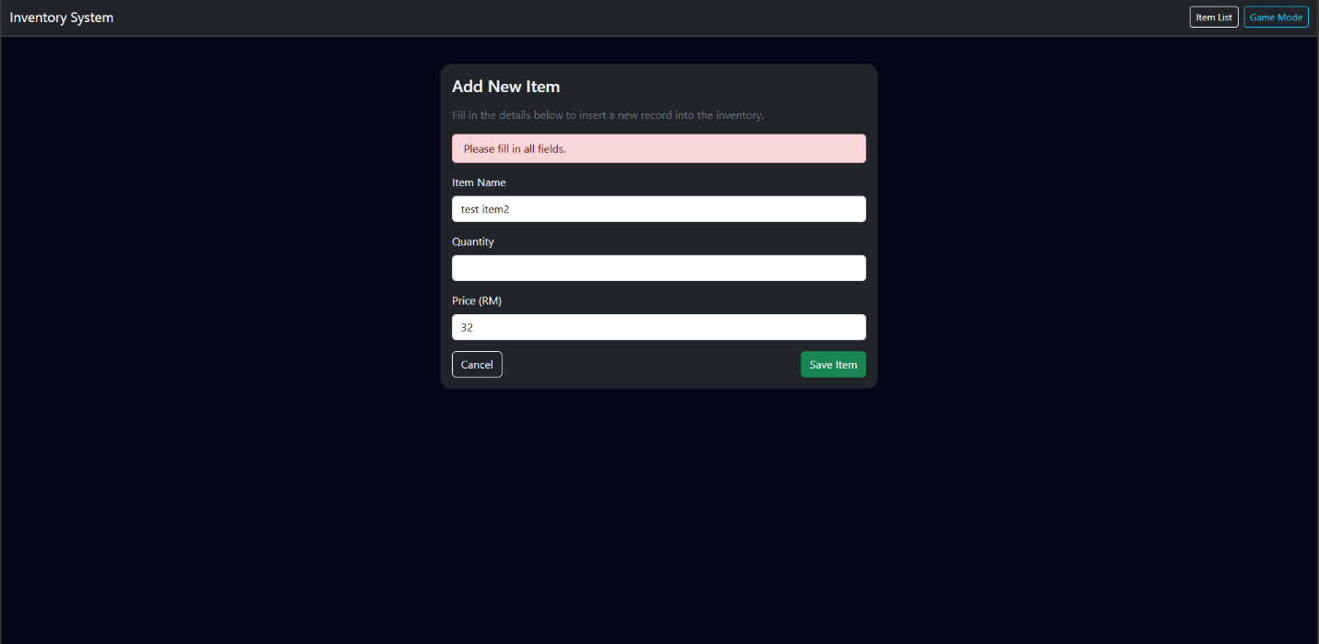
Screenshot: Successful item insertion message.
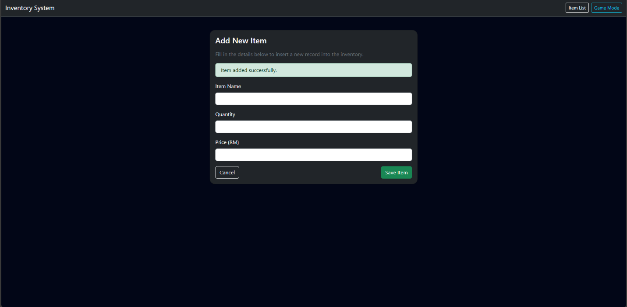

4.5 Inventory Listing Page (list_items.php)
The list_items.php page retrieves data from the items table and displays it in an HTML table. Each row shows the item ID, name, quantity, price, category, and creation timestamp. Records are ordered by created_at in descending order so that the most recent items appear first.
A simple search function is also included. Users can enter a keyword, and the system filters items by name using a LIKE query. Prepared statements are used to prevent SQL injection. If there are no records that match the search criteria, a message is displayed to inform the user.
Screenshot: Inventory list with data displayed in table form.
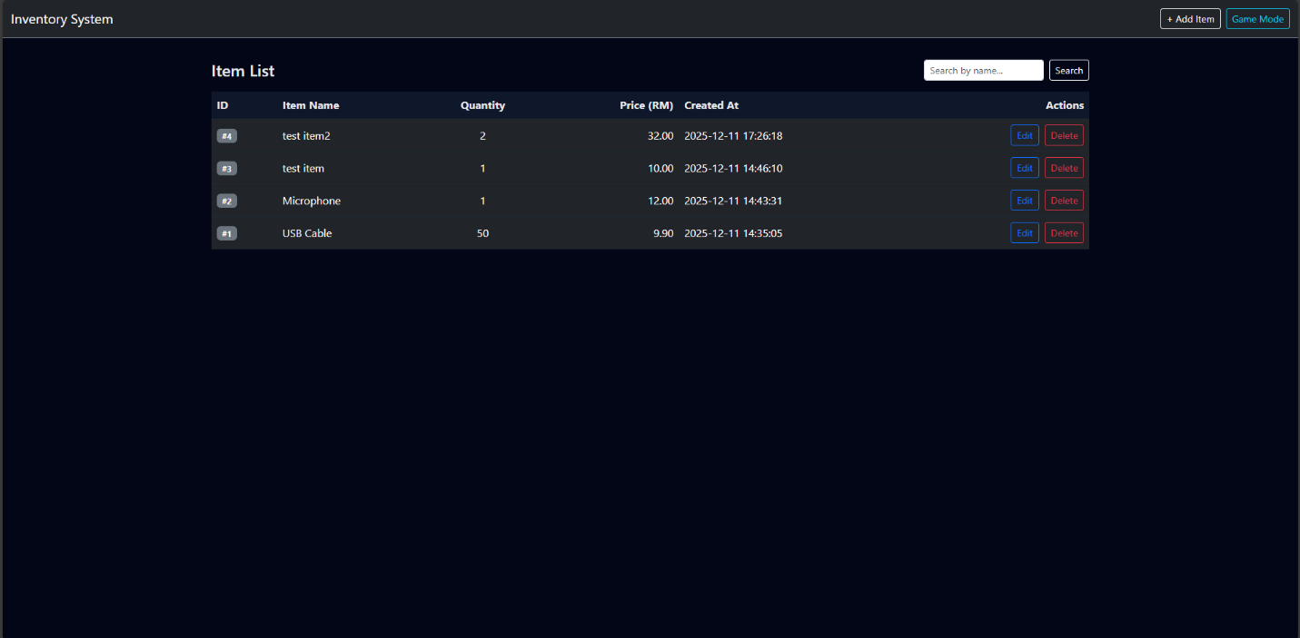
Screenshot: Search results for a specific item name.
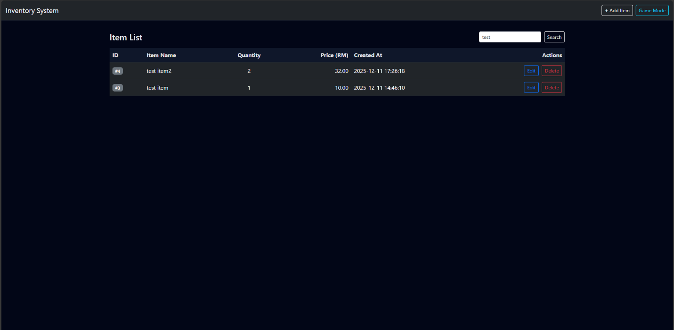

5.0 PHP Configuration and Testing (php.ini)

5.1 Initial Configuration Status
Before making any changes, the phpinfo() function was used to examine the current PHP configuration settings. On the phpinfo page, the values of display_errors and upload_max_filesize were observed and recorded as the default configuration.
Screenshot: phpinfo() before modification, showing display_errors and upload_max_filesize.
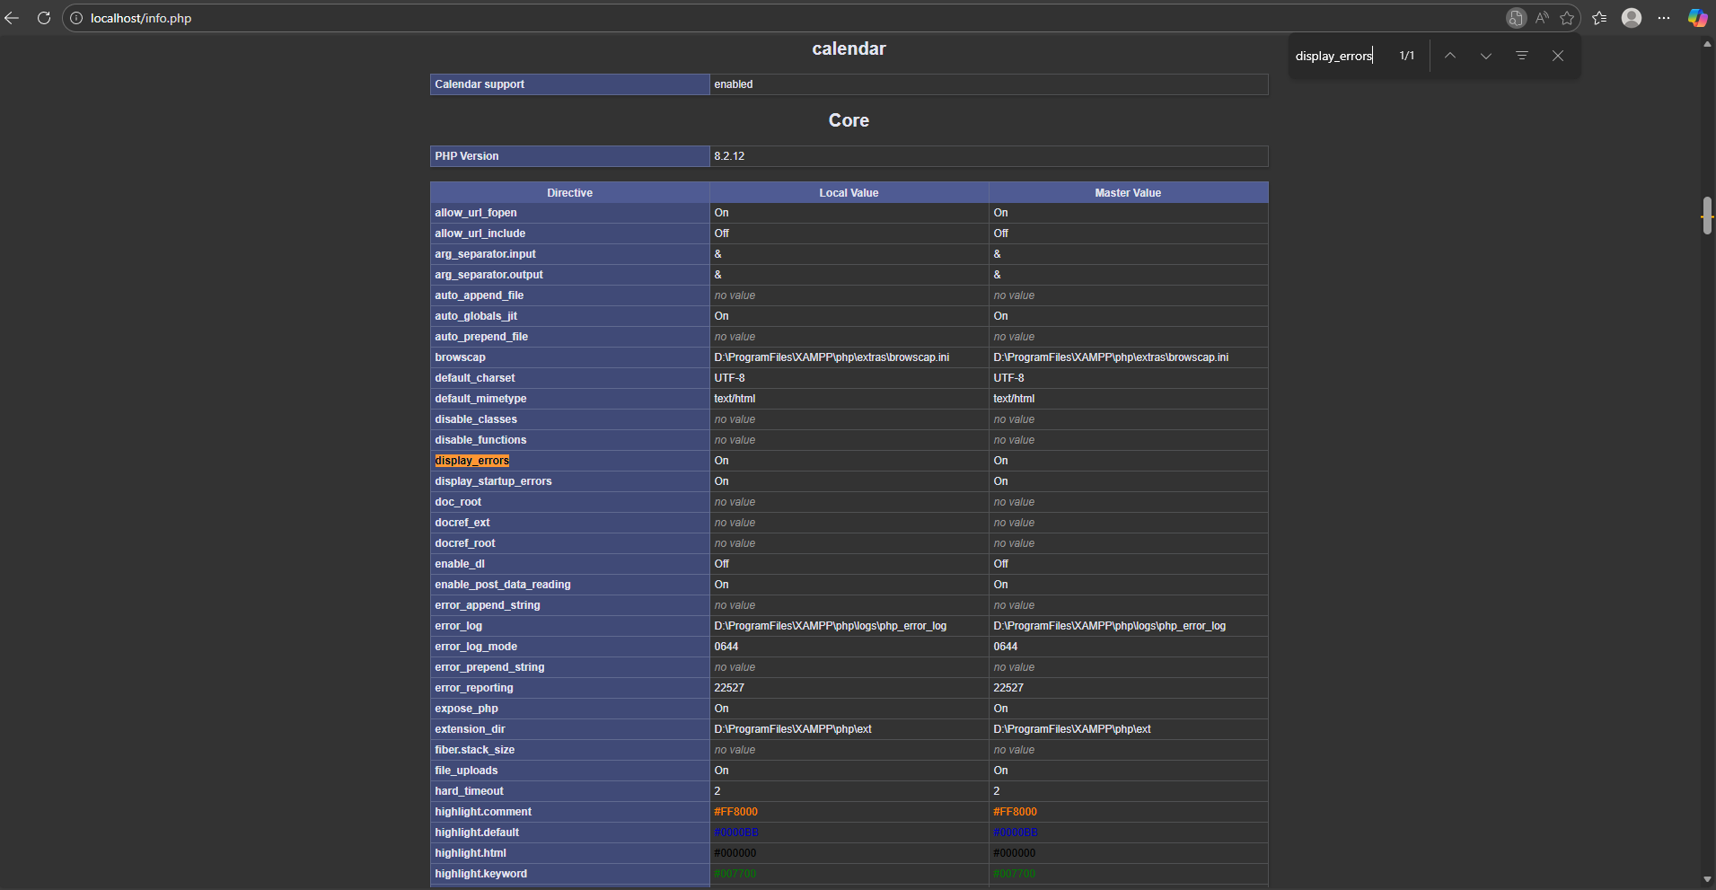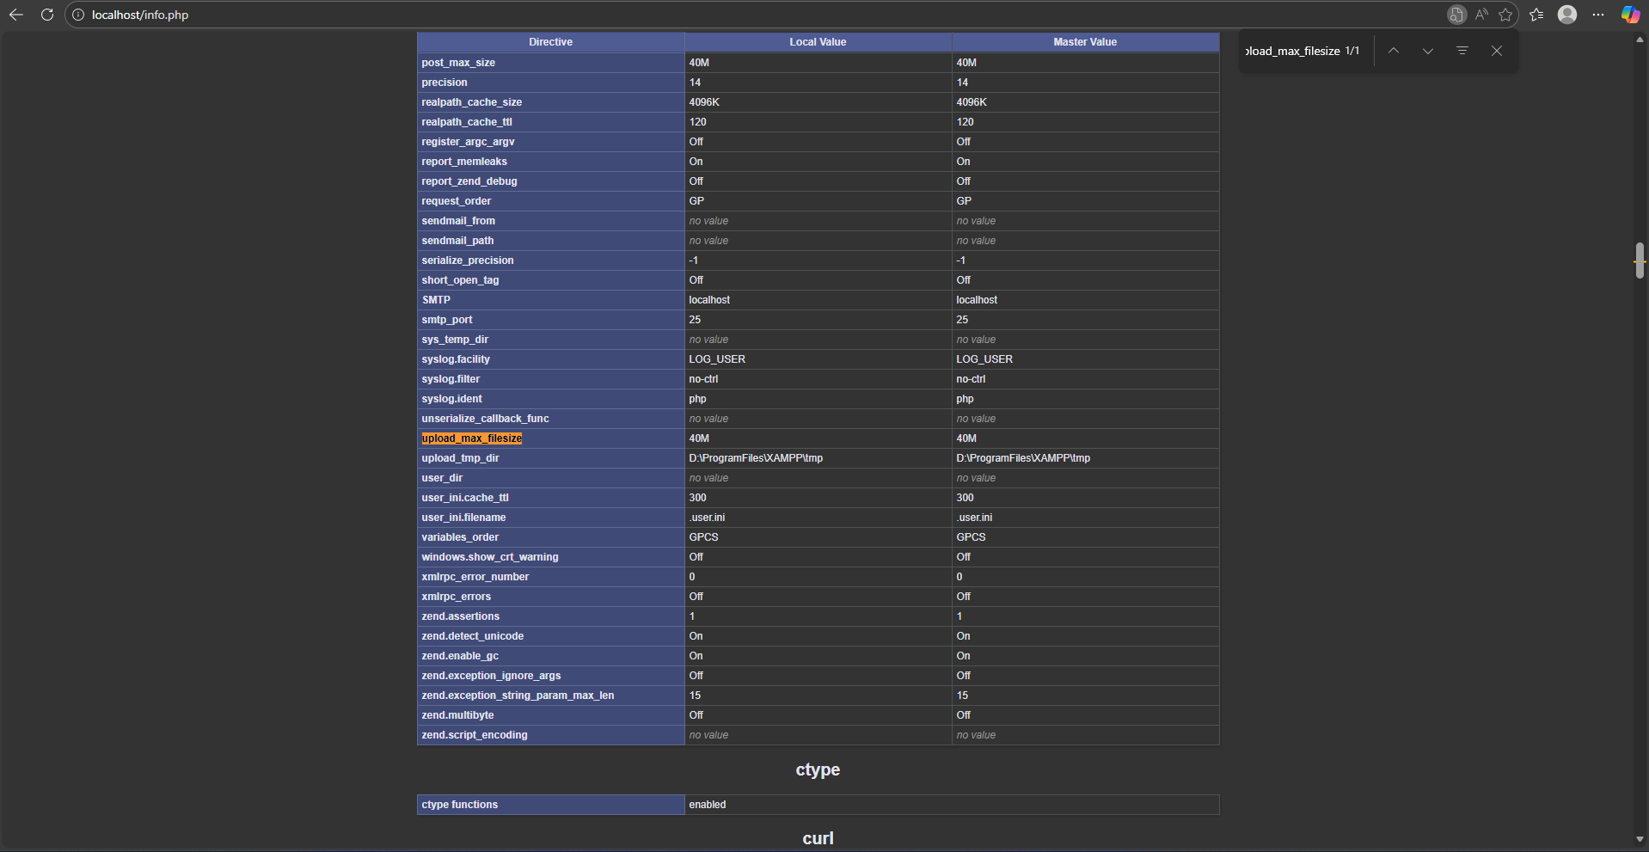

5.2 Modifying php.ini Settings
The main PHP configuration file, php.ini, was located using the path shown in phpinfo() under “Loaded Configuration File”. The file was opened and edited to adjust two important settings:
- display_errors
  - Original value: On
  - New value: Off
This change enables the display of error messages directly in the browser. It is particularly useful during development because it helps developers quickly identify syntax errors and runtime issues. However, this setting should be turned off in a production environment to avoid exposing sensitive information.
- upload_max_filesize
  - Original value: 40M
  - New value: 45M
This setting controls the maximum file size that can be uploaded through an HTML form. Increasing the value to 8M allows larger files to be uploaded if the application later requires file uploads.
After editing and saving php.ini, the Apache web server was restarted using the XAMPP Control Panel so that the new configuration values would take effect.

5.3 Verifying Configuration Changes with phpinfo()
To confirm that the new settings were applied correctly, the info.php page was loaded again in the browser. The phpinfo output was checked and both values had successfully changed:
- display_errors now showed Off.
- upload_max_filesize now showed 45M.
This verifies that php.ini was correctly modified and that the PHP environment is responding to configuration changes.
Screenshot: phpinfo() after modification, showing updated values for display_errors and upload_max_filesize.
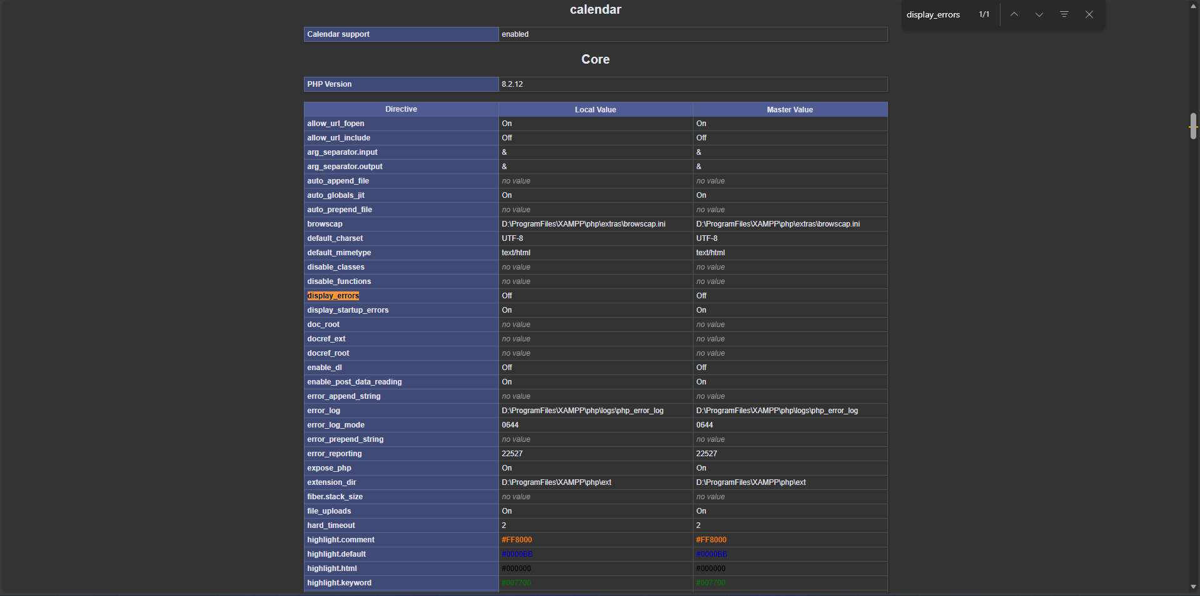
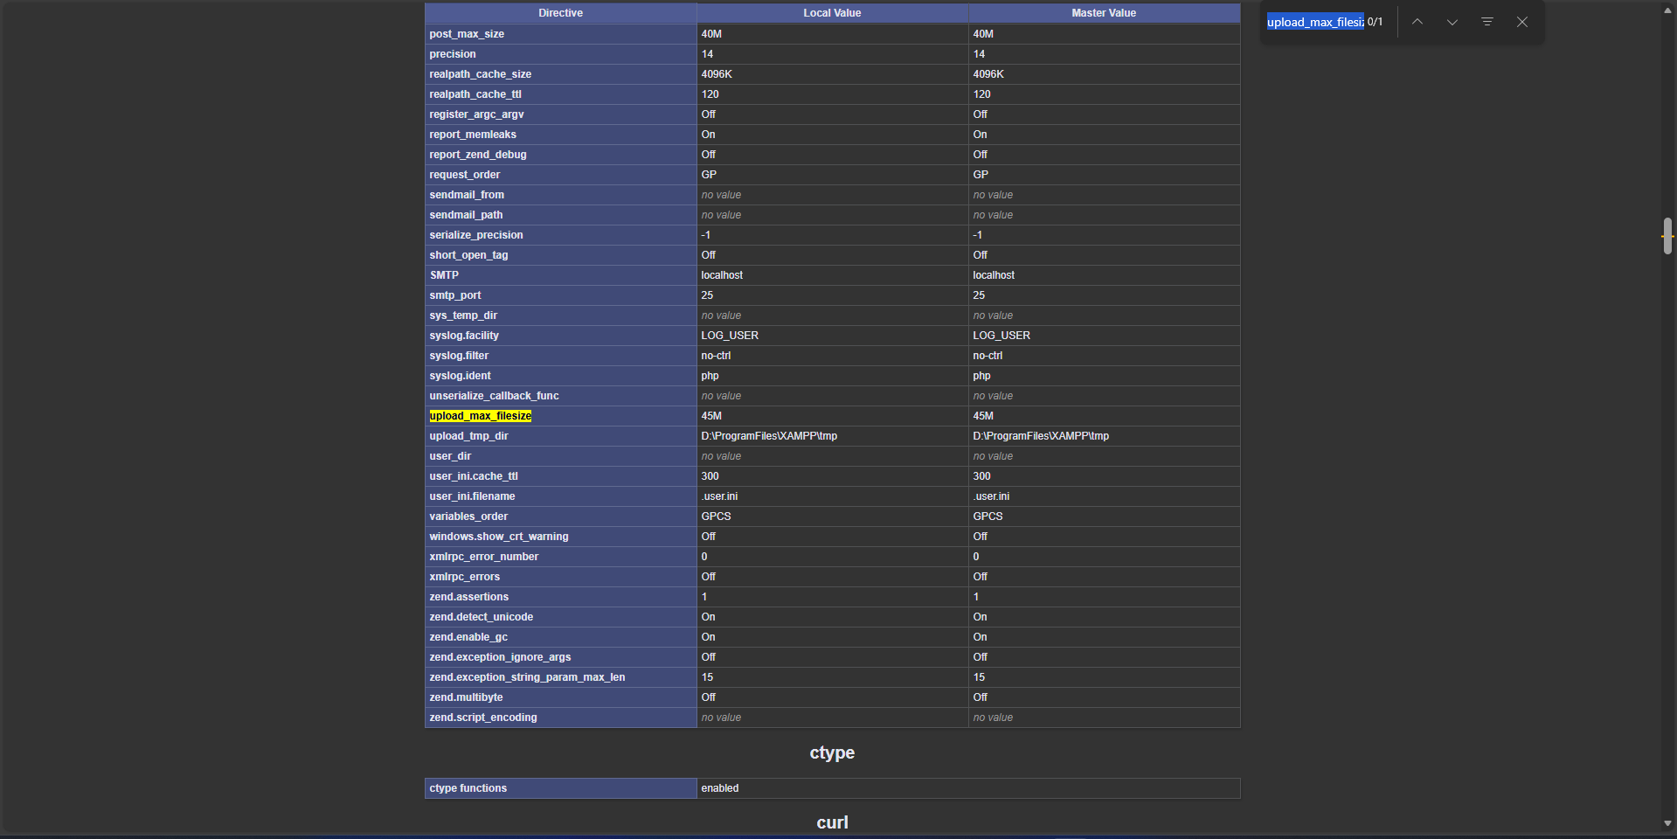

7.0 Short Answer Questions
Q1: What is the role of php.ini in PHP configuration?
php.ini is the main configuration file for PHP. It controls how PHP behaves on the server by defining settings such as error reporting, memory limits, file upload size, timeouts, and enabled extensions. When the web server starts, PHP reads php.ini and uses these settings to manage how scripts are executed and how resources are used.
Week 9-PHP_Environment_Configur…

Q2: Name two bundled packages used for PHP environment setup.
Two examples of bundled packages used to set up a PHP environment are:
- XAMPP – a package that includes Apache, MySQL, PHP, and phpMyAdmin in a single installer.
- WAMP – a Windows-based package that provides Apache, MySQL, and PHP together for local development.
Week 9-PHP_Environment_Configur…
(If you want a third name for speaking in presentation: MAMP for macOS.)

Q3: Why do we use phpinfo()?
The phpinfo() function is used to display detailed information about the current PHP configuration. It shows settings from php.ini, loaded extensions, environment variables, and server information. Developers use phpinfo() to verify that PHP is installed correctly, to confirm configuration changes (such as updates in php.ini), and to troubleshoot environment issues.

5.6 Additional Features: Edit and Delete Functions
To enhance the usability of the Inventory Tracking System, two additional functions were implemented: edit and delete.
- The Edit function is provided through the edit_item.php page. When a user clicks the “Edit” link in the inventory list, the system loads the selected record from the items table and displays it in a form. The user can modify the item name, quantity, price, or category. The same validation rules as the “Add Item” page are applied, and a prepared UPDATE statement is used to save the changes back to the database.
- The Delete function is implemented in the delete_item.php script. From the listing page, the user can click the “Delete” link for a specific item. A confirmation message is shown in the browser before the deletion is processed. If confirmed, a prepared DELETE statement removes the corresponding row from the items table and the user is redirected back to the item list.
These additional functions make the system behave more like a real inventory application and demonstrate CRUD (Create, Read, Update, Delete) operations using PHP and MySQL.
Screenshot: Inventory list showing Edit and Delete links.
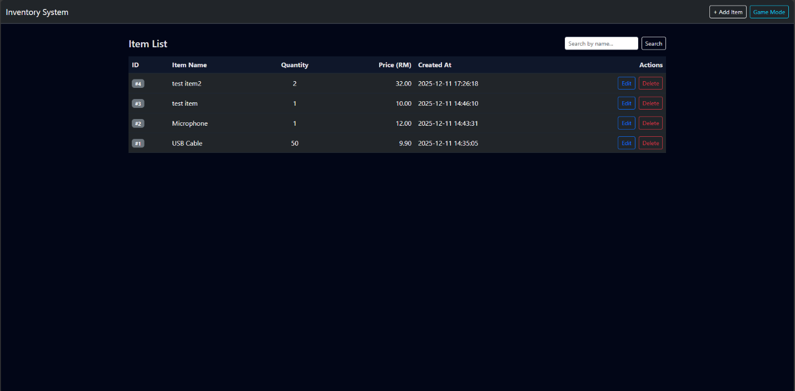
Screenshot: Edit Item page.

