# Code Kiwi

I selected **Scenario B**, which is an authentic project. The Code Kiwi app will serve as an event management, information hub, and membership management system.

The project was proposed and approved by my tutor, Asra.

## Story Brief

The Code Kiwi Club Management System is a software solution designed to streamline and enhance the management of coding club activities. It allows administrators to present upcoming events and for students to see them and those delivering and involved in them.

The application allows students to learn about the coding courses, their teachers, and fellow students. Its purpose is also to allow potential members to join by submitting their details through an online form received by a Postgres DB. The Postgres DB also returns data of other student club members (their name and email address) along with contact details of the tutors (name and email).

# Part 1: Planning and Web Application

Code Kiwi Club Management & Member Engagement App

## Epic

The "Club Management & Member Engagement" epic aims to create a unified system for the Code Kiwi Club, streamlining club activities and enhancing member engagement. This epic includes the following major features:

**Event Management System:** Administrators can schedule and manage club events, while students can access event details and participants.

**Information Hub:** Students can explore coding course instructor profiles and connect with fellow members.

**Membership Portal:** Prospective members can join through an online form, and their data is securely stored in a PostgreSQL database.

**Member Directory:** A directory of member names and email addresses fosters community building.

**Tutor Contacts:** Tutor and instructor contact details are stored for easy communication.

**Benefits:**

* Enhanced engagement and community building.
* Streamlined administration and efficient event management.
* Improved student networking and communication with tutors.
* Data-driven decisions for club activities.

## User Stories: Students and Staff

The app will serve as an event management, information hub, and membership management system.

As an administrator, I want to create and schedule events on a Django app so staff and students can see event names, dates, times, and locations.

As a student, I want to view upcoming events so that I can see the event details and the individuals involved.

As a student, I want to view instructors' profiles so that I can learn more about their expertise and teaching style.

As a student, I want to connect with the club through a CTA so that I can connect with other students.

As a prospective member, I want to join the club by filling out an online membership form providing my personal information and preferences so that I can become a member.

As a club administrator, I want to receive and manage membership applications submitted online so that I can manage all club members.

As a club member, I want to access a member directory through a Postgres DB that includes current club members' names and email addresses so that I can see all members.

As a student, I want to find the contact details of my course instructors, including their names and email addresses so that I can see if my friends are members.

## Project Delivery

The Code Kiwi Club management system project was completed through a well-structured plan. The project was divided into stages encompassing requirements analysis, design, development, testing, and deployment. Key roles were assigned as follows:

## Role and Plan

**Week 1-9**

**Project Manager:** Oversaw project coordination, scheduling, and milestone tracking. This was a critical role that could prove very demanding.

**Week 3**

**Business Analyst:** Gathered user requirements, crafted user stories, and aligned user needs and system features. This was imperative to building an app the client wanted and was a valuable learning experience.

**Week 4**

**UI/UX Designer:** Created an intuitive and accessible user interface design. It was a challenging but creatively rewarding side of the experience.

**Week 5-6**

**Front-end Developer:** Translated the UI design into a responsive and accessible interface. This did not present too many hurdles.

**Week 7-9**

**Back-end Developer:** Developed the core functionalities, including membership, event scheduling, and resource management. This was an area which presented the greatest challenge in the building stage.

**Week 7-9**

**Database Administrator:** Designed and managed the Postgres database for storing relevant data.

**Week 8-9**

**QA Tester:** Conducted rigorous testing across functionalities to ensure functionality, performance, security, and compatibility. Again, it is easy to overlook that this role is important to the project. I believe I did my test to test the app.

## Project Execution and Deviations

The project closely followed the planned timeline but encountered minor deviations:

**Technical Challenges:** Integrating user authentication with the existing website posed unexpected complexities, causing a slight development delay.

**Data Privacy Concerns:** Privacy concerns arose during testing, leading to enhanced security measures, including data encryption and access controls.

**Mitigation Strategies:**

The team addressed these deviations effectively:

**Technical Expert Consultation:** Expert guidance was sought from online resources to assist in the project delivery.

**Privacy Compliance:** Tests were taken to ensure the website met strict privacy requirements.

## Project Outcome

Despite deviations, the "Code Kiwi Club Management System" project was completed. It met functional and non-functional requirements, providing an efficient platform for club management. With careful planning, adjustments, and mitigation, the project will be of value to both staff and students.

# Part 2: Build Web Application

## Short Summary of the Code Push to GitHub

I: The app was successfully pushed to GitHub using the GitHub Desktop tool. I had previously practised using the Visual Studio Code IDE for pushing files and pulling files from my GitHub repository. However, I was eager to learn the Desktop tool to achieve the task. I am glad I have become proficient at using GUI and CLI tools. The upload happened without any errors.

II: There were no real errors encountered. I researched what to do in such hypothetical situations using Stack Overflow and Google. I also found that adjustments to code could be done within GitHub itself, which was very convenient. During the testing of the app, I used the debugging tools and the stop and breakpoint tools to test my code incrementally.

III: To enhance the user experience of the Code Kiwi Club Management System, I would consider implementing intuitive navigation, personalized dashboards, event reminders, course recommendations, interactive instructor profiles, discussion forums, membership application tracking, robust search and filters, mobile responsiveness, feedback mechanisms, onboarding tutorials, and strong data security. These improvements would provide an engaging, user-friendly, and personalized environment for administrators, students, and prospective members, fostering a strong sense of community and facilitating seamless access to club activities, courses, and member interactions.

# Part 3: Testing

Testing of the app was important. The form was an important test area as this was critical for gathering input from the user, which would then be sent to the DB. Python's Test Case was used to perform the tests, and the results confirm that the app and its connection with the DB were performing as desired. The tests were conducted within the VSC IDE through the terminal using the command: **"python manage.py test hello"**.

These tests provided peace of mind to the client (the Code Club) and the service it gives principally to its young student learners. Getting this functionality and performance spot on was imperative, as taking, storing, and representing data are the fundamental purposes of the app. Therefore, a form that worked was critical.

All tests returned positive results. Further tests would be beneficial in reassuring the client that the app is reliable enough to meet both the needs of themselves and their students. For me, achieving a complete successful return rate on these tests was critical as the form was the key requirement of the app. The good results greatly satisfied me.

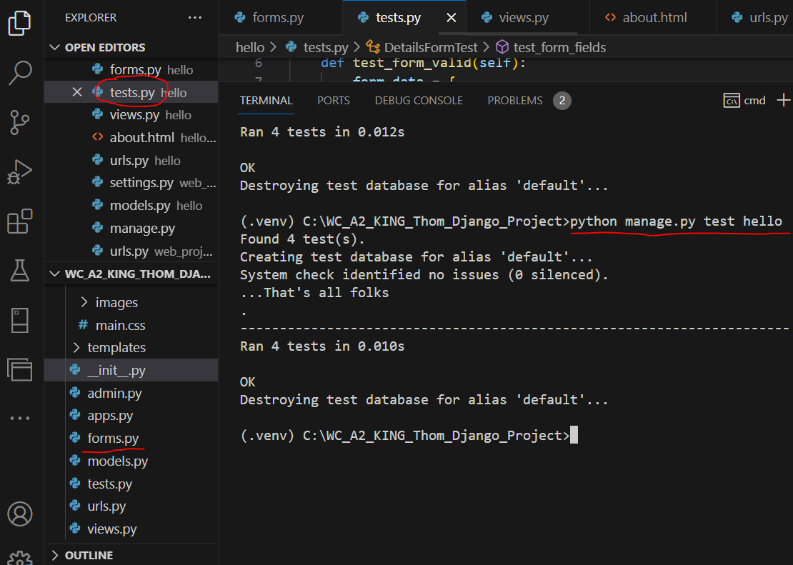

The models.py file was also rigorously tested, as this was crucial to managing and moving data in the app. Test results for this file were also excellent.

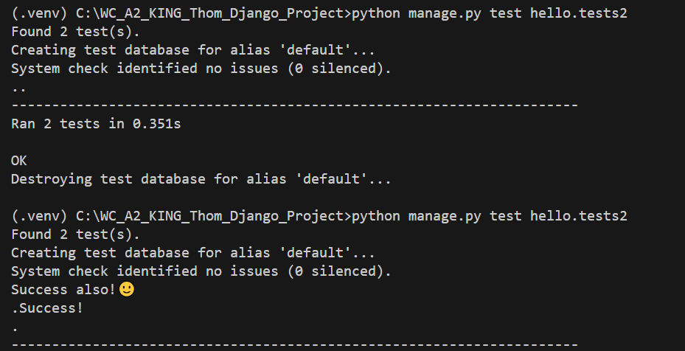

These tests have supported the faith in a product which should greatly satisfy the client's and their users' needs.

# Part 4: Reflection

While developing the Code Kiwi Django app, I experienced successes and challenges that enriched my learning journey. One notable success was the seamless integration of user sign-up functionality, which streamlined the process of joining the code club. This achievement resulted from careful planning and adherence to best practices, greatly enhancing the user experience.

However, a significant challenge emerged when handling data migrations. Adapting the database schema to evolving model changes proved to be more complex than expected. To address this challenge, I leaned on the comprehensive documentation provided by Django, engaged with the developer community, and implemented a step-by-step approach to database migrations. This experience taught me the importance of thorough version control and disciplined database management.

In retrospect, the project reinforced the significance of planning, adherence to best practices, and the value of a supportive developer community when facing unexpected challenges. The Code Kiwi project has been rewarding, emphasizing the importance of both successful accomplishments and the valuable lessons learned from overcoming obstacles.