Title

Your research questions
I would formulate them around three questions.

RQ1
How do different class-imbalance handling techniques affect the predictive performance of machine-learning models for credit-card fraud detection?
This establishes the ML side.

RQ2
How do different class-imbalance handling techniques affect the stability of XAI-based feature explanations?
This is your main research question.

RQ3
Is there a relationship between predictive performance and explanation stability under different class-imbalance strategies?
This gives the project a deeper analysis.
Contribution:
17. Your research questions
I would formulate them around three questions.
RQ1
How do different class-imbalance handling techniques affect the predictive performance of machine-learning models for credit-card fraud detection?
This establishes the ML side.
RQ2
How do different class-imbalance handling techniques affect the stability of XAI-based feature explanations?
This is your main research question.
RQ3
Is there a relationship between predictive performance and explanation stability under different class-imbalance strategies?
This gives the project a deeper analysis.

Implementation:

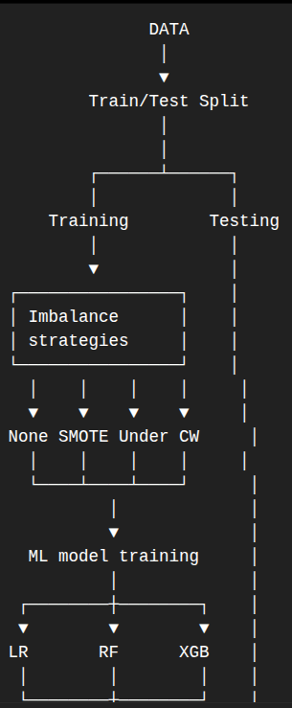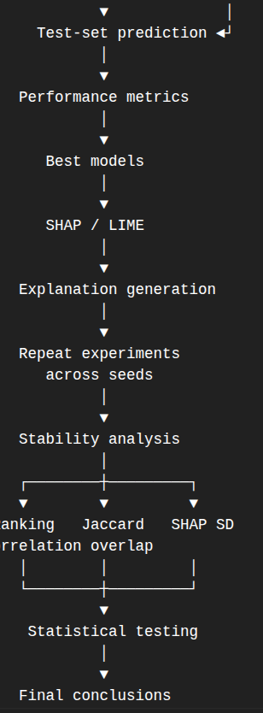
Context-Aware Machine Learning for Student Academic Performance Prediction: An Empirical Evaluation of Academic, Behavioral and Socioeconomic Features

