Axioms of Probablity

Ω = {1, 2, 4 6}
Axiom 1: Non-negativity P(A)≥0
Axiom 2: Normalization P(Ω)=1
Axiom 3: P(A U B) = P(A) + P(B)
if A and B are disjoint, or mutualy exclusive
then P(A n B) = 0

Probablity Rules:
- Addition rule: P(A or B) = P(A u B) = P(A) + P(B) - P(A n B)
if A and B are mutually execlusive( if they dont occure at the same time) then P(A n B) = 0
example: Probablity of geting Head or Tail on a single coin toss
Example 1: what is the Getting Head or tail on first trial
P(H or T) = P(H u T) = p(H) + P(T) - P(H n T) but p(H n T) = 0
1/2 + 1/2 = 1

Example 2: Simple Example:
Let’s say:

Event A = “person likes tea”
Event B = “person likes coffee”

Suppose:

P(A)=0.6 (60% like tea)

P(B)=0.5 (50% like coffee)

P(A∩B)=0.3 (30% like both)

Using the formula:
P(A∪B)=P(A)+P(B)−P(A∩B) =0.6+0.5−0.3=0.8
Simple Example:

- multiplication rule (product rule) or Joint probablity
P(A and B) = P(A n B) = P(A/B) P(B)
P(B/A)P(A)
p(A n B n C) = p(A) P(B/A) P(C/BnA)
if A is independent of B (if the outcome of A does not depend on B) then
P(A|B) = P(A)
- Conditional Probablity = P(A|B) = P(A n B) / P(B)
- Bays theorm P(A|B) = P(B|A) P(A) / P(B)
P (A n B) = P(B|A) P(A)
replace P(B|A) P(A) in place of P(A n B) on the conditional probablity

Question:
Probablity of geting 2 heads in 3 consecative COIN tosses
H | H | H
H | H | T
H | T | H
H | T | T
T | H | H
T | H | T
T | T | H
T | T | T
HHH, HHT, HTH, HTT, THH, THT, TTH, TTT 4/8

this is like joint porbablity(multiplication rule)
P(A n B) = P(A/B) P(B) But since the outcome of the first doesnot depend on the second one
we can say P(A n B) = P(A) P(B)

- If I have a box that contains 6 balls where 2 are black and 4 are white, what is the probability of getting a white ball on the second draw without replacement?

Black and White  P(b) P(W/B) | 2/6 x 4/5 = 8/30 | 20/30 = 2/3
or | + | 20/30 = 2/3
white and WHITE | 4/6 x 3/5 = 12/30 | 20/30 = 2/3
Total Probablity
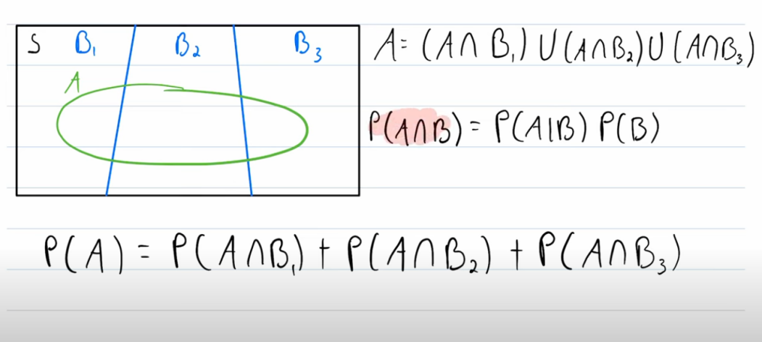
suppose B1= Brazil, B2 = Bolivia, and B3 = Bangladesh are countries..
Fb ( the green one) = who can play footbal

supose
10% of Brazil, = p(fb | brazil)
5% percent of bolivia, p(fb | bolivia)
7% Bangladesh. p(fb | bangladesh)

what is the probablity that a randomly selected person from those 3 countries can play football. ( Assuming a Country can be selected equally likely)

p(fb) = p(fb n Brazil) + p(fb n bolivia) + p(fb n bangladesh)
but according to multiplication rule
p(fb n Brazil) = p(fb | Brazil) p(Brazil)
but p(Brazil) = p(bangladesh) = p(bangladesh) = 1/ 3
P(B/A)P(A) = 0.1 .X 0.33
+
:-

1.the Law of total probablity
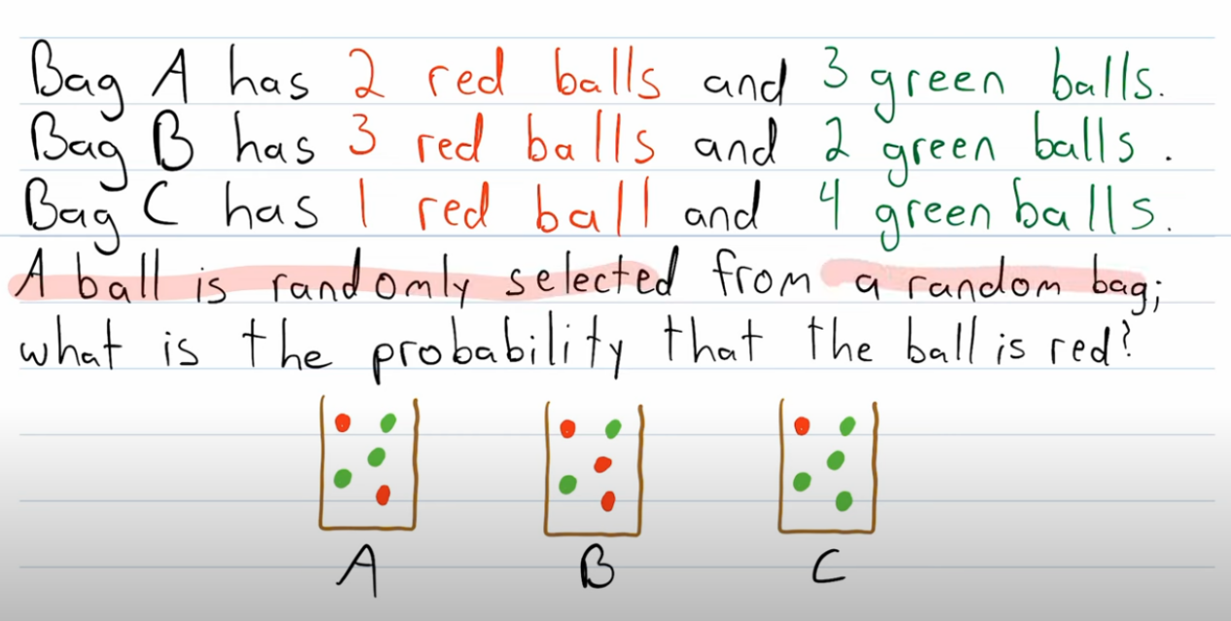
--
RED
Bag A
Bag B
Bag C

P(red) = P(Bag A n Red) + P(Bag B n Red) + P(Bag C n Red)
= P(BagA).P(RED| Bag A) + P(Bag B).P(RED| Bag B) + P(BagA).P(RED| Bag B)
= (1/3 X 2/5) + (1/3 X 3/5) + (1/3 X 1/5)
=

- The law of total probality
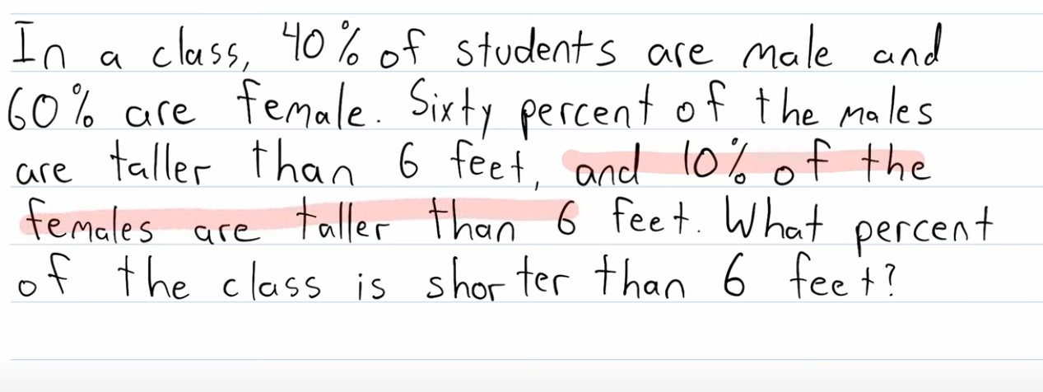
Male: 40%
Female: 60%
6 feet taller
: 60%
6 feet taller
: 10%
P(taller than 6ft) = P(6ft_taller n male) + P(6ft_taller n female)
P(6ft_taller n male) = P(6ft_taller | male) P(male)
P(6ft_taller n female) = P(6ft_taller | female) P(female)
= 0.4 x 0.6 + 0.6 x 0.1
= 0.7
p(shorter than 6 feet) = 1 - p (taller than 6ft)
= 1 - 0.7 = 0.3 = 30%

- Bayes thorem

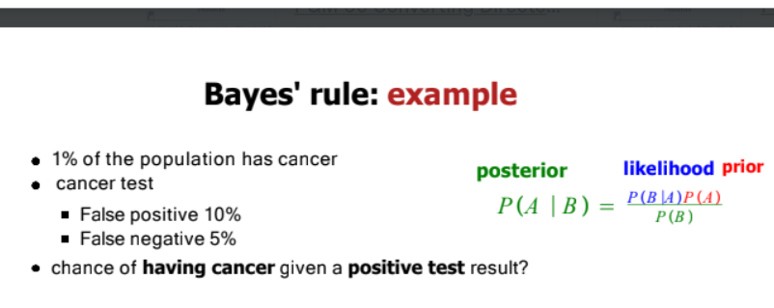
Bays theorm P(A|B) = P(B|A) P(A) / P(B)
P(D) = 1% = 0.01
P(D^{C}) = 0.999
P(+/D^{c}) = 10% = 0.1 --- P(-/D^{c) = 90%}
P(-/D) = 5% = 0.05 ---
P(D/+) = ? P(+|D)P(D) /P(+)
D | - 5%
D | + 95%
D_{C} | + 10%
D_{C} | - 90%

P(D/+) = P(+| D)P(D) /P(+)
BUT P(+|D) = 100% - 5% =95%
P(+) = P(+ n D) + P(+ n D^{c})
= P(+| D)P(D) + P(+| D^{c})P(Dc)
= 0.95 x 0.01 + 0.1 x (1 - 0.01)
= 0.0095 + 0.099
= 0.1085
P(D/+) = 0.0095/0.1085
=

- Bays theorem Question:
A screening test has been developed for a very rare form of cancer.
Given the following information:
- The prevalence of the cancer in the general population is 0.1%. P(D) = 0.1%
- The test is 99% accurate at detecting the cancer when it is present. (I.e., p(+ | D) (the probability of a positive test result given a person has the disease is 0.99).
- The probability of a false positive is 1%. (I.e., the probability of a positive test result given a person does not have the disease is 0.01). P( + | D^{c})
Question:
A person is randomly selected from the population and receives a positive test result. What is the probability that this person actually has the cancer?
P(D | +)
Event / Definition | Probability  (Prior / Likelihood) | Value
D – Has the Disease (Cancer) | P(D) | 0.001 (0.1%)
Dᶜ – Does Not Have the Disease | P(Dc) | 0.999 (99.9%)
+ – Positive Test Result (given disease) | P(+ | D) | 0.99 (99%)
+ – Positive Test Result (given no disease) | P( + |Dc) | 0.01 (1%)
Goal: Probability of Disease given Positive Test | P(D | +) | ?

$P(D | +)=\frac{P(+ | D) P(D)}{P(+)}$
but P(+) is not given so we have to compute P(+) using total probablity
P(+) = P(+)=P(+∣D)P(D)+P(+∣D^{c})P(D^{c})

Disease: 0.1%
noDisease D^{c}: 99.9%
+ve result: 99%
+ve result: : 10%

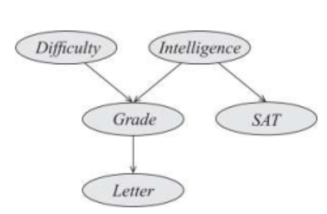
Factorize this Baysian Network
FACTORIZE MARCOVE NETWORK
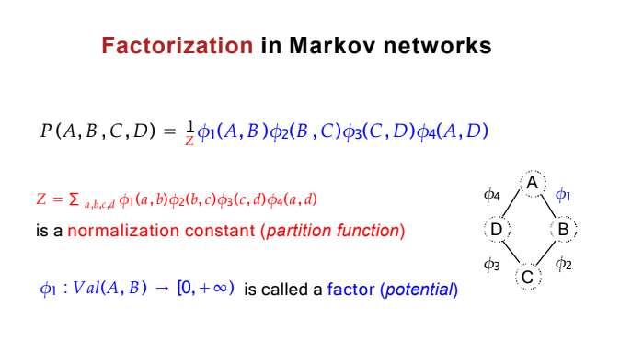

Chordal graph:
D
I
G
L
S
L
graph is chordal (or "perfect") if every cycle of four or more vertices has a chord, which is an edge that is not part of the cycle but connects two vertices in the cycle.
The cycle is: A - B - C - D - E - F
The Chord is: F - D

I-map

Structure | When BLOCKED? | Example
CHAIN | Condition on middle | X → A → Y + A = BLOCKED
FORK | Condition on middle | X ← A → Y + A = BLOCKED
COLLIDER | DON'T condition on middle | X → A ← Y + no A = BLOCKED

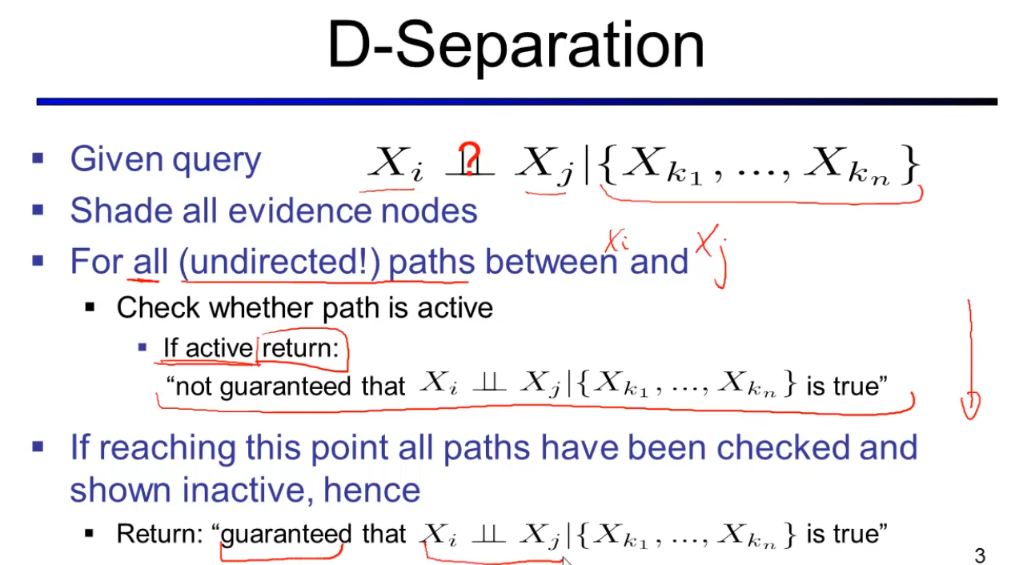
D ⊥ I = True  D ⊥ I | S = TRUE  D ⊥ I | G = False  special case  D ⊥ I | L  False (Special case)  collider G will be opend up because of L | 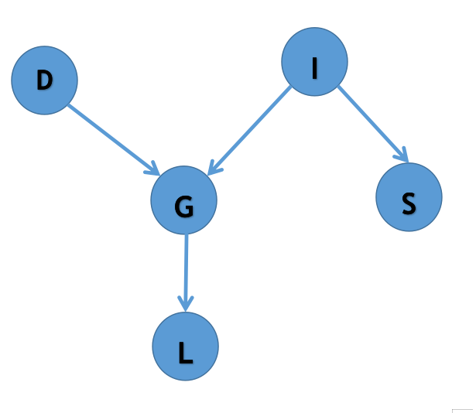
V ⊥ Z  V ⊥ Z | T  U ⊥ V  U ⊥ V | W  U ⊥ V | X  U ⊥ V | Z  W ⊥ X  X ⊥ T | V  Y ⊥ Z  Y ⊥ Z | T  Y ⊥ Z | X  Y ⊥ Z | V  W ⊥ Z | V | 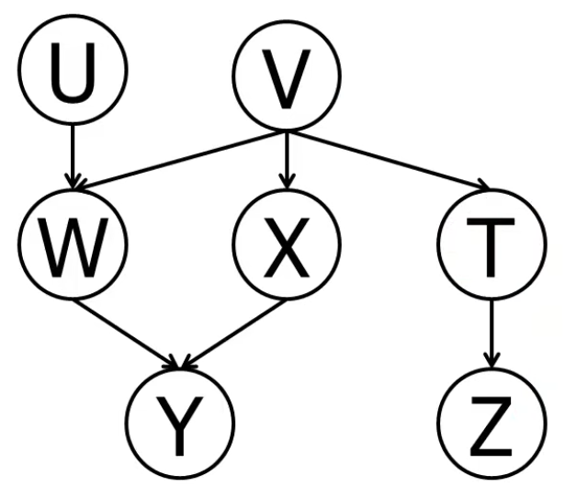

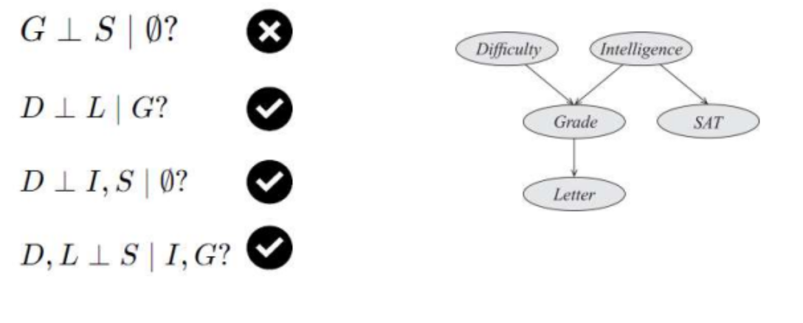
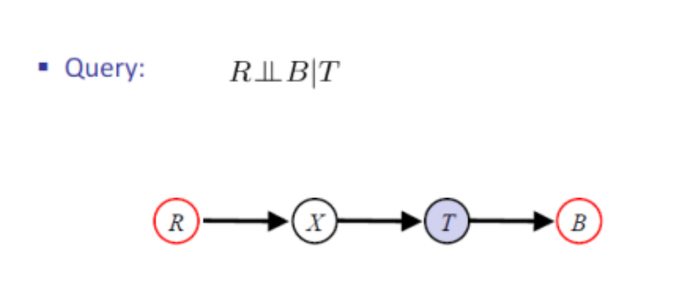
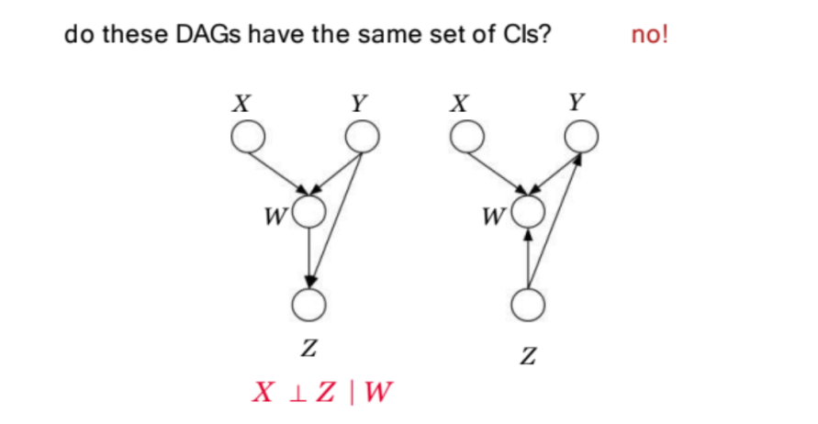

Convert Baysian Nw to Marcove Network
- BN to MN
- Two step process: called Moralization, the resulting graph is called
Moral graph.
Moralize: .
reform the character and conduct of.
Step 1: Marry Parents.
Step 2: Drop Directions.

- MN to BN

