***Time series – Assignment***

***Author: 20122011_Thomaskutty Reji***

***Question 1***

***Consider the time series model***

$$y_{t}=150-0.5y_{\left(t-1\right)}+ε_{t}$$

1. ***Is this a stationary time series process?***

This process is stationary because AR process of order 1. From the following plots we can see that the series is distributed randomly with mean 100. (easily noticeable from the QQ plot as well)

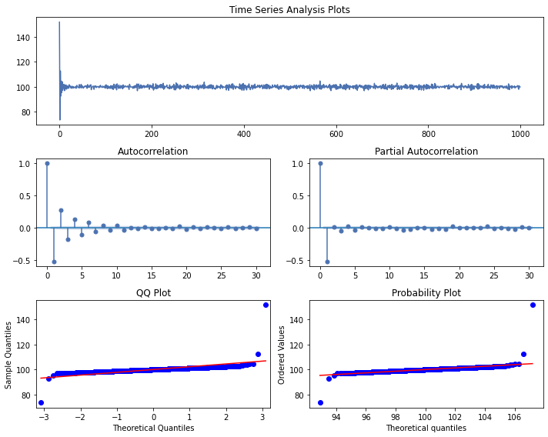

1. ***What is the mean of the time series?***

Mean = delta/ (delta-phi)

Mean = 150/ (1-(-0.5))

= 100

1. ***If the current observation if $y_{100}=85$, would you expect the next observation to be above or below the mean?***

$y_{1}01=150+\left(-0.5\right)*85+whitenoise$ = 108.147

So, the prediction for the 101th value will be above the mean.

***Question 2***

***Consider the AR (1) model $y_{t}=25+0.75y_{\left(t-1\right)}+ε_{t}$. Assume that the variance of the white noise process is $σ^{2}=1$.***

mean white noise = -0.026 and std of the white noise = 0.97

mean of the process =100.0

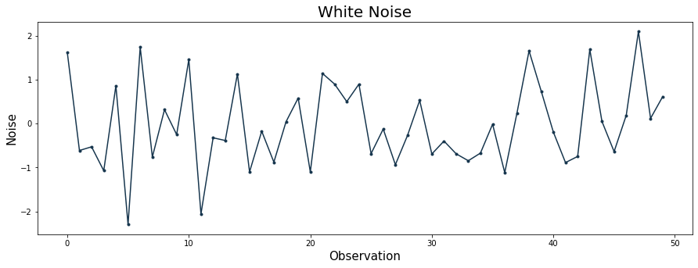

1. ***Sketch the theoretical ACF and PACF for this model.***

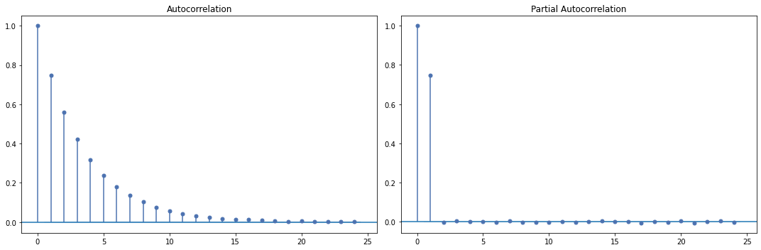

As expected, the distribution of our simulated AR (1) model is normal. There is significant serial correlation between lagged values especially at lag 1 as evidenced by the PACF plot.

1. ***Generate 50 realizations of this AR (1) process and compute the sample ACF and PACF. Compare the sample ACF and the sample PACF to the theoretical ACF and PACF. How similar to the theoretical values are the sample values?***

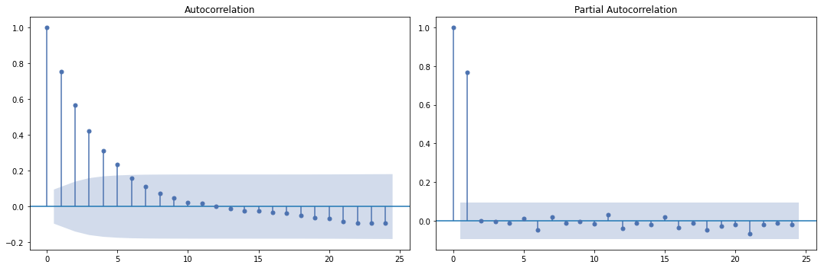

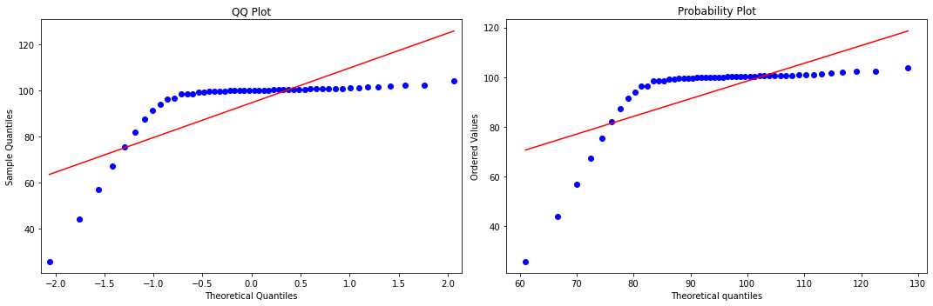

Observation: when we increase the sample size (50) the PACF after the lag 1 is closer to the theoretical zero. The pacf variation is little high as we can see from the blue region in the pacf plot.

1. ***Repeat part b using 200 realizations. How has increasing the sample size impacted the agreement between the sample and theoretical ACF and PACF? Does this give you any insight about models built to short time series?***

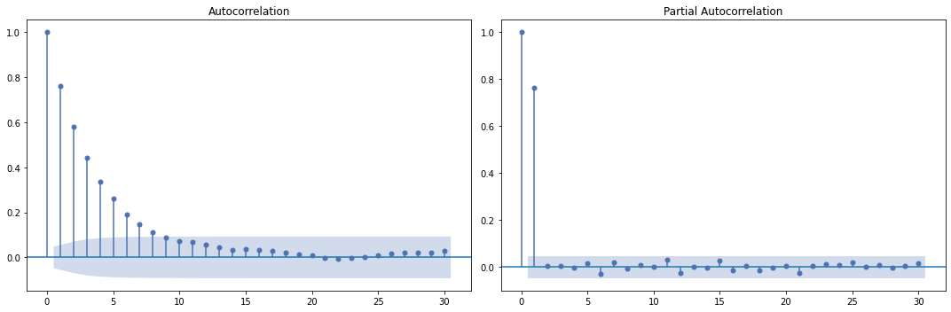

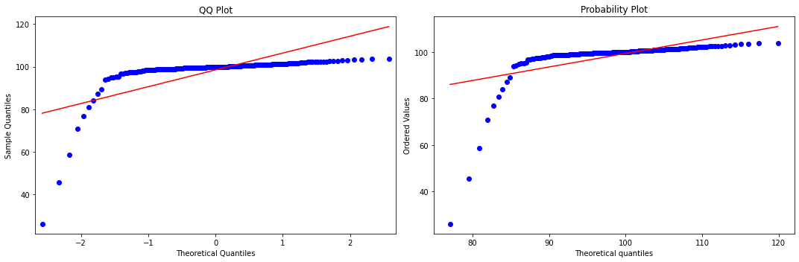

Observation: when we increase the sample size (200) the PACF is much closer to the theoretical PACF. This shows that we need high sample size to accurately model a time series.

**Question 3**

***Consider MA (1) model $y_t = 40 + 0.4ε_{t-1}.$ Assume that the variance of the white noise process is $σ^{2}=2$.***

1. Sketch the theoretical and PACF for this model.

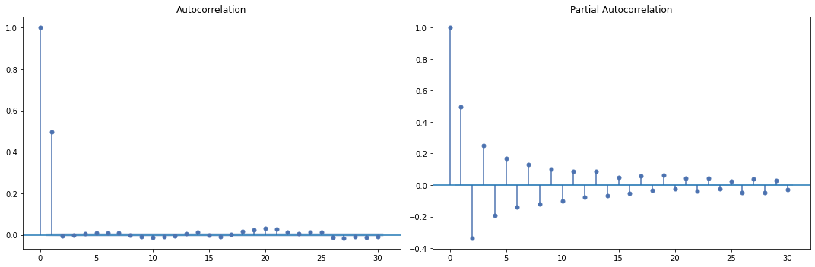

The ACF function shows that the lag 1 is significant which indicates that a MA (1).

1. ***Generate 50 realizations of this MA (1) process and compute the sample ACF and PACF. Compare the sample ACF and the sample PACF to the theoretical ACF and PACF. How similar to the theoretical values are the sample values?***

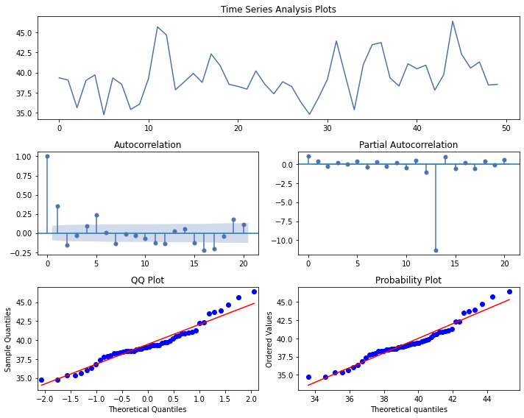

Observation:

We generated only 50 realizations of our model. Because of that in the ACF plot we see that autocorrelation function cuts of at lag 2. (Ideally it should cut off at lag 1).

1. ***Repeat part b using 200 realizations. How has increasing the sample size impacted the agreement between the sample and theoretical ACF and PACF? Does this give you any insight about models built to short time series?***

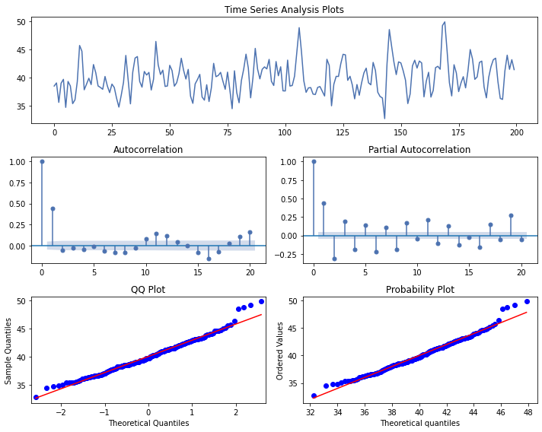

Observation: we can clearly see that when we increase the sample size, the ACF (in the case of MA Models) is getting closer to the theoretical ACF. So, we can conclude that higher the sample size, closer the theoretical and sample ACF.