**Comments**

* // TODO todo
* // ! important note
* // ? confusion
* // E explanation
* // L resource link
* // R reflection
* //

**Feedback**

* Give me all your use-cases
* Did a button look at you funny? I want to know

**Inspiration**

* PartiQ

**Postgres Database**

* TODO
  + ~~Ensure database uses ‘title’ instead of ‘name’ (for consistency) as it is a reserved word in javascript~~
  + Name is only reserved as a property of **functions**, will never have any cross over, also, any reserved words in SQL can be used via “quotes”
* Use surrogate primary keys (id column instead of a combination of existing columns (natural key))
  + as primary keys should not be changed
    - <https://stackoverflow.com/questions/3838414/can-we-update-primary-key-values-of-a-table>
  + Surrogate keys are simpler to implement
  + <https://dba.stackexchange.com/questions/8334/why-should-i-create-an-id-column-when-i-can-use-others-as-key-fields>
  + <https://www.techrepublic.com/blog/10-things/10-tips-for-choosing-between-a-surrogate-and-natural-primary-key/>
* camelCase
* Storing Playlists:
  + <https://dba.stackexchange.com/questions/21664/how-to-store-several-lists-and-their-items>
  + (artists won’t get its separate table as I’ll never want to search artists or split them from the track)
* **Primary and Foreign Key naming conventions**
  + <https://stackoverflow.com/questions/1369593/primary-key-foreign-key-naming-convention>
  + Only foreign keys should be named (foreignId)
* **Create Primary Key**
  + <https://www.techonthenet.com/postgresql/primary_keys.php>
  + Use CONSTRAINT
    - CONSTRAINT constraint_name PRIMARY KEY (column1, column2, …)
    - Or
    - column_name data_type CONSTRAINT constraint_name PRIMARY KEY
  + **Auto increment**
    - Use SERIAL
      * <https://stackoverflow.com/questions/787722/postgresql-autoincrement>
      * column_name SERIAL
  + Together
    - column_name data_type SERIAL CONSTRAINT constraint_name PRIMARY KEY

**New Server Setup**

* Download and install node js (LTS)
  + <https://nodejs.org/en/>
  + <https://github.com/LeCoupa/awesome-cheatsheets/blob/master/backend/node.js>
* Use nodemon for live updates
  + npm install -g nodemon
  + start server with nodemon instead of node
* Download and install postgre sql <https://www.postgresql.org/download/>
  + Start postgres via taskmanager services – postgres service
  + DBeaver for the gui <https://dbeaver.io/>
    - Username: postgres Password: my own password
* Create database (using dbeaver)
* npm install pg-promise

**Future Ideas**

Include not a commenting system but sort of a tracking system for when a user ‘likes’ a track, or if they ‘highlight’ a part of a track (sortof like new websites that allow highlighting and commenting on certain parts of an article), or maybe a most listened part of the track (like pornhub)

Allow users to do basic account functions from the site (liking, sharing, reposting, add to playlist, etc) based on the accounts connected, also have a sort of toggle system for if the accounts should be personal (library generating) or general (permission granting)

**Aesthetic**

Non cliché buttons/icons? <http://www.abc.net.au/triplej/programs/mix-up/whatsonot/9861470> , like just a simple box with a word to say ‘listen’

Large splashes on everything (using album art, waveforms, set colors, procedural etc)

Or, maybe a sort of designy, albumArt, style (check out DELAY. Cover art for example)

Or, minimalistic black and white style like dbr.ee

**Behavior**

Prev track button changes icon based on if it will start the previous track or just skip to the start of the current one

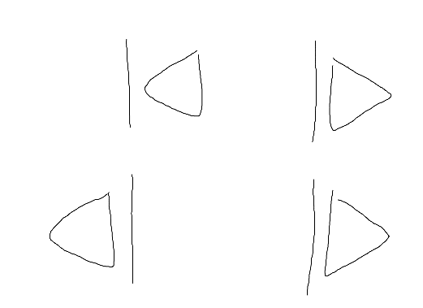

**Schema**

Accounts probably cant be stored with the user because they have no use, cant use stored name/passwords to log in anyways, these would probably be limited to the session

users(userID, username, password, email, *preferences:* image, color, feedSetting,

playlists(ownerID, playlistID, title, description, *settings:* image, color, visibility,

tracks(playlistID, index, uri, source, *stored details:* title, artists, length, image

private

link-only

public

PHP Web API wrapper and Javascript Web API

Can use api to identify available devices

Can use api to actively play on a targeted device

Account connected must be the one also connected to the device

Php curl is a synchronous request

Curl sends a request to a url and gets the response back to use in code

Ajax is an asynchronous request

Connect response types

<https://developer.spotify.com/web-api/working-with-connect/>

<https://beta.developer.spotify.com/documentation/web-api/>

PHP Wrapper:

<https://github.com/jwilsson/spotify-web-api-php>

Javascript Wrapper:

<https://github.com/JMPerez/spotify-web-api-js>