UCN Kicker Diagnostics and Control

Introduction
During operation of the Ultracold Neutron Facility, beam will be shared between the existing meson hall users (beamline 1A) and the new UCN line (beamline 1U). The UCN line is designed to take up to one-third of the total current, for example 40 μA to UCN and 80 μA to the meson hall, as shown here:

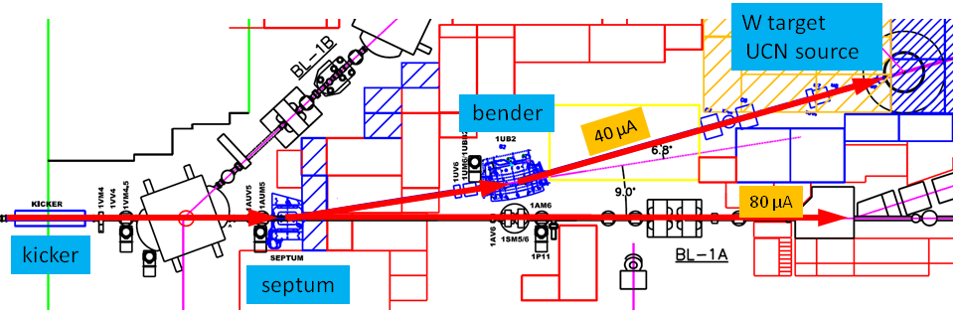
The beam from the cyclotron is delivered in 1 ms “buckets” separated by shorter periods were the beam is blanked by the ion source pulser. During UCN operation the blanking interval will be required to be 50 μs or longer (normally in the range 50μs to 100 μs). Beam sharing will be done by deflecting a certain fraction of the beam buckets to UCN. For the 2:1 split shown below, 1 bucket is deflected to UCN, 2 buckets allowed to pass undeflected, and so on.
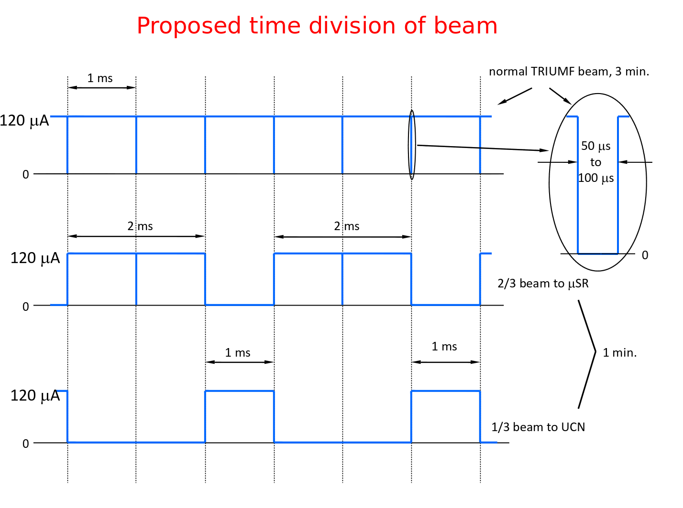

To deflect a beam bucket to UCN, the kicker magnet ramps up during the 50 μs blanking interval, deflects the bucket to the UCN line, then ramps down again in the 50 μs following the beam bucket.

The Kicker Diagnostics and control must deliver a signal synchronized with the arrival of the beam at the kicker. Since the beam takes approximately 330 μs to travel from the ion source to extraction, and the time can vary by some tens of μs depending on the machine tune, it is necessary to have a suitable beam current monitor near the kicker. This is currently provided by the 1VM4 capacitive beam monitor located just downstream of the kicker (see “UCN Kicker Time Pickoff” below). The kicker control system must use the 1VM4 signal to produce a kicker trigger locked to the real beam at the kicker magnet.

It is also important to measure the amount of beam present during the blanking notch. During this time, the beam sweeps from the straight-through port of the septum magnet to the magnetic field section that deflects the beam to UCN (see picture in appendix). If any beam is present during the sweep, it will hit the steel of the septum. The slower the beam sweeps, the more will be spilled on the septum. Assuming the slowest of 50 μs for the full sweep, the beam will cross the septum steel and beam pipe wall during the time from 18 μs to 32 μs after firing the kicker. In this interval the beam current should be below 430 nA to limit the spill onto septum to 1 nA averaged over the UCN cycle. If the beam monitor indicates notch contamination exceeding this limit, we can blank the kicker trigger and not kick until the contamination is once again under the limit. For good signal to noise ratio, the 430 nA limit based on long term beam spills could be be measured with several seconds of averaging. Spills large enough to cause a radiation trip of the cyclotron will be detected by the nearby TRIUMF beam spill monitors.

Finally, it should be noted that these fast kicker cycles (ramping up to spill on bucket onto UCN target, ramping down to send two buckets to 1A) is superimposed onto a slower UCN cycle, where we want to put beam onto the UCN target for 1 minute (to produce UCNs) and then have a 3 minute period to do measurements of the UCNs. This 1-minute ON, 3-minute OFF cycle would then be continuously repeated. It is also possible that the longer UCN cycles might be more complicated than just 1-min/3-min.

Context for proposed kicker control system
We note that there are several major questions about the kicker and the UCN beamline that will affect the design of the kicker control system:

- Who controls the kicker magnet? For this proposal we assume that the main cyclotron controls group will control the kicker operation, but that the UCN group will need regular input regarding the kicker operation (such as over the longer 1min-beam-on/3min-beam-off UCN cycles).
This question matters mainly because it impacts how the control and diagnostic information is implemented; if the main control room need to control the kicker then the control should be implemented in a way that works for them.
- Is the kicker timing alignment a safety issue? From my point of view the kicker timing alignment (ie, getting the kick timed correctly within 50us blanking interval) is not a safety issue, since the other beamline monitors will trip the beam if the kicker kicks at the wrong time. We would therefore treat the kicker timing alignment as a diagnostic issue, not a safety issue. Similarly the measurement of the amount of beam during the blanking notch is a diagnostic issue.
This question matters because if the kicker timing alignment is not a safety issue we have more flexibility in how we implement this element of the controls.
- Is the fraction of beam going to UCN target a safety issue? If there was a problem with the kicker configuration or kicker control that caused a larger-than-expected fraction of the beam to be sent to the UCN target, is that a safety concern? Ie, suppose 40uA was sent to UCN, when only 1uA was desired. If such a situation persisted then it might be a radiation safety issue, if the UCN shielding was only set for 1uA of current. It might also be a UCN source safety issue, since the UCN source would probably be unable to handle the higher heat load. Presumably the kicker control will also have interlocks from the UCN cooling system, so could also protect the UCN source that way.
Again, deciding if the fraction of beam to UCN target is a safety issue may influence the implementation of this element.

Overview of kicker control system
One possible organization of the kicker control system is shown below

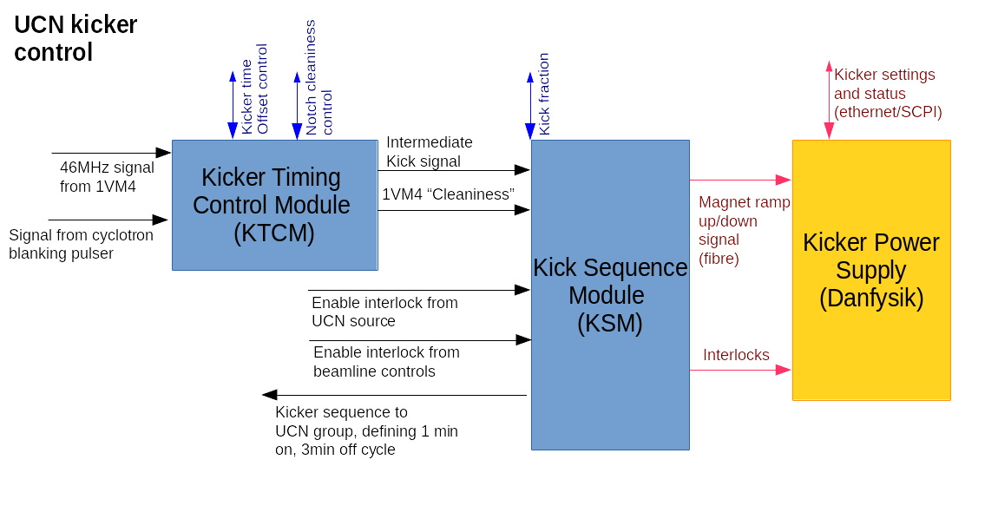

The two main parts of the control system would be

I) Kicker Timing Control Module (KTCM): this module would handle the following:
- digitizing the signal from the 1VM4 capacitive beam monitor
- creating a kick signal
- making a decision about whether the kick signal is well aligned with the notch and notch background is sufficiently low.

II) Kicker Sequence Module (KSM): this module would be essential just a AND gate for the kick signal with the detector and beamline protection interlocks, as well as the UCN sequence (1min on, 3min off). It would also prescale a fraction of the kicks in order to provide the desired beam on target to UCN. This module would generate the actual kick signal sent to kicker power supply.

We describe these modules more below, after describing 1VM4 signal.

UCN Kicker Time Pickoff
The TRIUMF beam has a microstructure of bursts a few nanoseconds wide separated by 43 nanoseconds (RF frequency 23 MHz). The time monitor is a capacitive pickoff, 1VM4, located just downstream of the kicker. The pickoff is sensitive to the 23 MHz microstructure. The raw signal is fed to a broadband preamp followed by a tuned second stage operating at the second harmonic, 46 MHz. The output of the tuned stage is a 46 MHz sine wave whose envelope follows the beam current. The bandwidth of the second stage can be adjusted to trade settling time against noise (low noise = long settling time). It is now set to settle (several 1/e time constants) in 1 μs. At this time constant, the electronic noise is 0.15 μA. The monitor and front-end electronics are already in place.

The electronics handles beam currents of 0 μA – 120 μA. The input is triax cable from the capacitive pickoff and the output is normal Coax. Leonid Kurchaninov has the details. We have to use the signal from the time pickoff to deliver a kicker signal synchronized with the arrival of the beam at the kicker, and to prevent kicking if the contamination in the beam-off-notch is too high.

Kicker Timing Control Module (KTCM)
The first task of this module is to digitize the signal from the tuned 1VM4 signal. We would start by demodulating the 46MHz signal down to a signal with 1us variations. We would then digitize the signal with a sampling of 0.2-1.0 MHz. The digitized signal should clearly show the 50us notchs in which we want to kick the magnet.

The next step for the module would be to define the time at which the magnet kick should start. This time could either be determined by the analysis of the digitized 1VM4 signals or by adding a fixed offset to the time from the cyclotron notch generation signal. In either case the operator would need the ability to change the time offset of the kick signal. Once set, it would be best if the time of kick signal was continually shifted (using some sort of phas locked loop) to adjust to changes in cyclotron operation.

The module would then analyze the digitized 1VM4 signal in order to determine how much beam background was present in the magnet ramping period. In order to get good signal to noise the module might need to average a number of notchs before measuring the beam background. The operator will need to specify a limit for the beam background.

The outputs from this module would be a properly timed kick signal and a logic level indicating if the 1VM4 output was 'clean'. For diagnostic purposes we would also want to have a way of examing the digitized 1VM4 signals.

Possible architecture for KTCM: this module could be a custom electronics card, with an ADC for digitizing the 1VM4 signal and an FPGA for processing the digital waveforms, determining a kick time and the notch cleaniness. An alternative achitecture would be to use some commercial electronics to digitize the waveform and do the waveform processing in a software program. Or perhaps some Altera evaluation card would be sufficient.

Challenges for KTCM: it may be hard to accurately measure the notchs if the cyclotron is running at low beam power.

Kicker Sequence Module (KSM):
This module would take the kick signal from the KTCM and generate the actual magnet ramp signals to send to the kicker power supply. Ie, the KSM would generate the magnet ramp up signal on one notch and then the ramp down signal on the next notch. It would then wait a set number of buckets before doing another magnet kick. The number of beam buckets to wait would determine the beam power on target and so would need to be controlled (possibly with hard limits) by the operator.

You could also imagine another mode where the KTCM generated a ramp up signal on one notch, waited for 10 beam buckets, generated a ramp down signal and then waited for 20 beam buckets. This would give the same 1:2 fraction of beam to UCN, but result in less magnet ramps.

The KSM would also have input logic signals from various UCN source and beamline interlocks, to ensure that the magnet was not kicked (in case any problems caused interlocks). A couple details about the interlocks include that:
1) The Enable interlock from UCN Source will have to also include an "UCN Area enable" (area armed, gates locked, certain magnets ON, and Beam-blocker OUT).
2) The Enable interlock from beamline controls will have to include a BL1A enable (i.e. a "BL1A ON/BL1B OFF" condition, because the dipole magnet 1BVB2 sits between the kicker and septum magnets, and is ON when BL1B is running). The prescaler or BL1U:BL1A current ratio is also folded into this signal, we presume.

Finally, the KSM should also combine the magnet ramp decision with the need to create the longer 1-minute ON, 3-minute OFF UCN cycle; ie, how many minutes to put beam on target and how long to measure the UCN. Logic signals would need to be sent to the UCN group defining the ON/OFF periods.

It should be noted that we talk of a nominal 1min:3min ratio, but that would probably be a ratio that the UCN group would want to sometimes vary. The cycle might also be more complicated, with additional OFF periods every 8th UCN cycle. Some flexibility in specifying these UCN cycles would be beneficial.

The KSM should probably calculate what fraction of beam buckets were kicked and ensure that the fraction is not higher than expected.

Possible architecture for KSM: perhaps a PLC controlled by EPICS?
Appendix

