UCN beamline machine protection

T. Lindner, March 2, 2016

This document is the start of a complete description of the beamline 1U (UCN beamline) machine protection systems.

Machine protection related to kicker operation

In the following sections we will describe some of the risks associated with the UCN kicker operation and the system in place to protect the machine against these risks.

As an introduction, we remind readers of the basics of the UCN kicker operation. Namely,

- During UCN operation the blanking interval will be required to be 50 μs or longer (normally in the range 50μs to 100 μs).
- Beam sharing will be done by deflecting a certain fraction of the beam buckets to UCN. For instance, to take one third of the 1V beam (40uA if the total beam is 120uA) we would kick one beam bucket to beamline 1U and then allow two beam buckets to pass to 1A and then repeat.
- The kicker magnet needs to ramp up and down within the blanking notch in order to avoid spilling beam on beamline components.

Protection related to Kicker timing
As noted above, the kicker timing alignment (ie, getting the kick timed correctly within 50us blanking interval) is a machine protection issue, since we don't want to spilling beam onto the septum magnet and the rest of the beamline. The figure below shows what is meant by the good and bad timing of the magnet ramp.
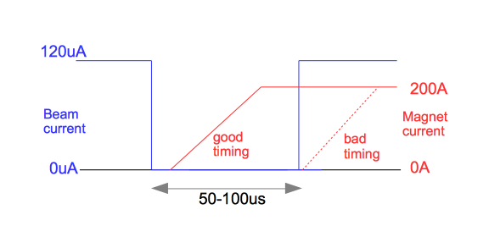

The necessary machine protection to stop this happening should be provided by a beamline monitors. There should be an interlock based on the septum beam spill monitor, as well as other beamline BSMs to prevent further kicker magnet kicks.

Blanking notch cleaniness
In a similar way, we might also have a problem where the kicker ramp was properly timed, but that the blanking notch was not 'clean'; ie, the blanking notch had some residual beam in it (for whatever reason). This situation is shown graphically below.

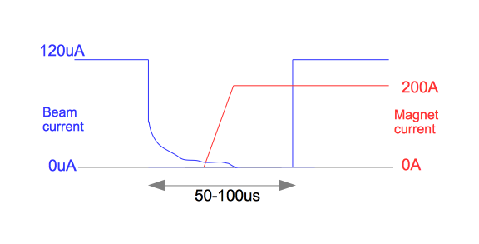

The protection for this situation would be provided in the same way as for the bad kicker timing: ie, by interlocks based on appropriate BSMs.

Beamline 1U power

We could imagine a situation where the kicker control was broken or misconfigured in such a way that 40uA or even 120uA was sent to beamline 1U, when only 1uA was desired. This situation would be a machine protection issue for both the UCN target and the UCN source, because of the increased heat load.

The necessary protection against this situation is to have an interlock based on the 1UTNIM2 non-intercepting beam monitor on beamline 1U; this interlock can be set to trip if the beam along 1U exceeds some current (say 1uA to start). This would ensure that we separate the element that decides the fraction of the beam to 1U (the kicker control) from the element that provides the safety interlock (the beam intensity monitors). It would be necessary to make the interlock based on some current measurement averaged over a longer timescale (say 100-5000ms); the instantaneous current would be up to the maximum beamline current (120uA) during the particular buckets that were being kicked.

Presumably the kicker control will also have interlocks from the UCN cooling system and temperature sensors, so we can also protect the UCN source that way. But the beam intensity monitors should react faster than interlocks from the UCN source.
If such a higher-than-expected-beam-power situation persisted then it might be a radiation safety issue, if the UCN shielding was only set for 1uA of current. But presumably that would be a much longer timescale than the UCN machine protection issue that would occur.

Protective actions based on 1U interlocks
We also need to decide how to react in the case of triggering our machine protection interlocks. In our opinion, we imagine the following actions in case of kicker problems
- If the septum beamline monitor indicated bad kick alignment or the 1U intensity monitors indicated too much beam current, then we could trigger the kicker interlock so that the kicker stopped kicking any beam. This would have the advantage of protecting the 1U beamline while maintaining beam to 1A and ISAC.
- On the other hand, there will be other kicker problems that should result in a cyclotron trip. For instance, if the kicker somehow gets stuck in a state where all the beam is being sent to 1U, then that should probably trip the cyclotron.

