 |  |  |  | Document-131404

Design Note TRI-DN-16-11

UCN Kicker Control and Diagnostics Work Request
Document Type: | Design Note
Release: | DRAFT | Release Date: |  |  | 2016/00/00
Author(s): | Thomas Lindner
 | Name: | Signature:
Author: | Thomas Lindner | APPROVAL RECORD
Reviewed By:
Approved By:
Note: Before using a copy (electronic or printed) of this document you must ensure that your copy is identical to the released document, which is stored on TRIUMF’s document server.
History of Changes
Release Number | Date | Description of Changes | Author(s)
#01 | 2016/00/00 | Initial release | Thomas Lindner

Keywords: list of keywords

Distribution List: list of names

Introduction
During operation of the Ultra-Cold Neutron facility, beam will be shared between the existing meson hall users (beamline 1A) and the new UCN line (beamline 1U). The UCN line is designed to take up to one-third of the total current, for example 40 μA to UCN and 80 μA to the meson hall, as shown here:

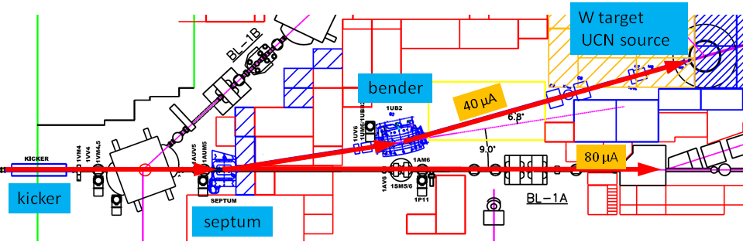

The beam from the cyclotron is delivered in 1 ms “buckets” separated by shorter periods were the beam is blanked by the ion source pulser. During UCN operation the blanking interval will be required to be 50 μs or longer (normally in the range 50 μs to 100 μs). Beam sharing will be done by deflecting a certain fraction of the beam buckets to UCN. For the 2:1 split shown below, 1 bucket is deflected to UCN, 2 buckets allowed to pass undeflected, and so on.
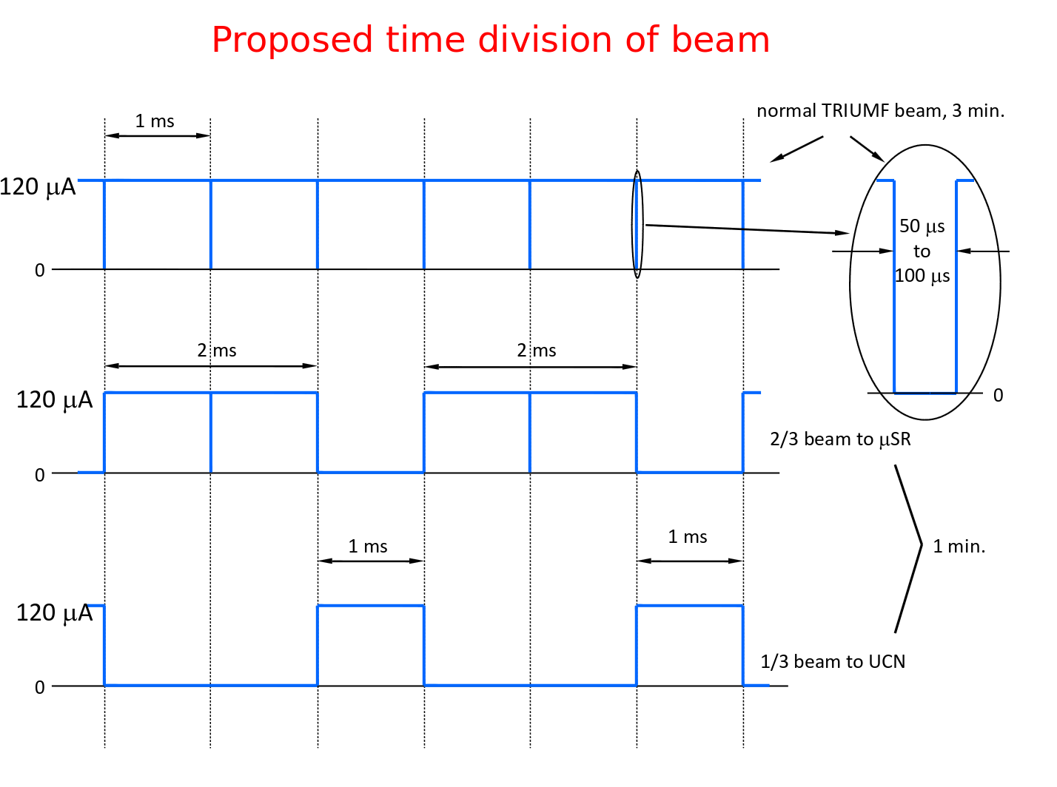
To deflect a beam bucket to UCN, the kicker magnet ramps up during the 50 μs blanking interval, deflects the bucket to the UCN line, then ramps down again in the 50 μs blanking interval following the beam bucket.

The Kicker control must deliver a signal synchronized with the arrival of the beam at the kicker. Since the beam takes approximately 330 μs to travel from the ion source to extraction, and the time can vary by some tens of μs depending on the machine tune, it is necessary to have a suitable beam current monitor near the kicker. This is provided by the 1VM4 capacitive beam monitor located just downstream of the kicker (see “UCN Kicker Time Pickoff” below). The kicker control system can use the 1VM4 signal to confirm that the kicker trigger is locked to the real beam at the kicker magnet.

It is also important to measure the amount of beam present during the blanking notch. During this time, the beam sweeps from the straight-through port of the septum magnet to the magnetic field section that deflects the beam to UCN (see picture in appendix). If any beam is present during the sweep, it will hit the steel of the septum. The slower the beam sweeps, the more will be spilled on the septum. Assuming the slowest of 50 μs for the full sweep, the beam will cross the septum steel and beam pipe wall during the time from 18 μs to 32 μs after firing the kicker. In this interval the beam current should be below 430 nA to limit the spill onto septum to 1 nA averaged over the UCN cycle. If the beam monitor indicates notch contamination exceeding this limit, we can blank the kicker trigger and not kick until the contamination is once again under the limit. For good signal to noise ratio, the 430 nA limit based on long term beam spills could be be measured with several seconds of averaging. Spills large enough to cause a radiation trip of the cyclotron will be detected by the nearby TRIUMF beam spill monitors.

Finally, it should be noted that these fast kicker cycles (ramping up to spill one bucket onto UCN target, ramping down to send two buckets to beamline 1A) is superimposed onto a slower UCN cycle, where we want to put beam onto the UCN target for 1 minute (to produce UCNs) and then have a 3 minute period to do measurements of the UCNs. This 1-minute ON, 3-minute OFF cycle would then be continuously repeated in final UCN operations. It is also expected that the different, more complicated UCN cycles will be needed (details in following section).

Overview of Kicker Control System
Given the context described above, one possible organization of the kicker control system is shown below:

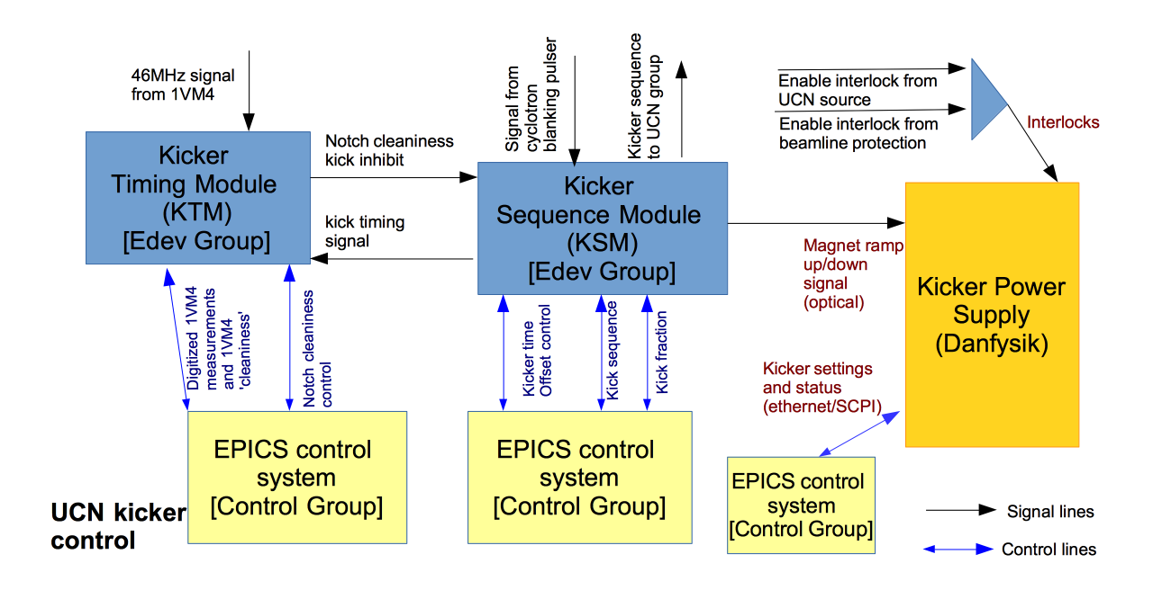
The three main components of the control system would be –
Kicker Sequence Module (KSM): this custom designed electronics module would handle the following:
- Creating a kick signal; i.e. adding a fixed delay to the signal from the cyclotron blanking pulser.
- Creating the short and long timescale sequence of kicks.
- Actually ramping the magnet.
We assume that the hardware and firmware for this module would be provided by the Science Technology department. It may be possible to use an existing module for the hardware.

Kicker Timing Module (KTM):
- Digitizing the signal from the 1VM4 capacitive beam monitor.
- Making a decision about whether the kick signal is well aligned with the notch and notch background is sufficiently low.
We assume that the hardware and firmware for this module would be provided by the Electronics Development group.
EPICS control system: this system would provide the EPICs control of the KSM and KTM as well as various control settings for the kicker magnet itself.
We assume that this component would be handled by the controls group.
We will describe these modules more below, as well as describing the 1VM4 signal.

Kicker Sequence Module (KSM)
This module is in charge of creating the sequence of kicks that will actually drive the kicker power supply.

This module would start by defining the time at which the magnet kick should start. This time could would by adding a fixed offset to the time from the cyclotron notch generation signal. The operator would need the ability to change the time offset of the kick signal.

Finally, this module would define the actual short term and longer term sequence for kicker magnet; i.e. define the short term kicking of a fraction of the beam buckets and the 1 min. beam-on / 3 min. beam-off cycle for normal operation. As mentioned earlier, there would need to be a large number of different modes and configurability in defining the longer term sequence. For a starting point we would want the ability to operate the KSM and kicker with the following different modes:
Operate the kicker magnet to permanently on so all beam gets directed to BL1U.
Operate the kicker to execute one sequence of kicking one bunch out of N, for a total of M minutes.
Operate the kicker to repeat a sequence of X minutes where we kick one bunch out of Y, followed by Z minutes of no beam being kicked.

The parameters N, M, X, Y and Z would need to be configurable from EPICS.

A possible additional feature for the KSM would be to add a more sophisticated interlock system. The default plan shown in the diagram above has the machine protection interlocks connected directly to kicker power supply. The problem with this is that if the interlock is enabled the kicker power supply will immediately ramp down the magnet, even if the beam is still going, causing beam spill across the septum magnet. A cleaner solution would be to have the machine protection interlocks feed into the KSM so that the KSM latches the interlock, but only ramps down at the next blanking notch (and didn't allow any subsequent ramps).

The diagram below shows the relevant input/outputs for the module.
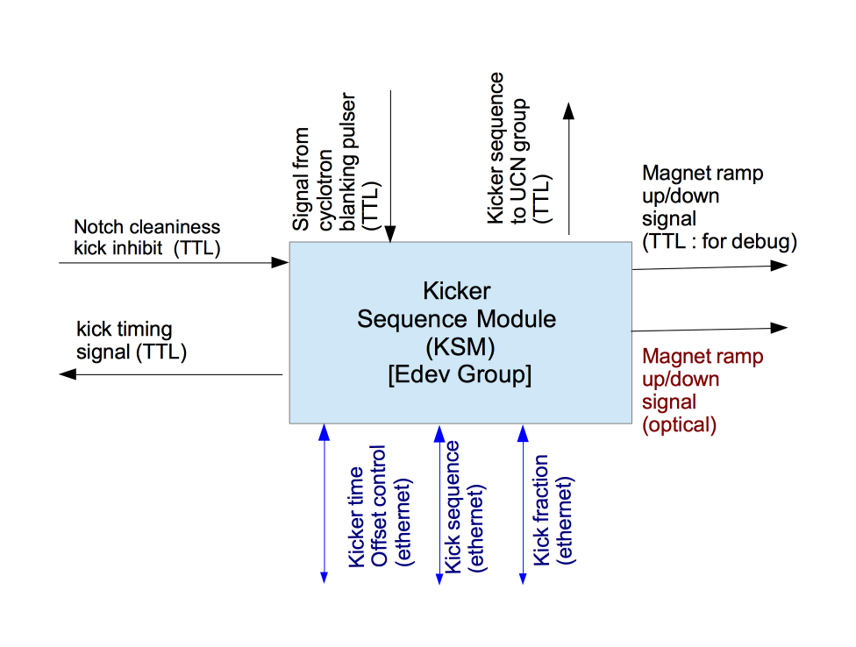
Possible architecture for KSM: this module could be a custom electronics card, though this might be difficult to achieve given existing resources. A couple other alternatives seem possible, using existing boards:
- Use the TRIUMF DAQ group VME IO-32 or PPG board, but with new firmware. In this case, the EPICS IOC could be on a VME processor in same crate.
- Use an Altera Cyclone V SoC evaluation card (either Terasic cards we already have or similar cards from Critical Link). Again, would need new firmware for the card. In this case the EPICS IOC could be in the ARM processor on the SoC and control the FPGA configuration directly through the SoC fabric.

UCN Kicker Time Pickoff
The TRIUMF beam has a microstructure of bursts a few nanoseconds wide separated by 43 nanoseconds (RF frequency 23 MHz). The time monitor is a capacitive pickoff, 1VM4, located just downstream of the kicker. The pickoff is sensitive to the 23 MHz microstructure. The raw signal is fed to a broadband preamp followed by a tuned second stage operating at the second harmonic, 46 MHz. The output of the tuned stage is a 46 MHz sine wave whose envelope follows the beam current. The bandwidth of the second stage can be adjusted to trade settling time against noise (low noise = long settling time). It is now set to settle (several 1/e time constants) in 1 μs. At this time constant, the electronic noise is 0.15 μA. The monitor and front-end electronics are already in place.

The electronics handles beam currents of 0 μA – 120 μA. The input is triax cable from the capacitive pickoff and the output is normal Coax. Leonid Kurchaninov has the details. We have to use the signal from the time pickoff to deliver a kicker signal synchronized with the arrival of the beam at the kicker, and to prevent kicking if the contamination in the beam-off-notch is too high.

Kicker Timing Module (KTM)
The first task of this module is to digitize the signal from the tuned 1VM4 signal. We would start by demodulating the 46 MHz signal down to a signal with 1us variations. We would then digitize the signal with a sampling of 0.2-1.0 MHz. The digitized signal should clearly show the 50 μs notches in which we want to kick the magnet.

The module would then analyze the digitized 1VM4 signal in order to determine how much beam background was present in the magnet ramping period. It would use the kick timing signal from the KSM to define when the ramping period starts; the kick timing signal is just the beam notch signal with a modifiable offset. In order to get good signal to noise the module might need to average a number of notches before measuring the beam background. The operator will need to specify a limit for the beam background. Based on the results of the analyzed 1VM4 signal the KTM would be able to inhibit the KSM if the 1VM4 shows misaligned or unclean blanking notches.

For diagnostic purposes we would also want to have a way of reading out and examining the digitized 1VM4 signals.

Challenges for KTM: it may be hard to accurately measure the blanking notches if the cyclotron is running at low beam power.

EPICS Control System
The EPICS control system would provide control of the kicker control system to the cyclotron operations group. Important parts of this control would include:
- Configuring the KTCM: setting the notch cleanliness threshold, kick timing offset, kick fraction and kick sequence. The EPICS control should provide some basic validation of the kick sequence, to ensure that the operator was not requesting a higher 1U beam current than allowed.
- Reading out the digitized 1VM4 signal and various KTCM status bits.
- Configuring the settings and monitoring the status of the Danfysik kicker power supply.
- Reading/controlling PLCs that monitor the various kicker interlocks. These interlocks would include –
  - The Enable interlock from UCN Source will have to also include an "UCN Area enable" (area armed, gates locked, certain magnets ON, and Beam-blocker OUT).
  - The Enable interlock from beamline controls will have to include a BL1A enable (i.e. a "BL1A ON/BL1B OFF" condition, because the dipole magnet 1BVB2 sits between the kicker and septum magnets, and is ON when BL1B is running). The prescaler or BL1U:BL1A current ratio is also folded into this signal, we presume.

Staging of Work Request
We would suggest that the kicker control work be staged as follows:
- Stage 1: the edev and controls groups would only implement the functionality of the KSM module. The KSM module is the critical piece necessary to actually operate the kicker in its regular, kicking mode; having this module would allow for earlier commissioning of the UCN beamline. In stage 1 we would manually monitor the 1VM4 signal using a scope or some other commercial digitizer, but would not require any automatic feedback from the 1VM4 measurement to the KSM. This would allow us to make better measurements of the 1VM4 signal and confirm how best to digitize and analyze it.
- Stage 2: based on the results of the first stage, the edev and controls groups would then create the KTM module.

Related Documents
For reference, see additional documents on –
UCN beamline operations
UCN beamline machine protection

Appendix:

