Generating a telegram bot for alertes:

download the telegram app. Write the bot father to generate a new bot:

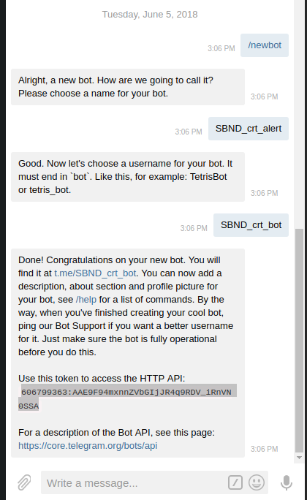
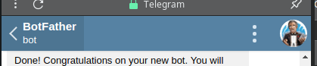

Add the bot to a group chat:
add the conntact: SBND_crt_alert and all other mebmers…

Go to the link:
https://api.telegram.org/bot606799363:AAE9F94mxnnZVbGIjJR4q9RDV_iRnVN0SSA/getUpdates
https://api.telegram.org/botYourAPINumber/getUpdates

there you see something like:
Imprtant number: -233207216 ( chat id!)
Add the chat id and the api number in grafana:
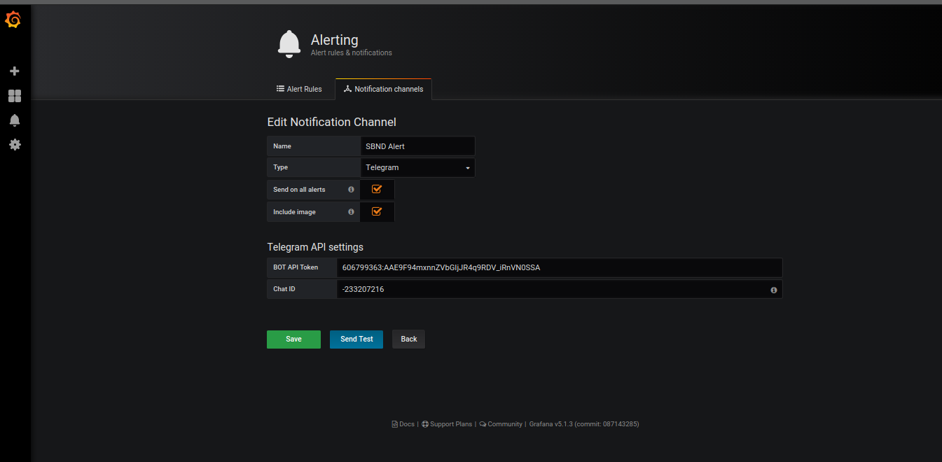

TomPi alert bot API:
694091311:AAF7PmMqhyB88LG1wMmYdIKmis7OqTGlYWk
ChatId: -318152844

@Argoncube_alert
API: 536740127:AAFFpySn8Yg-WOn0Sb-Z5yFnRJmFP9pxLhM
ChatId: -315294767

@uB_crt_alert
API: 512715215:AAGr4aCs2OqOlHlG6EdBlblKk52HLuaY5qw
ChatId: 590034798

@SBND_crt_alert
API: 606799363:AAE9F94mxnnZVbGIjJR4q9RDV_iRnVN0SSA
Chat id:-233207216

