Errata of Progress Report – P.8

Original:

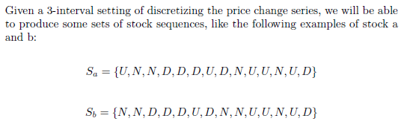

Edited:

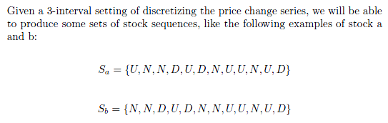

Original:

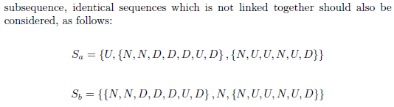

Edited:

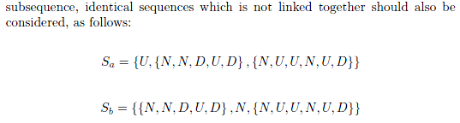

Original:

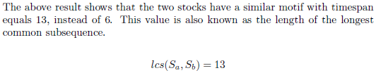

Edited:

