Finalised ERD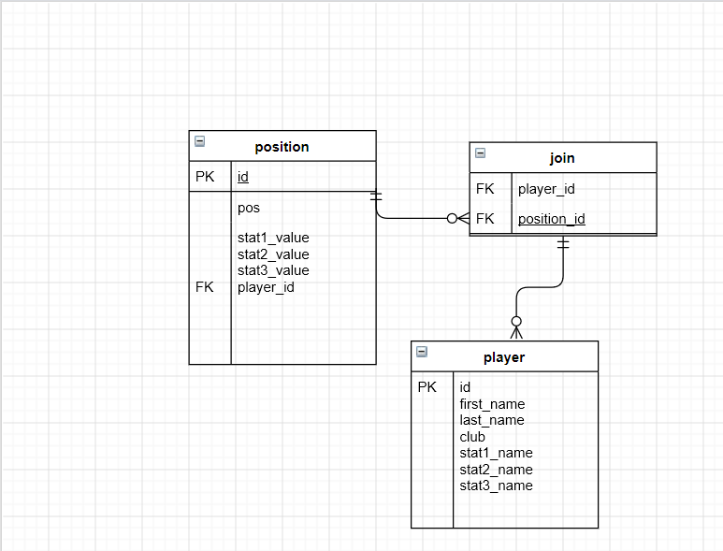

Finalised Risk Assessment

|  |  |  |  |  |  |  |
| --- | --- | --- | --- | --- | --- | --- |
| Potential Risk | Risk Rating | Who is at risk? | Proposed/current Mitigation | By whom? | When | Completed? |
| Servers crashing | Low | DEVS,Users,partners and staff | Files backed up regular to reduce risks of loss of data | Cloud provider | n/a | n/a |
| Database getting hacked | Medium | DEVS,Users,partners and staff | Data is encrypted in the database | Devs | ASAP | Yes |
| Traffic is monitored | High | DEVS,Users,partners and staff` | Encrypt all data within the application eg a HTTPS connection | Devs | Asap | No |
| DDOS attack | Medium | DEVS,Users,partners and staff` | Change the ip adress | Devs | Asap | yes |

Project planning

Trello

