

University of Padua

Information Engineering Department

Master’s Degree in Computer Engineering

Solutions to the Travelling Salesman Problem

Professor: Student:

Prof. Matteo Fischetti Thomas Porro

1237030

Academic year 2021/2022

Contents

1 | Introduction |  |  | 1
 | 1.1 | Brief history of the problem . . . . . . . . . . . . . . . . . . . . . . . . . . |  | 1
 | 1.2 | The mathematical formulation . . . . . . . . . . . . . . . . . . . . . . . . . |  | 2
2 | Compact models |  |  | 4
 | 2.1 | Basic model . . . . . . . . . . . . . . . . . . . . . . . . . . . . . . . . . . . |  | 4
 | 2.2 | The Miller, Tucker, and Zemlin model . . . . . . . . . . . . . . . . . . . . |  | 5
 |  | 2.2.1 | Implementation of the model . . . . . . . . . . . . . . . . . . . . . | 6
 | 2.3 | The Gavish and Graves model . . . . . . . . . . . . . . . . . . . . . . . . . |  | 7
3 Other sub-tour elimination methods |  |  |  | 8
 | 3.1 | Benders method . . . . . . . . . . . . . . . . . . . . . . . . . . . . . . . . . |  | 8
 | 3.2 | Callback method . . . . . . . . . . . . . . . . . . . . . . . . . . . . . . . . |  | 9
 |  | 3.2.1 | Callback on the fractional solutions . . . . . . . . . . . . . . . . . . | 10
4 | Non optimal solutions |  |  | 11
 | 4.1 | Matheuristics . . . . . . . . . . . . . . . . . . . . . . . . . . . . . . . . . . |  | 11
 |  | 4.1.1 | Hard- xing . . . . . . . . . . . . . . . . . . . . . . . . . . . . . . . | 11
 |  | 4.1.2 | Soft- xing . . . . . . . . . . . . . . . . . . . . . . . . . . . . . . . . | 13
 | 4.2 | Heuristics . . . . . . . . . . . . . . . . . . . . . . . . . . . . . . . . . . . . |  | 15
 |  | 4.2.1 | Greedy algorithm . . . . . . . . . . . . . . . . . . . . . . . . . . . . | 15
 |  | 4.2.2 | Extra mileage approach . . . . . . . . . . . . . . . . . . . . . . . . | 16
 |  | 4.2.3 | 2-opt re ning . . . . . . . . . . . . . . . . . . . . . . . . . . . . . . | 17
Bibliogra a |  |  |  | 19

i

Chapter 1

Introduction

In this report I am going to describe, analyze and implement solutions for the Travelling Salesman Problem (hereafter referred to as TSP). The TSP is a NP-hard problem formulated as follows:

Given a list of cities and the distances between them, nd the shortest path that connects all the cities and return to the origin one.

It is used mainly in plain logistics, planning, and as a benchmark for testing optimization problems. However, it can be helpful in many other areas with a slight modi cation of the formula - such as in DNA sequencing, considering cities as DNA fragments, and astronomy, where they are stars.

Even though it is an NP-hard problem, instances with the dimensions of thousand or even millions of cities can be solved with great precision (around 1%) thanks to many heuristics and exact algorithms.

1.1 Brief history of the problem

The German handbook Der Handlungsreisende from 1832 was a guide used by salesman traveling through Germany and Switzerland. Albeit without any mathematical languages, it proves that people were starting to realize that optimal paths could save time and so it can be seen as the rst example of TSP. The rst TSP mathematical formula was made by Hmail and Kirkman in the XIX century, but it was in the 1930s that the TSP was implemented - mainly in Vienna and at Harvard University. An important leap forward was made in the 1950s, when G. Dantzig, D. R. Fulkerson, and S. M. Johnson expressed the problem as an integer linear program, even if they did not propose an algorithmic solution. They were able to devise the cutting plane method, and solved an instance with 49 nodes - by constructing a tour and proving that no other tour could be shorter. In the 1980s, Grotschel, Padberg, Rinaldi and others gured out instances with up to 2392 nodes, using both cutting planes and branch and bound. In 1991, Gerhard Reinelt published

1

1.2 The mathematical formulation | 2

the TSPLIB, a collection of benchmark instances of varying di culty - which has been used for comparing results among many research groups. In the 1990s Applegate, Bixby, Chvatal, and Cook developed the Concorde TSP solver. Nowadays, this program can run even on mobile devices such as iPads and it has been used in many recent record solutions: in 2006, Cook and others computed the optimal tour for an instance of 85900 nodes given by a microchip layout problem and this is currently the largest solved TSPLIB instance. For many other instances with millions of cities, today’s solutions are guaranteed to be within 2-3% of an optimal tour.

1.2 The mathematical formulation

In this introduction, I used a natural way to describe the problem using the notion of cities and distance travelled. But applying from a mathematical point of view, the TSP problem can be thought as graph G = (V; E) where V = fv₁; : : : ; v_{n}g are the cities described in this introduction (from now on called nodes or vertices of the graph), and E in this case represents the path that connects one node to another and it can be described as E (V V )=ffi; jg : i 2 V gg, is the set of edges of the graph.
nother fundamental aspects to be taken in consideration are the concept of distance and its mathematical counterpart, the cost. I assign to each edge a real number that will be used to give weight (or cost) to the path chosen.

Now that I have introduced the main concepts I can explain the TSP problem from a mathematical point of view:

Given a list of nodes and the distances between them, nd the shortest hamil-tonian circuit.

One of the most important formulations is the following one [1], even if it presents slight modi cations:

8
<1 if the arc (i; j) 2 A is chosen in the optimal solution
x_{ij} = |  |  | (1.1)
:0 otherwise | X
min | ^{c}ij^{x}ij |  | (1.2a)
 | (i;j)2A
_{(i;j}^{X}_{)(j)} ^{x}ij ^{= 1;} |  | j 2 V | (1.2b)
(i;j^{X})(j) |  | i 2 V
x_{ij} = 1; |  | i 2 V | (1.2c)
+
1.2 The mathematical formulation | 3
^{X} x_{e} jSj 1; 8S V ; jSj 2 | (1.2d)
e2E_{G}(S)

x_{ij} 0 intero; (i; j) 2 A | (1.2e)

This model is not fully functional since it allows the presence of sub-tours in the solution. In order to avoid them, I am going to add some constraints to the model in the next sections.

Chapter 2

Compact models

In this section, I am going to explore the rst method used to solve the TSP problem. In particular, I will describe the Miller, Tucker, and Zemlin model (known as MTZ model) and the Gavish and Graves model (known as GG model).

2.1 Basic model

The rst model I took in consideration is a lightly modi ed version of the one presented in section 1.2. This formula still doesn’t adopt the Sub-tour Elimination Constraint (SEC) since it is intended to be used jointly with other SECs and with other methods such as matheuristics.

This con guration gives an undirected complete graph G = (V; E). The formulation used in the code is the following:
X
min | ^{c}ij^{x}ij |  | (2.1a)
(i;j)2A
_{(i;j}^{X}_{)(j)} ^{x}ij ^{= 1;} |  | j 2 V | (2.1b)
(i;j^{X})(j) |  | i 2 V
x_{ij} = 1; |  | i 2 V | (2.1c)
+
x_{ij} 0 intero; |  | (i; j) 2 A | (2.1e)

It is the same model used in section 1.2 but in this case 1.2d is not included.

In this implementation, the graph is symmetric. The arcs (i; j) and (j; i) have the same weight and then thus are represented with the same edge. In this way, the total number
of variables are reduced too, considering the starting point not of n², but only ^{n(n} ¹⁾ .

2

The result using this model can be seen in gure 2.1.

Since sub-tours are present, this solution cannot be accepted. In the next sections SEC constraints will be added to the formula for avoiding this problem.

4

2.2 The Miller, Tucker, and Zemlin model | 5
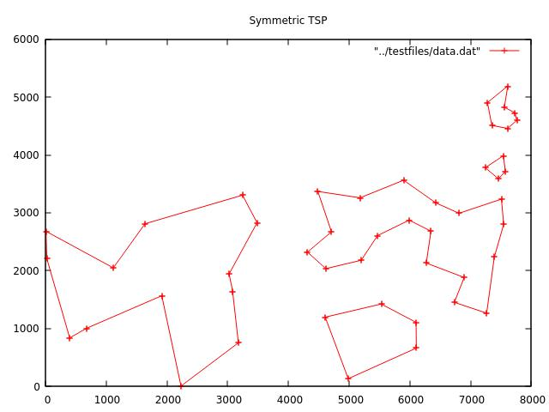

Figure 2.1: The image represent att48.tsp solved with the problem formulation showed in section 2.1

2.2 The Miller, Tucker, and Zemlin model

As said before, the basic model can create loops in the optimal solution

A rst constraint introduced to avoid this situation was described by Dantzig, Fulkerson, and Johnson. The constraint added was:

XX
x_{ij} jSj 1; 8S V : f1g 62S; jSj 2; i 6= j | (2.2)
i2S j2S

This constraint limits the number of edges in the solution, so that no cycles are al-lowed in the result. Nonetheless, the usage of this method is infeasible even with a low number of nodes since the amount of constraints needed is exponential, (O(n²)).

The model produced by Miller, Tucker, and Zemlin bypasses the exponential SECs by reducing their number to a simple polynomial. Di erently from the basic model, the graph used in this case is asymmetrical: x_{ij} and x_{ji} can have di erent weights.

In the new formulation, a new variable called u_{i} is assigned to each node of the solution. This number represents an increasing sequence number in the optimal tour: starting from the second one (u₂ = 0), each node will increase the value by 1 at each

following node until we reach the end of the solution (u_{n} = n 2). The rst node is considered special and its value is always set to 0.

This is the new constraint added to the basic model by MTZ:

u_{i} u_{j} + nx_{ij} n 1; i; j 2 f2; : : : ; ng; i 6= j (2.3)

0 u_{i} n 2; integer i 2 V : i > 1 (2.4)

2.2 The Miller, Tucker, and Zemlin model | 6

The meaning of this formulation is the following: if the arc x_{ij} is selected, then the value of u_{j} is u_{j} u_{i} + 1 .

2.2.1 Implementation of the model

To express 2.3 as a CPLEX constraint I need to rewrite (Check) the inequation in a way called Big-M. This method expects a new variable called M, that allows the system to activate or deactivate the constraint in a simple way. The new constraint will be:

u_{j} u_{i} + 1 M(1 x_{ij}) | (2.5)

With this approach, the constraint is strictly depending on the value of x_{ij}. If x_{ij} = 1 the constraint works like a normal one because the value of M(1 x_{ij}) will be 0, so the meaning of 2.5 will be the same as the one expressed in the previous section. If x_{ij} = 0 the right-hand side of the inequation will be certainly negative, making the constraint deactivated and allowing u_{j} to take up any possible value from 0 to n 2. Between all the values that M can assume, the smallest one is surely n 1 due to the fact that, in the case of X_{ij} = 0, the constraint will be still useful even if u_{i} will reach his case limit of

- 2.

Applying the Big-M trick, the constraints can be written in the CPLEX environment.
There are substantially 3 methods that can be implemented in the framework:

the use of standard constraints: all the constraints wrote in 2.3 are directly saved into the problem at once. This lead to have O(n²) constraints active, making the
- optimization too large or even too expensive to solve;

the use lazy constraints: as the name suggests, here the constraints are applied lazily. This means they are not always applied to the problem because CPLEX uses them only when necessary or not before needed. In doing so, a pool of constraints is created and every time an integer optimal solution is found, the violation of every constraint in the pool is checked. If one of them is infringed, it is added permanently to the instance. This method will hopefully make the problem smaller and faster to
- solve than the one created with the standard constraints;

the use of indicator constraints: in the rst two cases the Big-M trick is used to trigger a constraint when a particular variable assumes a predetermined value, but this method (Big-M) is not always preferable since it can behave in unstable ways. That is why a good implementation of 2.3 is the usage of the indicator constraints

provided by the CPLEX API: this method automatically activates the constraint u_{j} u_{i} + 1 when the x_{ij} assumes the user passed value.
2.3 The Gavish and Graves model | 7

2.3 The Gavish and Graves model

The second compact model implemented is the one proposed by Gavish and Graves (this model will be called GG from now on), based on the single commodity ow: the arcs are considered as pipes.

Like in the MTZ model, here too a new variable is introduced in the problem. It is called "Flow of the arc" and it is represented with the symbol y_{ij}. Compared with the model in section 2.2, the starting value of y_{ij} is n 1 and decrease by 1 at each following node in the optimal solution. To implement this proposition the following constraints are added to the instance:
y_{ij} (n 1)x_{ij} |  |  | (2.6)
_{j2}^{X}_{V;j6=1} ^{y}1j ⁼ ^{n} |  | 1 | (2.7)
i;j2^{X}V;i6=j ^{yij} | j;k2^{X}V;j6=k | y_{jk} = 1 | (2.8)

This formula nds an optimal solution without sub-tours. (vedere se aggiungere qual-cos’altro ma non credo)

Chapter 3

Other sub-tour elimination methods

In chapter 2 I described models that cut out any possibility to have some sub-tours in the optimal solution. In this section I use particular techniques to remove the tours in a faster way in relation to the one in the previous chapter.

3.1 Benders method

This method is the simplest one presented in this chapter. The basic idea is the insertion of the SECs only when sub-tours are found. This way is quite di erent from the imple-mentation of the lazy constraints of MTZ seen before: the constraints are not activated when one of them is violated, but they are manually added into the instance. This method uses the basic model described in 2.1 and follows this algorithm:

Algorithm 1 Benders

Input: G = (V; E); c : E ! <⁺
Output: z optimal solution

1: | instance | *initializing basic model*
2: | successors, component *initialize arrays*
3: | ncomp | 99999
4: while ncomp > 1 do
5: | z | CPXmipopt
6: | successors, component, ncomp build |  |  | solution(z )

- if ncomp > 1 then

8: instance add violated constraints

- end if

- end while
- return z

This algorithm shows the simplicity of the Benders method. The rst thing to do is building the basic model inside the instance of the CPLEX environment, afterwards the arrays that will contain the successors and the components are initialized. These two arrays are big enough to hold all the nodes, so they are n long. The most important

8

3.2 Callback method | 9

function in this algorithm, excluded the optimization (CPXmipopt), is absolutely the function build solution, it lls the arrays successors and components following this idea: searches all the connected components inside the solution, then each successors[i] will contain the next node inside the connected component, and component[i] will enclose the index of the component of the node i.

Then the algorithm will check the number of the connected components, saved into ncomp, and if are present more than one loops it inserts into the instance a new constraint, for each component, following this formula:

X
x_{e} jSj 1; 8S f2; : : : ; ng; jSj 2 | (3.1)
e(S)

where x_{e} are the edges contained inside the connected component S.

3.2 Callback method

In the previous section, the Benders method reaches the optimal solution of the problem through multiple calls of the CPLEX optimizer adding the sub-tour elimination con-straints if the solution found is composed of various tours. The purpose of this section is to introduce a di erent approach than the earlier one: I will exploit the branch-and-cut technique through the use of the CPLEX callbacks.

The API provided by IBM’s software grant the use of some callbacks during the opti-mization process. CPLEX provides a wide range of possibilities such as informational callbacks, query/diagnostic callbacks, and control callbacks. The rst ones give the user additional information on the current optimization without a ecting the performance or interfering with the solution search space. The second one access to more detailed infor-mation compared to the informational callbacks but can a ect the overall performance of the problem resolution; the query/diagnostic callbacks are also incompatible with the dy-namic search and deterministic parallel functions. The last ones are the one I am going to use and they allow the user to alter and customize how CPLEX performs the optimization.

During the optimization process, CPLEX will nd numerous possible solutions. Sup-pose that during operation a candidate solution x is found. Then if the cost of this new result is better than the anterior one the software will update the current best solution with the last found. Otherwise, the candidate is considered infeasible and is rejected by the system.

The CPXcallbacksetfunc method will set my custom callback that will be used every time a candidate solution is found. The algorithm adopt the same method explained in section 3.1 (build solution). In fact inside the callback if more than one connected component is found a new SEC is added to the instance of the problem and the candidate

3.2 Callback method | 10

solution is rejected (through the function CPXcallbackrejectcandidate).

The real di erence between this implementation of the branch-and-cut and the Benders method is that while the last one needs the iteration of various optimizations processes this one rejects the possible solution aforehand it is provided to the user. The algorithm used is the following:

Algorithm 2 Callback method

Input: G = (V; E); c : E ! <⁺
Output: z optimal solution

- procedure Main(G = (V; E); c : E ! <⁺)
2: | instance | *initializing basic model*
3: | instance | *instance [ custom callback*
- zCPXmipopt

- return z

- end procedure

- procedure customCallback(z)

- ncomp build solution(z)

- if ncomp > 1 then

- *Add SEC and reject candidate solution*

- end if

- return

- end procedure

3.2.1 Callback on the fractional solutions

In the previous section, the callback was called on each integer candidate solution. This sector will describe the use of the callback even on the fractional solution.

The object of this idea is to save computational time by adding new SECs that are probably common in the decision tree. The procedure de ned in this phase is the same in section 3.2, except that this callback is applied in the continuous relaxation of the problem. To implement this kind of operation I used an external library called Concorde [2]. This library is written in ANSI C and is one of the most powerful tool on the market: it can solve really large instances of the TSP problem to the optimal solution.

When the callback is called I use the library mentioned above to compute which SEC I require to exclude the fractional solution from the decision tree.

Chapter 4

Non optimal solutions

In this section I am going to explore a new branch of the TSP resolution. Now the discovery of an optimal solution is no longer important. This can be achieved through the use of the matheuristic and heuristic to nd a solution, with a great approximation to the optimal one, even with instances including millions of nodes. In this chapter I am going to cover di erent approach such as: matheuristic methods, heuristic and metaheuristic algoritms.

4.1 Matheuristics

As aforementioned in this chapter I am going to explore how big instances can be solved when the classical methods, such as MTZ and GG, would take too long to be solved to the optimal value. This section will explore the concept of matheuristic that combine mathematical programming and heuristics techniques. "The objective of a heuristic is to produce a solution in a reasonable time frame that is good enough for solving the problem at hand. This solution may not be the best of all the solutions to this problem, or it may simply approximate the exact solution. But it is still valuable because nding it does not require a prohibitively long time" [3].

The two techniques that I will explore are the hard- xing and the soft- xing.

4.1.1 Hard- xing

The main purpose of this method is to try to reduce the search space by cutting down the complexity of the optimization. For achieving this an initial feasible solution is needed, obtained by any approach described in this report.

The central thought of hard- xing is to obtain an easier problem by previously setting some variables of the solution passed to the method - and so by having fewer variables to compute. The variables that are going to be xed are x_{ij}, i; j 2 V . This task is done by settling the values to 1, so the edge will be surely part of the solution. A valid method

11

4.1 Matheuristics | 12

to choose which path is chosen to be xed is to link each edge to a probability 0 < p < 1,

then setting randomly - with the probability picked - the value to 1.

Hereupon the problem will have presumably p jEj variables xed and the instance can

be solved with a lower e ort, this will bring to a hopefully better solution. Although the

choice of using a probability is a good pick, any other method can be used to block the

edges.

The performance of this technique is strictly related to the choice of the rst feasible

solution, if it is not good enough this approach will get stuck on some non-optimal solution.

A good x is to lower down p whenever the solution is not improved for a predetermined

amount of time.

Algorithm 3 Hard- xing

Input: G = (V; E),c : E ! <⁺, global timelimit, iteration timelimit

Output: z hopefully good solution

1: instance *initializing model (any of this report)*

- z CPXmipopt *with nodelimit 0*

- p 0:9

- i 0

- while time elapsed < global time limit do

- if time remaining > iteration timelimit then

7: instance *set timelimit to iteration timelimit*

- else

9: instance *set timelimit to time remaining*

- end if

11: instance *hard- xing with probability p*
- z_{new} CPXmipopt

- if cost(z_{new}) < cost(z) then
- z z_{new}
- i 0

- else

- i i + 1

- end if

- if i = 10 then

- p p 0:1

- end if

22: instance *remove hard- xing*

- end while

- return z

In this algorithm, there are some variables never mentioned before: the global time-

limit and the iteration timelimit. As aforementioned the hard- xing is a technique that

aims to obtain a good solution in a short amount of time. So the parameters described

above are necessary to establish - as the name suggests - the timespan in which the

optimization is solved: global timelimit is the total time reserved to the solver, intera-

tion timelimit is the duration of each optimization in which the hard- xing is applied.

4.1 Matheuristics | 13

In the algorithm, the initial solution is provided by the solver, limited in the depth of its analysis. Then algorithm 3 starts to iterate the main process until the global timelimit is reached. During this phase the optimization is called several times, in each of which the instance is solved blocking some variables to 1.

4.1.2 Soft- xing

The technique described is called Local Branching. Since it is a slight modi cation of the hard- xing it is also called soft- xing.

In section 4.1.1 the value of the variables is xed in a manual way using a probability system. In local branching this operation is performed by adding a new constraint that forces the instance itself to block a predetermined number of variables, giving a degree of freedom to the solver on which variable to x and which not.

The main idea of soft- xing is the Hamming distance: "it measures the minimum number of substitutions required to change one string into the other" [4]. This description can be applied also to vectors. So given two vectors x and x~ in f0; 1g the hamming distance is the number of di erent bits they have. It can be described in this way:

j | X_{j} | X_{j}
H(x; x~) = | (1 x_{j}) + | ^{x}j | (4.1)
 | :~x =1 | j:~x =0

Considering that the output solution of the solver is a vector in f0; 1g it is possible to insert into the instance a new constraint that limits the hamming distance between the old solution and the new one. Since the number of edges active in each solution is forced to be n = jV j and therefore the Hamming distance is computed one the di erences in the bits equal to 1, it is possible to reduce 4.1 to:

j | X_{j} | X_{j}
H(x; x~) = | (1 x_{j}) = n | x_{j} | (4.2)
 | :~x =1 | j:~x =1

I recall that the purpose of this method is to limit the diversity of two solutions it is possible to add a new variable k. This will be the value that will limit the Hamming distance. Through elementary math this formulation is built:

X_{j} | j | X_{j}
H(x; x~) k ) n | x_{j} k ) | x_{j} n k | (4.3)
j:~x =1 |  | :~x =1

The e ect of 4.3 is to narrow the next iteration of the optimization to a k-neighborhood of the previous one. As the method described in section 4.1.1 the value of k can vary if for a predetermined number of times the optimization doesn’t improve the value.

As it is evident the algorithm 3 and 4 are almost identical. The unique change is upon the variable used and the constraint added to the instance. In this implementation, the
4.1 Matheuristics | 14

Algorithm 4 Soft- xing

Input: G = (V; E),c : E ! <⁺, global timelimit, iteration timelimit

Output: z hopefully good solution

1: instance *initializing model (any of this report)*

- z CPXmipopt *with nodelimit 0*

- k 2

- i 0

- while time elapsed < global time limit do

- if time remaining > iteration timelimit then

7: instance *set timelimit to iteration timelimit*

- else

9: instance *set timelimit to time remaining*

- end if

11: instance *soft- xing using a k-neighborhood*
- z_{new} CPXmipopt

- if cost(z_{new}) < cost(z) then
- z z_{new}
- i 0

- else

- i i + 1

- end if

- if i = 10 then

- k k + 1

- end if

22: instance *remove soft- xing*

- end while

- return z

4.2 Heuristics | 15

value of k is implemented by 1 every time the solution is not improved for 10 times.

4.2 Heuristics

In this section the concept of heuristic is explored in some of algorithms used to solve the

TSP problem. In particular a set of methods will be presented such as greedy algorithm,

extra mileage, and 2-opt optimization.

4.2.1 Greedy algorithm

This type of method is the easiest to understand and implement. This heuristic has its

base on the concept to construct the shortest path by connecting the nearest nodes.

This algorithm starts from an arbitrary node and chooses its following node by select-

ing the nearest one from the ones that are not already in the path. This greedy approach

is also called Nearest Neighbor.

The main side e ect it has is that the shortest path is easily missed since the last

nodes - apart from special cases - are far from each other. In this way, the optimal solution

is surely not selected. The algorithm is the following:

Algorithm 5 Greedy

Input: G = (V; E),c : E ! <⁺
Output: z hopefully good solution

1: best cost +1

- z *empty*
3: | for start |  | node |  |  | 1 to n do
4: | current |  |  |  | node | start |  | node

- while *each node is visited* do

6: candidate node 1

- for i 1 to n do

- *Finds the nearest node and marks it as visited*

9: candidate node *nearest node*

- end for

- *Saves candidate node as next node*

12: current node candidate node

- end while
- if cost(z_{curr})< best cost then

15: best cost cost(z_{curr})

- z z_{curr}
- end if

- end for

- return z

This algorithm describes exactly the behavior of the greedy algorithm. In my im-

plementation, each node is tested as starting node to obtain the best nearest neighbor
4.2 Heuristics | 16
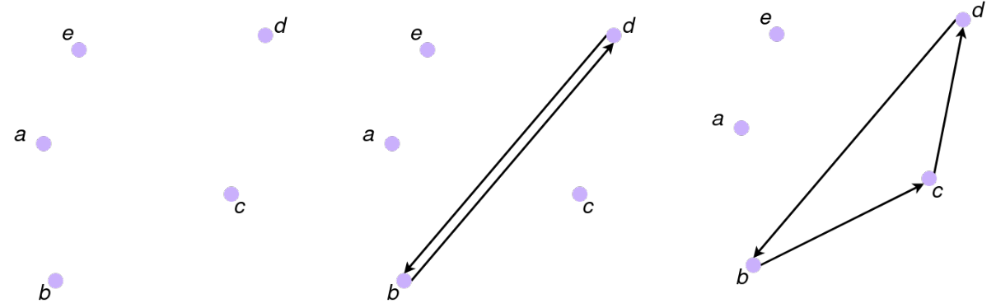

(a) No edges
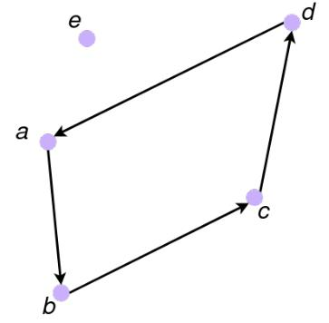

(b) First two edges added

(c) One edge is substituted with other two connecting one more node
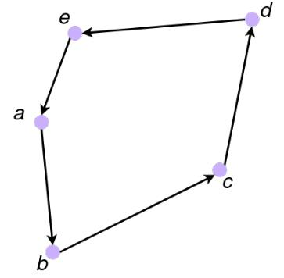

(d) Added one more node (e) All nodes are connected

Figure 4.1: In this image we can see the process done by extra-mileage to nd the solution.

solution. The classic implementation has a complexity of O(n²) since each node has to search the nearest node all over the graph. In particular 5 has a complexity of O(n³) because of the aforementioned method to select the best starting node.

This complexity is quite low but with some instances with a great number of nodes can be slower than expected.

4.2.2 Extra mileage approach

This approach is more complex than the previous one but in favor of a better solution. The main idea behind this algorithm is very simple and it starts from an empty solution and provides a good solution.

It starts with connecting with a cycle the farthest nodes in the instance, this will be the beginning of the solution. Then the closest node among the active edges is selected and is added to the solution. This action is performed by replacing the edge with two more that allow the new node to enter the solution.

The process can be seen in gure 4.1 where it is performed with a bunch of nodes.

The method with the next node to be inserted is chosen is the triangle inequality. Actually, with the replacing phase, some cost is added to the solution. Imagine taking into consideration three nodes (x; y; z), where x and y are already in the solution and z

4.2 Heuristics | 17

wants to join them. The mathematical operation to use is the following:

(x; y; w) = c_{xw} + c_{yw} c_{xy} | (4.4)

This value will always be positive thanks to the aforementioned triangle inequality which states that the sum of the lengths of any two sides must be greater than or equal to the length of the remaining side.

The algorithm used is the following:

Algorithm 6 Extra mileage

Input: G = (V; E),c : E ! <⁺
Output: z hopefully good solution

- x; y * nds the farthest nodes*

- z Add(x; y)

- while jzj < n do

- (x; y; w) argmin( (x; y; w) : x; y 2 z; w 62z)

- z Add(w)

- end while

- return z

4.2.3 2-opt re ning

This section will analyze one re ning technique. The target of this approach is to take an existing solution x and try to take it closer to the optimum one.

A method to do so is represented by the k-opt re ning that consists on rearrange k edges in order to obtain a new solution with a lower cost. In particular, this section it is describes the 2-opt re ning.

To apply this approach e ectively it is applied starting from a solution obtained with a heuristic approach such as the ones described in section 4.2.1 and 4.2.2. The idea of this algorithm is to remove all the crossing edges and insert new edges that will decrease the cost of the nal solution.

To do so it is used the triangle inequality, is used to nd the couple of edges that allow the best improvement of the solution. In this implementation the operation is done across four nodes: i, succ[i], j, and succ[j]. Since the tour is asymmetric it has a direction, succ[i] and succ[j] are respectively the following nodes in the path of the nodes i and j.

(i; j) = (c_{i;succ[i]} + c_{j;succ[j]}) (c_{i;j} + c_{succ[i];succ[j]}) i; j 2 V ; i 6= succ[j]; j 6= succ[i] (4.5)

In 4.5 in is described the correct way to compute the delta of the method. Greater the value, better the improving.
4.2 Heuristics | 18
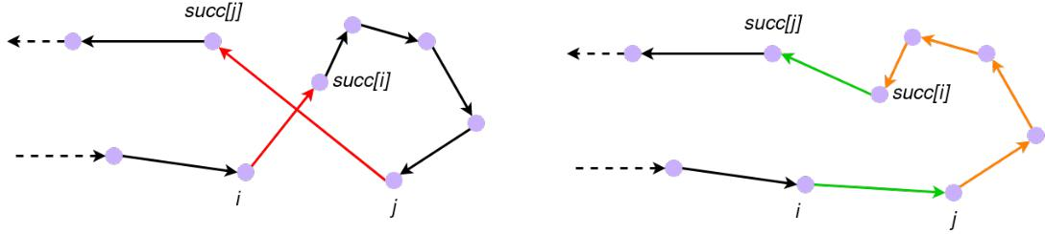

Figure 4.2: The image represent the replacement of two edges during the 2-opt re ning.
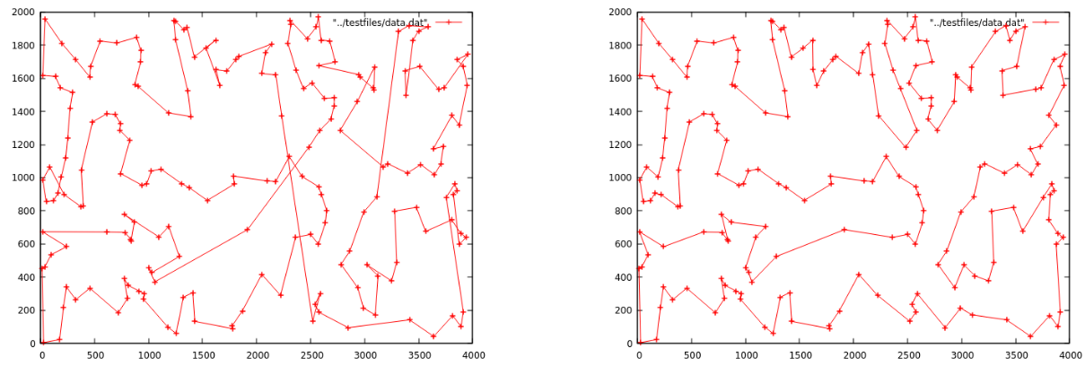

Figure 4.3: The improvement obtained applying to a greedy algorithm (left) the 2-opt re ning approach (right).

In gure 4.2 it is possible to notice the replacement of two arcs. A detail to give atten-

tion to is that the path from i and succ[i] changes direction after the substitution of the

old edges, this is done to maintain the solution integrity. In particular, this optimization

is performed until no more (i; j) positive are found, in that case, the solution is no more

improvable by the 2-opt algorithm.

Algorithm 7 2-opt re ning

Input: G = (V; E),c : E ! <⁺
Output: z hopefully good solution

- z * nd feasible solution with an algorithm*

- ag f alse

- while f lag == f alse do

- ag true

- (i; j) argmax( (i; j) : i; j 2 V )

- if (i; j) > 0 then

- ag f alse

- z *edge replacement*

- end if

- end while

- return z

References

- Fischetti M., Lezioni di Ricerca Operativa, Aprile 2018.

- Concorde TSP Solver, https://www.math.uwaterloo.ca/tsp/concorde.html, last consultation: 02/02/2022.

- Heuristic (computer science), https://en.wikipedia.org/wiki/Heuristic_ (computer_science), last consultation: 02/02/2022.

- Hamming distance, https://en.wikipedia.org/wiki/Hamming_distance, last consultation: 05/02/2022.

19

