Using Your Old PicoBoard Homemade Sensors

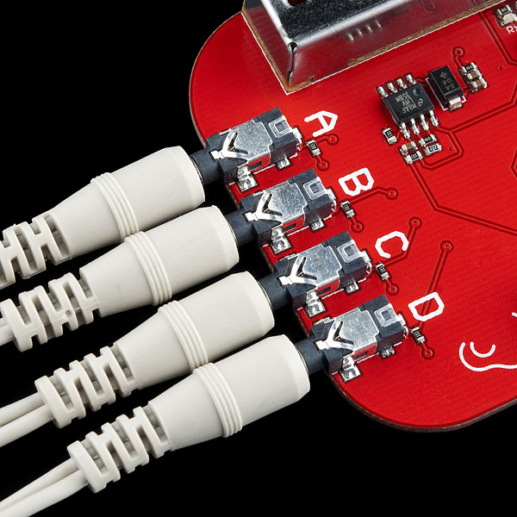
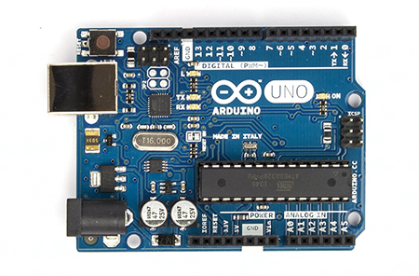
There are lots of resources on how to make very fun sensors for Scratchboards/Picoboards especially on the Technology Volunteers website: http://go.warwick.ac.uk/scratchresources. However these resources aren’t just limited to the Picoboard, they can be used with Arduino too!
Simply construct the below circuit and connect your picoboard sensors up to it. Do note that whereas the Picoboard gives sensor values from 0 to 100, the Arduino gives sensor values from 0 to 1023 in Scratch.
Connect these two leads to your Picoboard sensor. (These replace the crocodile clips)
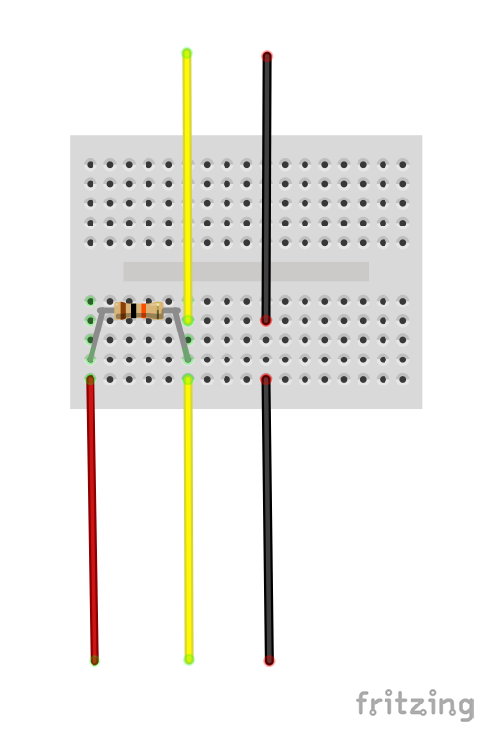
10K ohm Resistor
5V
GND/0V
Analog Pin
The Analog Pin can be any available analog pin on your Arduino such as A0,A1,A2,...
You can then read that pin in Scratch to get your sensor value.
Arduino Pins

