Using an Arduino with Scratch V2.0

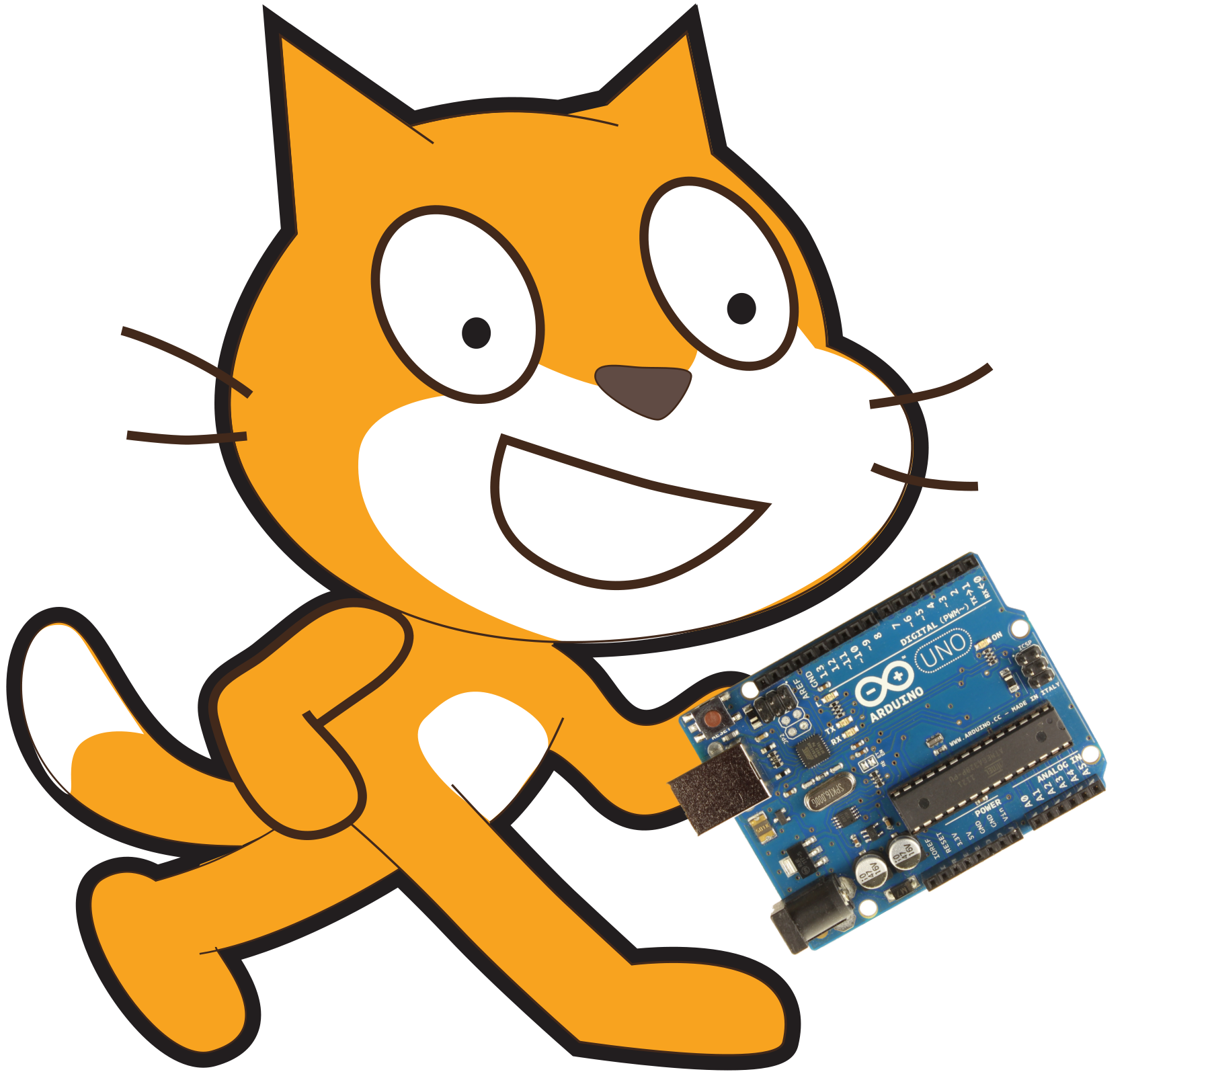
This document is designed to guide you gently through the process of getting the Arduino working with Scratch V2.0. We shall achieve this through the use of a program called A4S.

- Firstly download A4S from here: http://thomaspreece.com/resources.php and install the program to your computer.
- Plug in your Arduino into your computer.
- Launch the A4S program and follow the on screen instructions for Step 1, Step 2 and Step 3.
- Your Arduino is should now be working with Scratch V2.0. You can now find the Arduino blocks in the 'More Blocks' section. You should notice that they are under the title 'A4S (Arduino For Scratch)' and if all is working correctly there should be a green circle next to this title.

