Using an Arduino Esplora with Scratch V2.0

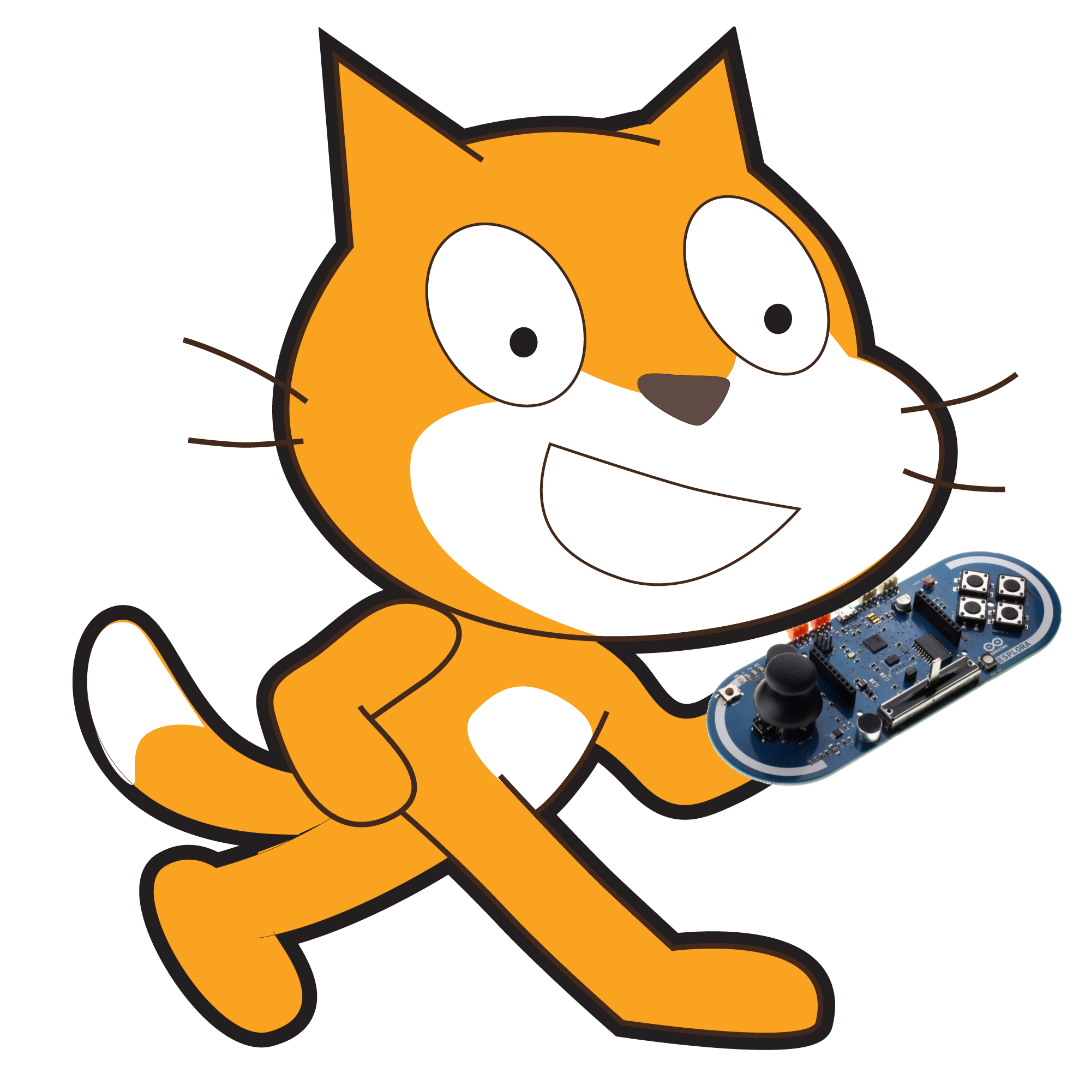
This document is designed to guide you gently through the process of getting the Arduino Esplora working with Scratch V2.0. We shall achieve this through the use of a program called A4S.

- Firstly download A4S from here: http://thomaspreece.com/resources.php and install the program to your computer.
- Plug in your Arduino Esplora into your computer.
- Launch the A4S program and follow the on screen instructions for Step 1 and Step 2
- For Step 3 follow the instructions but when it tells you to load the ImportBlocks.sb2 file ignore that and instead load the EsploraBlocks.sb2 from the same folder.

Your Esplora and Scratch are now working together and you should continue through the rest of the Arduino-Scratch worksheets before coming back here to read about the advanced features of the Esplora.

Advanced Features

Now in Scratch click on the stage sprite and you should see something like below. These purple blocks are helper blocks to make it easy for you to use the sensors connected to the multiplexer.

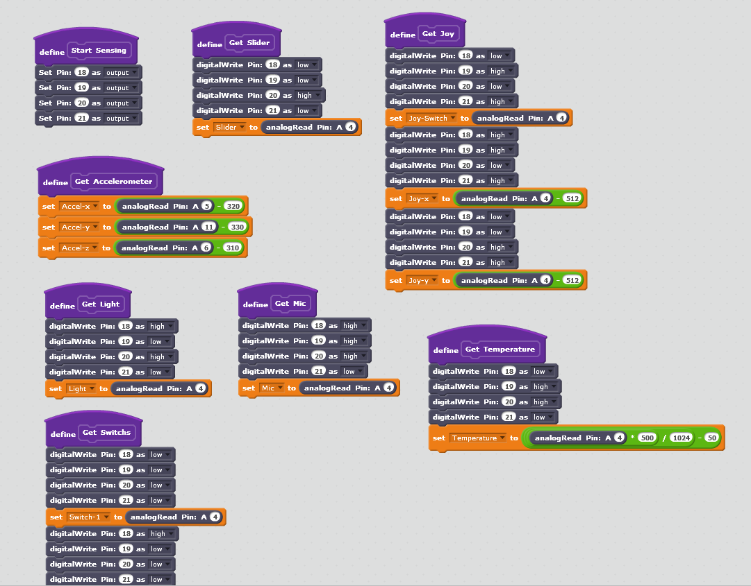

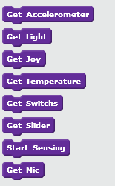

You will also notice that clicking on More Blocks while on the stage sprite gives you a list of new blocks like the ones on the left. Basically each of these blocks when placed in your code executes the blocks in the paired Define block of the same name. So using the block 'Get Mic' is the same as using the 5 blocks below the 'define Get Mic' block.

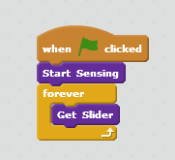
Each of these blocks has been made to get one or more sensor values from your Esplora and put those values into Scratch variables. So 'Get Slider' gets the value from the Esplora's slider and puts it into the 'Slider' variable (which is available from the Data block section). Before we can use any of the Get Sensor blocks we must first call Start Sensing. This only has to be done once so you can stick it at the top of your code. Copy the code on the right into your Stage on Scratch. Then make sure that in the Data tab you have the Slider variable ticked like the picture.

Now click the green arrow to start your program. Move the slider on your Esplora and you should see the value in the Slider variable change depending on how you move the slider. You can then use this variable with your other sprites to do many things such as moving the sprite or changing its colour. Each of the sensor values has will return a value between 0 and 1024.

How do the purple blocks work?

Because there is too many analog pins for the Esplora to handle naturally we use the inbuilt multiplexer. The multiplexer allows us to use the Esplora's 5 analog pins A0 to A4 (With A0-A3 also called pins 18-21 in Scratch), to return 13 different analog sensors. This works by setting each of the pins A0 to A3 to either high or low and depending on this combination the multiplexer gives us one of our sensor values on pin A4. So in each of our purple blocks we are setting pins 18-21 (also called A0-A3) to high or low and reading A4 to get that sensors value. If you want to know which pins to set high and which to set low for a specific sensor please read the EsploraPinout document.

