River Flow Calculation

As the next step, we would like you to write a solution to the River Flow problem as discussed on the whiteboard during our previous meeting. Use your strongest language to implement the solution, provided it is one of the objected oriented languages of C#, C++, or Java. The timeframe is at your convenience, so please take the time to write production-quality code (clean and tested). Feel free to specify any assumptions that you’ve made, along with any missing details that would complete the solution.

If you require further clarification, then please do not hesitate to ask.

Problem:

To calculate the volume of water that moves through a specific point in a stream. To determine the river flow, the cross-sectional area of the stream is multiplied by the velocity of the river. Consider improved accuracy of the flow, by sectioning the cross-section in order to take multiple measurements of the depth and velocity (as shown in the diagrams below).

River Cross Section:

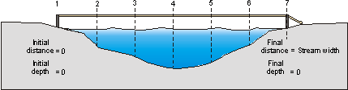

River Velocity:

