**Specification  
  
TrendTrader**Version 1.4  
2022-07-29

**AutoTrade**

An Autotrade is a combination of a Qualifier, Candidates, Quantity, and an Order-template.

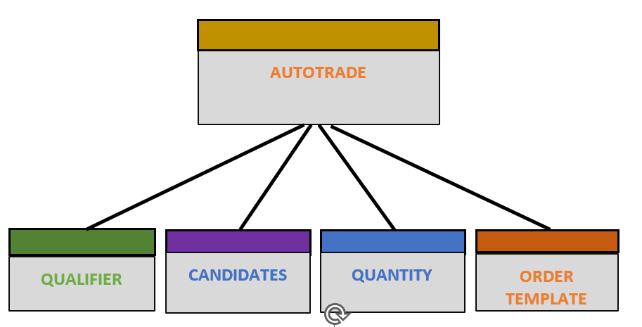

**PROCESS**

**Main form**

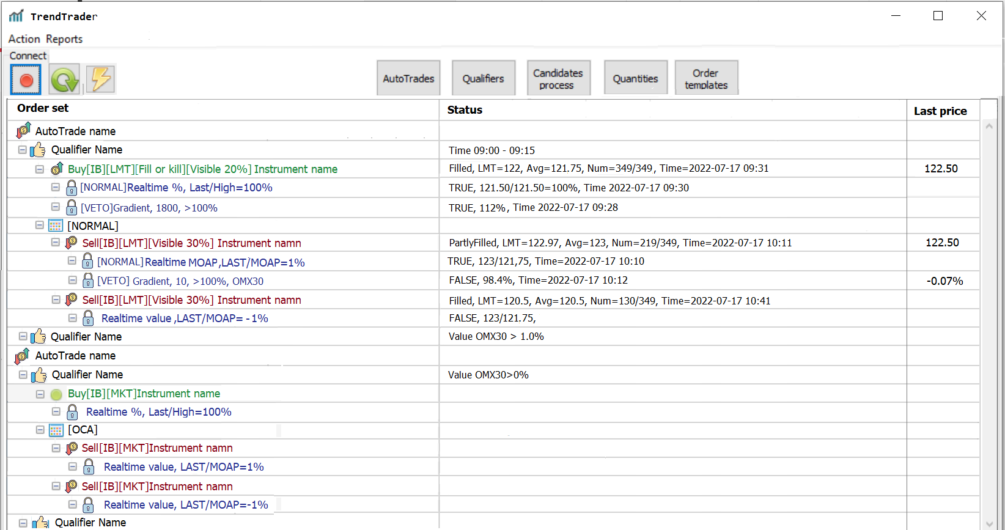

**Status kolumn/AutoTrade**  
Empty  
  
**Status column/Qualifier**1. [Compare]Instrument1>Instrument2 *and/or*  
 [Value]Instrumet>X *and/or*  
 [Time]From-To *and/or*  
 [Parse] Parse name  
  
**Status column/Order**  
1. Status: PendingSubmit, PendingCancel, PreSubmitted, Submitted, Cancelled,  
 Filled, PartlyFilled, Sleeping, Error *or* Not Considered  
2. Limit order: If LMT then LMT=X  
3. Average price: Avg=X  
4. Numbers: Num=Received/Total number in order  
5. Time last : Time

How it will work:

1. En bild som visar text

   Automatiskt genererad beskrivningWhen clicking on START button  on main form all active AutoTrades will start and be visible on main form. An AutoTrade is active when its active checkbox is checked. An active AutoTrade will become TRUE when its qualifier is TRUE.  
     
     
     
     
   If none of the three upper checkboxes are checked in the AutoTrade-form, is automatically TRUE otherwise all its checked conditions must be true.
2. When an AutoTrade becomes TRUE its qualifier will be visible. and it will start its Candidates process.

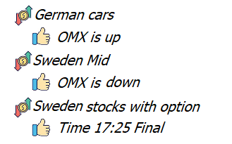

1. When there are instruments (candidates) in a candidates-list which reach up to the candidate’s limit, an order set will be created from the Quantity and the Order template. The mother orders in those order groups will then be visible in the monitor form. Factor will not be used in AutoOrder. The choice of instrument is included in Order and Condition.

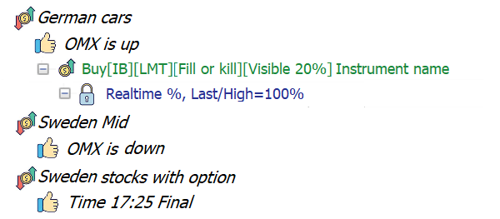

1. When mother order is *filled*, the order group with child orders will be visible.   
   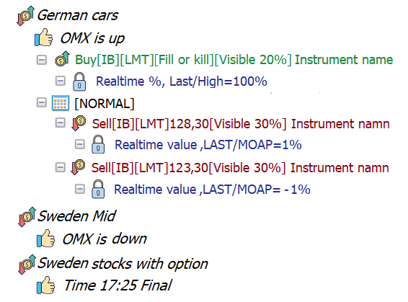
2. If “*Hide filled orders”* is checked this Auto order will be removed.

**AutoTrade**  
An AutoTrade has a name and must include one Qualifier, one Candidates process, one quantity and one order template. It can be active or not.   
If it’s not active, it will never start.   
If it is active, it will start when its qualifier is true.

All AutoTrades has a name and must include one Qualifier, one Candidates process, one quantity and one order template

**Qualifier**A Qualifier is a part which activates an AutoTrade.   
A Qualifier will be true and activate it’s AutoTrade if it’s active itself and all other checkboxes which are checked have conditions which is true.   
If no checkbox is checked the **Qualifier** is true.   
  
Parse will be specified later. It will be an external applications that send a signal to our application. (Example: An application search text from Reuters and find “big order to Volvo cars” it will then send signal to our application)   
When clicking on Qualifier button you open the Qualifier-List.

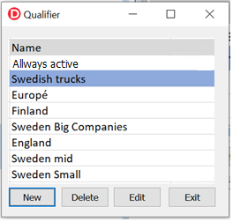

When double click on an item or selecting New or Edit you open the Qualifier-form.

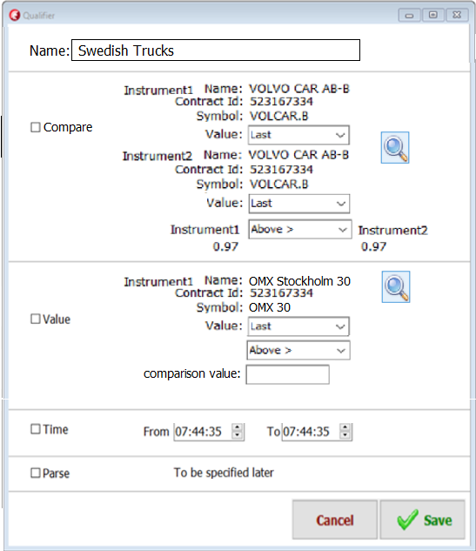

**Candidates process**(change name from Scan to Candidates process)

In the candidates-form we produce a list of instruments.   
The list is produced with *IBScanner, Static lists, Added columns* and *Gradient*. All rows in the candidate list will have a ranking sum. This sum is produced by adding each columns value multiplied by its weight value. This ranking sum is compared with Candidates limit and if the ranking sum is grater or equal to this limit the instrument is ready to be processed in an *AutoTrade*.   
The most important part in the candidates process is the *IBScanner* which allow you to search and create a list of instruments which have behaved in an asked way.   
You need to add at least one *Static list* or one *IBScanner*to produce a list. There can maximum be one IBScanner and maximum one Gradient but there can be several static lists and several added columns.  
The list is continually updated in real time.

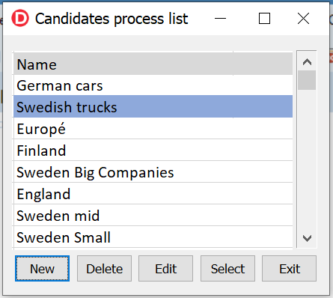

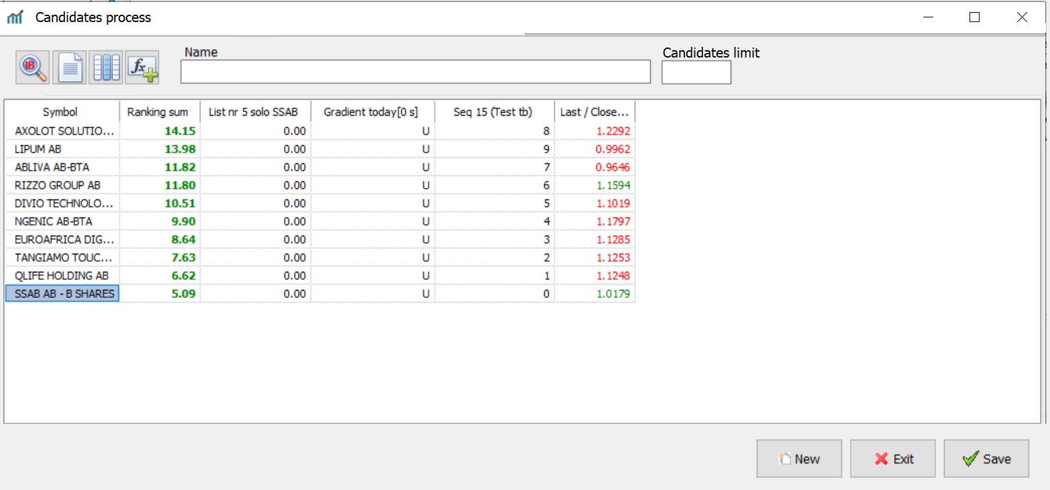

 Opens IBScanner. Opens Gradient.

**Candidates / IBScanner**(Change name from MarketScanner to IBScanner)

IBScanner is a functionality which produce a list of instruments. It can find instrument in almost every part of the world which have behaved in a specific way.   
To produce this, you select:

1. A region and type. (Example: “Europe Stocks”)  
2. A location. (Example: “Sweden (SFB)”)  
3. A parameter (Example: “Top % Gainers Since Open”)  
4. You may add extra filters (Example: “Revenue over 200 000 000”)

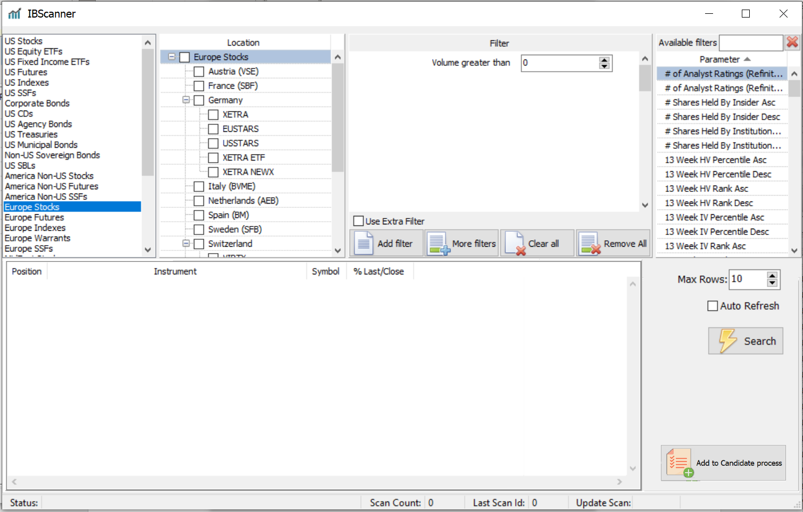

Erase “Exclude instruments”. It’s not necessary. It can be done with a Static list added to candidate list with  function.

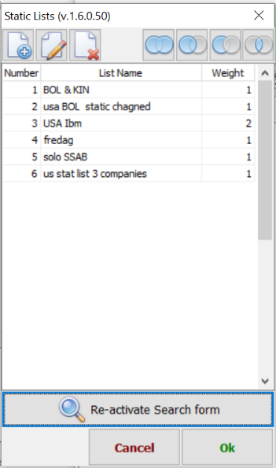  
**Candidates / Static list**This is user produced lists. A static list includes a number of instruments which can be used when collecting candidates.  
First open all static lists: Editing or adding a new list with  :

**Adding functions**When adding a list to the candidate process there is four   
types of adding function:   
(1) Add all instruments/values in the statis list to candidates,   
(2) Add only instruments/values from static list which already exists in candidates.  
(3) Erase candidates which exists in static list.  
(4) Keep only candidates which exists in both lists.

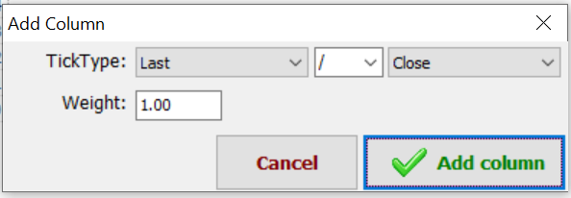**Candidates / Add columns**You can add new columns to the Candidates process and give them weight value.

**Candidates / Gradient**  
The Gradient function indicates the direction the price is going the last X seconds. It is a value produced by the price different divided by price X seconds ago. This value can also be multiplied with a weight value.  
Example: If last price is 100 and X is 10 seconds and the price 10 seconds ago was 99,85 and weight value is 1000 then   
Gradient value is 1000*(100-99,85)/99,85 = 0,2003.

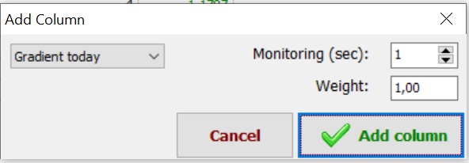

**Quantity**

Each AutoTrade has a quantity. It decides how big the amount is to spend in total and how big the amount is for each order. It’s also saying what currency is used.  
If an instrument is ordered in another currency the amount must be converted.  
The total amount is the sum of all activates mother orders which uses this specific Quantity.

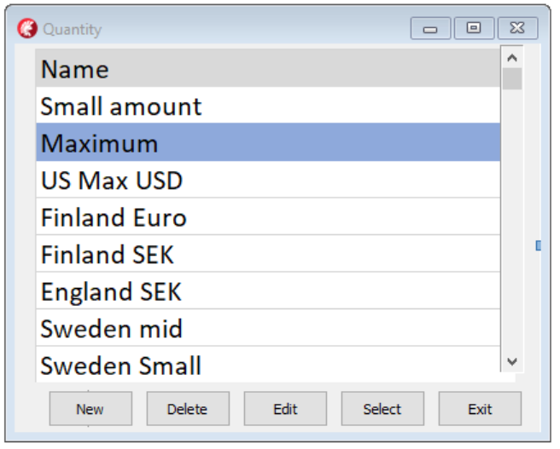

Clicking on Edit will open this dialog.

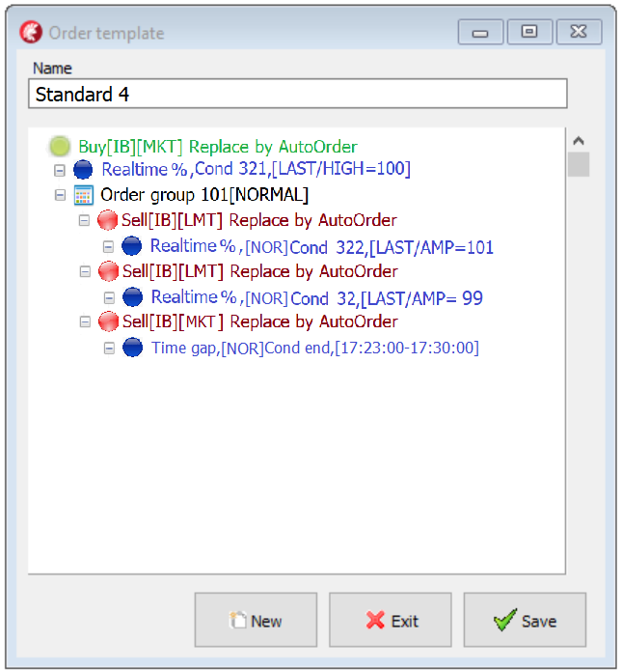**Order templates**  
  
An order template consist normally of a   
mother order and an order group with   
child orders. Normally the mother order   
is a buy order and the child orders are   
normally sell orders. But it can be the   
opposite.  
  
When clicking on the order-template   
button on main form you open   
the order-template-list.  
You can edit an order template with  
New or Edit -button or with a double click.  
  
  
  
When starting a new template,   
you open a window tree structure   
including only one mother order.  
When the mother order is selected   
the pop-up menu includes look like this:  
  
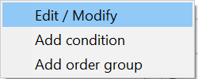  
  
For “Edit / Modify” se Order.  
For “Add condition” se Condition.  
If an order group already is added   
then “Add order group” is disabled.  
Next step is to “Add an order group” .   
Se Order group.

**Order Group**  
An order group decides how its child orders shall behave.  
  
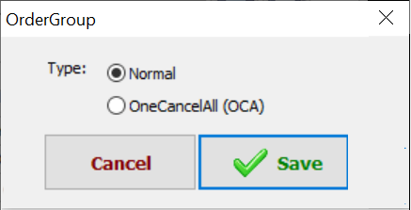  
  
*Order Group “****Normal****”*This order group type activates and deactivates different orders depending on what happens to the price of the instrument in question.  
Example:  
Mother order buys 200 shares for SEK 20000 (MOAP=100).  
The first child orders condition that becomes true will send its order to TWS.  
If another orders condition becomes true the first order will be canceled and this order will be send to TSW with the number of shares which is remaining.  
If a third orders condition becomes true the second order will be canceled and this order will be sent to TSW with the number of shares which not sold. Etc  
  
If an order is a limit order it is not certain that you will succeed in selling / buying all the shares. Example:  
 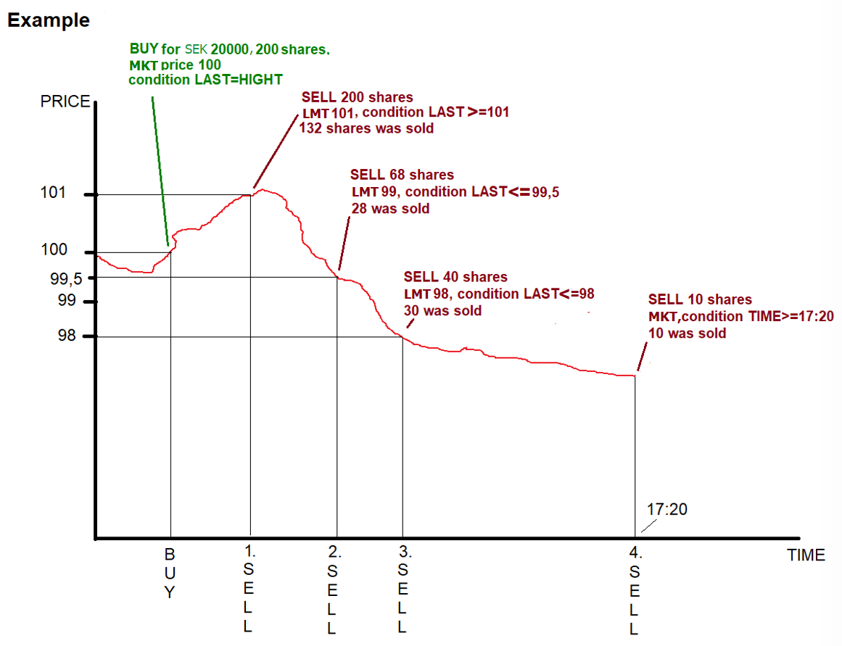  
In the same way, you do not know what price you have to pay for the mother order. Therefore, it is important to calculate the Mother Order Average Price (**MOAP**).   
Example:   
If you want to buy 100 shares and manage to buy 700 for SEK 100 and 300 for SEK 101, the average price will be   
(700 * 100 + 300 * 101) / 1000 = SEK 100.30

We don’t want to sell instruments and the buy the same back again because they still in candidate list with a value over the limit value.  
So, if sale order becomes active and the instrument is still in candidate list with a value over the limit value, do recalculate all limit values for all orders in the order group.  
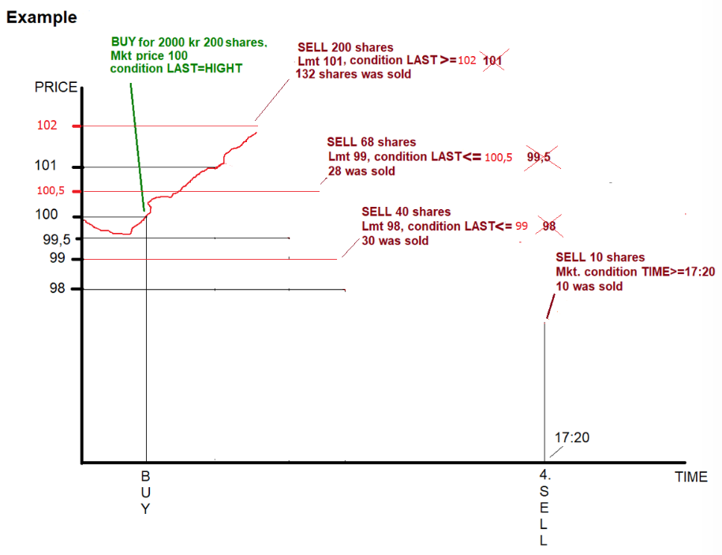  
*Order Group “****OneCancelAll****”*The first orders condition that becomes true will send its order to TWS.  
The other orders in the group are canceled.

**Order**  
  
An order is either a BUY or a SELL.  
The order type is either a market order (MKT) or a limit order (LMT).  
If it is a limit order (LMT) it has set a limit. The limit is set when the   
order is executed and is calculated as a % from the last price at that moment.  
  
*Example:   
If the limit order is a BUY-order and is executed when last price is 100 and  
then limit percent is 0,5 then the limit is 100,5.  
If the limit order is a SELL-order and is executed when last price is 100 and  
then limit percent is -0,5 then the limit is 99,5.*  
Scope is NONE or FILL OR KILL.   
NONE means I receive what the market can give me.  
FILL OR KILL means: I will receive everything or nothing. If the market can’t fill the order, it will, otherwise I receive nothing.   
If visible part is less the 100%, only a part of the order will be visible on the market.   
  
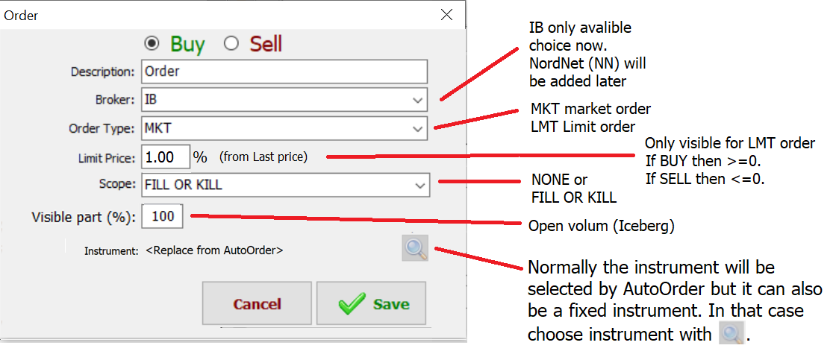

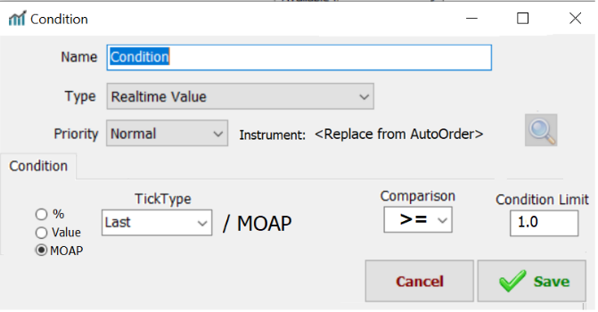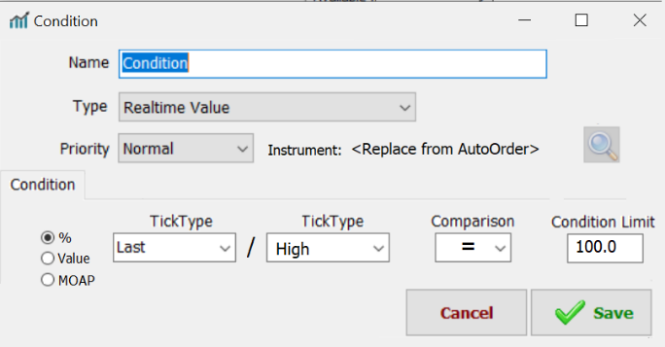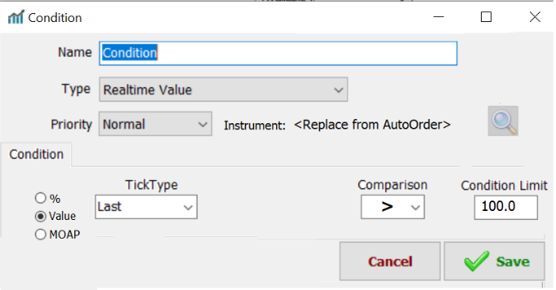**Condition**  
  
A Conditions has a Description, a Type, a Priority, an Instrument.  
A Condition is either false or true.  
There can be several Conditions connected to an order.  
All Conditions together decides if the order shall be executed or not.  
What decides if the order shall be executed or not are two things. It is if a Condition is true or not and its priority.  
The instrument which the condition uses is normally set by the Auto Order, but it can also, as an option, be set manually.  
TickType: **Last, High, Low, Bid, Ask, Bidsize, Asksize, Volume,   
 Open, Close** and **NotSet**Comparison: **=** (Equal) **>** (Above), **>=** (Above or Equal),   
 **<** (Below), **<=** (Below or Equal)  
**Condition/Priority**  
  
If Priority is **Normal** then this Condition together with all other condition with priority **Normal** must be true.  
If Priority is **Exclusive** then it is enough if this Condition is true.  
If Priority is **Veto** then this Condition must be true.  
  
**Condition/Type**  
The types can be **Realtime %**, **Realtime value**, **Realtime MOAP**, **Time gap** or **Gradient**.  
  
**Realtime %**  
This condition divides two TickTypes with   
each other and compare with a condition   
limit.  
This condition becomes true if the   
last price is the highest price today.   
Value%=100*(Last/High)  
  
  
**Realtime value**   
This condition becomes true if the   
last price for Volvo Cars AB-B   
passes 100.   
  
  
 **Realtime MOAP**  
This condition compares the Last price with  
the *mother order average price* (MOAP).  
It is only useful for child orders.  
In this example it becomes true if the   
last price 1% higher than MOAP.  
*Condition value=100*(Last price - MOAP)/MOAP*

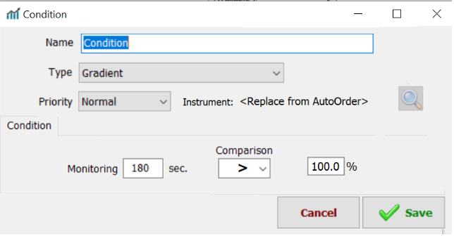**Condition/Time gap**  
This condition compares the current time  
with gap time.  
In this example the condition is true   
between 17:23 and 17:30.  
 **Condition/Gradient**  
This condition compares the last price   
for an instrument with the price   
X seconds ago.   
In this example the condition is true   
if the price is higher than it was   
180 seconds ago.  
X0=Price now (Last Price)  
X1=Price 180 sec ago.  
  
Value%=100*(X0/X1)

**Orders set**

An order set is containing one mother-order and a group of child-orders.  
It is created from an order template.

Example:   
In the mother-order I buy 1000 shares of IBM for SEK 100 each.  
Total cost SEK 100.000. Mother order average price (MOAP) is SEK 100 /share.  
  
I then like to sell them all if they go up 1% with a limit price of 1%  
If they go down 1% I likes to sell them with no limit (market-order)  
If nothing happens I like to sell them at 17:20 (before the market close)  
So it will be one mother-order and 3 child-order.

**Instrument search**

