AutoTrade
An Autotrade is a combination of a Qualifier, candidates, quantity and an order-template.
AUTOTRADE

Qualifier
Order template
CandidateS
quantity

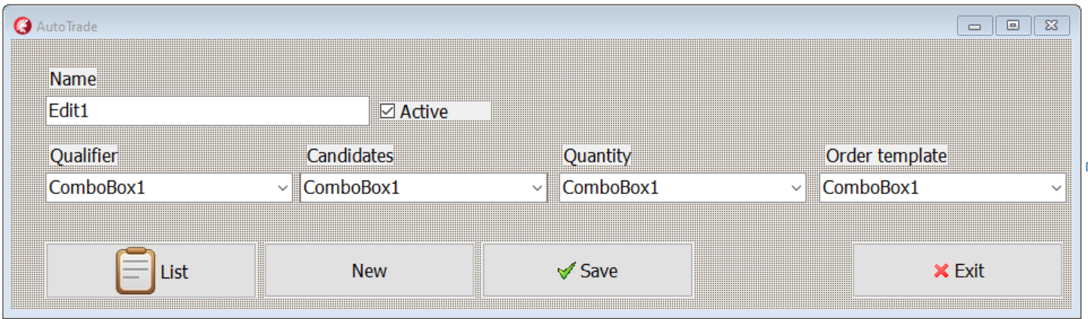

How it will work:
- When pushing a START button on main form all active AutoTrades will start.
(A AutoTrade is active when its active checkbox is checked)
If none of the three upper checkboxes are checked the Qualifier is automatically true otherwise the condition beside
- Then the Candidate procedure starts and if there are instruments (candidates) in the list which fulfill the requirements an order group will be created from the Quantity and the Order template.

Qualifier
A Qualifier is a part which activates an AutoTrade. It will be activated if the bottom checkbox is checked, and if the other checkboxes are checked the conditions related to those are true. If only the Active-checkbox is checked the Qualifier is true.
Parse will be specified later. It will be external applications that send a signal to our application. (Example: An application search text from Reuters and find “big order to Volvo cars” it will then send signal to our application)

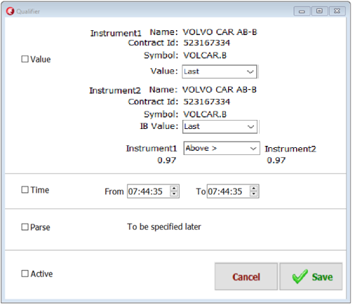

Candidats (change name from Scan to Candidats)
In the candidates-form we produce a list of instruments. The list is produced with IBScanner, Static lists, new added columns and gradient. All rows in the candidate list The most importen part in this is the IBScanner which allow you to create a list of instruments which have behaved in an asked way. You need to add at least one static list or one IBScanner. Those four parts will together produce a list there each instrument have a value. The list is continuely updated in realtime.
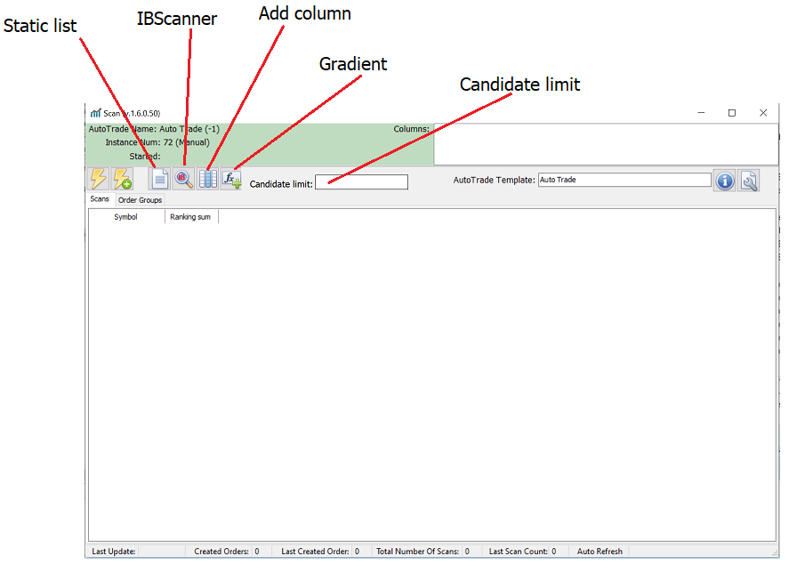

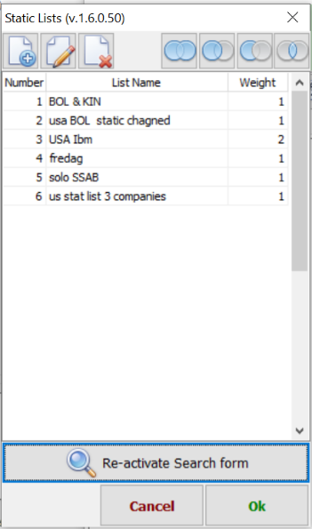
Static list
This is user produced lists. A static list includes a number of instruments which can be used when collecting candidates.


Adding functions
There is four types of adding function:
(1) Add all instruments/values in the statis list to candidates,
(2) Add only instruments/values from static list which already exists in candidates.
(3) Erase candidates which exists in static list.
(4) Keep only candidates which exists in both lists.

IBScanner (Change name from MarketScanner to IBScanner)
IBScanner is a functionality which produce a list of instruments. It can find instrument in almost every part of the world which have behaved in a specific way.
To produce this, you select:
1. A region and type. (Example: “Europe Stocks”)
2. A location. (Example: “Sweden (SFB)”)
3. A parameter (Example: “Top % Gainers Since Open”)
4. You may add extra filters (Example: “Revenue over 200 000 000”)

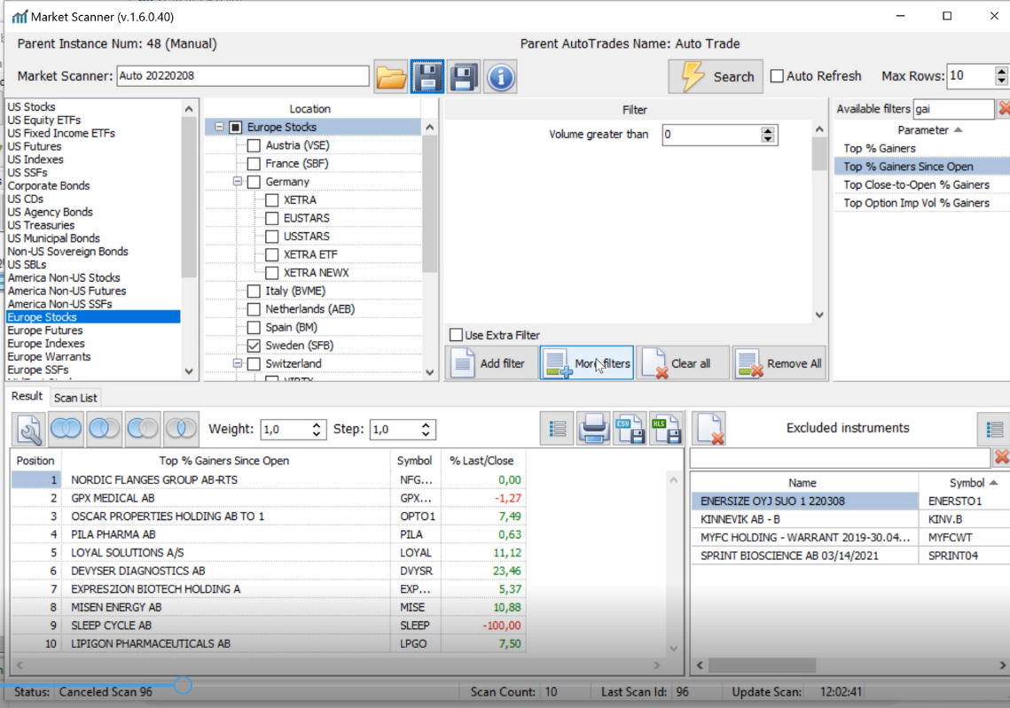

Erase “Exclude instruments”. It’s not necessary. It can be done with a Static list added to candidate list with function.
Quantity
