AutoTrade
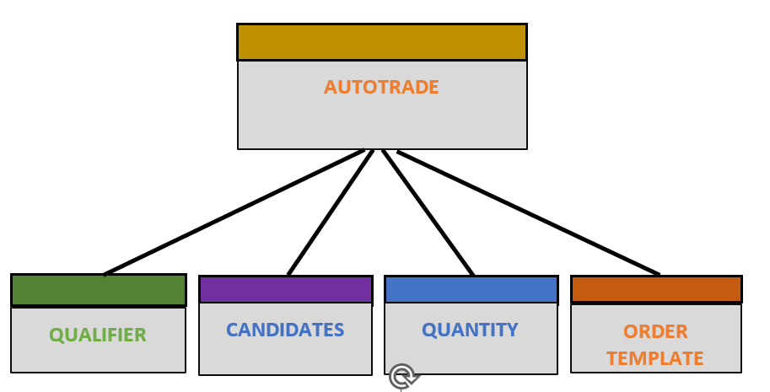
An Autotrade is a combination of a Qualifier, Candidates, Quantity, and an Order-template.
PROCESS

Main form
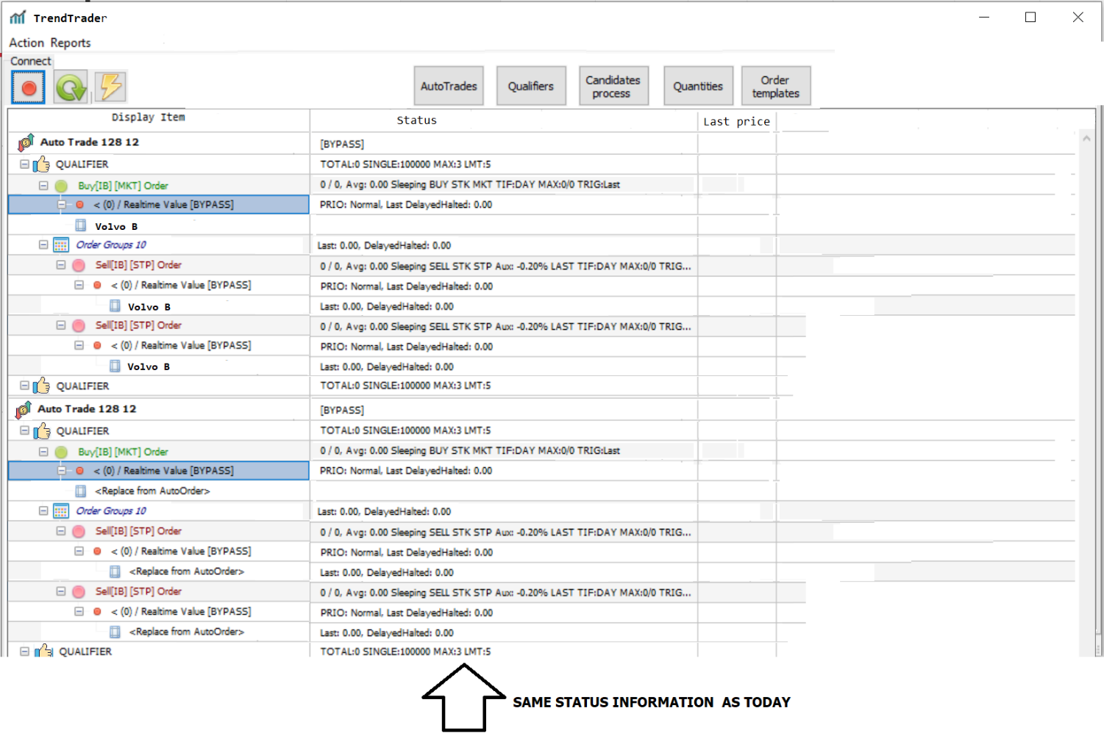

How it will work:
- When pushing START button  on main form all active AutoTrades will start and be visible on main form. An AutoTrade is active when its active checkbox is checked. An active AutoTrade will become TRUE when its qualifier is TRUE.
If none of the three upper checkboxes are checked in the AutoTrade-form, is automatically TRUE otherwise all its checked conditions must be true. 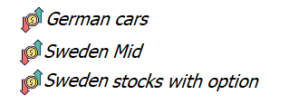

- When an AutoTrade becomes TRUE its qualifier will be visible. and it will start its Candidates process.
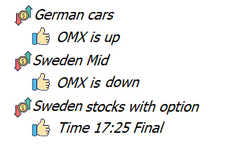

- When there are instruments (candidates) in a candidates-list which reach up to the candidate’s limit, an order group will be created from the Quantity and the Order template. Those order groups will then be visible in the monitor form.
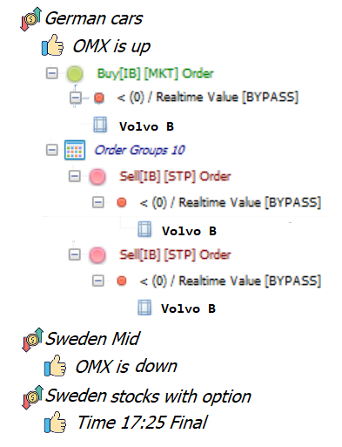

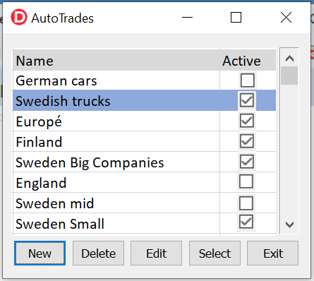
AutoTrade
An AutoTrade has a name and must include one Qualifier, one Candidates process, one quantity and one order template. It can be active or not.
If it’s not active, it will never start.
If it’s active it will start when it’s qualifier is true.
All AutoTrades has a name and must include one Qualifier, one Candidates process, one quantity and one order template
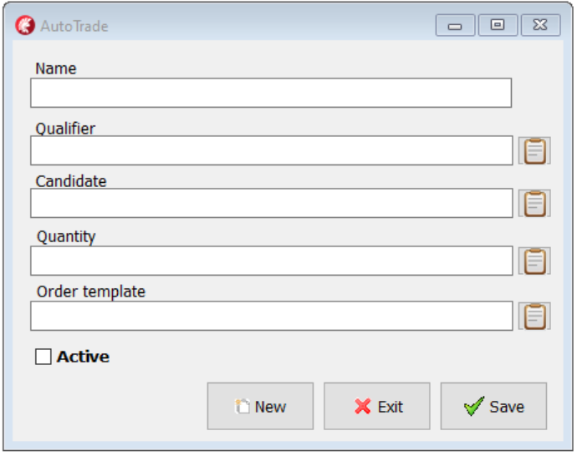

Qualifier
A Qualifier is a part which activates an AutoTrade.
A Qualifier will be true and activate it’s AutoTrade if it’s active itself and all other checkboxes which are checked have conditions which is true.
If only the Active-checkbox is checked the Qualifier is true.
Parse will be specified later. It will be external applications that send a signal to our application. (Example: An application search text from Reuters and find “big order to Volvo cars” it will then send signal to our application)

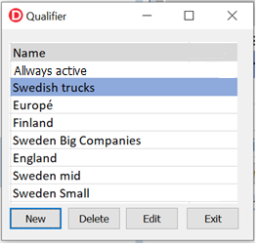

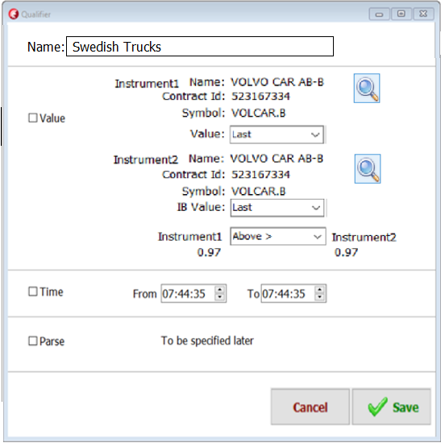
Quantity
Each AutoTrade has a quantity. Its decide how big the amount is to spend in this AutoTrade and how big the amount is for each order. It’s also what currency is used.
If an instrument I ordered in another amount the amount has to be converted.
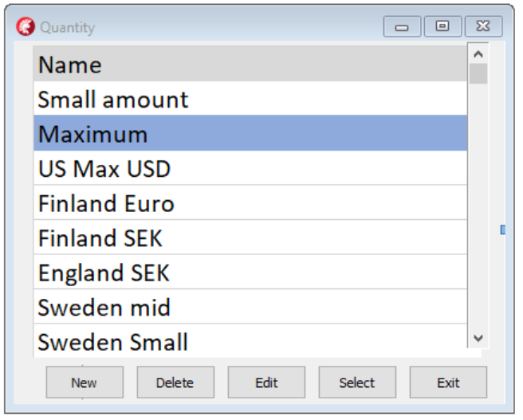

Clicking on Edit will open this dialog.
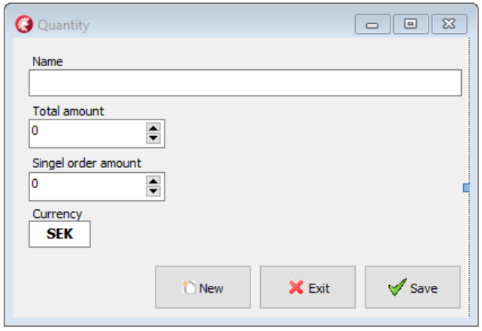

Candidates process
(change name from Scan to Candidates process)
In the candidates-form we produce a list of instruments.
The list is produced with IBScanner, Static lists, Added columns and Gradient. All rows in the candidate list will have a ranking sum. This sum is produced by adding each columns value multiplied by its weight value. This ranking sum is compared with Candidates limit and if the ranking sum is grater or equal to this limit the instrument is ready to be processed in an AutoTrade.
The most important part in the candidates process is the IBScanner which allow you to search and create a list of instruments which have behaved in an asked way.
You need to add at least one Static list or one IBScanner to produce a list. There can maximum be one IBScanner and maximum one Gradient but there can be several static lists and several added columns.
The list is continually updated in real time.
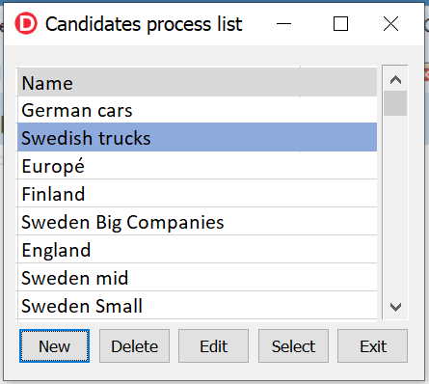

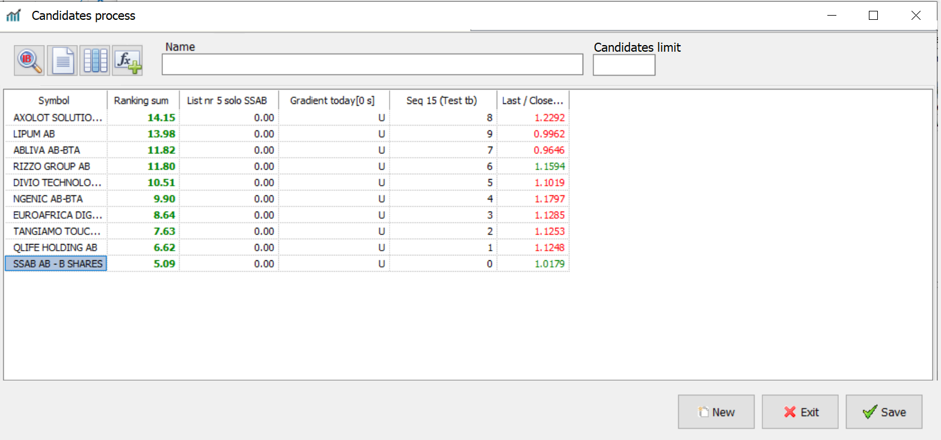

 Opens IBScanner.  Opens Static lists.  Opens Add Column.  Opens Gradient.

Candidates / IBScanner
(Change name from MarketScanner to IBScanner)
IBScanner is a functionality which produce a list of instruments. It can find instrument in almost every part of the world which have behaved in a specific way.
To produce this, you select:
1. A region and type. (Example: “Europe Stocks”)
2. A location. (Example: “Sweden (SFB)”)
3. A parameter (Example: “Top % Gainers Since Open”)
4. You may add extra filters (Example: “Revenue over 200 000 000”)

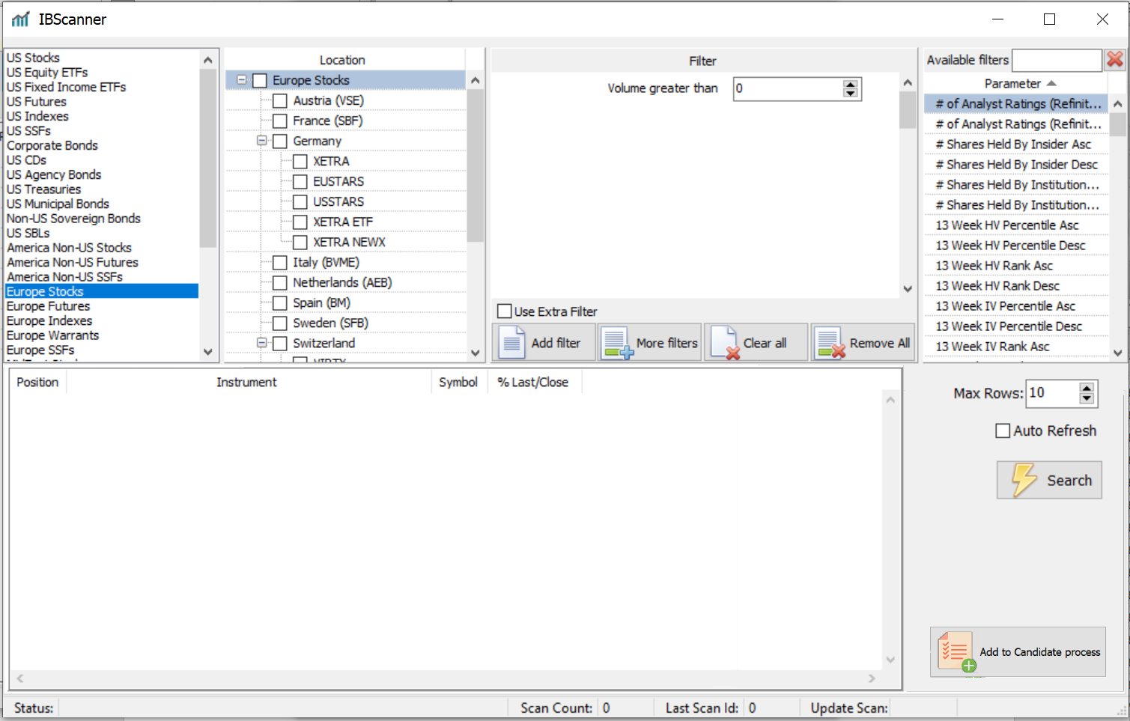

Erase “Exclude instruments”. It’s not necessary. It can be done with a Static list added to candidate list with function.

Candidates / Static list
This is user produced lists. A static list includes a number of instruments which can be used when collecting candidates.
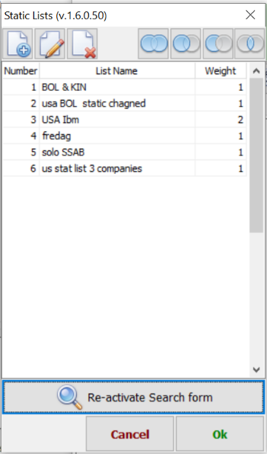


Adding functions
There is four types of adding function:
(1) Add all instruments/values in the statis list to candidates,
(2) Add only instruments/values from static list which already exists in candidates.
(3) Erase candidates which exists in static list.
(4) Keep only candidates which exists in both lists.

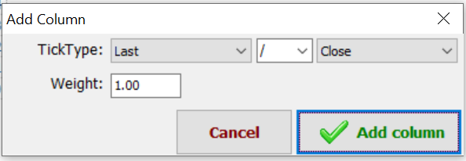
Candidates / Add columns
You can add new columns to the Candidates process and give them weight value.

Candidates / Gradient
The Gradient function indicates the direction the price is going the last X seconds. It is a value produced by the price different divided by price X seconds ago. This value can also be multiplied with a weight value.
Example: If last price is 100 and X is 10 seconds and the price 10 seconds ago was 99,85 and weight value is 1000 then
Gradient value is 1000*(100-99,85)/99,85 = 0,2003.

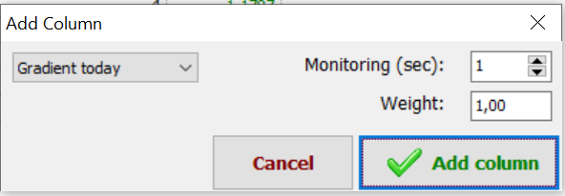
Quantity
Each AutoTrade has a quantity. It decides how big the amount is to spend in this AutoTrade and how big the amount is for each order. It’s also saying what currency is used.
If an instrument is ordered in another currency the amount must be converted.

Clicking on Edit will open this dialog.

Orders
An order or rather an order group is containing one mother-order and a group of child-orders.
Example:
In the mother-order I buy 1000 shares of IBM for 100 SEK each.
Total cost 100.000 SEK. Mother average cost is 100 SEK/share.
I then like to sell them all if they go up 1% with a limit price of 1%
If they go down 1% I likes to sell them with no limit (market-order)
If nothing happens I like to sell them at 17:20 (before the market close)
So it will be one mother-order and 3 child-order.

Instrument search

