**Control Scheme.**

“W,A,S,D” or arrow keys to move.

Space to jump.

Escape for menu.

Mouse to look around

**Objectives.**

Avoid enemy robot.

If he touches you your health will go down (left bar).

Over time you battery goes down (right bar).Go to your starting location to charge back up.

There is a map collectable for you to find.

**Background info**

It has taken me a year and a half to get this far.

There are currently 25 scripts that control how objects move and interact with each other.

The game can be played from a keyboard and mouse or with a game controller.

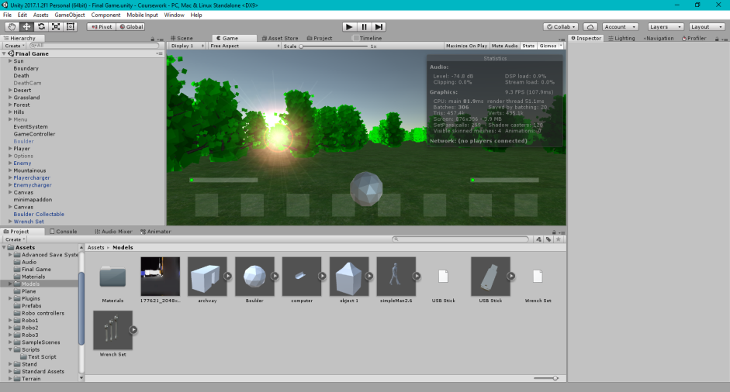There are five biomes for you to explore.

This is Unity. It is a game development platform which uses C# which is a programing language used for cross platform applications.

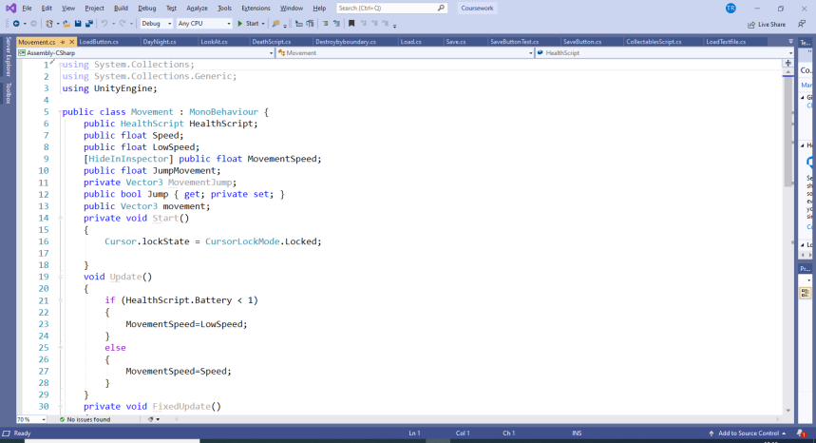

This is Visual Studio which is an IDE (integrated development environment). This is the script editor, my movement script is open in this example.