**A PROJECT REPORT ON**

AMAZON MUSIC REVIEWS

**For the Course:**

Big Data Analytics (AY2022- 2023: TRIMESTER-III)

Submitted in partial fulfilment of the requirements for the

Two-year full time Master’s Degree in MBA - Business Analytics

**Submitted By**

Abinash Mishra - Roll No: B003 (SAP ID: 80812200003)

Aditi Srivastava - Roll No: B004 (SAP ID: 80812200065)

Ashwin Lanka - Roll No: B014 (SAP ID: 80812200016)

Bezawada Jeevika - Roll No: B016 (SAP ID: 8081200177)

Bindu Vasini Kanney - Roll No: B018 (SAP ID: 80812200020)

(Batch of 2022- 24)

**Submitted to**

**Faculty Mentor**

Prof. Cyrus Lentin,

Centre of Excellence in Analytics & Data Science,

SVKM'S NMIMS, MUMBAI

**MARCH 2023**

**Table of Contents (TOC)**

**Content**

Project Overview 3

**Brief Overview of the Project** 3

**Learning Objectives** 3

Code & Command Section 3

**HDFS Code:** 3

**PIG Code:** 4

**HIVE Code:** 5

**SQOOP Code:** 9

Summary 9

**Experience of using Hadoop for analysing Big Data** 10

**List of Figures**

**Figure 1: Creation of the folder in the HDFS directory** 4

**Figure 2: Output for the dump command for Pig** 5

**Figure 3: Output file being stored in the HDFS directory** 5

**Figure 4: Output for the table description** 6

**Figure 5: Output for Query 1** 6

**Figure 6: Output for query 2** 7

**Figure 7: Output for query 3** 7

**Figure 8: Output for query 4** 8

**Figure 9: Output for query 5** 8

**Figure 10: Output for query 6** 8

# **Project Overview**

## **Brief Overview of the Project**

Amazon Music is a music streaming service that allows users to access a vast collection of songs, playlists, and podcasts. The service offers various subscription plans, including Amazon Music Unlimited, which provides access to over 70 million songs and is compatible with various devices, including desktop, mobile, and smart speakers. The project focusses on viewing the reviews posted by people for the various music tracks made available by Amazon along with the ratings provided for the same.

## **Learning Objectives**

1. Appreciating the fundamental concepts of Big Data Management and Analytics.
2. To gain hands on experience on using Hadoop architecture and develop basic proficiency in using the same.
3. To perform Big Data Analytics on mega dataset using Hadoop architecture such as: HDFS, Pig, HIVE and SQOOP.

# **Code & Command Section**

## **HDFS Code:**

**# *Starting the HDFS terminal***

su root

Password: cloudera

***# Creating the folder in the hdfs***

>> hdfs dfs -mkdir /bda

>> hdfs dfs -ls /bda

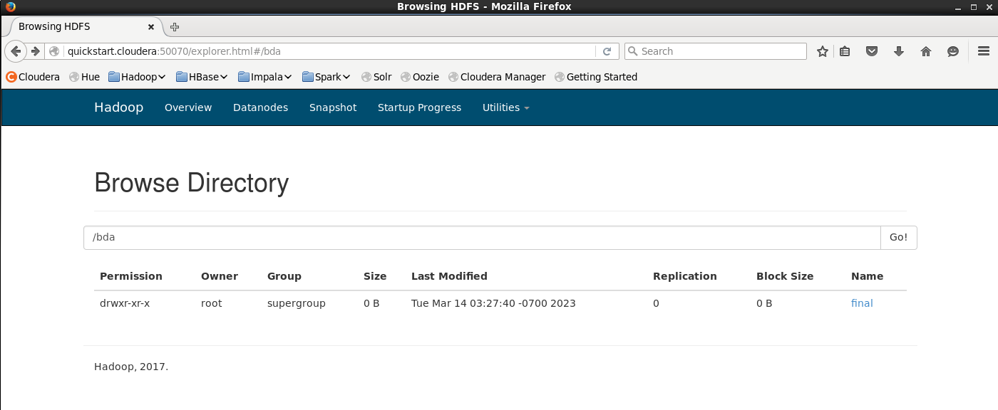>> hdfs dfs -mkdir /bda/final

**Figure 1: Creation of the folder in the HDFS directory**

***# Shifting the file from the local to hdfs***

>> hdfs dfs -put /home/cloudera/myfiles/review.txt /bda/final/amazon_review.txt

>> hdfs dfs -ls /bda/final

## **PIG Code:**

***# Starting the PIG terminal***

>> pig

***# Parsing the text file stored in the hdfs***

>> amazon = load ‘/bda/final’ using PigStorage (‘\t’) as ( marketplace:chararray, customer_id:chararray, review_id:chararray, product_id:int, product_parent:chararray, product_title:chararray, product_category:chararray, star_rating:int, helpful_votes:int, total_votes:int, vine:chararray, verified_purchase:chararray, review_headline:chararray, review_body:chararray, review_date:chararray );

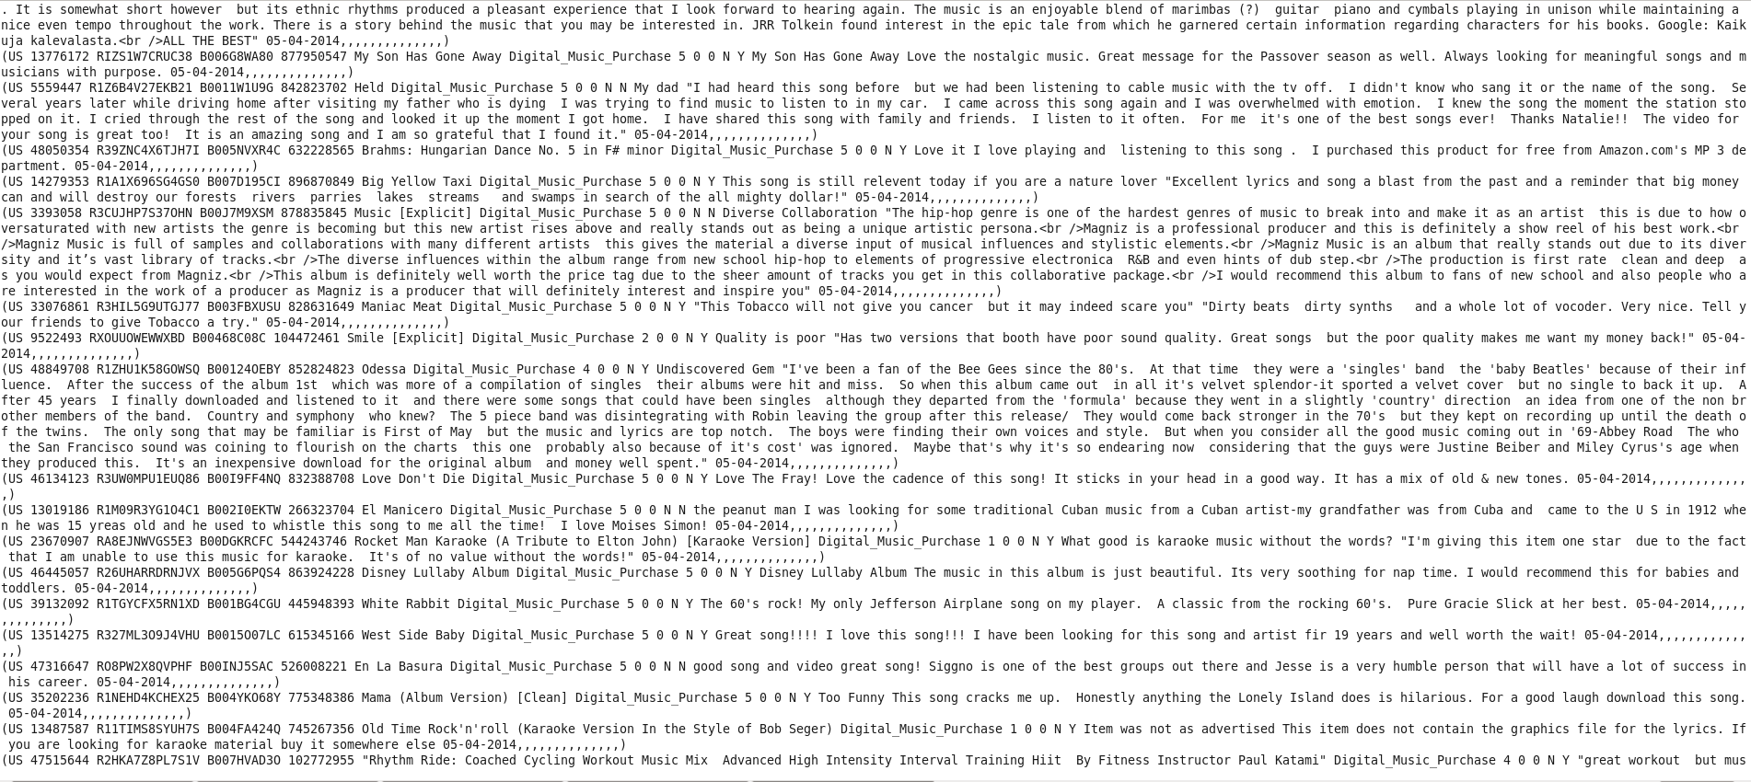>> dump amazon;

**Figure 2: Output for the dump command for Pig**

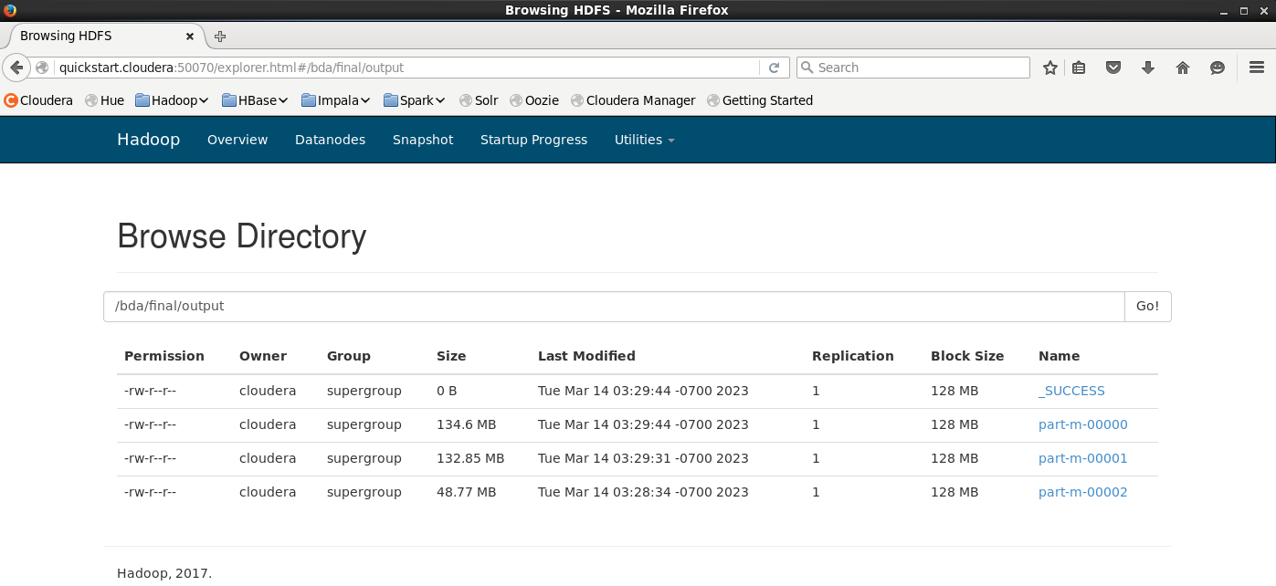>> store amazon into '/bda/final/output' using PigStorage(',');

**Figure 3: Output file being stored in the HDFS directory**

## **HIVE Code:**

***# Starting the HIVE terminal***

>> beeline -u jdbc:hive2://

***# Creating the database***

>> create database amazon;

>> use amazon;

***# Creating the table***

>> create table reviews (marketplace string, customer_id string, review_id string, product_id string, product_parent int, product_title string, product_category string, star_rating int, helpful_votes int, total_votes int, vine string, verified_purchase string, review_headline string, review_body string, review_date string) row format delimited fields terminated by ',' lines terminated by '\n';

***# Loading the data***

>> load data local inpath '/home/cloudera/myfiles/amazon_review.csv' overwrite into table reviews;

***# Checking the description of the table***

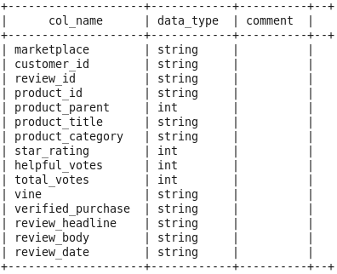>> desc reviews;

**Figure 4: Output for the table description**

***# Running Queries to generate insights***

1. **To know the overall reviews for the review headline titled as “favorites”**

>> select review_body from reviews where review_headline like 'favorites';

**Figure 5: Output for Query 1**

**Insight –** It is observed that the people have provided the highest rating for the music tracks categorized as favourites under the review headline. Additionally, their response has been very positive towards the type of the music and even the music composer.

1. **Finding the music tracks which have been reviewed as great by the people**

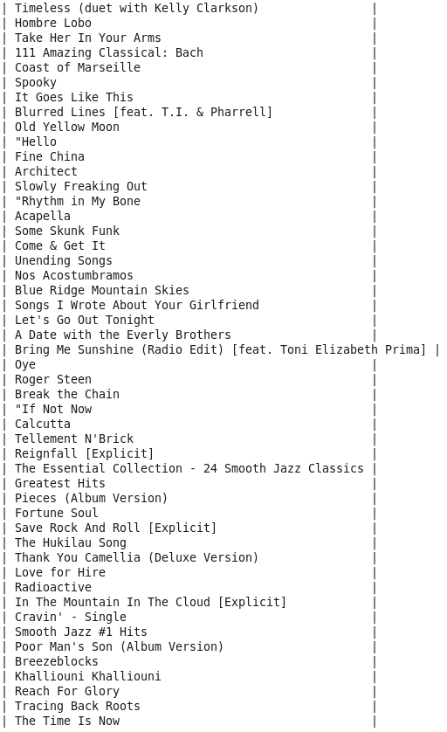>> select product_title from reviews where review_body like ‘%Great%;

**Figure 6: Output for query 2**

**Insight –** It was observed that music tracks such as the one provided above in the output have been rated Great by the people. Some of the noted artists who have appeared on the list include: Kelly Clarkson, Pharell Williams etc.

1. **Finding the count of music tracks which are verified and unverified as well as reviewed as Great by the people.**

>> select verified_purchase, count(product_title) as Total_Count from reviews where review_body like '%Great%' group by verified_purchase;

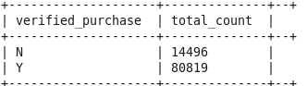

**Figure 7: Output for query 3**

**Insight –** It was observed that around 16% purchase of the music tracks have been unverified and yet have been reviewed as “Great” while the share of the verified purchase of the music tracks with “Great” rating is 84%.

1. **Finding the count of music tracks which have been loved by the people as posted in the review headline.**

>> select count(product_title) as Total_Count from reviews where review_headline like '%Love%';

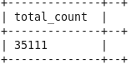

**Figure 8: Output for query 4**

**Insight –** It is observed that people have loved 35,111 music tracks provided by Amazon.

1. **Finding the count of music which have been rated as 5, reviewed as great and the music track contains “Praise the Lord”.**

>> select star_rating, count(product_title) as Total_Count from reviews where product_title like '%Praise the Lord%' group by star_rating;

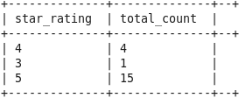

**Figure 9:Output for query 5**

**Insight –** It was observed that 20 music tracks contained the phrase “Praise the Lord”. Out of the 20 music tracks, 75% of the people voted the track to be very good i.e. 5, with 20% of the people voting the track to be average i.e. 3 and the rest 5% voting it to be good.

1. **Finding the count of music tracks which have total votes greater than 10 and has atleast helpful votes greater than 5.**

>> select count(product_title) as Total_Count from reviews where total_votes > 10 and helpful_votes >= 5;

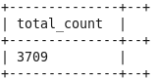

**Figure 10: Output for query 6**

## **SQOOP Code:**

***# Creating the database in mysql***

>> create database amazon_review;

>> use amazon_review;

>> create table amazon_reviews (marketplace varchar(20), customer_id varchar(20), review_id varchar(20), product_id varchar(20), product_parent int, product_title varchar(20), product_category varchar(20), star_rating int, helpful_votes int, total_votes int, vine varchar(20), verified_purchase varchar(20), review_headline varchar(20), review_body varchar(20), review_date varchar(20));

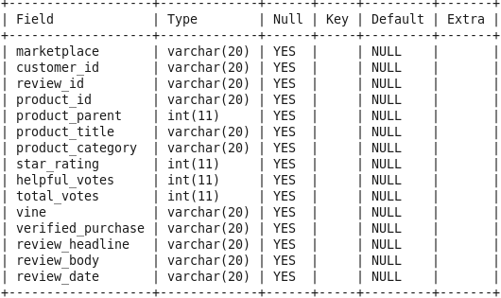>> desc amazon_review;

***# Exporting the hive commands to my sql***

>> sqoop export --connect jdbc:mysql://localhost/amazon_review --username root -P --table amazon_reviews --export-dir /bda/final/amazon_review.csv --input-fields-terminated-by ',' --lines-terminated-by '\n'

# **Summary**

Hadoop has been helpful in Data ingestion, Data Processing and Data Analysis. Data has been ingested into Hadoop Distributed File System. Once the Amazon music Data has been ingested into the system, we have used Hadoop's MapReduce processing framework to perform data transformations and aggregations. It has been used in multiple scenarios like:

* Counting the positive & negative reviews of the music
* Counting the music tracks which have got ratings = 5

After processing the Amazon music data, we have used Hadoop's query engines like Apache Hive and Apache Pig to perform ad-hoc queries and analysis on the data. This has allowed us to extract meaningful insights from our dataset.

## **Experience of using Hadoop for analysing Big Data**

The dataset that we have considered was around 600+ MB dataset which is tough for tools like Excel to handle. But when such a voluminous dataset has been ingested into HDFS, the processing was very smooth and analysis has been performed at the least possible time.

Given the queries that we had to execute, the processing of the information would be very time consuming in any other platforms but Hadoop made the work very easy and smooth to handle.