Thomas Salda

Date: 24 Oct 18

How to Log in to a CentOS7/RHEL Box Without A Password

[1] Turn VM on HyperVisor (KVM, Hyper-V, VMWare, etc)

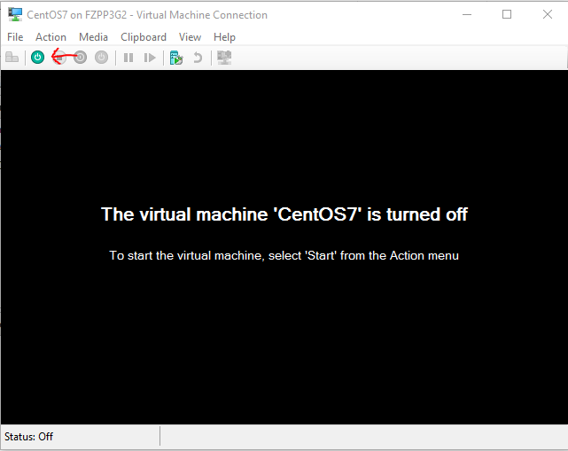

[2] Find the newest Kernel and click ***‘e’*** for edit.

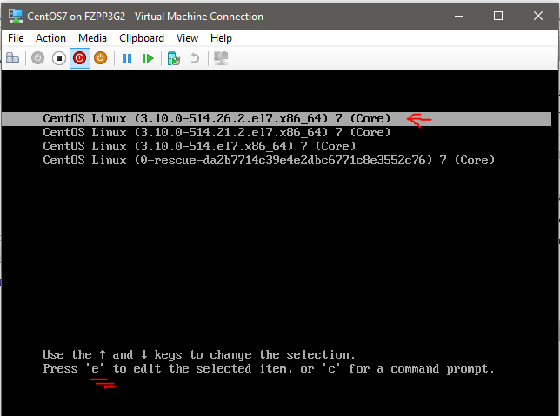

[3] Scroll down. Find the line that says ***vmlinuz***. Press ***End*** on your keyboard (to go to the end of the line), and type **rd.break** at the end of the line. Then press ***Ctrl-x*** to boot up.

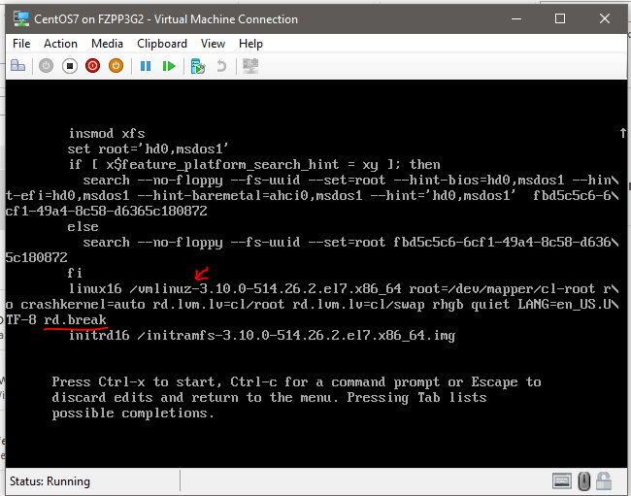

[4] Once the system is booted, Linux will mount the root filesystem as ***read*** only on /sysroot.

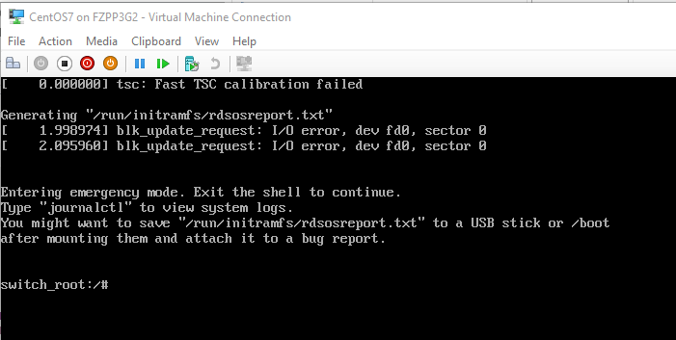

[] Remount the root file system as ***read-write***. Enter the following command:

**#mount –o remount,rw /sysroot**

Ex)

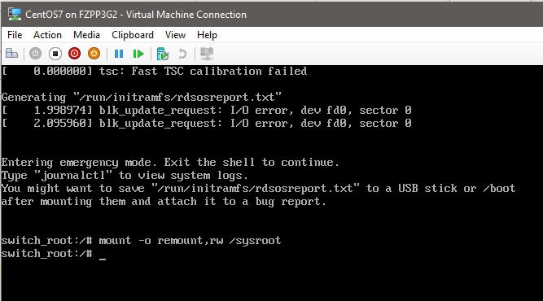

[] Verify you are in the / directory.

Ex)

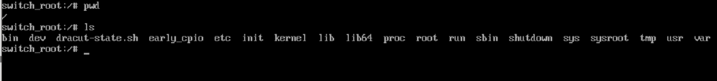

[] We will now change the root file system to ***/sysroot*** with the ***chroot*** command.

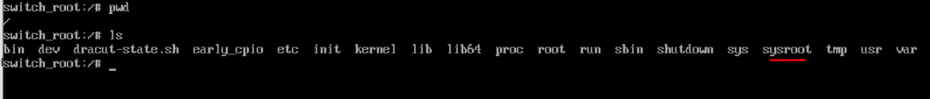

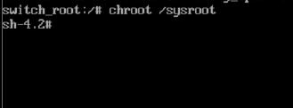

[] Run ***pwd*** and ***ls***, and notice that we are still in / but the contents are different

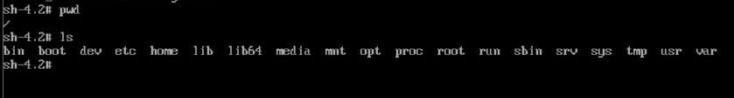

[] Now, change the password with the ***passwd*** command

Ex)

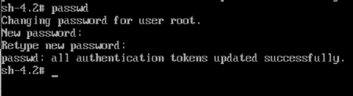

[] Next, have SELinux rewritethe security context of all files on the next reboot by creating a hidden file in / called **/.autorelable**.

Ex)

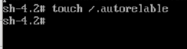

[] Type exit to exit the ***chroot*** shell and ***exit*** againto continue booting. After the booting completes, you should be able to log in with your new password.

Ex)

