[1] Turn VM on HyperVisor (KVM, Hyper-V, VMWare, etc)

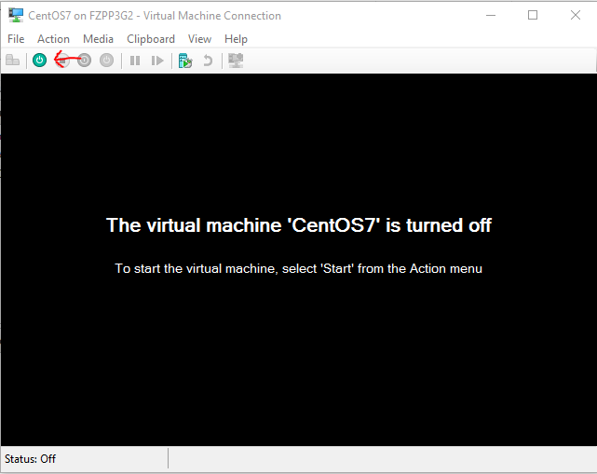

[2] Find the newest Kernel and click ***‘e’*** for edit.

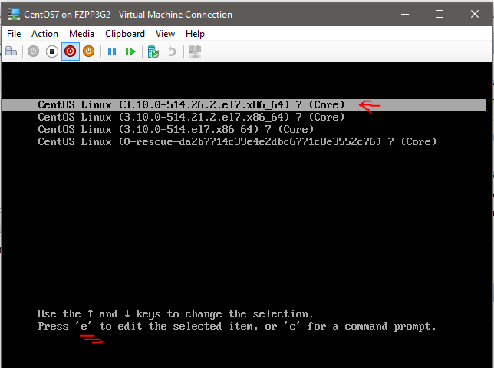

[3] Scroll down. Find the line that says ***vmlinuz***. Press ***End*** on your keyboard to go to the end of the line, and type **systemd.unit=emergency** at the end of the line.

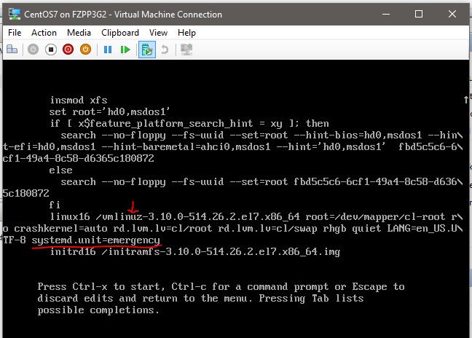

[4]Enter your password to log in in emergency mode.

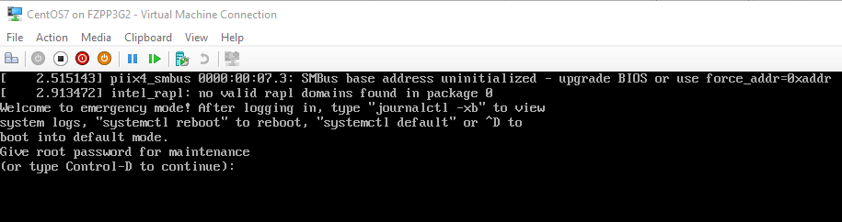

[] Type ***Exit*** to continue booting