# NEUTRON KINETICS

Time dependent diffusion equation (1 group)

 (1)

In-leakage - Abs. + Prod. = change/sec

*n* - neutron density (n/cm3)

= *v*×*n*

*vfast* = 2.105 m/s

*vth*  = 4.103 m/s

The source has two contributions:

- *Prompt neutrons* – directly from fission

- *Delayed neutrons* – from fission product decay

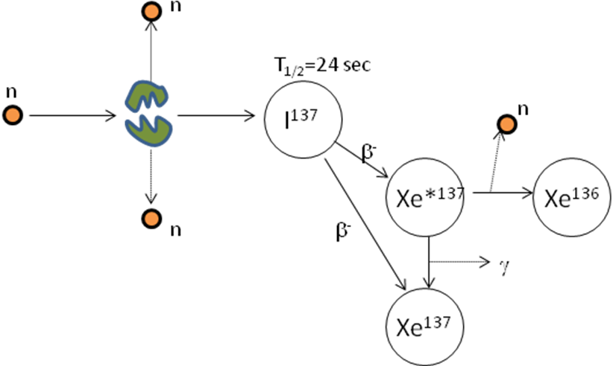

I137 is a so-called precursor.

I*137 is in an isomeric state.

Precursors are grouped into 1-8 families, each characterized by its average half life (from 0.2 sec to 1 minute).

If there is only one family: *T*1/2 = 8 sec.

Compare this with the neutron generation time: *l* = 0.05 ms - *T*1/2 /*l* ~ 105.

The fraction of delayed neutrons for U-fission: *β* = 0.007.

Equation for precursor concentration *C*

 (2)

The diffusion equation becomes

 (3)

## 1. Point Kinetics

If the migration of neutrons is neglected in the diffusion equation, i.e. if 2*φ*=0, then an equation without space dependence is obtained. The core is treated as one point.

In one-group theory *k=νΣf/Σa*. Further, *=vn*

 (4)

The neutron mean free path because of absorption = 1/*a* (cm). Define

 Neutron ‘life time’

 ‘Effective life time’

 ‘Reactivity’

 (5)

These are the point kinetics equations (with only one family of delayed neutrons).

## 2. The In-Hour Equation

Solve the point kinetics equations assuming that

* Up to time *t* the reactor is just critical (*ρ*=0)
* At time *t* a constant reactivity insertion *ρ* is applied.

By assuming the solution *n*(*t*) = Ae*ωt*, *C*(*t*) = Be*ωt* in the point kinetics equation one arrives at the *inhour* equation

 (6)



 (7)

If small reactivity insertion: *ρ<<β*

 (8)

*l* = 0.05 ms Life time of prompt neutrons

*l*’ = β/λ = 80 ms Prompt + Delayed neutrons

If large reactivity insertion: *ρ>β*

 (9)

The solution explodes.