Exercise Lecture 4

- Write a script that programmatically import gasprices.
Hint: use [data,textdata]=xlsread(‘gasprices.xls’);
Pull out colheaders from textdata.
- Program the script so that the Prices in France is stored in the variable France etc.
Hint: import again with the Wizard and click on the checkbox ‘Generate Matlab Code’:
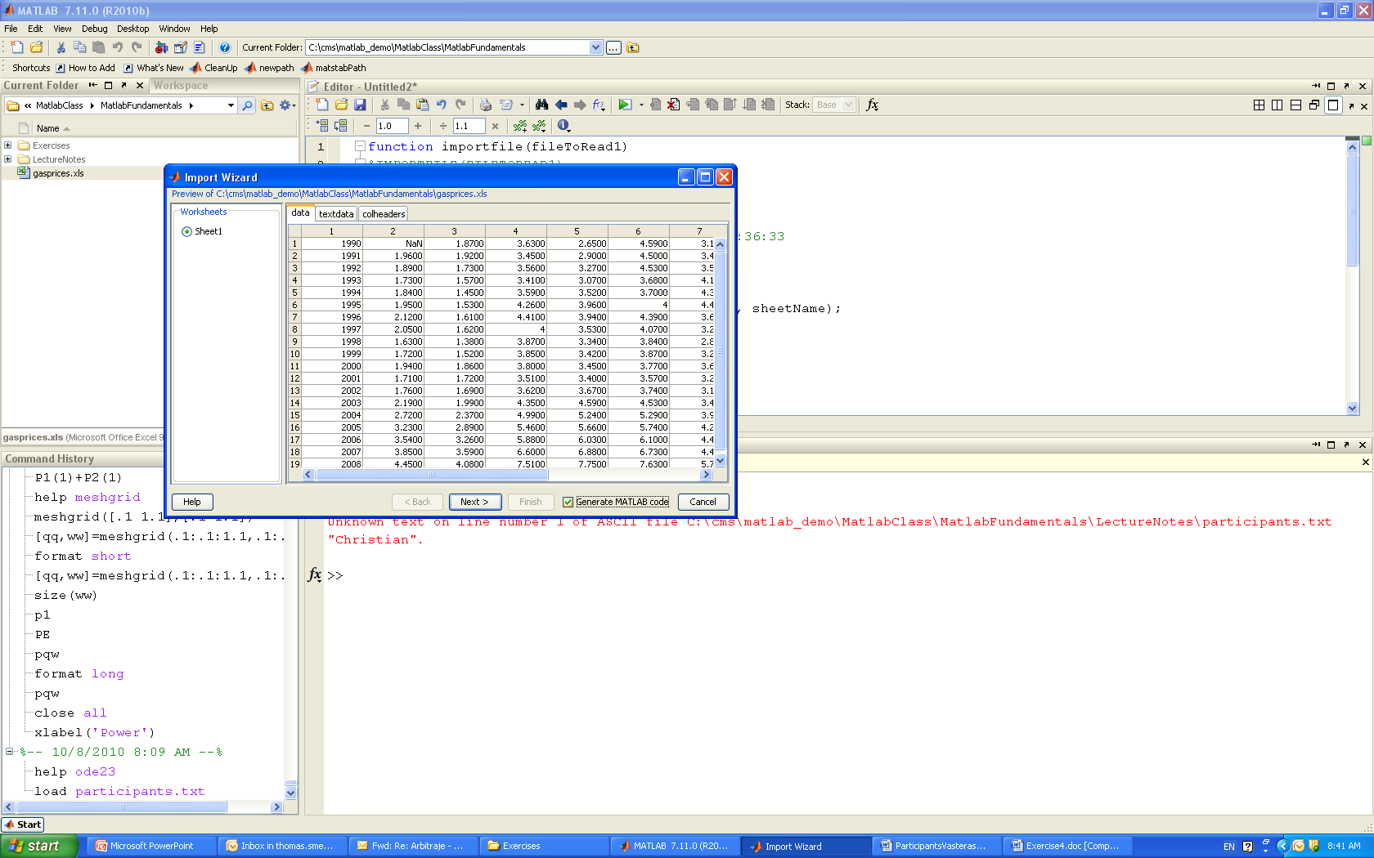
Hint 2: Use the function genvarname to generate valid variable names from the colheader

