Exercise Functions

- 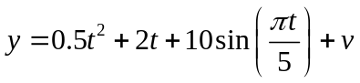Write a script that plots the function
in the interval [0,10] with a resolution of 0.01. v is normally distributed white noise with variance 4.
Hint use randn to create the white noise.
- 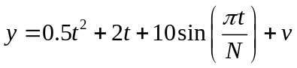Modify the script to a function that takes N, T, dt as input variables. In the example above,
N=5, T=10, and dt=0.01
Let y and t be the outputs of the function
- Modify the function in 2 such that default values for N, T, dt are used if they are not given.
Hint use nargin to determine if the numbers are given.
- Modify the function in 3 such that T can be a time vector with the specified times at which solutions are desired, T=[T0 T1 T2 … Tfinal]
Hint: use length(T) to determine what kind it is.

