Exercise Lecture 11

1. Define a matrix A
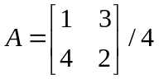

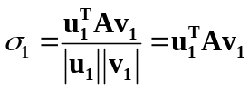 Determine the singular values and verify that

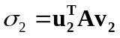

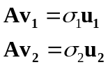2. Confirm that

3. Use the file prepfile.m to load the k-effective for Mϋhleberg
First try to make a linear fit wrt power and flow for the transient between 2009-11-10 17:01:00 to
2009-11-14 19:01:00.
ett=ones(size(q));
A=[ett q w];
p=A\keff(i0:i1)
Compare the coefficients with those in the word document keff-correlation.doc
Why are they different?
Reproduce the results in keff-correlation.doc

Hint: What if you only can fit one independent variable at a time?

4. Can we do better?
Use the file MaybeBetterFit.m and try to develop a better fit. With better, I mean a simpler, more intuitive appealing and more robust, but not necessarily a marginally lower rms pcm for a given transient.
Look at the matrix v. What is your conclusion on the dependence of Q and W.
Are the resulting coefficients reliable?
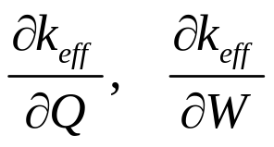

In which direction in the Power flow map do we have better information, along the red line A or the yellow line B below?
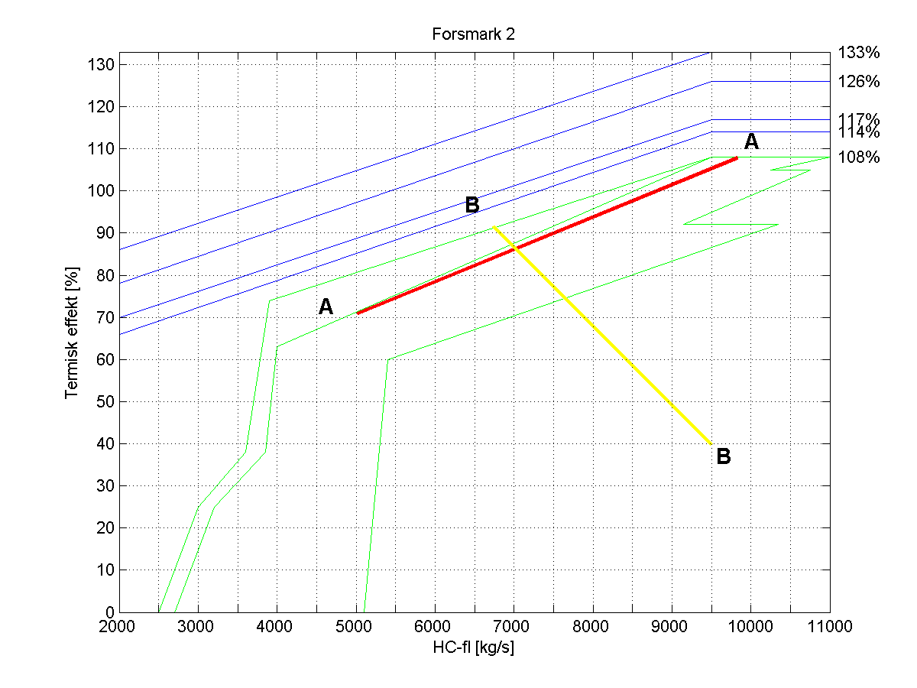
Would you say the conclusion is surprising?

