Regression

- Use the data in regressionExample.m
t=[0 .3 .8 1.1 1.6 2.3]';
y=[.5 .82 1.14 1.25 1.35 1.4]';

Assume the following function and fit the c_{n} coefficients
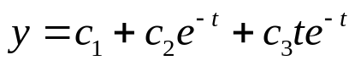Evaluate and plot in the range [0 3] and compare with the polynomial fit in regression example.

- 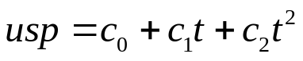Use the file uspop.m to define the variables t and usp. Make a quadratic fit of the us population:
Determine the coefficients c₀,c₁ and c₂.
Try the function svd(A) on your design matrix.

