September 3, 2010 – Nestor Patiño

Calculation of K-effective regression coefficients in GARDEL

When this function’s interface is first opened in ATLAS, the user is presented with a window like the one shown below, where all the cases in the current cycle are listed chronologically, tabulating and plotting each case’s core thermal power, core coolant flow and calculated k-effective.

The user then chooses the transient to focus on (surrounded with an oval in the figure below is the transient to be used in this example).

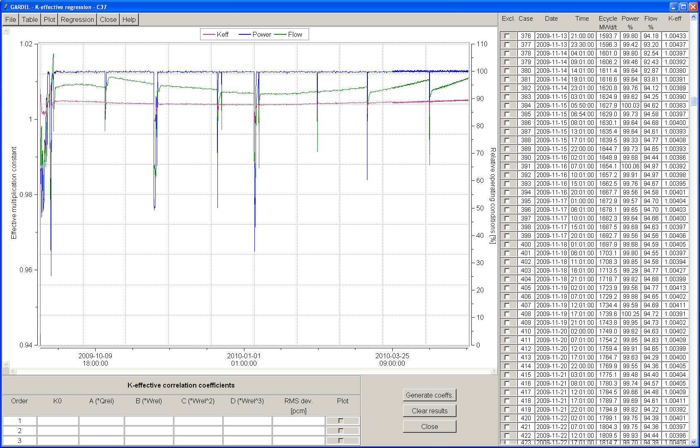

The boundaries of the transient are selected graphically with the mouse; this is the interval in which the correlation will be generated. The parts of the curves outside the selected interval are ignored when generating the correlation’s coefficients.

After doing this, the plot and the table in the right panel show the selected interval, as illustrated below.

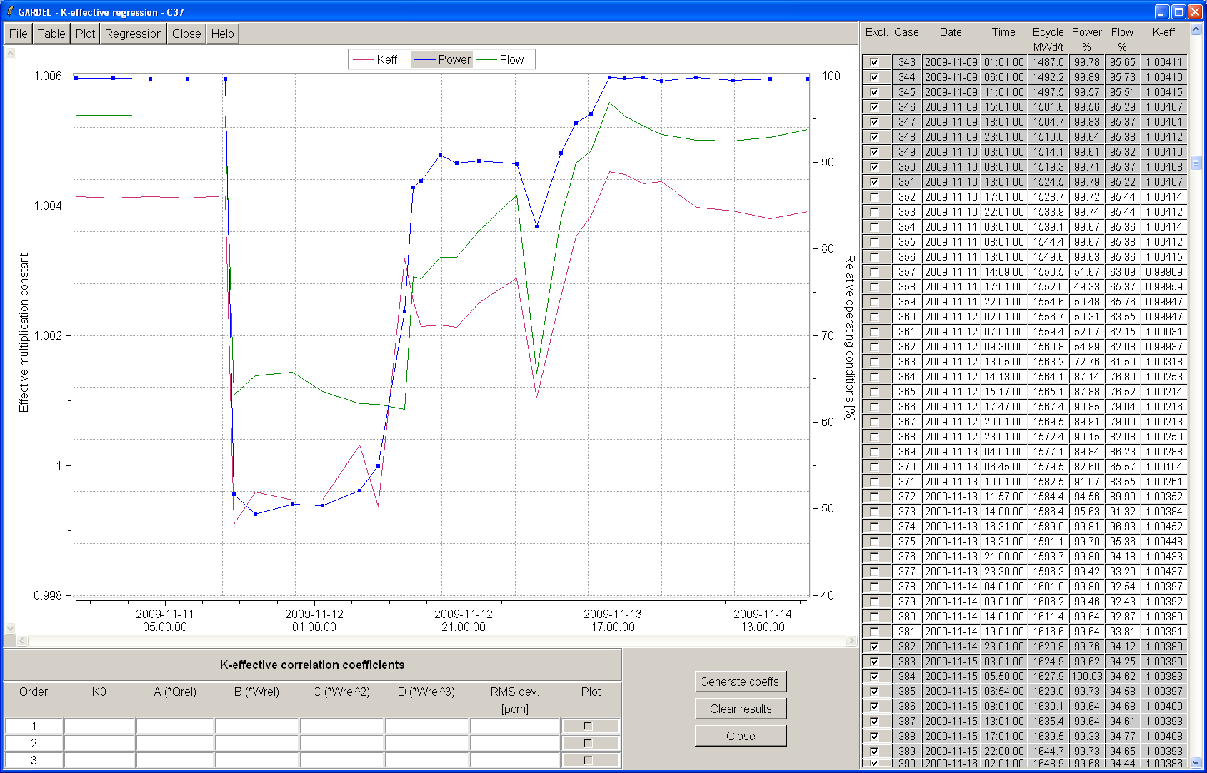

The user now clicks “Generate coeffs.” and the regression coefficients are generated and displayed in the lower panel. GARDEL generates simultaneously the coefficients of a first-, second-, and third-order regression, and computes the RMS deviation of each curve, so the user can select the desired order (usually the third) for use in the Simulate-3 calculations.

The general form of the third-order regression is:

where 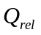is the relative core thermal power and 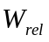 is the relative core coolant flow.

The lower-order regressions are obtained by discarding the quadratic and/or cubic terms in the above equation.

After the coefficients are generated, the user can plot the k-effective curves corresponding to any of the regression orders, by checking the corresponding button in the “Plot” column at the right-hand side of the lower table. The figure below shows the k-effective curve generated with the third-order regression (in black), and compares it with the curve being fitted (the red one). As shown in the right-most column, the RMS deviation of both curves in this interval is 41 pcm.

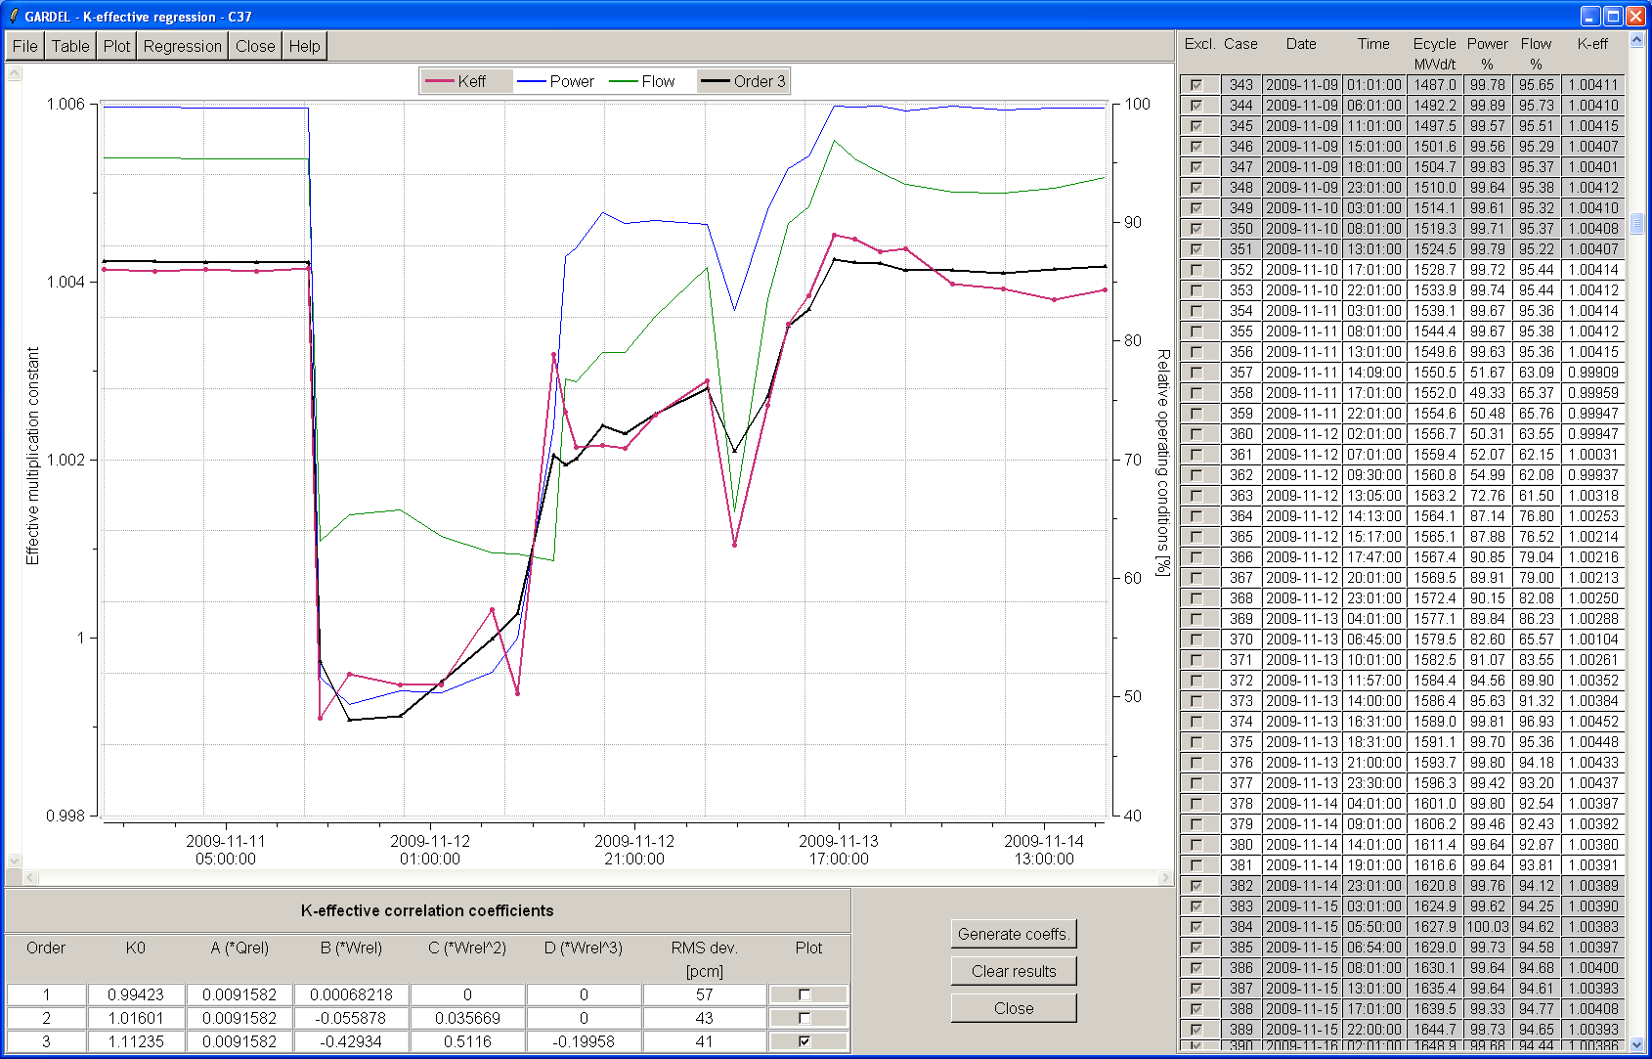

Once the user is satisfied with the regression, he can click to have the coefficients exported so that subsequent Simulate-3 calculations use them.

