Exercise Inverse Iteration

1. Define a matrix A
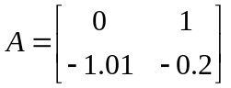

And compute the eigenvalues eig(A)
What happens with the eigenvalues if you compute
eig(A-a*eye(2))
Try with a=1, 1i, 0.5+0.5i

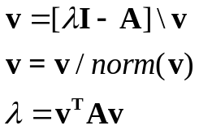2 Implement inverse iteration with shift for the matrix A

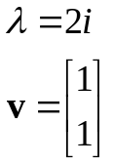Use the starting guess

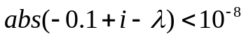How many iterations do you need to get an accuracy 1e-8?

