Exercise Simple Models I
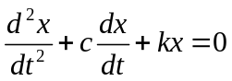
1. Define a matrix A for the system such that
(A spring-mass system with c=0.2 and k=1.01)
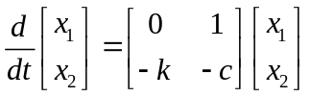

Determine the eigenvalues and corresponding decay ratio and frequency

2. Determine the time domain response if the initial condition is x(0)=1, dx/dt(0)=-0.1,
i.e. x1(0)=1, x2(0)=-0.1;

use Euler Forward to solve the problem:

x(i+1) = x(i) + dt * A * x(i)

Note that the equation above is only for memory reference for Euler Forward, you will have to figure out how the exact indexing in Matlab should be performed. Use dt=1ms, simulate from 0 to 10 seconds

3. Use the file Eulerex to study the impact of the time step and integration method on stability.
use the time steps 1ms 10 ms 50ms and 100ms

4. Use the matrix A from 1 above and calculate both eigenvectors and eigenvalues with eig:
[v,e]=eig(A);
Plot both speed and position from exercise 2 and compare with the components of the v (the phasors)
and convince yourself that it makes sense.

