

**CMS PLOT**

**2012-04-18**

Overview

CmsPlot is a basic GUI plot tool for the cms-files. The program works with the CmsSuite reading routines and the geometrical tools in CmsTools. CmsPlot is a flexible analysis tool for viewing the data from different files. CmsPlot can also be used to export data to other file types (.xls and .txt)

Basic use

There are two ways of starting CmsPlot

* cmsplot
* cmsplot(‘filename’)(cmsplot filename)

the first call with no input arguments opens a file dialog to select the file you want to view.

This is the main window of CmsPlot

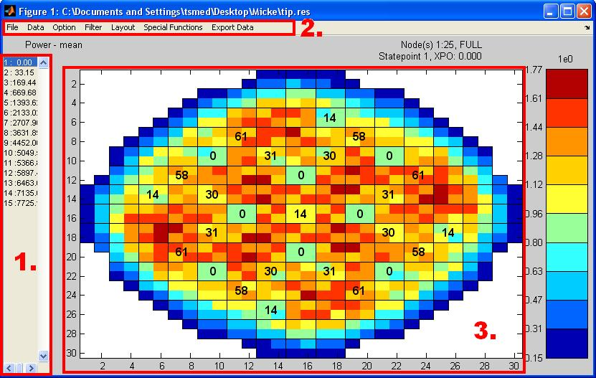

1. Exposure list – used to select state point viewed.
2. Menu bar – see below
3. Plot window – core map window

There are also some information about the current plot and file on header and around the plot window.

The menu bar

* *File* – open new file and save image.
* *Data* – list of available distributions on the file which can be plotted in the plot window. The MATLAB is an option to put your own variable from MatLab into CmsPlot. It has to be a 1-by-knum vector, or kmax-by-knum vector, where knum is the number of channels and kmax the number of axial nodes in the plotted core.
* *Options* – change the operation made and change node planes for the three dimensional distributions, also change the scale on legend.
* *Filters* – apply a filter present on file (fuel type or hydraulic type) or a Matlab-vector. The Matlab-vector should be a logical vector, 1-by-kmax.
* *Layout* – controls how the data is presented in the plot window, orientation, colors, axis labels, detectors and control rods.
* *Export data* – this option allows you to export the plotted data (or raw data in some cases) to another format, .xls, .txt, .mat or just load it as a variable in MatLab.   
    
  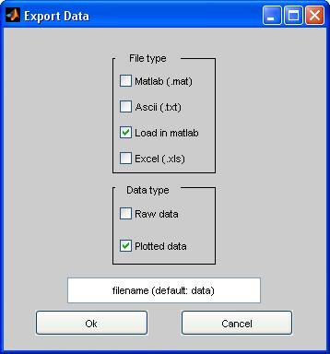  
    
  In the Export Data dialog, the available file types and data types are presented. The Export Data menu is available in all other plots from CmsPlot.
* Special functions – these functions are mostly to open new figures and get information, and are different for different files. These will be gone through below.

Common Special functions

* Axplot – displays the average axial distribution of core
* Ind.chan – gives the user the option to plot the axial distribution for a number of assemblies
* SC-plot – displays the axial average of the super cell (in the plot window)
* Info – get information from the assembly chosen (data presented in command window)
* Surf – make a surf plot of the present distribution
* Dynamics – data as a function of exposure for each axial node on chosen assembly
* Profile – the axial distributions for each state point on chosen assembly
* Operating data – operational data for the active state point
* Compare2 – compares different distributions for the chosen assembly. The dialog started will ask for the distributions wanted for comparison, and it is also possible to select a distribution from another file. At least two distributions has to be selected but additional distribution can be added with “Add Distribution” button. Compare2 can also be used from the command line with input arguments being variables in worskspace:  
  >> compare2(s3pow,s5pow,s5powqth)

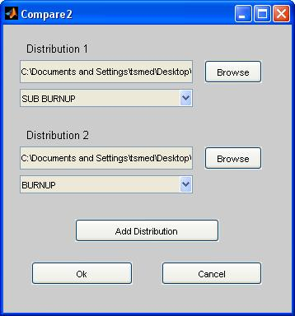

File specific special function

* Pinplot/Attach Pinfile – opens the separate plot tool Pinplot that plots the pin distribution of a single assembly. Pinplot has the same basic menu as CmsPlot but with one addition, the segment plot, which plot the segment distribution of the assembly active.
* PlotScalars – plots scalar values as a function of exposures (S3KPlot)
* PlotSubMesh – (only Simulate5 restart-file) plots a part of the core and displays the sub mesh data from the file. As Pinplot it has the same menu as CmsPlot.