5/12/2023

GUI preliminary planned layout:

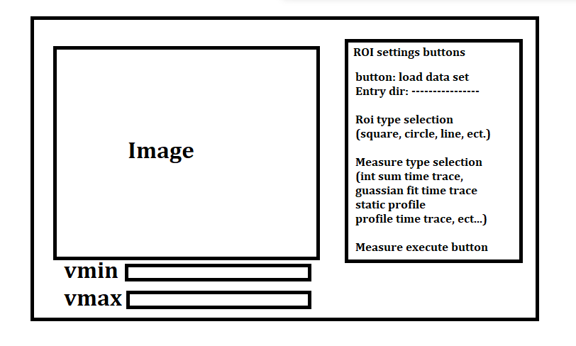

Add pseudo data image to the GUI window | TRUE
Give vmin and vmax adjustment on the gui window | TRUE
Create a zoom and click navigation on the gui (fix the zoom issue) | TRUE
Create initial tkinter window that asks for scan directory, select the image averages, it will go up a directory if it is looking for batch information | TRUE
Add roi type selection: square, ellipse, annulus, line (no backend yet) | TRUE
Add measure type selection: pixel sum time trace, gaussian fit time trace, static profile, profile time trace (no backend yet) | TRUE
Add data plots, 2 windows on the right hand size of the figure | TRUE
Add selection for time (ps) or dsPos (mm) | TRUE
Time zero pos entry with label | TRUE
Pin enter key to update the value in the label to the entry value | TRUE
Setup a special scan analysis drop down menu with  - Gaussian fit to the data sets  - Static profile on current image  - Profile time trace  We don’t need a backend yet | TRUE
Slider for running through image stack | TRUE
Setup way to load real image data, averages
Create backend for image stack slider | TRUE
Print the dsPos and corresponding time value as the title when sliding through images | TRUE
Add the rectangle ROI | TRUE
Update the figure title when a time-zero pos is entered | TRUE
Add the dsPos data plot | TRUE
Add the time data plot | TRUE
Backend for the static profile measurement with a rectangular ROI | TRUE
Plot mouse x and mouse y on the figure for identifying pixel values | TRUE
Backend for static gaussian fit | TRUE
Backend for gaussian time trace | TRUE
Bg subtract entry | TRUE
Pixel value on cursor printed to gui | TRUE
Calibrate Bravais lattice, uses 3 Bragg peaks to create a Bravais lattice and plots vectors | TRUE
Way to toggle bravais lattice annotations on and off | TRUE
Way to manually ad an ROI with Bravais lattice notation
Checkbox to set whether a difference image is plotted, uses the time-zero entry for this | TRUE
Way to drag an roi window by clicking on it | TRUE
Text label next to roi that indicates it’s index in the rm array | TRUE
Add colormap selection | TRUE
Save button for the pixel sum plot data
Save button for the plot data on the separate plot windows
Gaussian time trace should produce a figure with the separate roi plots along with the average | TRUE
Way to activate and deactivate roi’s
Way to copy and paste roi’s
Quick fit of pixel sum time trace to a few fit functions
- Erf type fit
- Sigmoid maybe …..
Way to automatically use this fit to set the t0pos value

For speed we will actually definitely want a data plots figure that updates live as we change the rois
This requires rethinking the gui layout

