3/29/2023

Setup a simple gui window for looking at data live and setting up a scan

The data collection is done asynchronously via the “threading” module

Next additions:

* ROI additions
  + Square (we don’t need sophisticated live analysis…)
  + Separate ROI’s for data and signal
  + We can plot each separately along with the difference during the scan
  + Plot window on this pre-scan screen that just plots the intensity of the roi’s vs true time
* Button additions
  + Exposure and gain adjustments
  + Save image
  + Save image set
  + Scan settings entries
    - Array notation for setting positions in a scan
    - Motor wait time
    - Batch size

3 April 2023

Additions:

1. Line profile updates when clicking on image to click location
2. Buttons for adding ROI
3. Fast zoo

4 April 2023

Additions:

1. Square ROI
2. New Buttons
   1. Exposure
   2. Gain
   3. Update button on camera settings
   4. Delay stage position entry + button
3. New plot window for live intensity + window with average and error bar
4. Save image button for cam image
5. Remove inbuilt matplotlib figure controls

Current GUI appearance:

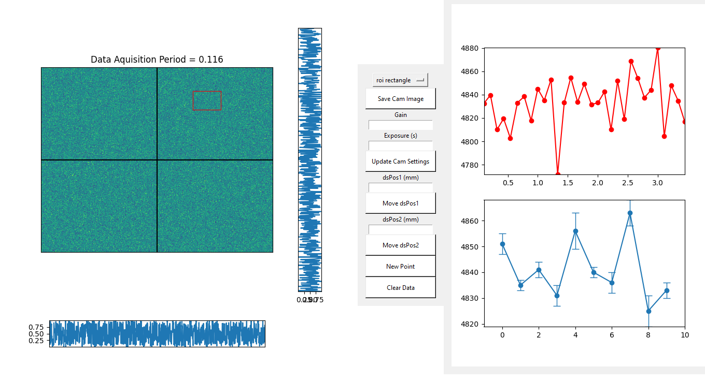

5 April 2023

Adding the scan control buttons

1. Entry for ds Positions:
   1. (start,end,step) notation
   2. Look for + sign to add regions
      1. So (1,2,0.1)+(2,3,0.5) would add these regions
2. Entry for batch number
3. Check box for translation correction
4. Check box for smart scan
5. Button for starting scan
6. Active directory button

Misc features.

1. Adding dividers to separate logically separate controls
2. Adding a back end to the save image button
   1. Should save image with the current data + exposure + gain
   2. Remember the directory of the last save

TO DO LIST

|  |  |
| --- | --- |
| **Task** | **Completed ?** |
| Put a limit of 100 data points on the live data plot so that it doesn’t look cluttered | True |
| Fix user warninig: UserWarning: Attempting to set identical low and high x…… | True |
| Fix name of image_0 (should just be camImage) | True |
| Setup a virtual camera that approximates the code structure for taking a real image | True |
| Change feather logo of tkinter to Anshul’s face | True |
| Setup a back end for the exposure and gain entries (will just work with virtual cam for now) | True |
| Setup a virtual ds stage that approximates the real delay stage interface | True |
| Setup back end for the move ds buttons that approximates the real ds interface | True |
| Plot the current exposure and gain in the label on the entries | True |
| Add dynamic entry for last sent dsPosition | True |
| Make sure an ROI has an area of at least 1 | True |
| Add clear all ROI button, save button, and load button | True |
| Add backend for ROI controls buttons, save, load, clear | True |
| Display ROI number in image title | True |
| Fix issue of history deleting!!! | True |

What should be displayed during a scan?

6 April 2023

Additions:

ROI object now has a method that is used to update the patch size

Pseudo back end for scan controls:

1. Save a metadata file
   1. Exact time of the start of scan
   2. Exposure on camera
   3. Gain on camera
   4. dsPos array
   5. batch size
   6. translation correction?
   7. smart scan?
   8. scan directory
2. Setup proper exit sequence

13 April 2023

What arguments should the 2nd GUI “ScanApp” take?

1. Camera Object
2. camFig
3. camAx
4. Delay stage Object
5. dsPositions
6. Batch Size
7. Translation correction?
8. Smart scan?
9. Scan Directory
10. ROIS

Setup the scan loop:

* While scan live
  + for bi in the batch size
  + for p in length of delay stage positions
    - Move to new ds pos
    - Wait motor time
    - Take image
    - Load the averaged images, save with a moving average
    - Update data plots with roi information

Some bug fixes and tasks

|  |  |
| --- | --- |
| **Task** | **Completed ?** |
| Save figure showing translation correction data | TRUE |
| Thread the image analysis | TRUE |
| For scan app, Removing the tkinter update scheme that Atharva showed me | TRUE |
| Remove Blitting on image plots (not necessary) | TRUE |
| Add padding to buttons | TRUE |
| Setup the bottom data plot to display the results so far from the scan within the ROI | TRUE |
| Setup the top data plot to display the average scan intensity vs. scan number | TRUE |
| Make it so the full roiScanData and time history is saved to txt files | TRUE |
| Make a run log that saves the timing that occurred during the scan | TRUE |
| Make a batch average script that runs async whenever a batch finishes | TRUE |
| Collect data on running speed vs dsPos, scan #, batch # ect. To find out why it slows sometimes | TRUE |
| Add a backend to the pause scan button | TRUE |
| Add a gentle stop button | TRUE |
| Add a hard stop button | TRUE |
| Save figures of scan data for quick viewing after the scan | TRUE |
| Translation correction, has initial list of tracer Bragg peak locations vs. dsPositions, corrects to it | TRUE |
| Make it so it generates a new directory if the current directory already has data in it | TRUE |
| Make sure all meta data saves on exit | TRUE |
| Add a pseudo beam for testing tracker | TRUE |
| Add a log that counts all translation corrections | TRUE |
| Add the usePrevFitAsGuess for fitting of the gaussians on translation correction | TRUE |

Setup App fixes

|  |  |
| --- | --- |
| **Task** | **Completed ?** |
| Make it so the data plots in the setup app don’t start with a data point at zero | TRUE |
| For setup app, Removing the tkinter update scheme that Atharva showed me | TRUE |
| Move canvas draw to a separate loop | TRUE |
| Allow closing of the scan app without glitch | TRUE |
| Setup way to close setup gui and open scan gui | TRUE |
| Add a tzpos entry | TRUE |
| Make batch entry default to 1 | TRUE |
| Pass the rois from setup to scan | TRUE |
| Remove errors that occur when no roi is selected | TRUE |
| Make default roi selection rather than line profile selection | TRUE |
| Make the scan dir and other errors popups rather than prints | TRUE |
| Add the ds positions to the pipeline | TRUE |
| Fix error when there is no translation correction | TRUE |
|  |  |
|  |  |
|  |  |
|  |  |
|  |  |

Error:

