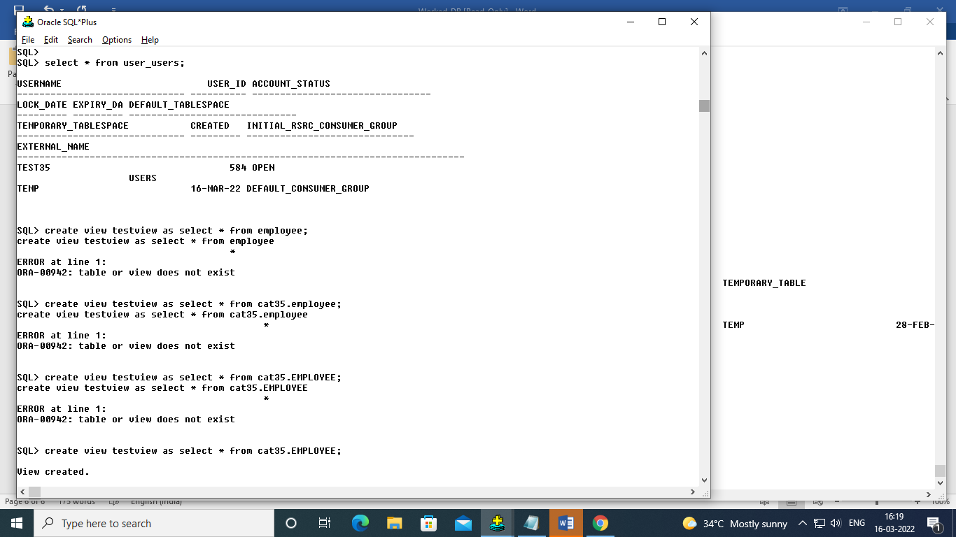create table employee (empno number(9), name varchar(15),job varchar(20),sal number(10),commission number(10),department varchar(10), primary Key(empno));

Table created.

Insert into employee values(1,'Ram','manager',20000,2000,'IT');

alter table employee add constraint ckh_sal CHECK(sal>=0 and sal>commission);

select constraint_name from user_constraints where table_name='EMPLOYEE';

2.

To create an view with excepting job=manager:

create view workers AS select * from EMPLOYEE where job!='manager';

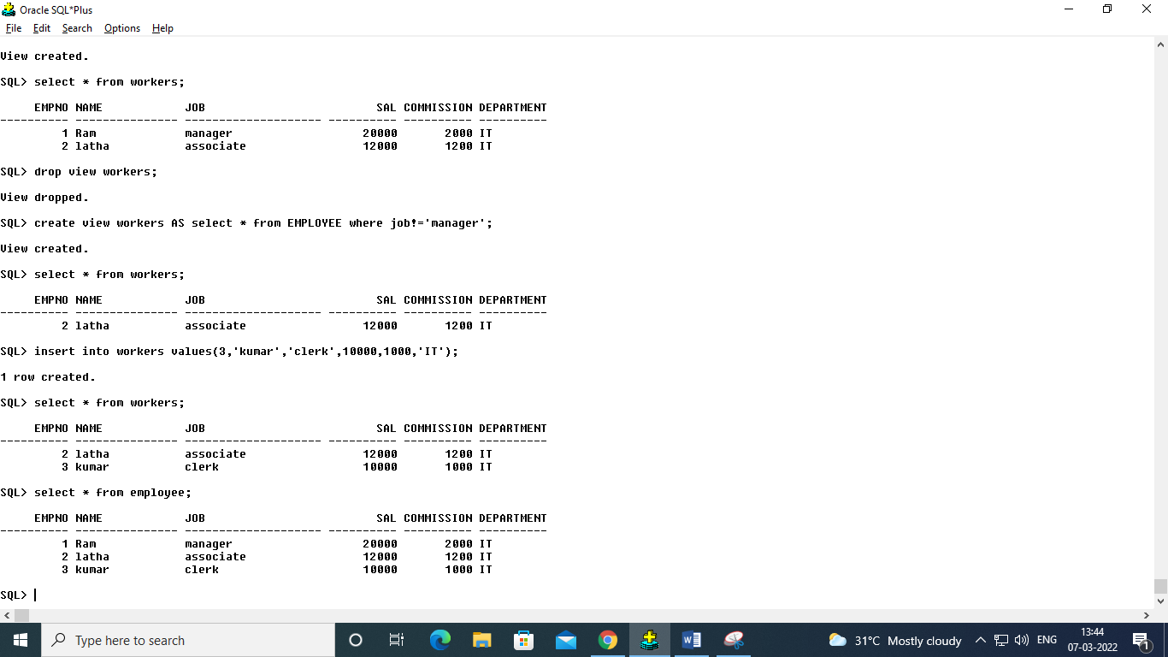

alter table employee add age number(5);

code to be add here:

INDEX:

1.create index idx_name on employee(name);

2.create index idx_upper_name on employee(UPPER(name));

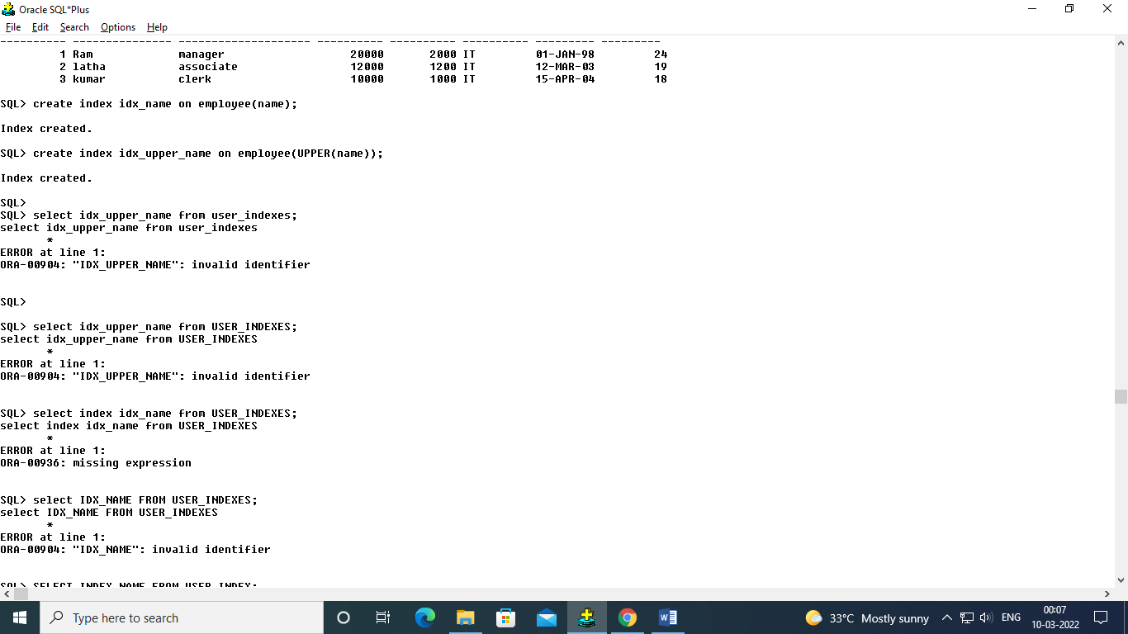

3.SELECT INDEX_NAME FROM USER_INDEXES;

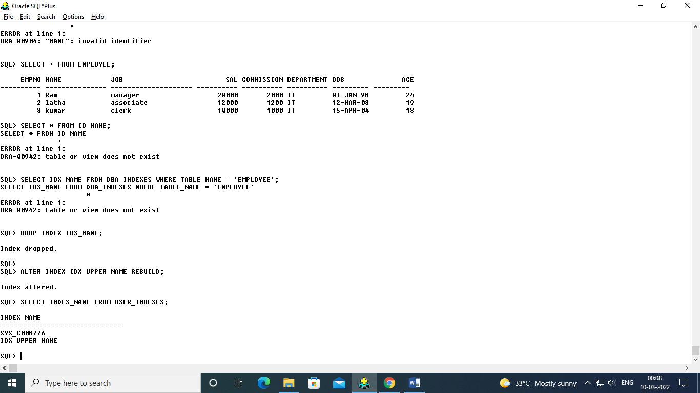

4. DROP INDEX IDX_NAME;

5. ALTER INDEX IDX_UPPER_NAME REBUILD;

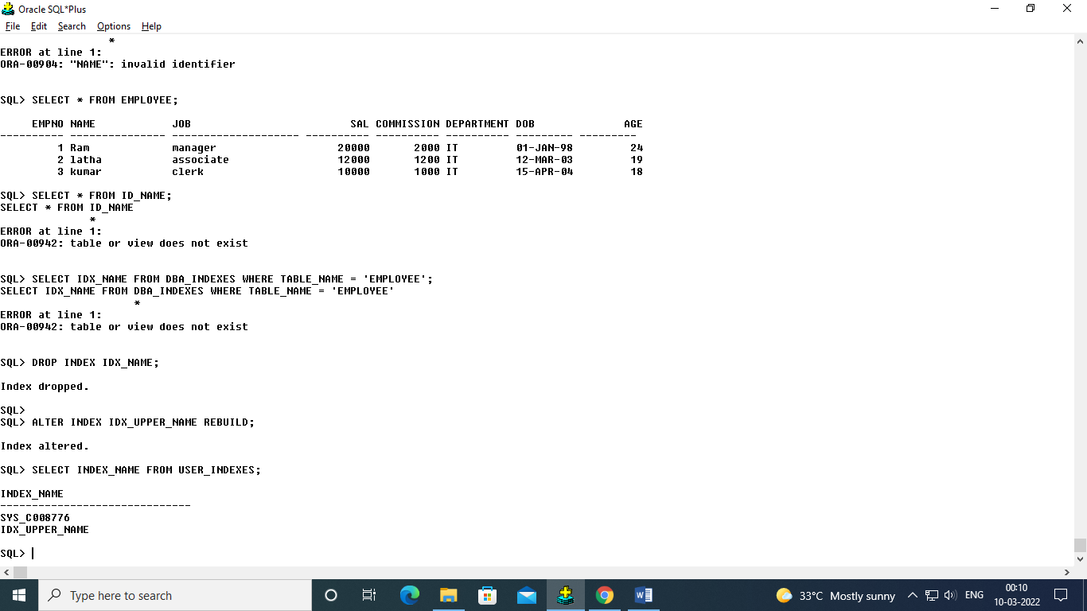

Sequences:

create sequence seq_no start with 999 minvalue 1 maxvalue 1000000 nocycle;

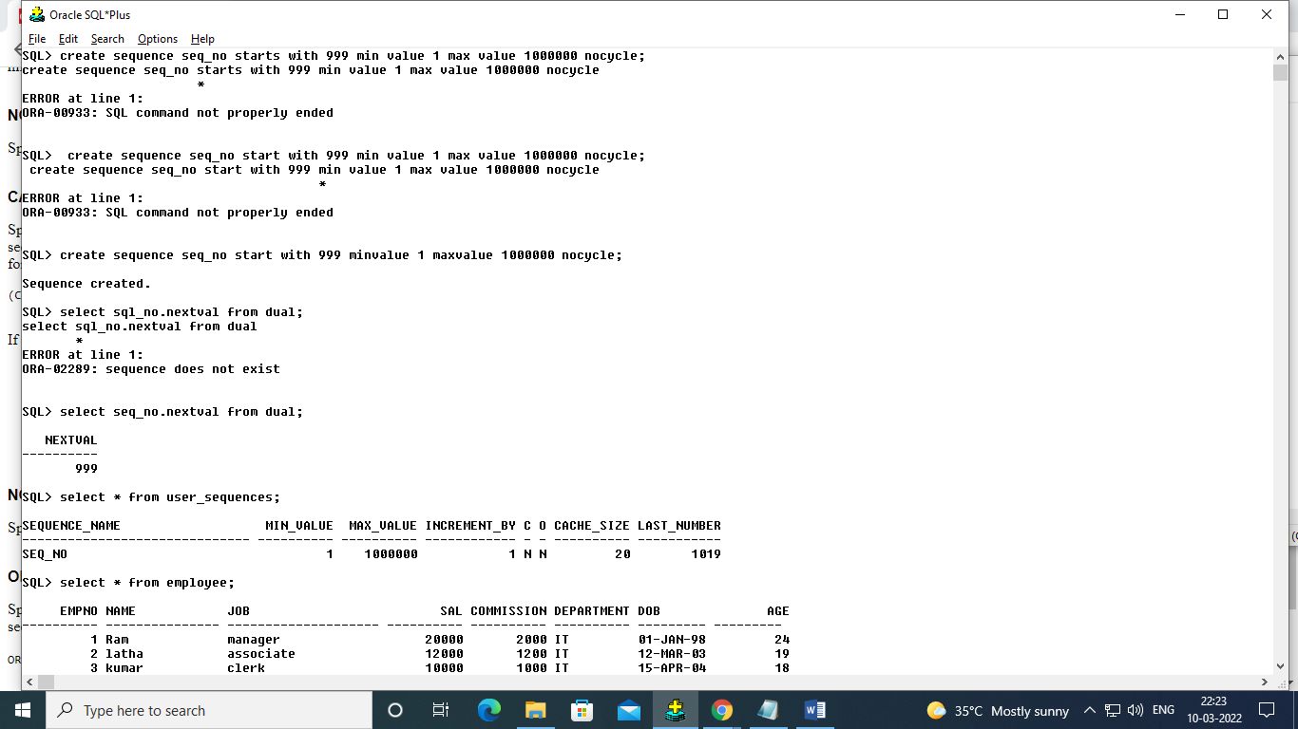

select seq_no.nextval from dual;

select * from user_sequences;

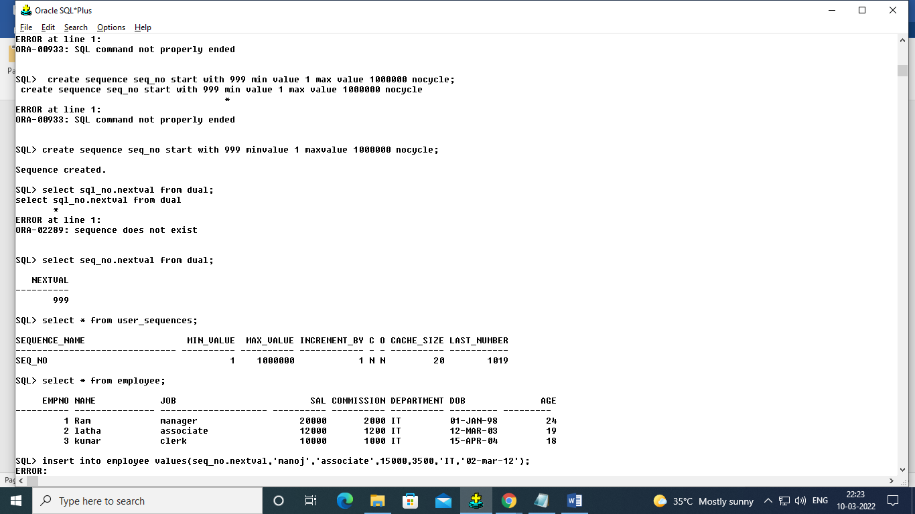

insert into employee values(seq_no.nextval,'manoj','associate',15000,3500,'IT','02-mar-12',45);

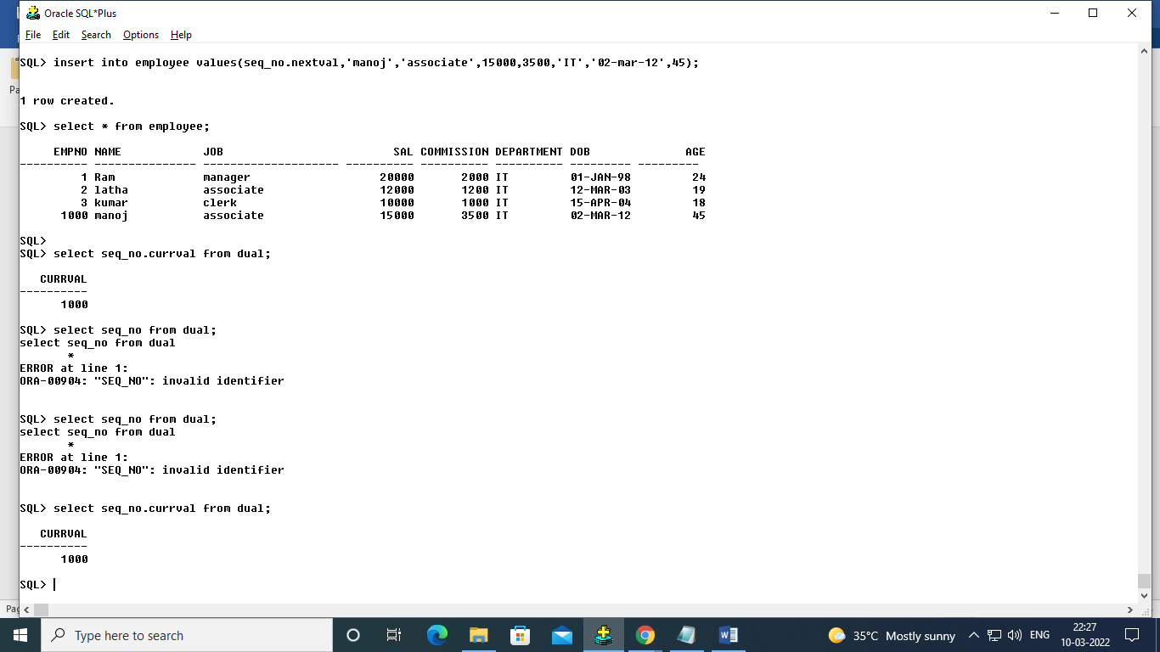

create user test35 identified by tom13;

grant create session to test35;

GRANT RESOURCE TO TEST35;

login with credentials in aother window:

select * from user_users;

grant create view to test35;

in test35:

create view testview as select * from cat35.EMPLOYEE;

grant all on employee to test35;

select * from TESTVIEW;

revoke delete on employee from test35;

select * from cat35.employee;

insert into cat35.employee values(1001,'raj','clerk',20000,2000,'IT','02-mar-2002',45);

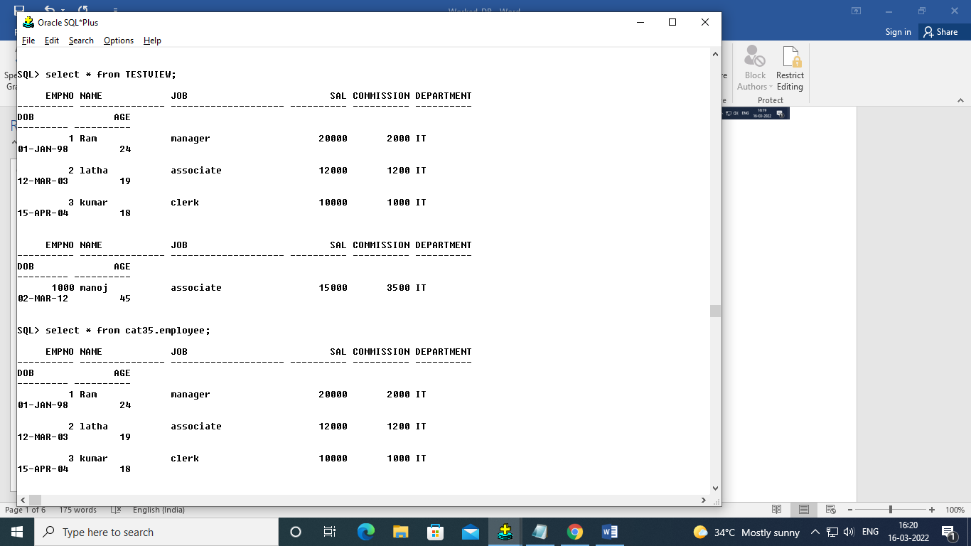

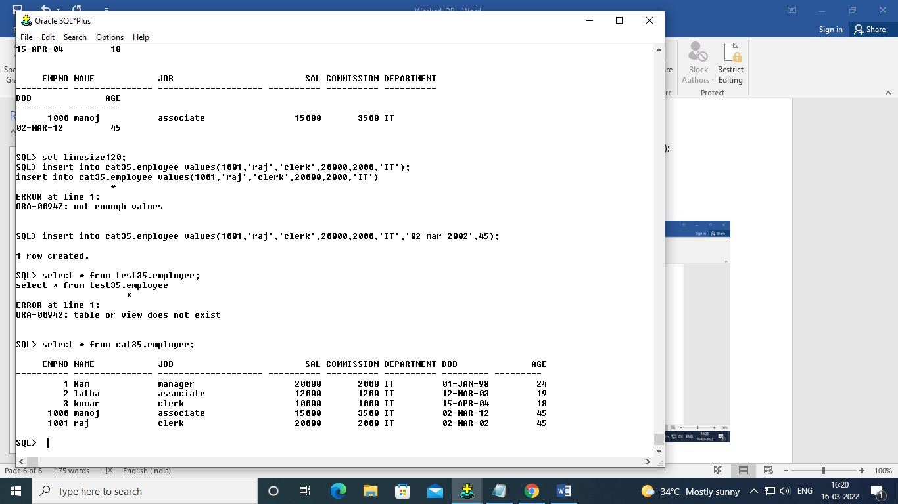

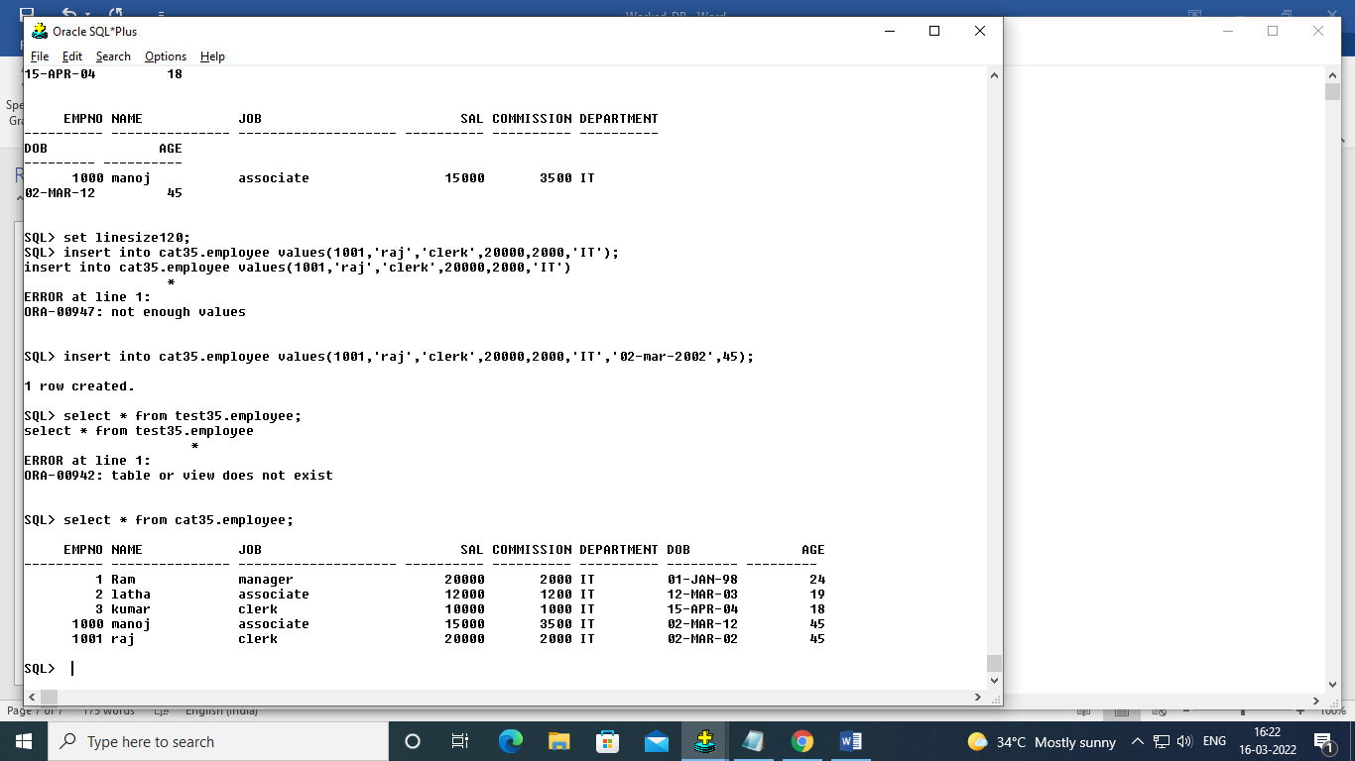

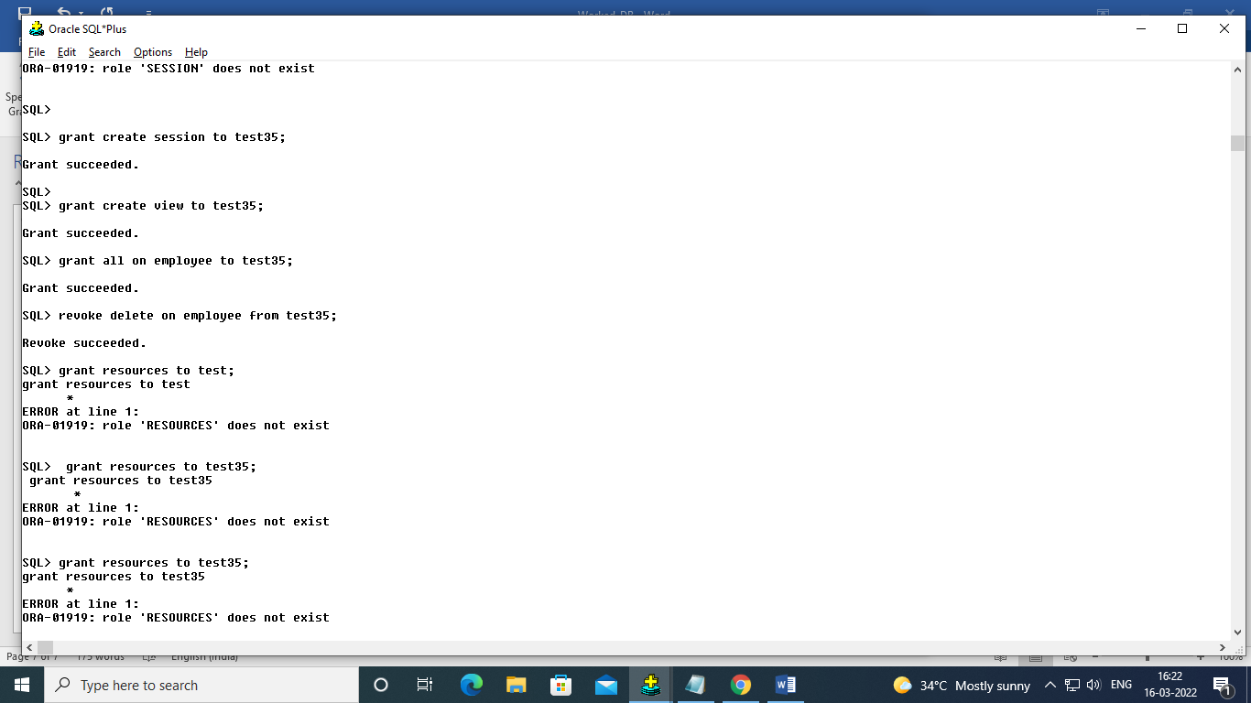

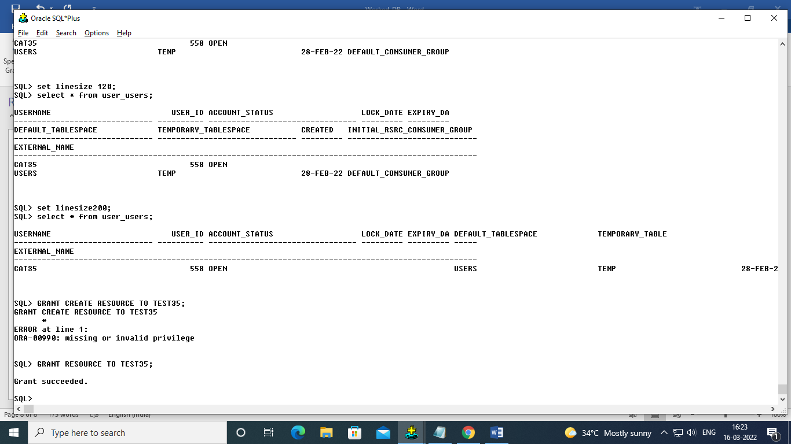

Ex:07

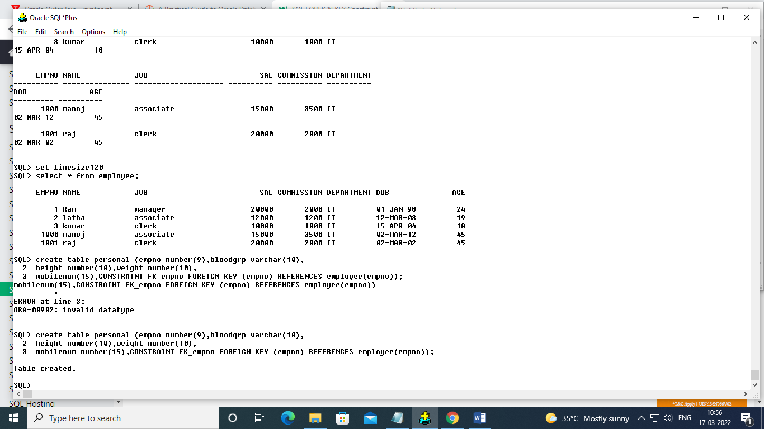

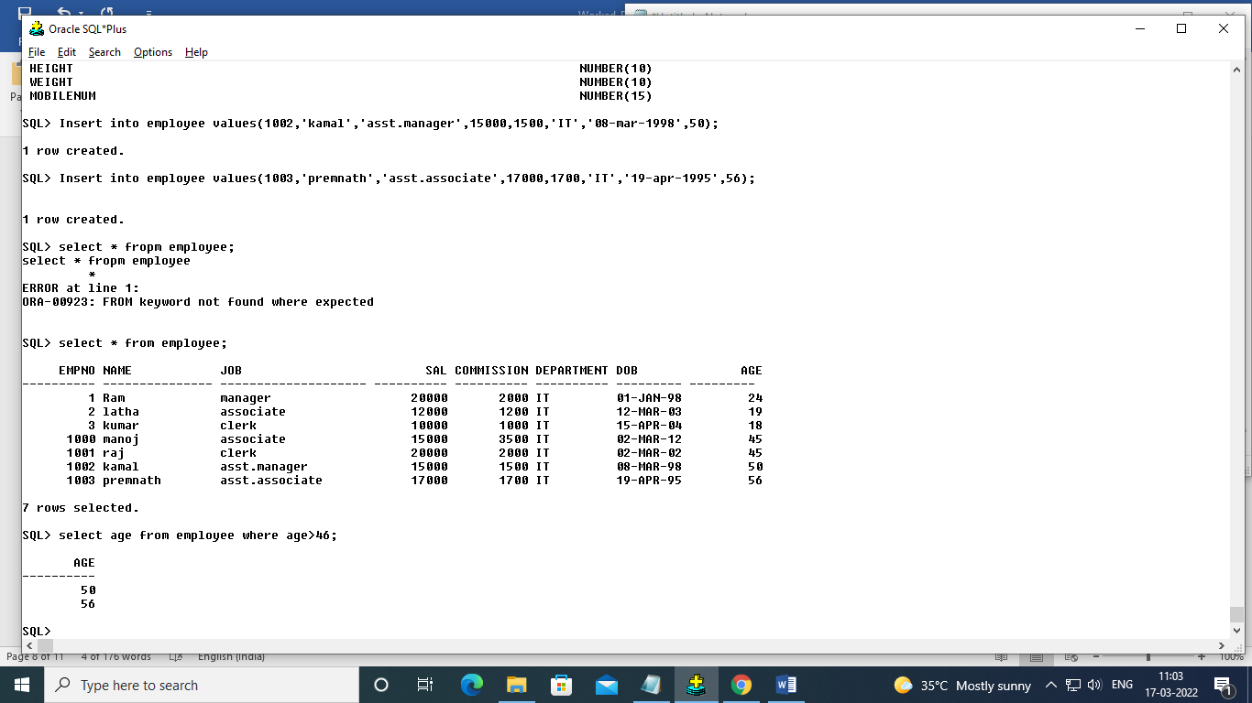

Procedure:

create procedure emp_pro1 (NAME VARCHAR2,JOB VARCHAR2,SAL NUMBER,COMMISSION NUMBER,DEPARTMENT VARCHAR2,DOB DATE,AGE NUMBER)

is

begin

Insert into employee values(SEQ_NO.nextval,NAME,JOB,SAL,COMMISSION ,DEPARTMENT,DOB,AGE);

end;

execute EMP_PRO1('harish','analyst','50000','5000','it','05-sep-04');

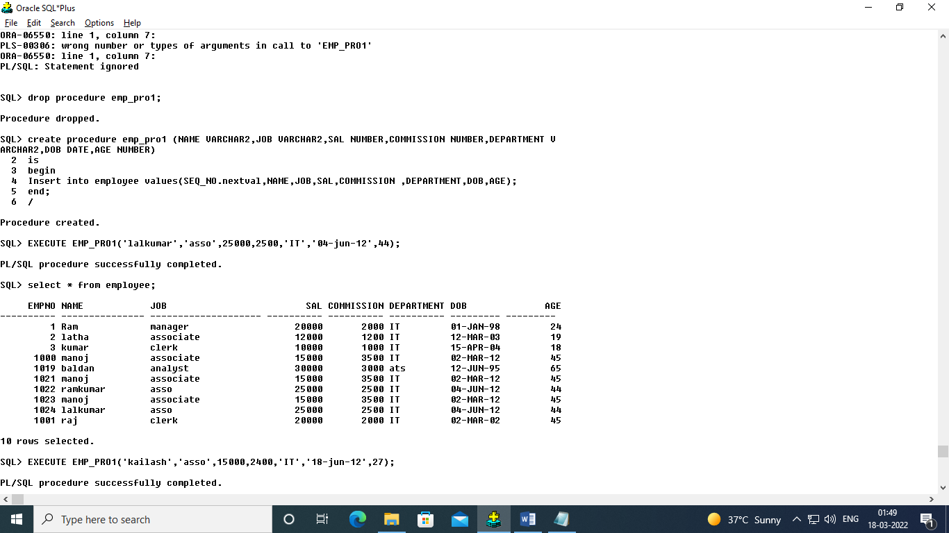

select decode(empno,1,'One',2,'two',3,'three') from employee;

create procedure dec_pro (d NUMBER)

IS

word varchar(20);

BEGIN

select decode(d,1,'ONE',2,'Two','Not an number') into word from dual;

DBMS_OUTPUT.PUT_LINE(word);

end;

exec dec_pro(6);