Guided Capstone Project Report
Problem Statement
Big Mountain Resort in Montana charges $81.00 for an adult weekend ticket, a price historically set by adding a premium to the local market average rather than by assessing what the resort's facilities are actually worth. With a new chair lift adding $1,540,000 to annual operating costs, leadership needs a data-driven way to determine whether the current price is justified, how much room exists to change it, and which facility investments or cuts would best support revenue. This project builds a pricing model from data on other US resorts to answer those questions.
Data Wrangling
The initial dataset covered 330 US ski resorts across 27 columns, including resort characteristics (elevation, vertical drop, lifts, runs, skiable and snow-making acreage, snowfall, days open) and two ticket prices, AdultWeekday and AdultWeekend. The fastEight column was dropped because over half its values were missing, and about 14% of rows lacking any ticket price were removed, leaving 277 resorts. State population and land-area figures were scraped from the web and merged in, enabling later competitive-context features. Big Mountain's own record was verified intact and complete.
Exploratory Data Analysis
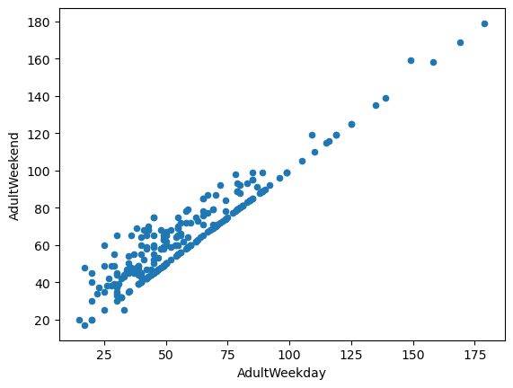
Figure 1. AdultWeekday vs. AdultWeekend ticket price across US resorts.
Weekday and weekend prices are almost perfectly correlated (Figure 1): resorts that charge more on weekdays charge proportionally more on weekends, with weekend prices at or above weekday prices throughout. Because the two carry essentially the same signal, AdultWeekend was selected as the single modeling target: it is the more business-relevant figure and had fewer missing values. To capture each resort's competitive context, state-level ratio features were engineered (resorts per capita, resorts per square mile, and each resort's share of its state's skiable area, days open, terrain parks, and night skiing). A PCA of the state summary data showed the first two components explain roughly 77% of variance, yet resorts showed no clustering by ticket-price quartile in that space, evidence that state identity alone does not predict price. Raw state labels were therefore excluded in favor of the engineered ratios. The correlation heatmap also flagged multicollinearity to manage in modeling, notably summit vs. base elevation and the state-share ratios vs. resorts_per_state.
Model Selection
Data were split 70/30 into training and test sets, with Big Mountain held out entirely for scenario analysis. Three approaches were compared. A naive baseline predicting the mean price produced a test MAE near $19, the bar any model had to beat. A cross-validated linear regression pipeline (median imputation, scaling, SelectKBest with k=8) reached a CV MAE of $10.50 (±1.62) and test MAE of $11.80, identifying vertical drop and snow-making acreage as the strongest positive price drivers. A grid-search-tuned random forest regressor (median imputation, no scaling) performed best: CV MAE of $9.64 (±1.35) and a consistent test MAE of $9.54, with fastQuads, Runs, Snow Making_ac, and vertical_drop as its top features, agreeing with the linear model on what drives price. The random forest was selected for its lower, more stable error. A learning-curve analysis showed performance plateaus at the current sample size, so collecting more resort data is not an immediate priority.
Pricing Analysis
Refit on all resorts except Big Mountain, the model predicts Big Mountain's facilities support a ticket price of $95.87, which is $14.87 above the current $81.00 and a gap larger than the model's $10.39 MAE. Big Mountain ranks near the top of the market on the features that matter most (vertical drop, fast quads, runs, snow-making coverage), so its facilities genuinely justify a premium price; the current figure appears to reflect conservative local benchmarking rather than national market value. A prudent path is to raise the price in steps toward the low end of the modeled range (around $91 initially) while monitoring visitation and season-pass renewals, rather than moving to $95.87 at once.
Scenario Analysis
Four operational scenarios were evaluated for their effect on supportable price and season revenue (350,000 visitors × 5 tickets each):
• Closing runs: closing 1 run changes nothing; closing 2–3 steps price down slightly; closing 4–5 adds no further loss beyond the 3-run level (Figure 2). If cost cutting is desired, up to 4 runs can close with no penalty beyond that of closing 3. Deeper cuts (6+) drive substantially larger price and revenue losses.
• Add 1 run, +150 ft vertical drop, +1 chair lift: raises supportable price by $1.99, worth about $3,474,638 per season, comfortably exceeding the new lift's $1.54M operating cost. This is the clear best investment.
• The same plus 2 acres of snow making: identical result; the extra snow making adds no value and should be skipped.
• Longest run +0.2 mi with +4 acres of snow making: $0.00 price impact; these features rank low in importance.
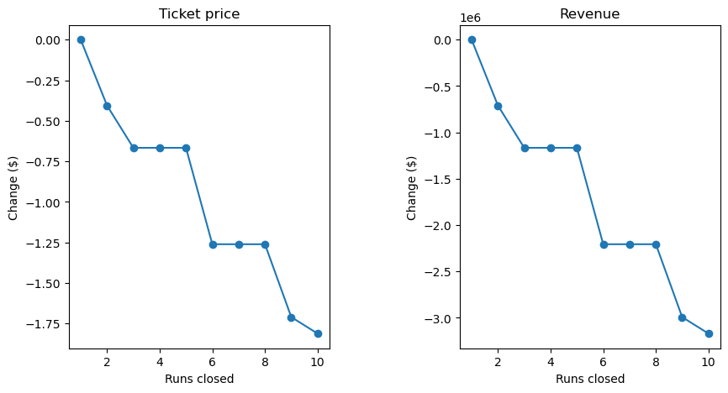
Figure 2. Predicted change in ticket price (left) and season revenue (right) as runs are closed.
Conclusion and Future Work
Big Mountain is underpriced relative to its facilities. The recommended actions are: (1) raise the adult weekend ticket toward the modeled range in monitored increments; (2) proceed with the run/vertical-drop/chair-lift expansion, which pays for itself through supportable price gains; (3) decline the additional snow-making and longest-run investments; and (4) if cost savings are needed, pilot closing 1–2 low-traffic runs before committing further. Two limitations point to future work: the dataset lacks operating-cost data, so scenarios are judged on revenue rather than profit; and the model would be far more useful to the business as a self-serve tool: a simple internal dashboard where analysts can test parameter combinations themselves, with the model retrained annually and its MAE displayed alongside every prediction.

