WikiGraph

Mark Jordan
Jeremy Lenz
Robert McClure
Austin Nakamura
Michael Rush
Khanh Tran
Thomas Van Doren

Software Requirements

Specification

Draft 1
January 21, 2011

CSE 403 - CSRocks Inc.

Version | Primary Author(s) | Description of Version | Date Completed
1 | Rob McClure, Thomas Van Doren | Initial revision: description, features, scope. | 2011-01-19
2 | Mark Jordan, Jeremy Lenz, Michael Rush | Use cases | 2011-01-19
3 | Austin Nakamura, Khanh Tran | UI Prototypes | 2011-01-20
4 | Thomas Van Doren | Description and Feature updates to reflect changes to UI implementation  (js -> flash) | 2011-01-23

Description
WikiGraph is a graphical interface for visualizing the connections among Wikipedia articles via their links. This product will provide an easy to use search engine to target a specific article, which will become the central node. From the central node a directed graph will display how this article is connected to other Wikipedia articles.

The WikiGraph is ideal for Wikipedia enthusiasts. Enthusiasts are interested in digging deep into articles and their connections. WikiGraph provides a clean interface to visualize connections among Wikipedia articles. This could be useful for any Wikipedia user by showing article relations via a directed graph. However, this product will exist outside of Wikipedia, so enthusiasts will be the target audience.

There are no known alternatives to this product. There is a similar, possibly identical, product being created in parallel. It remains uncertain how WikiGraph will distinguish itself.

WikiGraph will employ an inductive user interface design. Users will be able to use their intuition to get started. There will be help tips throughout the product to aide users in accomplishing advanced tasks. The inductive ui will rely on standard layouts to maximize user intuition. The goal is to make WikiGraph easy to learn and use.

WikiGraph is an extension for Wikipedia. It allows a specific relation among articles, specifically through in-article links, to be easily discovered via a graphical interface. It is easy to use and easy to learn.

Scope
WikiGraph will only be a method for visualizing the connections between Wikipedia articles. It will not be a replacement for Wikipedia, and as such, it will not allow users to edit or comment on articles.

WikiGraph is a web application. The front-end will be a modern web browser with Internet connection, JavaScript enabled, and Adobe Shockwave Flashplayer plugin installed and enabled. The back-end will be a web server with a MySQL database.

Browsers will be supported as listed below:
Absolutely Support
- Google Chrome 5.x (most users will have the newest version, though)
Hope to Support
- IE 8
- Mozilla Firefox 3.5
- Internet Explorer 9 (beta)
- IE 7
- Apple Safari 4.x
- Opera 10.50
Not Supported
- Internet Explorer 6

There might be some performance issues with the Wikipedia database. It is extremely large and it is unknown to the developers how it will act under the stress of WikiGraph. It is not expected to be a limiting factor, but it currently unknown.

Use Case Diagram
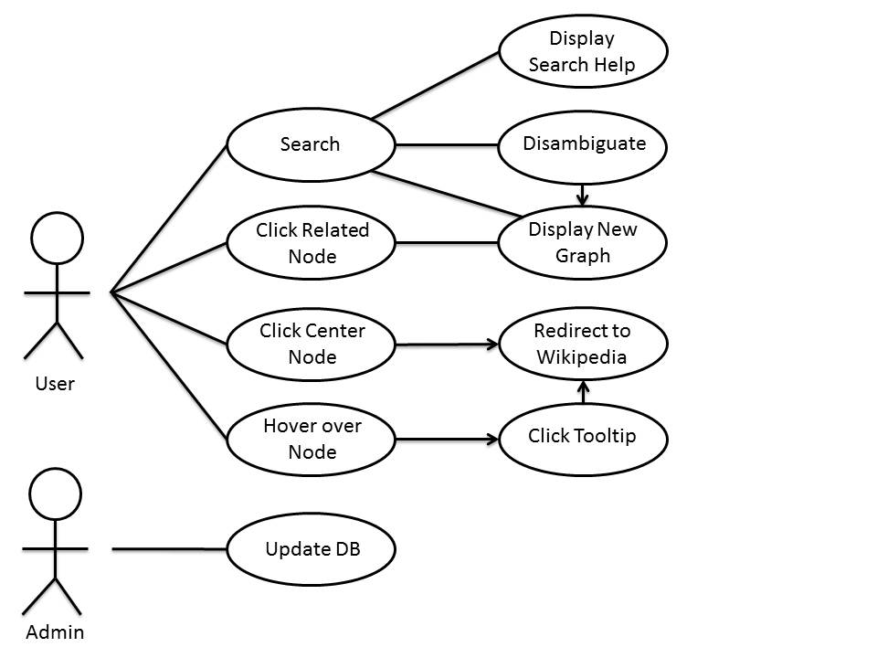
User functions: Users may enter a search, which will result in a help page if no matches were found, a disambiguation page if many matches were found, or a new graph if an exact match was found. Users may enter a new search from any stage during this process. Users may also click on any node in the graph. Clicking on a related node (leaf) will center the graph on that node. Clicking on the center node will redirect the page to the Wikipedia article. Users may hover over any node to display a popup (including article title and abstract), which may be clicked to redirect to the article.

Admin functions: The admin may make any changes to the database, such as ensuring that the DB is up to date with the current version of Wikipedia.

Formal Use Case #1
Project Team | WikiGraph
Goal | To find a wiki article
Level | User Goal
Primary Actor | User
Precondition | User is at home/instruction page
Success end condition | User finds a desired article
Failure end condition | User does not find a desired article
Trigger | User wants to know more about some article
Main success scenario | - User enters a string related to an article in the search query text field, clicks search.  - WikiGraph finds a relevant article from the search query and displays the article found as a center root node with related articles around it as leaf nodes.  - User hovers over some node, bringing a popup with extra information on the article.  - User finds the article desirable and wants to know more, user decides to click ‘go-to wikipage’ link in popup which opens a new tab/window of the related Wikipedia article.
Extensions | - a. User submits a different search query (return to success scenario step 2.  - a. same as 2.a.  - a. same as 2.a.  - b. WikiGraph finds several relevant articles to query, displays such relevant articles to user as leaf nodes connected to a center node which displays some disambiguation information saying that multiple articles to the search were found.  - c. Many articles are found (related to search query, or of the search query) which brings up a 'different page' option where user can specify a page of nodes to display.
Variations | - a. WikiGraph does not find a relevant article, displays such results to user and asks for another query (back to success scenario step 1).  - a. User takes advantage of double-click feature on a node, which immediately opens a new tab/window of the nodes related Wikipedia article  - a. User clicks on 'center node' feature for some leaf node (might be in popup) node is centered, with related articles as leaf nodes (continue to success scenario step 3)

Formal Use Case #2
Project Team | WikiGraph
Goal | User wishes to explore connections between two chosen, seemingly random topics
Level | User goal
Primary Actor | User
Precondition | User is at our instructional homepage
Success end condition | User finds a connection using links between articles
Failure end condition | User gives up on finding a connection
Trigger | User queries for one of the two articles
Main success scenario | - User enters an article name  - User views related articles and chooses most similar to desired article  - GUI redraws graph around chosen article  - User goes back to 2. until article is found
Extensions | - a. Article does not exist  - a.1. User is shown similar articles  - a.2. User can choose to use a random page
Variations | - a. Article is ambiguous  - a.1. User is shown disambiguation page  - a.2. User picks a displayed node

Feature List
Feature | Target
Map outbound links for an article | Beta
Search for an article | Beta
Display article title in node | Beta
Provide link to Wikipedia page for node | Beta
Display article abstract in tooltip | Beta
Limit number of links to display | Beta
Provide search disambiguation | Release
Provide search-not-found resolution | Release
Search history and navigation | Release
Direct links to specific node maps | Release
Autocomplete for search | Release
Ability to navigate and expand map | Release
Rank strength of links | Release
Map inbound links for an article | Stretch
Animation for map navigation | Stretch
Ability to cycle through/view all links for a node | Stretch
Allow users to change display settings | Stretch
Display multiple nodes with common connections | Stretch

UI Diagrams

Welcome splash version #1:
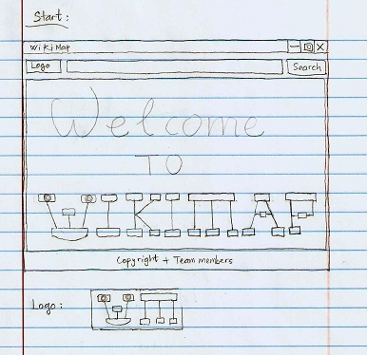

Welcome splash version #2:
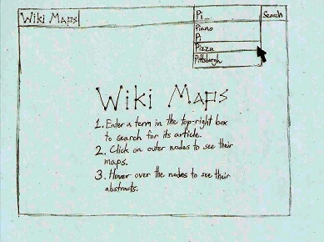

Search Result Not Found:
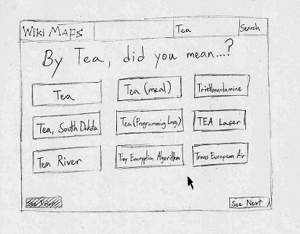

Search Result Graph:U