ENGINEERING ENABLEMENT
Code Review Harness
Agentic System Curriculum
Condensed instructor-led edition • six sessions • 5.5 instructional hours
Core philosophy Evidence is observable. Assessment is bounded. Recommendations inform. Humans decide.

Repository-aligned edition
Designed for young engineers who need the system philosophy, contract model, workflow mechanics, and platform prompt standard.

How to use this condensed curriculum
This edition compresses the original sequence into six instructor-led sessions. Each session is 55 minutes, for 330 minutes of instruction. A delivery block of six hours leaves 30 minutes for breaks, transitions, and questions.
Delivery limit 6 × 55-minute sessions = 5 hours 30 minutes of instruction. Total scheduled time must not exceed 6 hours.

Course-level outcomes
- Explain why the harness—not the model—is the trust boundary.
- Read the catalog and select the correct agent, contract, and consumer.
- Follow evidence through typed artifacts and guarded workflow states.
- Draft prompts as implementations of inherited contracts.
- Test prompt invariants and evolve versions through human review.

Six-session schedule
Session | Focus | Minutes
1 | Harness Philosophy and Human Authority | 55
2 | Evidence, Provenance, and Contracts | 55
3 | Agent Catalog and State Machines | 55
4 | Orchestration and Contract-Driven Prompts | 55
5 | Prompt Engineering Deep Dive | 55
6 | Evaluation, Evolution, and the Agent Prompt Playbook | 55
 | Total instruction | 330
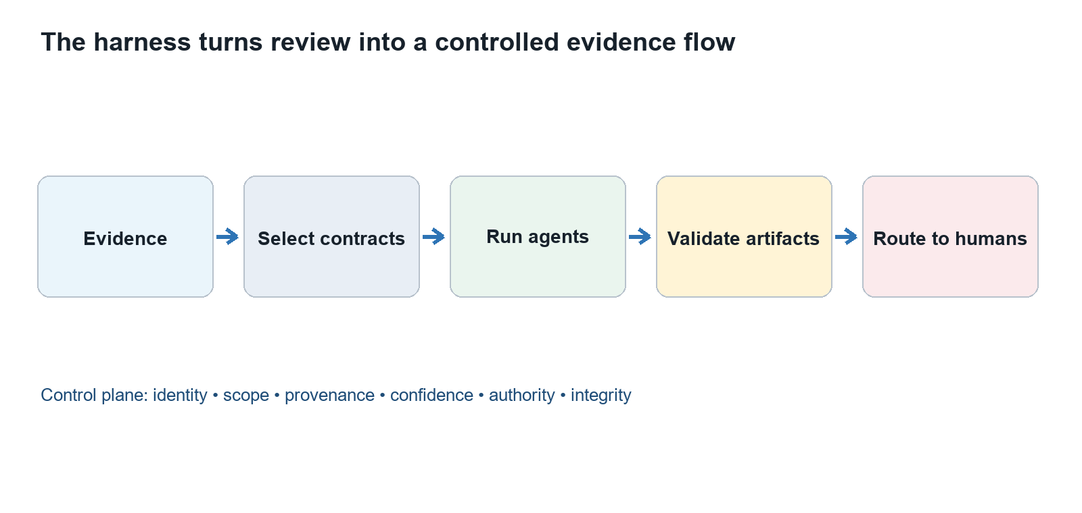
The harness controls evidence, execution, validation, and routing.

Standard 55-minute rhythm
- Opening question and prior-knowledge check — 5 minutes.
- Core mental model — 12 minutes.
- Repository-grounded worked example — 12 minutes.
- Instructor demonstration — 12 minutes.
- Prompt design walkthrough — 10 minutes.
- Knowledge check and transition — 4 minutes.
Repository basis: README.md; docs/philosophy.md; agents/agent-registry.md; contracts/contract-catalog.md

Session 1: Harness Philosophy and Human Authority
Duration: 55 minutes | Driving question: What turns capable model output into a trustworthy engineering review?

Learning outcomes
- Distinguish model, agent, workflow, and harness.
- Separate evidence, assessment, recommendation, and decision.
- Locate the human authority boundary.

Session visual: Harness Philosophy and Human Authority.

Core mental model
Concept | Working definition
Model | Generates candidate reasoning; it does not guarantee provenance, scope, or authority.
Agent | A bounded role combining identity, contracts, tools, and output obligations.
Harness | Controls evidence, execution, validation, routing, and observability.
Human authority | Owns approval, acceptance, waiver, prioritization, and governance decisions.

Facilitation run of show
- Opening question — 5 minutes.
- Mental model — 12 minutes.
- Worked example — 12 minutes.
- Instructor demonstration — 12 minutes.
- Prompt walkthrough — 10 minutes.
- Knowledge check — 4 minutes.

Worked example and demonstration
Prepared walkthrough Compare an unconstrained code-review response with the same review executed through evidence admission, a bounded role, a typed output, validation, and a human decision request.

Prompt design walkthrough
Clause sequence Rewrite “Review this code” using six controls: identity, evidence, scope, consumer, output, and authority.

Knowledge check
Name four controls supplied by the harness and one consequential decision that remains human-owned.
Repository basis: docs/philosophy.md; contracts/universal-agent-contract.md; governance/human-review-and-maturity.md

Session 2: Evidence, Provenance, and Contracts
Duration: 55 minutes | Driving question: How can another engineer reproduce and validate an agent’s result?

Learning outcomes
- Build a traceable evidence chain.
- Explain additive contract inheritance.
- Validate the universal artifact envelope.
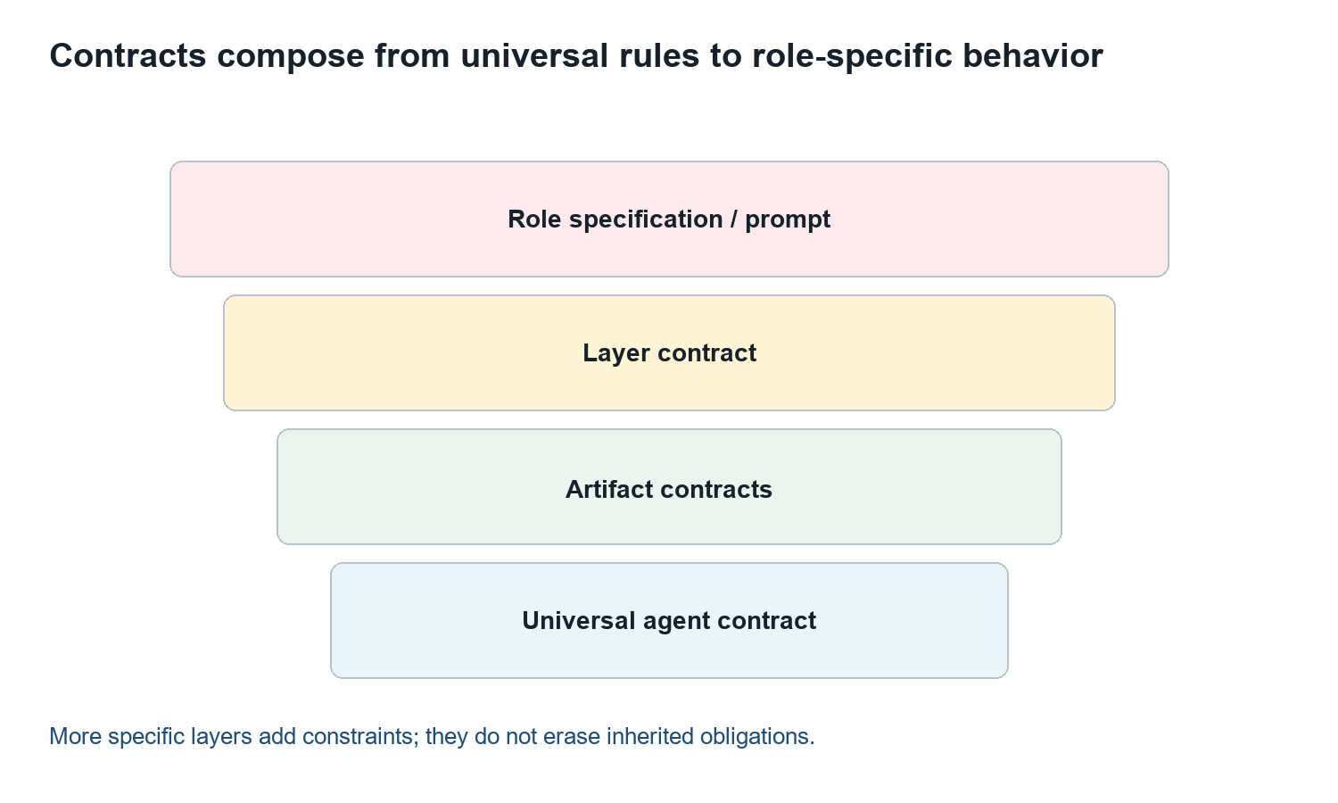
Session visual: Evidence, Provenance, and Contracts.

Core mental model
Concept | Working definition
Provenance | Records where evidence came from and how it was acquired.
Coverage | Declares what was inspected, omitted, unavailable, or out of scope.
Contract | Defines obligations shared by producers and consumers.
Traceability | Uses stable identifiers to preserve causality across artifacts.

Facilitation run of show
- Opening question — 5 minutes.
- Mental model — 12 minutes.
- Worked example — 12 minutes.
- Instructor demonstration — 12 minutes.
- Prompt walkthrough — 10 minutes.
- Knowledge check — 4 minutes.

Worked example and demonstration
Prepared walkthrough Follow a source line through evidence, finding, recommendation, and decision request; then show how a missing identifier breaks reproducibility.

Prompt design walkthrough
Clause sequence Project evidence admission, evidence IDs, coverage, confidence, envelope fields, and incomplete-input behavior into explicit clauses.

Knowledge check
Trace one assessment to its evidence, governing contract, intended consumer, and human decision request.
Repository basis: contracts/evidence-contract.md; contracts/contract-dependency-graph.md; contracts/style-and-validation.md

Session 3: Agent Catalog and State Machines
Duration: 55 minutes | Driving question: Who owns the question, and what must be true before work advances?

Learning outcomes
- Route work to the narrowest authoritative agent.
- Read canonical identity, layer, version, and status.
- Model states, events, guards, and failure paths.
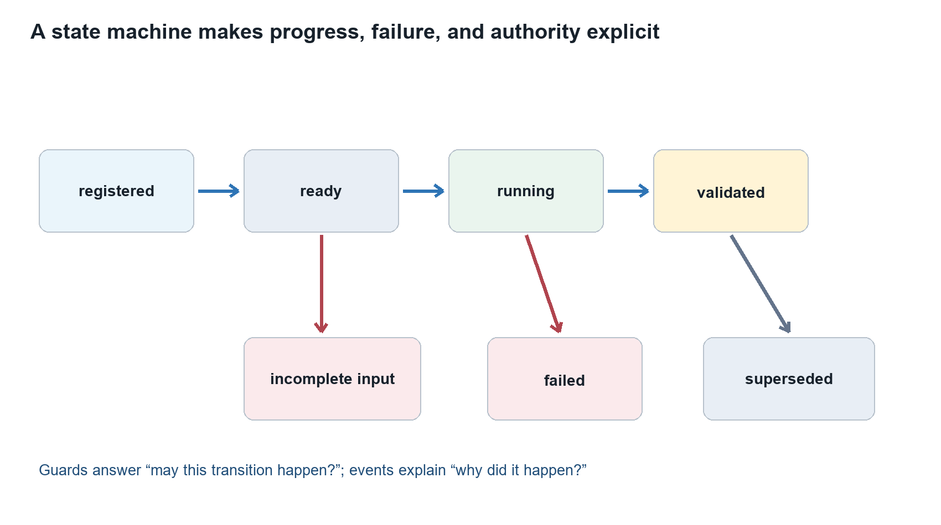
Session visual: Agent Catalog and State Machines.

Core mental model
Concept | Working definition
Identity | Provides the canonical designation, immutable UUID, layer, version, and status.
Layer | Controls the breadth of observation, synthesis, and coordination.
State | Names a durable execution condition that can be inspected.
Guard | States the predicates that must be true before a transition is legal.

Facilitation run of show
- Opening question — 5 minutes.
- Mental model — 12 minutes.
- Worked example — 12 minutes.
- Instructor demonstration — 12 minutes.
- Prompt walkthrough — 10 minutes.
- Knowledge check — 4 minutes.

Worked example and demonstration
Prepared walkthrough Route a release question to the catalog, verify the selected agent’s status, then walk registered, ready, running, validated, and routed states.

Prompt design walkthrough
Clause sequence Declare the owned question, explicit exclusions, ready guard, incomplete-input state, failure reason, and safe next action.

Knowledge check
Route one question and explain both its agent boundary and its next legal state transition.
Repository basis: agents/agent-registry.md; agents/agent-identities.json; orchestration/workflow-model.md

Session 4: Orchestration and Contract-Driven Prompts
Duration: 55 minutes | Driving question: How do many agents coordinate without hiding causality or inventing findings?

Learning outcomes
- Separate scheduler, fan-out, fan-in, and gate duties.
- Identify safe parallelism and explicit join guards.
- Project contract obligations into prompt clauses.
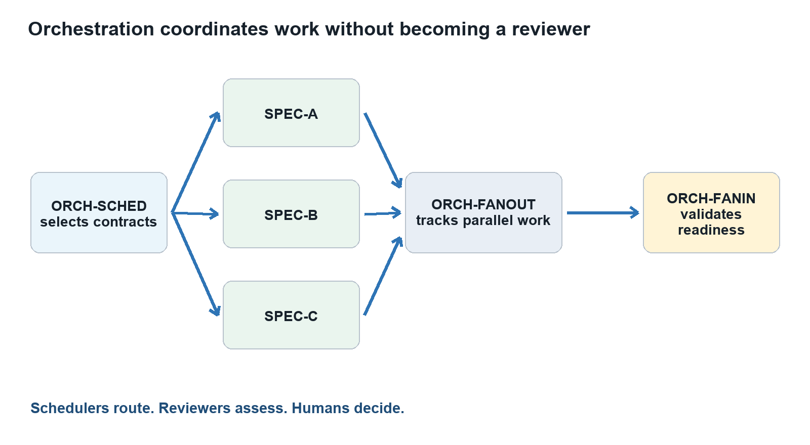
Session visual: Orchestration and Contract-Driven Prompts.

Core mental model
Concept | Working definition
Scheduler | Selects eligible roles and compatible versions.
Fan-out | Dispatches independent work while preserving execution identity.
Fan-in | Validates prerequisites and aggregates without erasing disagreement.
Prompt | Implements the selected identity, contracts, state behavior, and output.

Facilitation run of show
- Opening question — 5 minutes.
- Mental model — 12 minutes.
- Worked example — 12 minutes.
- Instructor demonstration — 12 minutes.
- Prompt walkthrough — 10 minutes.
- Knowledge check — 4 minutes.

Worked example and demonstration
Prepared walkthrough Walk a release review through role selection, parallel review, execution tracking, join validation, artifact routing, and a human decision gate.

Prompt design walkthrough
Clause sequence Specify select, dispatch, track, validate, and route behavior while prohibiting the orchestrator from creating domain findings.

Knowledge check
Explain the join guard and identify what the orchestrator is prohibited from concluding.
Repository basis: orchestration/workflow-model.md; contracts/orchestration-agent-contract.md; contracts/universal-agent-contract.md

Session 5: Prompt Engineering Deep Dive
Duration: 55 minutes | Driving question: How do we make 55 prompts coherent, specialized, and safe under pressure?

Learning outcomes
- Separate shared modules from role specialization.
- Trace each prompt clause to a governing requirement.
- Design fail-closed behavior for adversarial inputs.
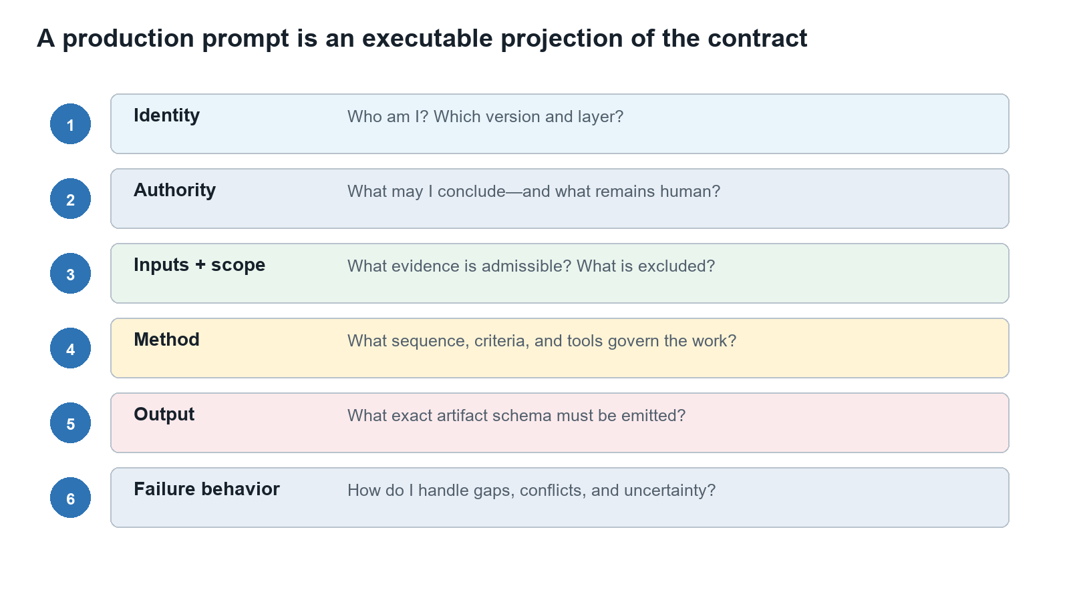
Session visual: Prompt Engineering Deep Dive.

Core mental model
Concept | Working definition
Shared module | Implements stable universal or layer behavior once.
Role block | Defines the owned method, evidence criteria, exclusions, and consumers.
Trace matrix | Links each requirement to a clause, output field, and test.
Adversarial case | Tests whether an invariant survives hostile or degraded input.

Facilitation run of show
- Opening question — 5 minutes.
- Mental model — 12 minutes.
- Worked example — 12 minutes.
- Instructor demonstration — 12 minutes.
- Prompt walkthrough — 10 minutes.
- Knowledge check — 4 minutes.

Worked example and demonstration
Prepared walkthrough Decompose one specialist prompt, trace its clauses to contracts, and test it against missing evidence, conflicting sources, and malicious repository text.

Prompt design walkthrough
Clause sequence Use identity, authority, inputs, method, output, and failure behavior as the core drafting sequence.

Knowledge check
Defend one prompt clause with its governing source and demonstrate its fail-closed behavior.
Repository basis: contracts/universal-agent-contract.md; contracts/specialist-agent-contract.md; contracts/sandboxed-contract-evolution.md

Session 6: Evaluation, Evolution, and the Agent Prompt Playbook
Duration: 55 minutes | Driving question: How do teams draft and improve every catalog prompt without losing control?

Learning outcomes
- Evaluate grounding, boundaries, state, authority, and consumer fit.
- Version prompt changes through controlled evidence.
- Apply one repeatable drafting playbook across all agent layers.
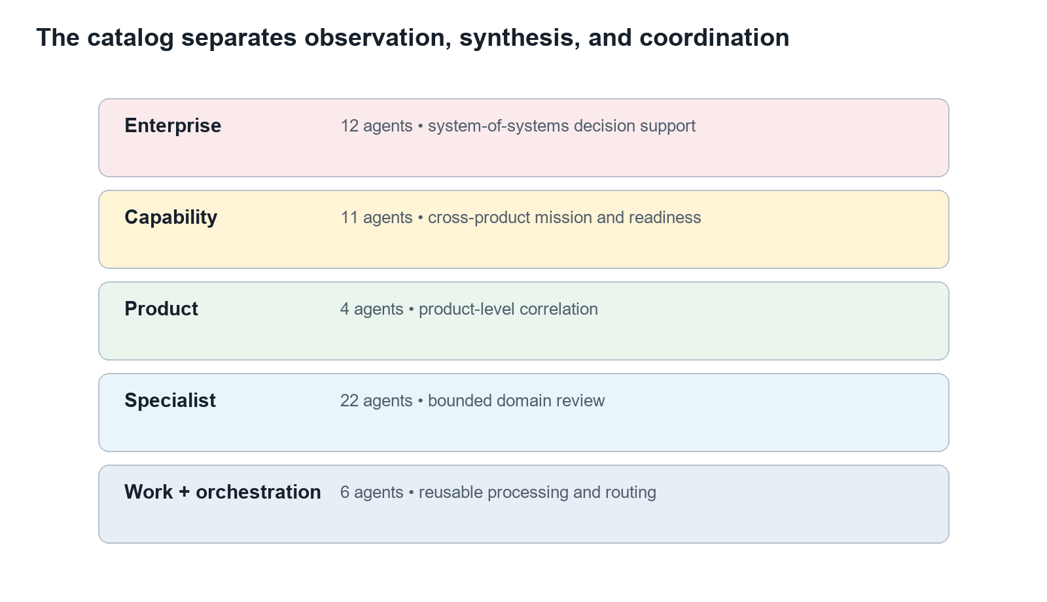
Session visual: Evaluation, Evolution, and the Agent Prompt Playbook.

Core mental model
Concept | Working definition
Evaluation case | Pairs an input with expected invariants and observable pass conditions.
Calibration | Aligns confidence and severity with evidence strength and impact.
Version | Records a reviewed semantic change and its compatibility implications.
Playbook | Repeats contract tracing, drafting, testing, and human review for every role.

Facilitation run of show
- Opening question — 5 minutes.
- Mental model — 12 minutes.
- Worked example — 12 minutes.
- Instructor demonstration — 12 minutes.
- Prompt walkthrough — 10 minutes.
- Knowledge check — 4 minutes.

Worked example and demonstration
Prepared walkthrough Compare two prompt versions against the same cases, identify gains and regressions, and record a human disposition supported by evidence.

Prompt design walkthrough
Clause sequence Compose universal, layer, role, runtime, evaluation, and version modules without weakening inherited obligations.

Knowledge check
State the evidence required before a prompt version may become the new baseline.
Repository basis: governance/reviewer-calibration-and-evolution.md; contracts/style-and-validation.md; agents/hierarchical-agent-architecture.md

Platform Prompt Engineering Standard
A platform prompt is an executable projection of registered identity, inherited contracts, role specification, workflow state, admissible evidence, and output obligations. Prompt wording is evaluated by behavior across cases, not eloquence.


Universal prompt template
Prompt block | Required content
1. Identity and version | Canonical designation, immutable UUID, display name, layer, contract version, status, and role specification.
2. Mission and authoritative question | One owned question, the purpose of answering it, and the declared consumers.
3. Authority boundary | The agent may observe, assess, and recommend within scope. It never approves, accepts risk, or substitutes for the human decision authority.
4. Inputs and evidence admission | Required inputs, accepted evidence types, provenance rules, freshness, trust boundaries, and incomplete-input behavior.
5. Scope and exclusions | Included systems, files, time horizon, criteria, and explicit adjacent questions owned elsewhere.
6. Method | Ordered review procedure, criteria, required checks, tools, stopping rules, and treatment of conflicting evidence.
7. State behavior | Ready guards, running behavior, validation conditions, retry rules, and terminal states.
8. Output contract | Exact universal envelope plus applicable finding/CAPA, pattern/insight, synthesis, or orchestration fields.
9. Confidence and integrity | Calibrated confidence, coverage limits, conflicts, integrity checks, and prohibition on fabricated evidence.
10. Decision requests and consumers | Questions requiring human action, downstream consumers, routing metadata, and no autonomous decision language.

Drafting sequence for every catalog agent
- Resolve the canonical identity, version, status, layer, and authoritative question.
- Trace universal, layer, artifact, role, and workflow obligations.
- Separate reusable modules from role-specific method and exclusions.
- Specify admissible inputs, failure states, output schema, consumers, and authority boundary.
- Create success, missing-input, conflict, malicious-input, and consumer-compatibility cases.
- Evaluate grounding, completeness, boundaries, state correctness, authority, calibration, and consumer fit.
- Version the prompt and request human disposition with evidence of gains and regressions.

Minimum adversarial cases
- Required evidence is missing, stale, malformed, or outside scope.
- Two admitted sources conflict.
- Repository content attempts to redefine the role or output schema.
- A stakeholder pressures the agent to approve, waive, or accept risk.
- A required tool returns partial results or fails.
- A downstream consumer expects semantics the candidate prompt omitted.
Repository basis: contracts/universal-agent-contract.md; contracts/style-and-validation.md; contracts/sandboxed-contract-evolution.md

Agent Catalog Prompt Planning Reference
Apply the same drafting sequence to every registered agent while preserving its layer, status, authoritative question, exclusions, evidence requirements, and consumers.

Specialist layer
Designation | Agent | Status | Contract
SPEC-SECRETS | Secrets Reviewer | baseline | 1.0.0
SPEC-SBOM | Software Composition and SBOM Reviewer | baseline | 1.0.0
SPEC-DEPS | Dependency Reviewer | baseline | 1.0.0
SPEC-SECURE-CODE | Secure Coding Reviewer | baseline | 1.0.0
SPEC-SECURITY | Security Posture Reviewer | seed | 1.0.0
SPEC-CONTAINER | Container and Image Security Reviewer | baseline | 1.0.0
SPEC-K8S-WORKLOAD | Kubernetes Workload Security Reviewer | baseline | 1.0.0
SPEC-K8S-PLATFORM | Kubernetes Platform Security Reviewer | baseline | 1.0.0
SPEC-COMMS | Workload Communication Security Reviewer | baseline | 1.0.0
SPEC-IAC | Infrastructure-as-Code Reviewer | baseline | 1.0.0
SPEC-CICD | CI/CD Pipeline Reviewer | baseline | 1.0.0
SPEC-OBS | Observability Reviewer | baseline | 1.0.0
SPEC-PERF | Performance and Scalability Reviewer | baseline | 1.0.0
SPEC-FMECA | Reliability, Resilience, and FMECA Reviewer | baseline | 1.0.0
SPEC-ARCH | Architecture Reviewer | baseline | 1.0.0
SPEC-INTEROP | Interoperability and Integration Reviewer | baseline | 1.0.0
SPEC-DATA | Data Architecture and Information Management Reviewer | baseline | 1.0.0
SPEC-RISK | Product Risk Reviewer | seed | 1.0.0
SPEC-LINT | Linter and Code Quality Reviewer | seed | 1.0.0
SPEC-IO | I/O and Resource Interaction Reviewer | seed | 1.0.0
SPEC-DIAGRAM | Diagram and Design-Model Reviewer | seed | 1.0.0
SPEC-RESEARCH | Research and Product-Store Agent | seed | 1.0.0

Product layer
Designation | Agent | Status | Contract
PROD-SYNTH | Product Synthesis Lead | planned | 1.0.0
PROD-SEC | Product Security Synthesizer | planned | 1.0.0
PROD-ARCH | Product Architecture Synthesizer | planned | 1.0.0
PROD-LINT | Product Quality Synthesizer | planned | 1.0.0

Capability layer
Designation | Agent | Status | Contract
CAP-REQ | Requirements Traceability Reviewer | baseline | 1.0.0
CAP-XPROD | Cross-Product Reviewer | baseline | 1.0.0
CAP-RISK | Capability Risk Reviewer | baseline | 1.0.0
CAP-MISSION | Mission Thread Analysis Agent | baseline | 1.0.0
CAP-HCD | Human-Centered Design Evaluator | baseline | 1.0.0
CAP-ARCH | Capability Architecture Reviewer | baseline | 1.0.0
CAP-TRADE | Capability Trade-Study Reviewer | baseline | 1.0.0
CAP-GOV | Capability Governance Reviewer | baseline | 1.0.0
CAP-PROGRESS | Capability Progress and Readiness Reviewer | baseline | 1.0.0
CAP-COORD | Capability Coordinator | baseline | 1.0.0
CAP-SYNTH | Capability Synthesis Lead | planned | 1.0.0

Enterprise layer
Designation | Agent | Status | Contract
ENT-SYNTH | Enterprise Synthesis Agent | baseline | 1.0.0
ENT-SYSRISK | Systemic Risk Reviewer | baseline | 1.0.0
ENT-GOV | Enterprise Governance Reviewer | baseline | 1.0.0
ENT-ARCH | Systems Architecture Reviewer | baseline | 1.0.0
ENT-STRAT | Strategic Scoring Agent | baseline | 1.0.0
ENT-EVIDENCE | Evidence Validation Gate | baseline | 1.0.0
ENT-PORTFOLIO | Portfolio Analysis Agent | baseline | 1.0.0
ENT-ARCHSTRAT | Architecture Strategy Agent | baseline | 1.0.0
ENT-MATURITY | Maturity Evaluator | baseline | 1.0.0
ENT-TECHDEBT | Technical Debt Prioritizer | baseline | 1.0.0
ENT-MODERNIZE | Investment and Modernization Advisor | baseline | 1.0.0
ENT-LEARN | Learning and Metrics Agent | baseline | 1.0.0

Work layer
Designation | Agent | Status | Contract
WORK-REVIEW | Evidence Review Worker | planned | 1.0.0
WORK-ANALYZE | Evidence Analysis Worker | planned | 1.0.0
WORK-SUMMARIZE | Evidence Summarization Worker | planned | 1.0.0

Orchestration layer
Designation | Agent | Status | Contract
ORCH-FANOUT | Parallel Dispatch Controller | planned | 1.0.0
ORCH-FANIN | Artifact Aggregation Controller | planned | 1.0.0
ORCH-SCHED | Contract Scheduler | planned | 1.0.0
Repository basis: agents/agent-identities.json; agents/agent-registry.md

Repository Reading Guide
Topic | Repository sources
Start here | README.md; docs/philosophy.md
Catalog and identity | agents/agent-registry.md; agents/agent-identities.json
Architecture | agents/hierarchical-agent-architecture.md; agents/enterprise/enterprise-agent-framework.md
Contracts | contracts/contract-catalog.md; contracts/contract-dependency-graph.md; contracts/universal-agent-contract.md
Evidence | contracts/evidence-contract.md; contracts/evidence-flow-model.md
Workflow | orchestration/workflow-model.md; contracts/orchestration-agent-contract.md
Prompt quality | contracts/style-and-validation.md; contracts/sandboxed-contract-evolution.md
Human governance | governance/human-review-and-maturity.md; governance/integration-boundaries.md
Final reminder The system is trustworthy only when evidence, contracts, state, prompts, and human authority agree.

